**CSC8503 Coursework – Physics and AI**

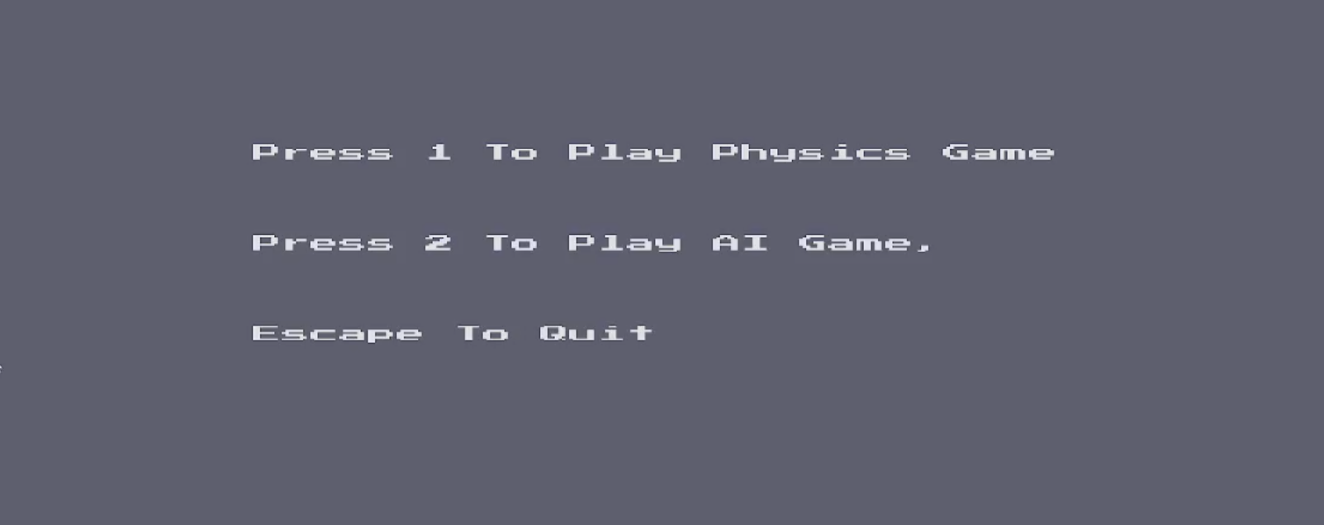

Basic menu using pushdown Automata to navigate through game states

KEYBINDS:

1 : Play Physics Game

2: Play AI game

ESC: quit game

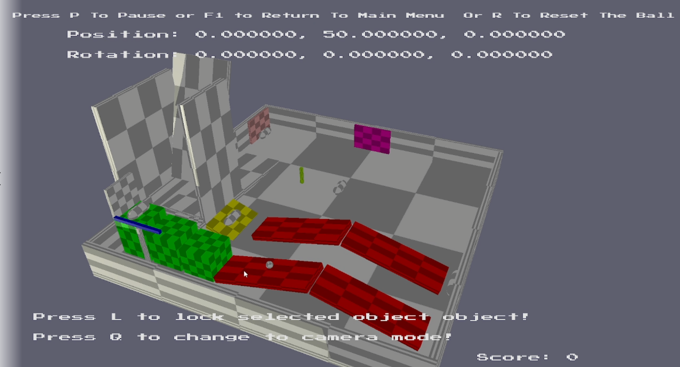

Physics level with OBBs, ABBs, Spheres and Capsules. Reach a capsule checkpoint to get points and press R to reset to last checkpoint. Click on coloured objects to influence the balls movement and orientation of certain objects. Objects have different elasticities, friction and masses that influence the balls movement.

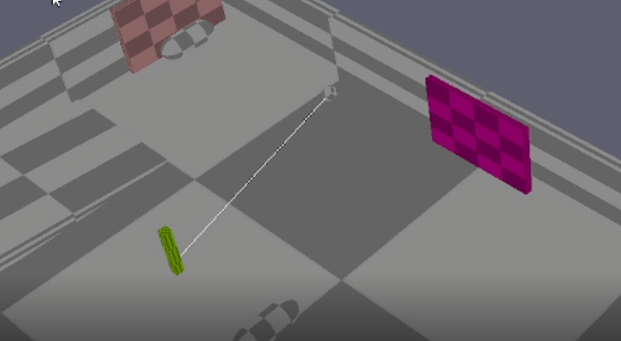

Constraint acting as a tether for the ball to move around.

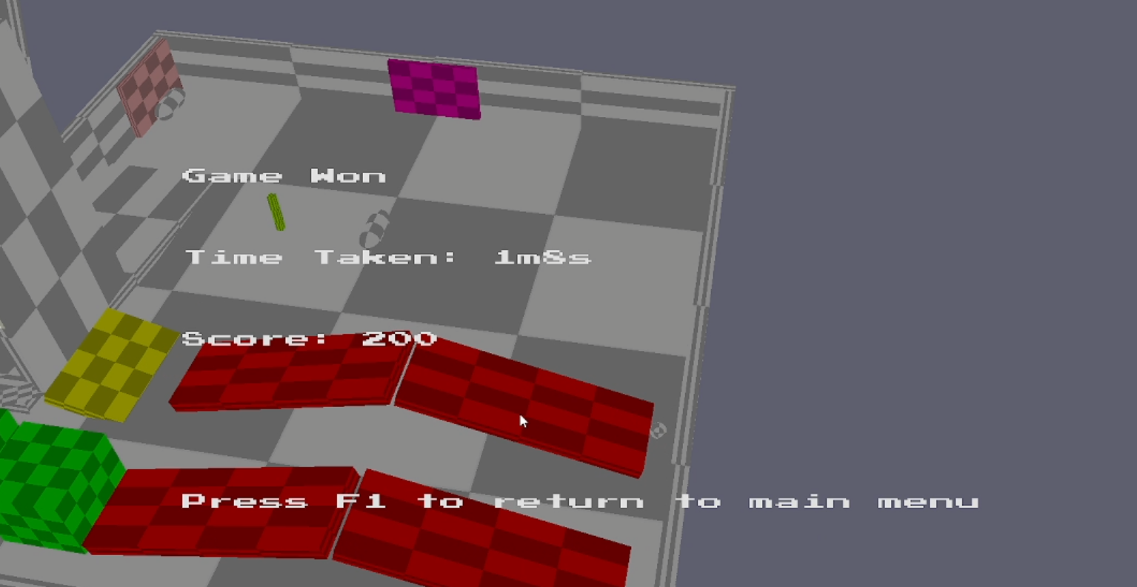

Reach the final capsule to complete the game and show the end screen with points and time taken to complete the game.

KEYBINDS:  
WASD + MOUSE: CAMERA MOVEMENT

CLICK ON OBJECTS: INFLUENCE WORLD

R: RESET BALL TO LAST CHECKPOINT

G: ENABLE/DISABLE GRAVITY

P: PAUSE GAME

F1: RETURN TO MAIN MENU

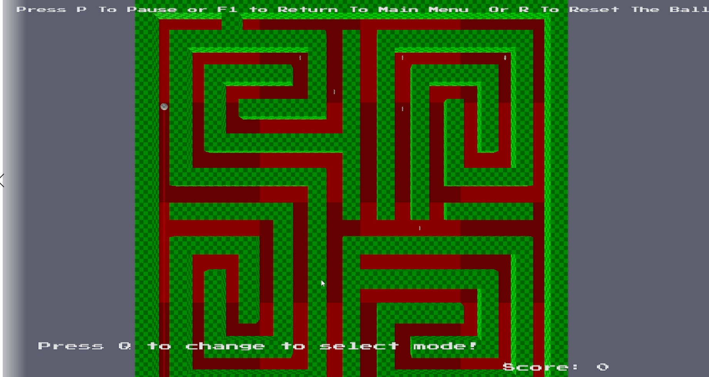

AI maze game with player and enemy ball. Enemy switches between states using a behaviour tree between searching for the closest powerup and chasing the player using A* pathfinding. If the player collides with the enemy both are reset to their start position and the player loses 100 points.

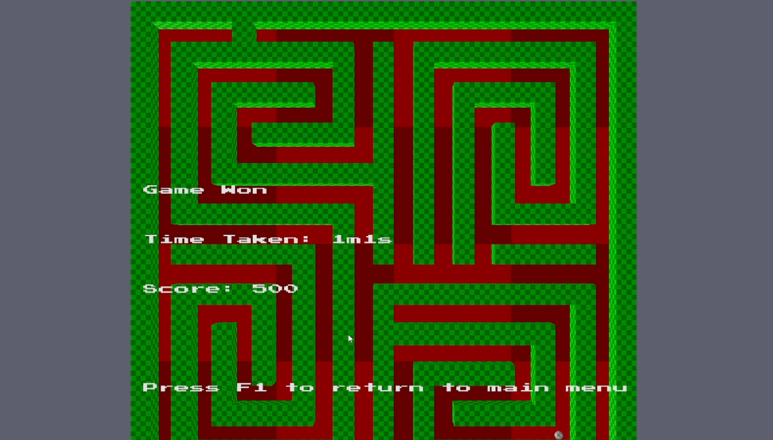

Once all of the powerups have been obtained the game ends and the endscreen is shown, the points are based upon how many powerups a player collects and how many the AI collects. The game is lost if the AI collects more powerups than the player.

KEYBINDS:  
ARROW KEYS: MOVE PLAYER BALL

P: PAUSE GAME

LINK TO YOUTUBE VIDEO: <https://youtu.be/22DtEcaE7_E>