Universal Travel Project Report

# TSUI Wai Yin

Project Specification and Introduction:

In this project, a universe-like world and try to travel around and between planets scene is built using C++ and graphics-related libraries (FreeGLUT, GLEW, GLM etc.). The basic scene is like the following picture:

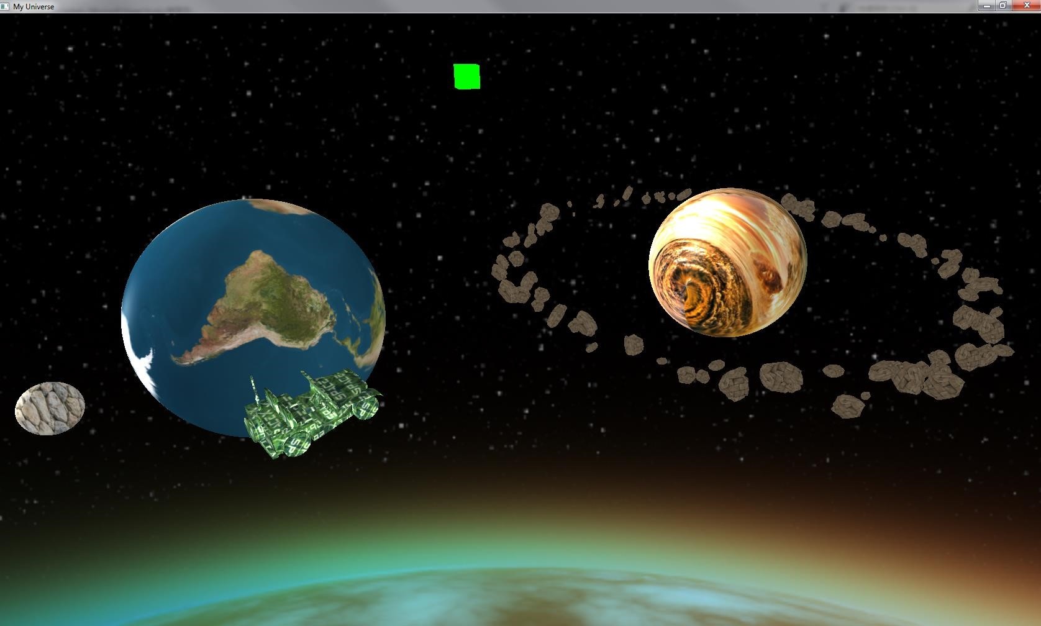

Fig. 1. Sample Scene of the universe transportation.

The program is implemented from scratch. The program allows the user to explore the Universe from different aspects. Another sample snapshot is shown below.

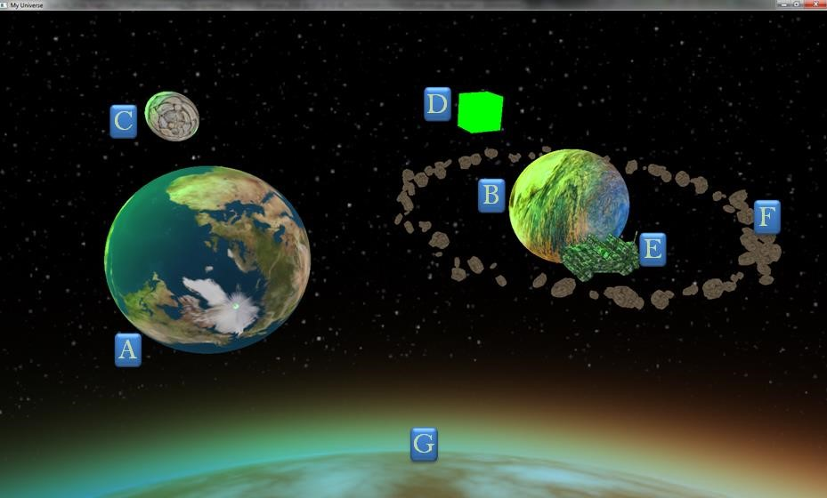

The ultimate objective of this project is to practice multiple computer graphics techniques skills in one time: From object loading, transformation matrix, viewpoint switch, skybox, lighting, multiple texture mapping, multiple shaders, normal mapping, instancing, interaction and GUI. It also rewards the creator a good insight of the rendering pipeline in OpenGL and hope to learn more about the OpenGL for more complex rendering.

II. Implemented Features

1. 3 planets (A, B, C), 1 light source box (D) and 1 space vehicle (E) created and placed properly. Aspect ratio of the scene is kept when window is resized.

2. Skybox (G) as background is created and rotate accordingly when change view direction is changed around the Universe.

3. An asteroid ring cloud F which contains at least 200 random floating rocks around planet B. Those floating rocks have random sizes and locations in a limited range.

4. Single texture mapping for planet C, space vehicle E and every rock in F; Multiple texture mapping for planet B; Normal mapping for planet A.

5. Basic light rendering for scene (ambient, diffuse and specular)

6. Self-rotation all the time for planet A and B, speeds of A and B can be associated with their volume size.

7. Planet C with self-rotation moves around A at a designed circular orbit, like moon around earth.

8. Light source D move from negative Z to positive Z along a straight line which lies somewhere between planet A and B periodically, just like sunrise and sunset. A red box is used to visualize the light source.

9. Space vehicle E first move around A at designed orbit before starting space travel.

10. For asteroid ring cloud F, all the floating rocks in it should move around planet B simultaneously.

11. For viewpoint switch, 4 distinctive viewpoints are provided to explore the Universe from different aspects.

12. Once we start the travel, the space vehicle E would be transformed to a fix site on its orbit immediately. Then, the vehicle E move to a fix site close to planet B gradually.

13. Keyboard Interaction: Switch between 4 different viewpoints; ‘T’ as the switch to start space travel. Up and down arrow keys control travel speed. ‘Esc’ for exit.

14. Mouse Interaction: Control position of camera by mouse:

i. When mouse moves up, the whole scene we see moves down.

ii. When mouse moves left, the whole scene we see moves right.

15. Intensity Control by Keyboard

16. Rotation around Mars after finishing space travel similar to original rotation around Earth

Final Implemented Results

1. Frames showing Objects Movement before space travel, with four viewpoints being shown (Point 5. In Spec)

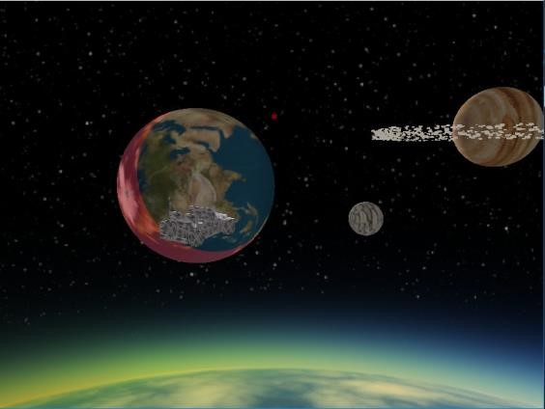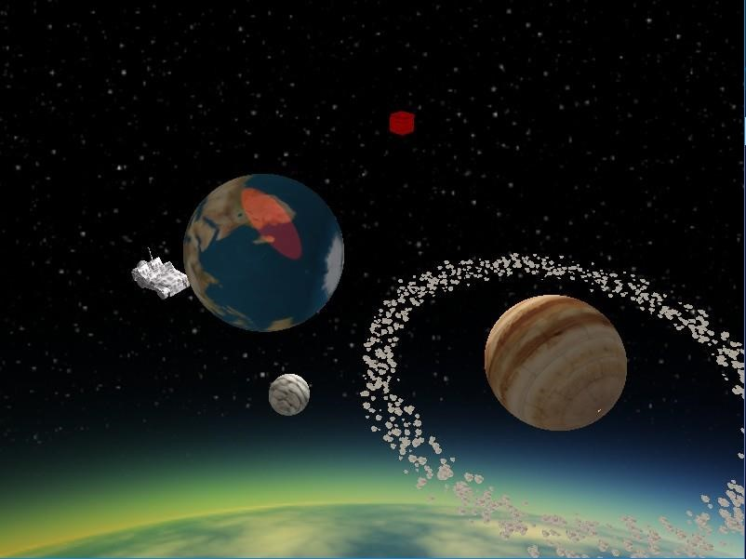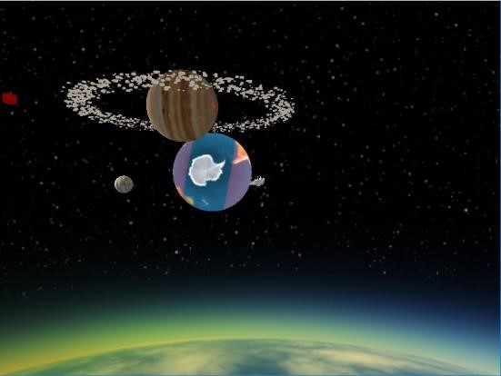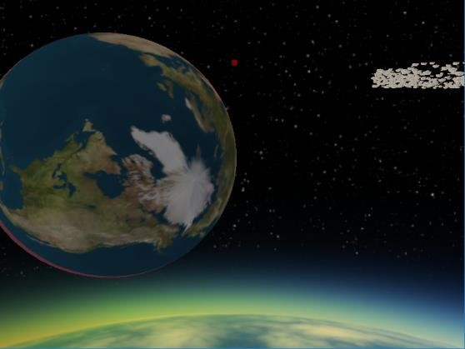

1. Frames showing light rendering result

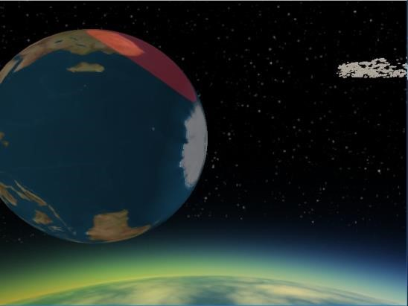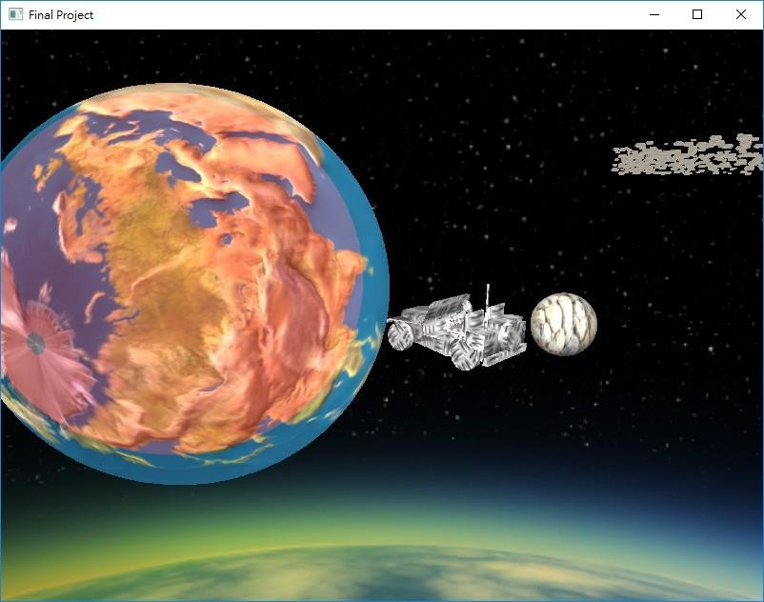

1. Frames showing Normal Mapping



1. Space Travel Procedure ( Start, On the way, End)

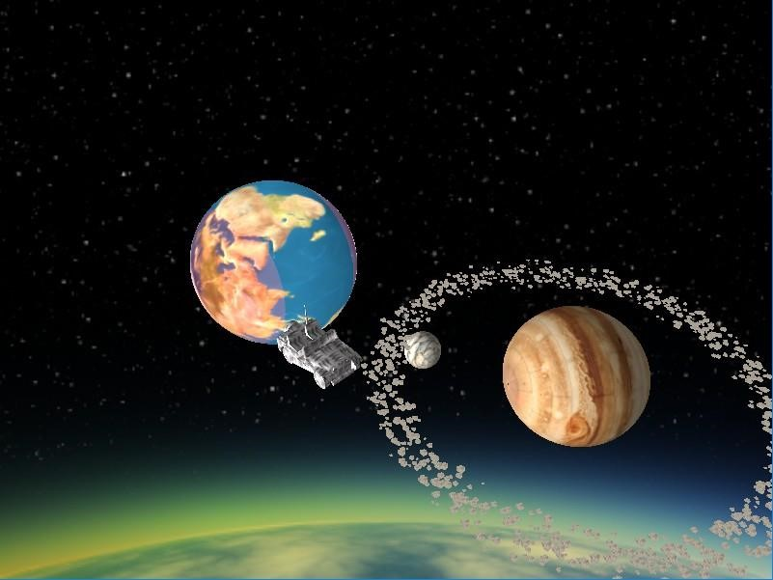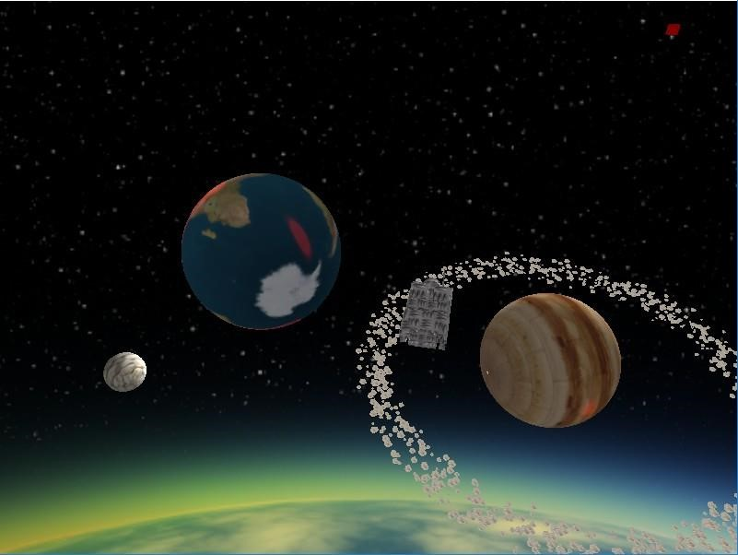

6. Frames showing Extra Credit (Intensity Control)

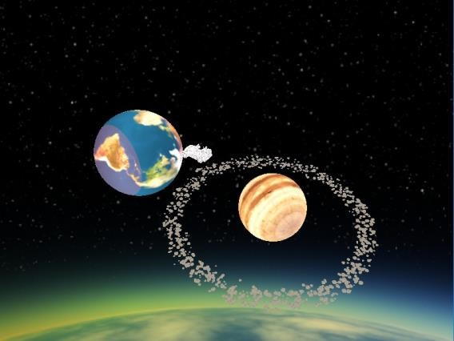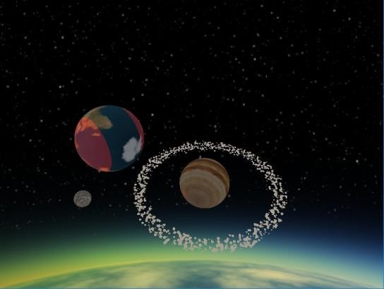

Extra Credit (Move around Mars)

