CS 576 – Assignment 1

Yu,Dung-Ru

Q3

1. plot a graph for the reconstruction error

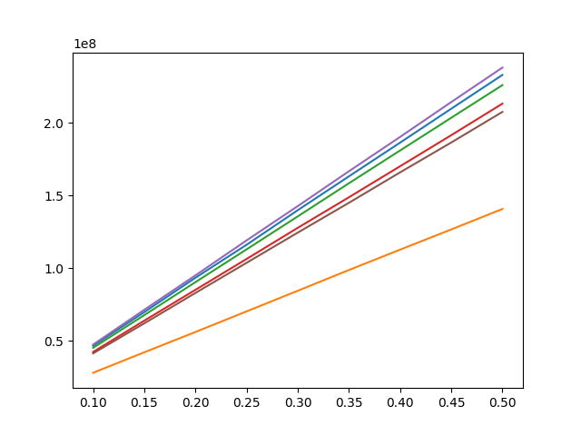

Blue: miamibeach Orange: rubixcube

Green: lake-forest Red: skyclouds

Purple: stagforest Brown: worldmap

X: percentage of missing samples

Y: error in reconstruction (distance between original and reconstruction)

1. Which image has higher errors, which image has lower error? Why are all the plots different?

Ans:

By plot, We can find that Stagforest has higher error and rubixcube has lower error. Some images are easier to reconstruct while some are hard to construct. For example, rubixcube is the easiest among these images.

1. From your quantitative analysis, can you qualitatively describe which image will have higher error and which image will have lower error.

Ans:

If the picture’s structure is made by multiple same color sections, it would be easier to construct and have lower error. For example, in rubixcube , the background color is black and when we construct the pixel in the background, we barely get error of them. And the cube is made by many square with same color, so the construction loss could be less. On the contray, Miamibeach has lots of color, especially gradual color would easily get error. Moreover, the segment of this is not clear. So, when we reconstruct the border of different object, it would get higher error.