ML HW7 report 0410024余東儒

Modified code:

x2p function 沒有做任何更改，因為symmetric SNE 和 t-SNE對P的算法都相同，另外就是加了一個坐symmetric SNE的function:

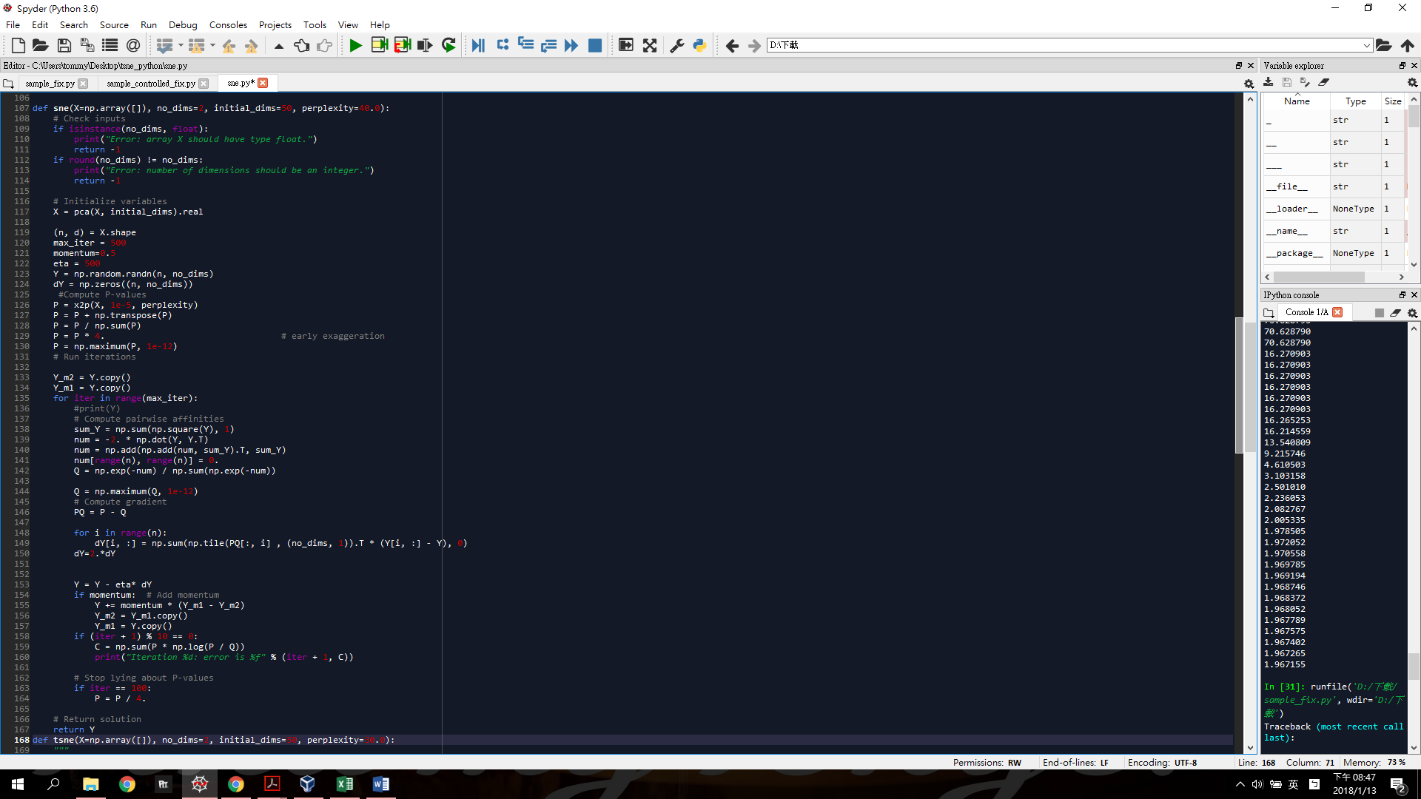

內容跟sample code裡的t-SNE有些地方重複，一樣的都先將X坐PCA再用x2p算出P，但計算Q和Y的方法並不相同

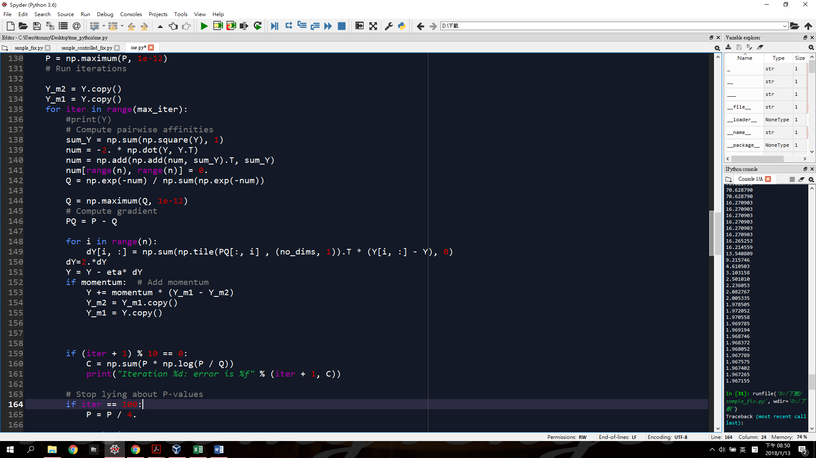

Y_m2和Y_m1是到時候做gradient descent需要的參數

計算Q的euclidean distance也是用sample code給的方法，但這邊只要把算出來的num取exponetial就好，並不需要乘上beta

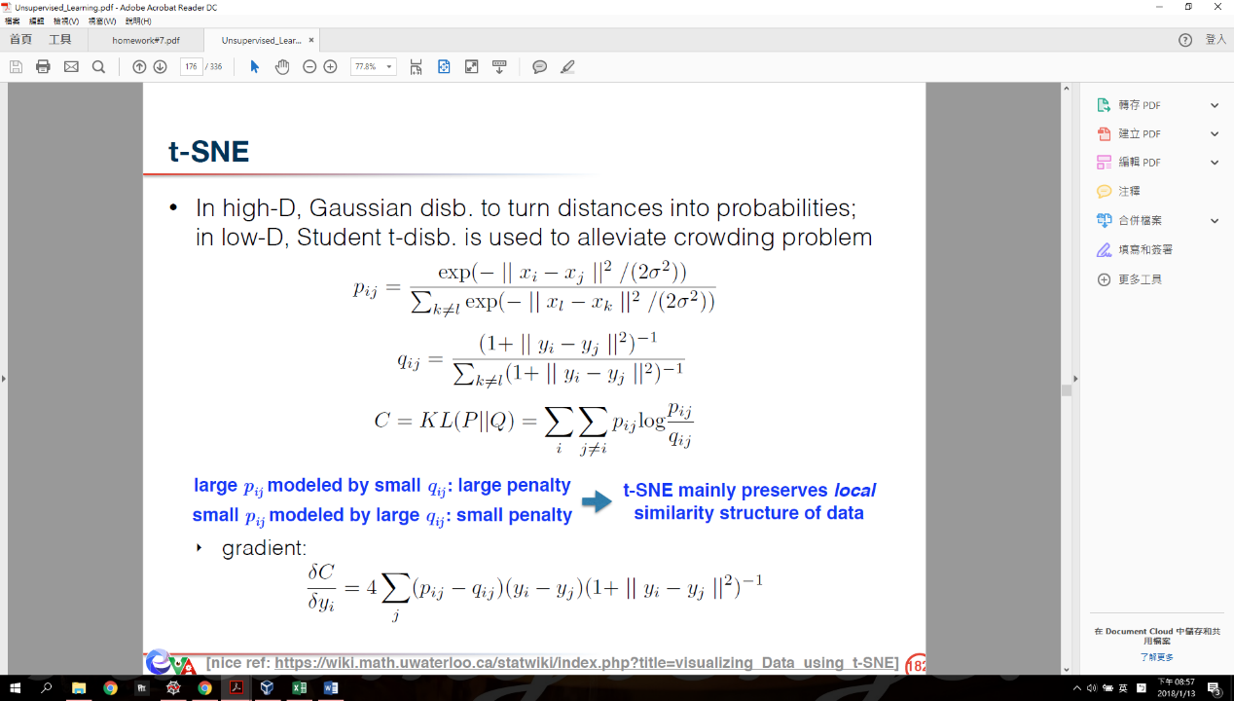Gradient 的部分也跟sample code類似，只是不需要乘上

Y的update方法我用

Performance:

|  |  |  |
| --- | --- | --- |
|  | SNE | t-SNE |
| 10 |  |  |
| 20 | C:\Users\tommy\AppData\Local\Microsoft\Windows\INetCache\Content.Word\sne20.png |  |
| 30 |  |  |
| 40 |  |  |
| 50 |  | C:\Users\tommy\AppData\Local\Microsoft\Windows\INetCache\Content.Word\tsne40.png |

表一、symmetric SNE和t-SNE ,perplexity=10-50的visualization

不管是t-SNE或symmetric SNE都可以做到將同class的data都分到同一區，但是SNE的class與class之間很難分開，不像t-SNE這樣分較開，因此有crowding problem。

Perplexity在這個範圍對t-SNE感覺沒有太大的影響，但是symmetric SNE的perplexity太低(=10,20)時，會接近成一條斜線，導致無法有效分類。

圖一、Symmetric SNE perplexity=10-50,iteration=500的cost function

10-100次iteration的error會逐漸上升，越接近100斜率越小，100次後會突然急速下降，應該是因為sample code的寫法當iteraion=10時P=P/4的關係，減少P的影響，讓error變小。

圖二、t-SNE perplexity=10-50,iteration=500的cost function

t-SNE iteration=10-100時error就開始下降，越接近100越慢，一樣在iteration=100後快速下降到2.多，因此後續的下降的速度會越來越慢。

|  |  |  |  |  |  |  |  |  |  |
| --- | --- | --- | --- | --- | --- | --- | --- | --- | --- |
|  | SNE p=10 | SNE p=20 | SNE p=30 | SNE p=40 | SNE p=50 | t-SNE p=10 | t-SNE p=20 | t-SNE p=30 | SNE p=10 |
| 10 | 44.78779 | 25.8054 | 22.7082 | 20.97272 | 19.65617 | 25.89339 | 23.54522 | 21.99663 | 21.17037 |
| 20 | 73.02304 | 42.20472 | 26.90408 | 19.99286 | 16.79016 | 23.33279 | 20.89636 | 19.74181 | 18.62819 |
| 30 | 74.85994 | 68.16102 | 47.8041 | 29.22184 | 18.90068 | 19.97774 | 17.7842 | 17.05557 | 15.98265 |
| 40 | 74.85994 | 72.19868 | 69.25403 | 49.48036 | 25.15505 | 18.45285 | 16.73898 | 16.04274 | 15.31069 |
| 50 | 74.85994 | 72.19868 | 70.62825 | 67.14418 | 37.004 | 17.77829 | 16.35676 | 15.77213 | 15.20323 |
| 60 | 74.85994 | 72.19868 | 70.62879 | 69.44491 | 54.85283 | 17.43998 | 16.21589 | 15.6717 | 15.22026 |
| 70 | 74.85994 | 72.19868 | 70.62879 | 69.50957 | 66.10005 | 17.20544 | 16.12288 | 15.58526 | 15.27325 |
| 80 | 74.85994 | 72.19868 | 70.62879 | 69.51072 | 68.43587 | 17.03779 | 16.03743 | 15.53826 | 15.30836 |
| 90 | 74.85994 | 72.19868 | 70.62879 | 69.51072 | 68.62888 | 16.9023 | 15.97413 | 15.51911 | 15.29175 |
| 100 | 74.85994 | 72.19868 | 70.62879 | 69.51072 | 68.63935 | 16.79005 | 15.92902 | 15.50836 | 15.26903 |
| 110 | 17.32869 | 16.66338 | 16.2709 | 15.99139 | 15.76882 | 2.564395 | 2.31946 | 2.186745 | 2.115809 |
| 120 | 17.32869 | 16.66338 | 16.2709 | 15.99139 | 15.62659 | 2.374713 | 2.081059 | 1.905317 | 1.781619 |
| 130 | 17.32869 | 16.66338 | 16.2709 | 15.99139 | 13.66385 | 2.203673 | 1.894665 | 1.719158 | 1.580218 |
| 140 | 17.32869 | 16.66338 | 16.2709 | 15.98486 | 6.062552 | 2.053857 | 1.753892 | 1.589145 | 1.451489 |
| 150 | 17.32869 | 16.66338 | 16.2709 | 15.88317 | 3.058229 | 1.927428 | 1.6458 | 1.494013 | 1.361343 |
| 160 | 17.32869 | 16.66338 | 16.2709 | 11.36178 | 2.108623 | 1.822447 | 1.561709 | 1.421823 | 1.295262 |
| 170 | 17.32869 | 16.66338 | 16.26525 | 7.323785 | 1.864685 | 1.735286 | 1.494438 | 1.365118 | 1.245118 |
| 180 | 17.32869 | 16.66338 | 16.21456 | 3.479313 | 1.833667 | 1.662718 | 1.439422 | 1.319761 | 1.205309 |
| 190 | 17.32869 | 16.66338 | 13.54081 | 2.222921 | 1.826626 | 1.602532 | 1.393761 | 1.282412 | 1.172888 |
| 200 | 17.32869 | 16.66338 | 9.215746 | 2.006609 | 1.821833 | 1.552815 | 1.355373 | 1.251171 | 1.146068 |
| 210 | 17.32869 | 16.66338 | 4.610503 | 1.948728 | 1.817962 | 1.511293 | 1.322802 | 1.224733 | 1.123559 |
| 220 | 17.32869 | 16.66338 | 3.103158 | 1.930881 | 1.814889 | 1.475528 | 1.294906 | 1.202026 | 1.104405 |
| 230 | 17.32869 | 16.66338 | 2.50101 | 1.919382 | 1.812882 | 1.443876 | 1.27081 | 1.182457 | 1.087912 |
| 240 | 17.32869 | 16.66338 | 2.236053 | 1.912727 | 1.811756 | 1.415813 | 1.24989 | 1.165519 | 1.073629 |
| 250 | 17.32869 | 16.66338 | 2.082767 | 1.909007 | 1.811162 | 1.390917 | 1.231555 | 1.150657 | 1.0612 |
| 260 | 17.32869 | 16.66338 | 2.005335 | 1.904597 | 1.81083 | 1.368766 | 1.215321 | 1.137489 | 1.050258 |
| 270 | 17.32869 | 16.66338 | 1.978505 | 1.895085 | 1.81062 | 1.34898 | 1.200827 | 1.125742 | 1.040653 |
| 280 | 17.32869 | 16.66338 | 1.972052 | 1.883019 | 1.81047 | 1.331084 | 1.187786 | 1.115349 | 1.032125 |
| 290 | 17.32869 | 16.66338 | 1.970558 | 1.879145 | 1.810352 | 1.314768 | 1.176026 | 1.106021 | 1.024473 |
| 300 | 17.32869 | 16.66338 | 1.969785 | 1.87736 | 1.810256 | 1.299859 | 1.165419 | 1.09756 | 1.017584 |
| 310 | 17.32869 | 16.66338 | 1.969194 | 1.876219 | 1.810175 | 1.286232 | 1.155795 | 1.089741 | 1.011388 |
| 320 | 17.32869 | 16.66338 | 1.968746 | 1.875417 | 1.810103 | 1.273803 | 1.147082 | 1.082769 | 1.005802 |
| 330 | 17.32869 | 16.66338 | 1.968372 | 1.874825 | 1.81004 | 1.262298 | 1.139103 | 1.076438 | 1.000716 |
| 340 | 17.32869 | 16.66338 | 1.968052 | 1.874375 | 1.809982 | 1.251572 | 1.131772 | 1.070594 | 0.996056 |
| 350 | 17.32869 | 16.66338 | 1.967789 | 1.874024 | 1.809926 | 1.241669 | 1.125035 | 1.065299 | 0.99182 |
| 360 | 17.32869 | 16.66338 | 1.967575 | 1.873748 | 1.80987 | 1.232483 | 1.118785 | 1.060437 | 0.987845 |
| 370 | 17.32869 | 16.66338 | 1.967402 | 1.873526 | 1.809811 | 1.223904 | 1.112993 | 1.05593 | 0.984311 |
| 380 | 17.32869 | 16.66338 | 1.967265 | 1.873344 | 1.809745 | 1.215896 | 1.10762 | 1.051733 | 0.981121 |
| 390 | 17.32869 | 16.66338 | 1.967155 | 1.873193 | 1.809669 | 1.208391 | 1.10262 | 1.047841 | 0.978177 |
| 400 | 17.32869 | 16.66338 | 1.967066 | 1.873062 | 1.809575 | 1.201342 | 1.09796 | 1.044223 | 0.975434 |
| 410 | 17.32869 | 16.66338 | 1.966995 | 1.872945 | 1.809447 | 1.194696 | 1.093614 | 1.040841 | 0.972635 |
| 420 | 17.32869 | 16.66338 | 1.966937 | 1.872837 | 1.809262 | 1.188421 | 1.089565 | 1.037676 | 0.970021 |
| 430 | 17.32869 | 16.66338 | 1.966888 | 1.872732 | 1.80896 | 1.182485 | 1.085771 | 1.034723 | 0.967827 |
| 440 | 17.32869 | 16.66338 | 1.966848 | 1.872625 | 1.808383 | 1.176867 | 1.082197 | 1.031968 | 0.965876 |
| 450 | 17.32869 | 16.66338 | 1.966815 | 1.872513 | 1.807071 | 1.17154 | 1.07883 | 1.029383 | 0.964084 |
| 460 | 17.32869 | 16.66331 | 1.966787 | 1.872391 | 1.804337 | 1.166499 | 1.075657 | 1.026954 | 0.96239 |
| 470 | 17.32869 | 16.66338 | 1.966762 | 1.872258 | 1.801956 | 1.161732 | 1.072668 | 1.02466 | 0.960768 |
| 480 | 17.32869 | 16.66338 | 1.966742 | 1.872104 | 1.800822 | 1.1572 | 1.069843 | 1.022485 | 0.959238 |
| 490 | 17.32869 | 16.66338 | 1.966724 | 1.871932 | 1.800229 | 1.152897 | 1.067177 | 1.020422 | 0.95779 |
| 500 | 17.32869 | 16.66338 | 1.966708 | 1.871745 | 1.799875 | 1.14879 | 1.064659 | 1.018476 | 0.956418 |

表二、symmetric SNE和t-SNE ,perplexity=10-50 iteration=0-500次的cost function