Tommy’s Website Design Photo License

Pexel’s

License:

All Photos on Pexels can be used for free. While the most photos are released under the Pexels license, some photos are covered by the Creative Commons Zero (CC0) license. Both licenses are similar and allow you to do the following:

Use all photos for free for commercial and noncommercial purposes.

Giving credit to the photographer or Pexels is not required but appreciated.

You can edit and adapt the photos as you like.

All photos that are covered by the Creative Commons Zero license are marked with "CC0" on the photo page. The CC0 license was released by the non-profit organization Creative Commons. You can get more information about Creative Commons and their license on the official license page.

1. art-big-data-blur-373543.jpg
   1. Pexel
   2. 
2. river.jpg
   1. Pexel
   2. 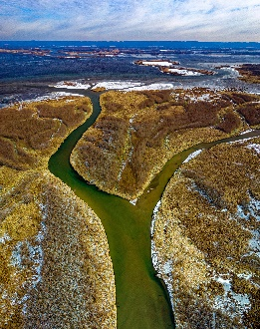
3. beautiful-cascade-daylight-225732.jpg
   1. Pexel
   2. 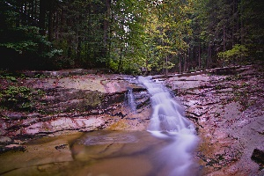
4. art-dark-dawn-1638061.jpg
   1. Pexel
   2. 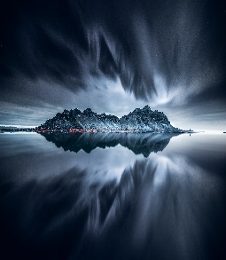
5. abstract-art-burn-604672.jpg
   1. Pexel
   2. 