NRSG 741: HW_01

TommY Flynn

1/26/2018

GitHub Repository @ <https://github.com/tommyflynn/N741_Homework.git>

## Task One:

The mean life expectancy is 59.47 years, with a standard deviation of 12.92, median of 60.71, and sample size of 1704.

## Task Two:

kable(gapminder %>%   
 group_by(Continent = continent) %>%  
 summarise(LE_median = median(lifeExp), LE_sd = sd(lifeExp), LE_mean = mean(lifeExp)), caption = "Life Expectancy by Continent: Summary Statistics"  
)

Life Expectancy by Continent: Summary Statistics

|  |  |  |  |
| --- | --- | --- | --- |
| Continent | LE_median | LE_sd | LE_mean |
| Africa | 47.7920 | 9.150210 | 48.86533 |
| Americas | 67.0480 | 9.345088 | 64.65874 |
| Asia | 61.7915 | 11.864532 | 60.06490 |
| Europe | 72.2410 | 5.433178 | 71.90369 |
| Oceania | 73.6650 | 3.795611 | 74.32621 |

## Task Three:

contXlife <- ggplot(gapminder, aes(x = continent, y = lifeExp))  
contXlife + geom_boxplot(fill = "yellow", colour = "blue", outlier.colour = "hotpink") +  
 geom_jitter(position = position_jitter(width = 0.1, height = 0), alpha = 1/4)

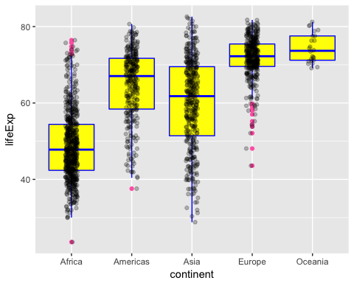 #### Boxplot of Life Expectancy by Continent

contXgdp <- ggplot(gapminder, aes(x = continent, y = gdpPercap))  
contXgdp + geom_boxplot(fill = "hotpink", colour = "yellow", outlier.colour = "blue") +  
 geom_jitter(position = position_jitter(width = 0.1, height = 0), alpha = 1/4)

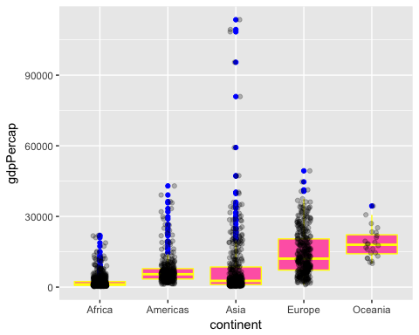 #### Boxplot of Per Capita GDP by Continent

contXpop <- ggplot(gapminder, aes(x = continent, y = pop))   
contXpop + geom_boxplot(fill = "black", colour = "red", outlier.colour = "yellow") +  
 geom_jitter(position = position_jitter(width = 0.1, height = 0), alpha = 1/4)

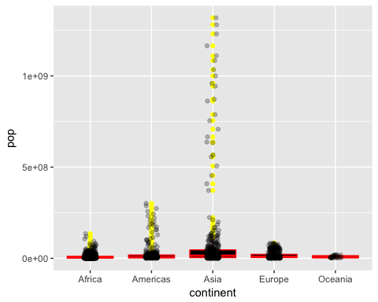 #### Boxplot of Population by Continent

## Task Four:

colorful_gap <-  
 data.frame(gapminder,  
 cc = I(country_colors[match(gapminder$country,  
 names(country_colors))]))  
Continents <- with(colorful_gap, continent %in% c("Americas", "Asia") & year == 1992)  
plot(lifeExp ~ gdpPercap, colorful_gap, subset = Continents, log = "x", pch = 21, cex = sqrt(colorful_gap$pop[Continents]/pi)/1500, bg = colorful_gap$cc[Continents])

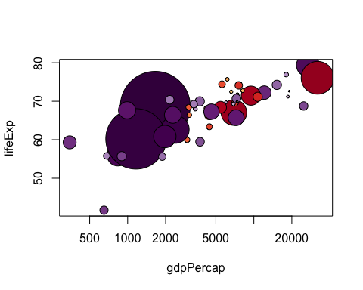 #### Scatterplot of Countries in the Americas & Asia by Life Expectancy and GDP (node size scaled to population) from 1992

**References**  
1. Jennifer Bryan (2017). gapminder: Data from Gapminder. R package version 0.3.0. <https://CRAN.R-project.org/package=gapminder>