library(tidyverse)
## ── Attaching core tidyverse packages ──────────────────────── tidyverse 2.0.0 ──
## ✔ dplyr 1.1.4 ✔ readr 2.1.6
## ✔ forcats 1.0.1 ✔ stringr 1.6.0
## ✔ ggplot2 4.0.1 ✔ tibble 3.3.1
## ✔ lubridate 1.9.4 ✔ tidyr 1.3.2
## ✔ purrr 1.2.1
## ── Conflicts ────────────────────────────────────────── tidyverse_conflicts() ──
## ✖ dplyr::filter() masks stats::filter()
## ✖ dplyr::lag() masks stats::lag()
## ℹ Use the conflicted package (<http://conflicted.r-lib.org/>) to force all conflicts to become errors
product = read_csv("product.csv")
## Rows: 26570 Columns: 26
## ── Column specification ────────────────────────────────────────────────────────
## Delimiter: ","
## chr (4): product_code, attribute_0, attribute_1, failure
## dbl (22): id, loading, attribute_2, attribute_3, measurement_0, measurement_...
##
## ℹ Use `spec()` to retrieve the full column specification for this data.
## ℹ Specify the column types or set `show_col_types = FALSE` to quiet this message.
head(product)
## # A tibble: 6 × 26
## id product_code loading attribute_0 attribute_1 attribute_2 attribute_3
## <dbl> <chr> <dbl> <chr> <chr> <dbl> <dbl>
## 1 0 A 80.1 material_7 material_8 9 5
## 2 1 A 84.9 material_7 material_8 9 5
## 3 2 A 82.4 material_7 material_8 9 5
## 4 3 A 101. material_7 material_8 9 5
## 5 4 A 188. material_7 material_8 9 5
## 6 5 A 75.4 material_7 material_8 9 5
## # ℹ 19 more variables: measurement_0 <dbl>, measurement_1 <dbl>,
## # measurement_2 <dbl>, measurement_3 <dbl>, measurement_4 <dbl>,
## # measurement_5 <dbl>, measurement_6 <dbl>, measurement_7 <dbl>,
## # measurement_8 <dbl>, measurement_9 <dbl>, measurement_10 <dbl>,
## # measurement_11 <dbl>, measurement_12 <dbl>, measurement_13 <dbl>,
## # measurement_14 <dbl>, measurement_15 <dbl>, measurement_16 <dbl>,
## # measurement_17 <dbl>, failure <chr>
summary(product)
## id product_code loading attribute_0
## Min. : 0 Length:26570 Min. : 33.16 Length:26570
## 1st Qu.: 6642 Class :character 1st Qu.: 99.99 Class :character
## Median :13284 Mode :character Median :122.39 Mode :character
## Mean :13284 Mean :127.83
## 3rd Qu.:19927 3rd Qu.:149.15
## Max. :26569 Max. :385.86
## NA's :250
## attribute_1 attribute_2 attribute_3 measurement_0
## Length:26570 Min. :5.000 Min. :5.00 Min. : 0.000
## Class :character 1st Qu.:6.000 1st Qu.:6.00 1st Qu.: 4.000
## Mode :character Median :6.000 Median :8.00 Median : 7.000
## Mean :6.754 Mean :7.24 Mean : 7.416
## 3rd Qu.:8.000 3rd Qu.:8.00 3rd Qu.:10.000
## Max. :9.000 Max. :9.00 Max. :29.000
##
## measurement_1 measurement_2 measurement_3 measurement_4
## Min. : 0.000 Min. : 0.000 Min. :13.97 Min. : 8.008
## 1st Qu.: 5.000 1st Qu.: 4.000 1st Qu.:17.12 1st Qu.:11.051
## Median : 8.000 Median : 6.000 Median :17.79 Median :11.733
## Mean : 8.233 Mean : 6.257 Mean :17.79 Mean :11.732
## 3rd Qu.:11.000 3rd Qu.: 8.000 3rd Qu.:18.47 3rd Qu.:12.410
## Max. :29.000 Max. :24.000 Max. :21.50 Max. :16.484
## NA's :381 NA's :538
## measurement_5 measurement_6 measurement_7 measurement_8
## Min. :12.07 Min. :12.71 Min. : 7.968 Min. :15.22
## 1st Qu.:16.44 1st Qu.:16.84 1st Qu.:11.045 1st Qu.:18.34
## Median :17.13 Median :17.52 Median :11.712 Median :19.02
## Mean :17.13 Mean :17.51 Mean :11.717 Mean :19.02
## 3rd Qu.:17.80 3rd Qu.:18.18 3rd Qu.:12.391 3rd Qu.:19.71
## Max. :21.43 Max. :21.54 Max. :15.419 Max. :23.81
## NA's :676 NA's :796 NA's :937 NA's :1048
## measurement_9 measurement_10 measurement_11 measurement_12
## Min. : 7.537 Min. : 9.323 Min. :12.46 Min. : 5.167
## 1st Qu.:10.757 1st Qu.:15.209 1st Qu.:18.17 1st Qu.:10.703
## Median :11.430 Median :16.127 Median :19.21 Median :11.717
## Mean :11.431 Mean :16.118 Mean :19.17 Mean :11.702
## 3rd Qu.:12.102 3rd Qu.:17.025 3rd Qu.:20.21 3rd Qu.:12.709
## Max. :15.412 Max. :22.479 Max. :25.64 Max. :17.663
## NA's :1227 NA's :1300 NA's :1468 NA's :1601
## measurement_13 measurement_14 measurement_15 measurement_16
## Min. :10.89 Min. : 9.14 Min. : 9.104 Min. : 9.701
## 1st Qu.:14.89 1st Qu.:15.06 1st Qu.:13.957 1st Qu.:15.268
## Median :15.63 Median :16.04 Median :14.969 Median :16.436
## Mean :15.65 Mean :16.05 Mean :14.996 Mean :16.461
## 3rd Qu.:16.37 3rd Qu.:17.08 3rd Qu.:16.018 3rd Qu.:17.628
## Max. :22.71 Max. :22.30 Max. :21.626 Max. :24.094
## NA's :1774 NA's :1874 NA's :2009 NA's :2110
## measurement_17 failure
## Min. : 196.8 Length:26570
## 1st Qu.: 619.0 Class :character
## Median : 701.0 Mode :character
## Mean : 701.3
## 3rd Qu.: 784.1
## Max. :1312.8
## NA's :2284
product = product %>% drop_na()
product <- product %>%
mutate(failure = as.factor(failure))
ggplot(product, aes(x = failure)) +
geom_bar() +
labs(x = "Failure",
y = "Count")
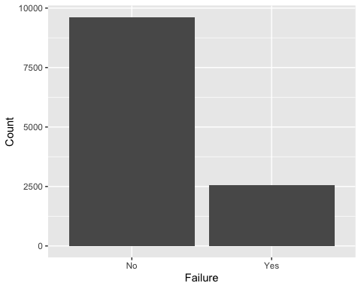
numeric_vars <- product %>%
select(where(is.numeric)) %>%
names()
product %>%
group_by(failure) %>%
summarise(across(all_of(numeric_vars),
list(mean = mean, sd = sd),
na.rm = TRUE))
## Warning: There was 1 warning in `summarise()`.
## ℹ In argument: `across(all_of(numeric_vars), list(mean = mean, sd = sd), na.rm
## = TRUE)`.
## ℹ In group 1: `failure = No`.
## Caused by warning:
## ! The `...` argument of `across()` is deprecated as of dplyr 1.1.0.
## Supply arguments directly to `.fns` through an anonymous function instead.
##
## # Previously
## across(a:b, mean, na.rm = TRUE)
##
## # Now
## across(a:b, \(x) mean(x, na.rm = TRUE))
## # A tibble: 2 × 45
## failure id_mean id_sd loading_mean loading_sd attribute_2_mean attribute_2_sd
## <fct> <dbl> <dbl> <dbl> <dbl> <dbl> <dbl>
## 1 No 13146. 7632. 126. 38.0 6.77 1.48
## 2 Yes 13334. 7781. 136. 41.6 6.75 1.48
## # ℹ 38 more variables: attribute_3_mean <dbl>, attribute_3_sd <dbl>,
## # measurement_0_mean <dbl>, measurement_0_sd <dbl>, measurement_1_mean <dbl>,
## # measurement_1_sd <dbl>, measurement_2_mean <dbl>, measurement_2_sd <dbl>,
## # measurement_3_mean <dbl>, measurement_3_sd <dbl>, measurement_4_mean <dbl>,
## # measurement_4_sd <dbl>, measurement_5_mean <dbl>, measurement_5_sd <dbl>,
## # measurement_6_mean <dbl>, measurement_6_sd <dbl>, measurement_7_mean <dbl>,
## # measurement_7_sd <dbl>, measurement_8_mean <dbl>, measurement_8_sd <dbl>, …
for (var in numeric_vars) {
print(
ggplot(product, aes(x = failure, y = .data[[var]])) +
geom_boxplot() +
labs(title = paste("Failure vs", var))
)
}
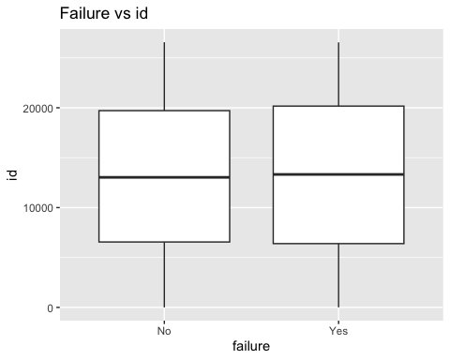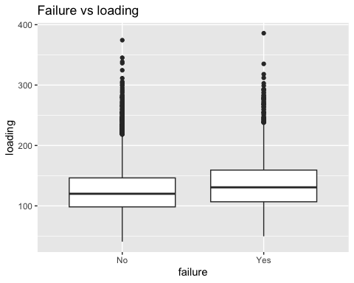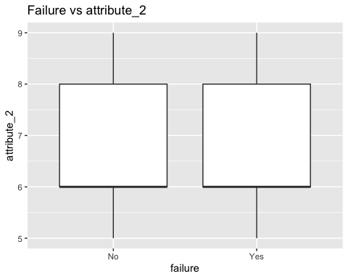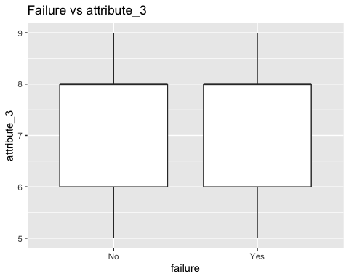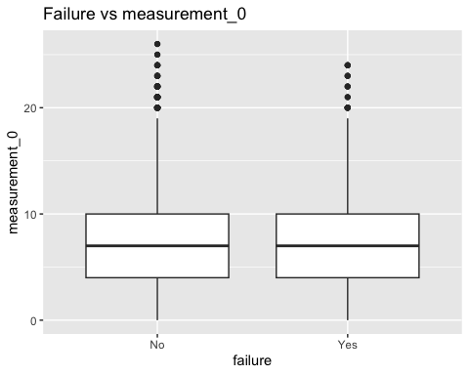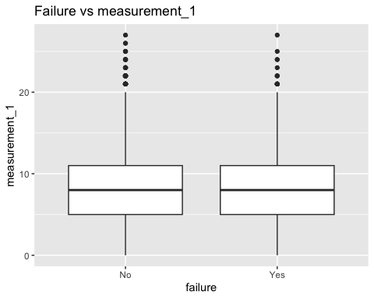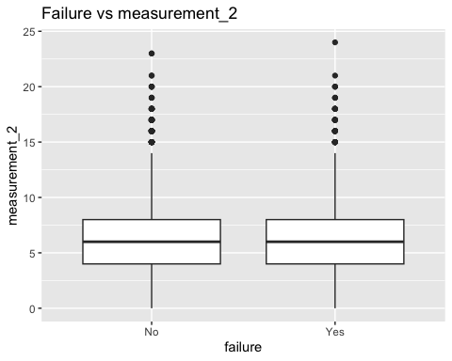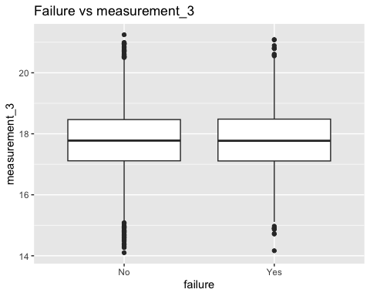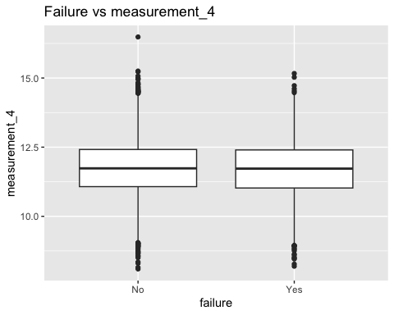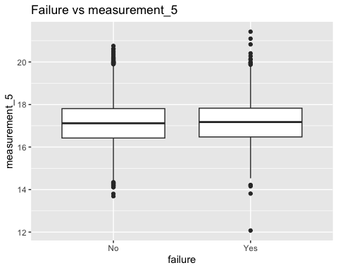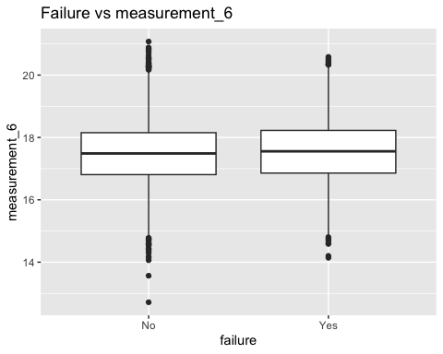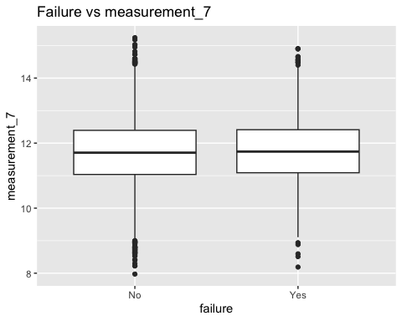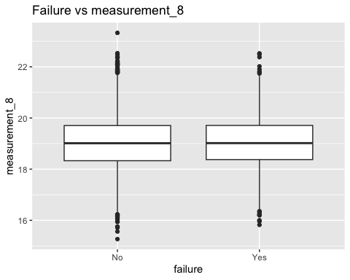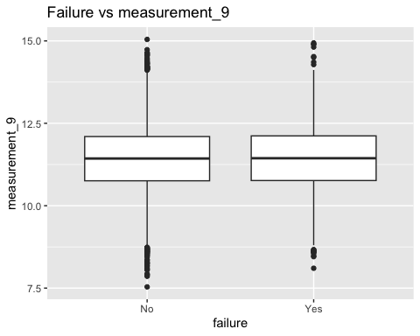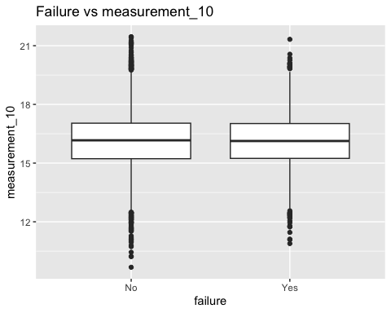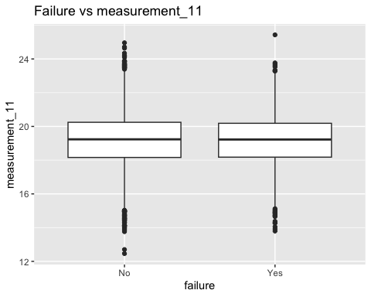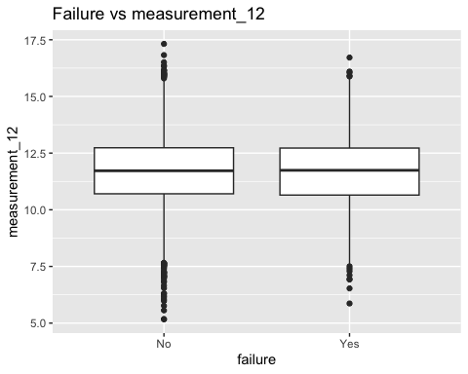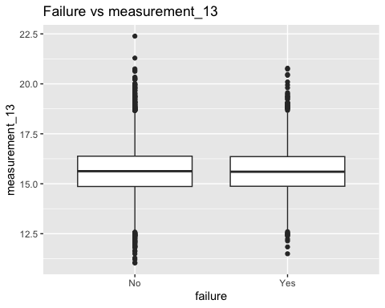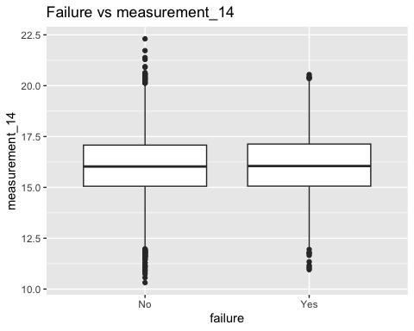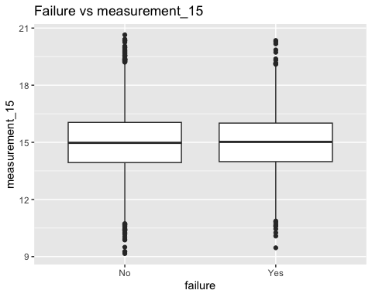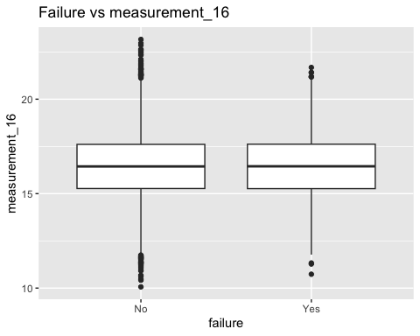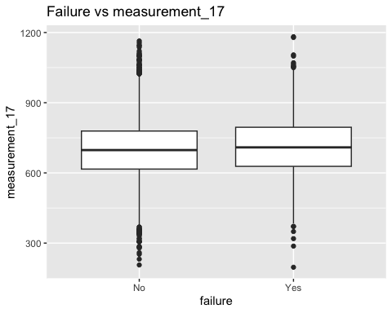
product <- product %>%
mutate(failure_num = ifelse(failure == levels(as.factor(failure))[2], 1, 0))
# Select numeric predictors only (exclude failure_num first)
numeric_vars <- product %>%
select(where(is.numeric)) %>%
select(-failure_num, -id) %>%
names()
# Compute correlation with failure
cor_results <- sapply(numeric_vars, function(x) {
cor(product[[x]], product$failure_num, use = "complete.obs")
})
# Sort by strongest relationship
sort(cor_results, decreasing = TRUE)
## loading measurement_17 measurement_6 measurement_5 measurement_7
## 0.1133340834 0.0372130222 0.0271860098 0.0220809232 0.0165630968
## measurement_14 measurement_8 measurement_2 measurement_0 measurement_3
## 0.0083531202 0.0070598907 0.0068379609 0.0066065106 0.0061993854
## measurement_9 measurement_15 measurement_11 measurement_12 measurement_10
## 0.0051655448 0.0030306373 0.0015136670 0.0015128762 -0.0001709006
## measurement_16 measurement_1 measurement_13 attribute_3 attribute_2
## -0.0004861654 -0.0009651279 -0.0026109128 -0.0031938354 -0.0060943168
## measurement_4
## -0.0172508918
categorical_vars <- product %>%
select(where(is.character), where(is.factor)) %>%
names()
for (var in categorical_vars) {
plot_product <- product %>%
count(!!sym(var), failure) %>%
group_by(!!sym(var)) %>%
mutate(prop = n / sum(n))
print(
ggplot(plot_product, aes(x = !!sym(var), y = prop, fill = failure)) +
geom_col(position = "dodge") +
labs(title = paste("Failure Rate by", var),
x = var,
y = "Proportion") +
theme_minimal()
)
}
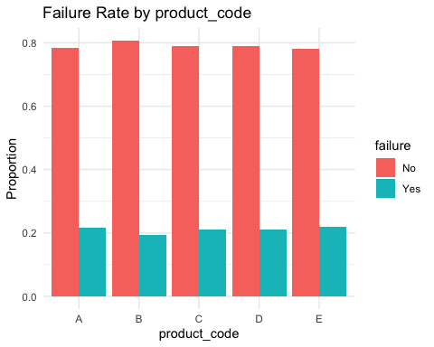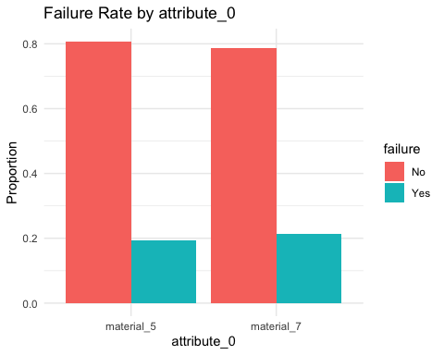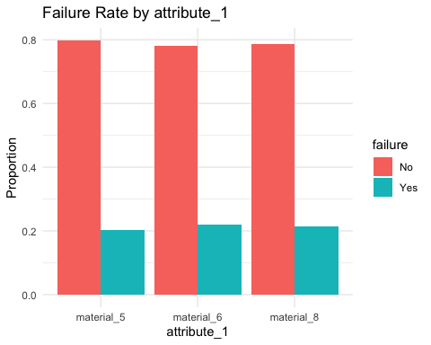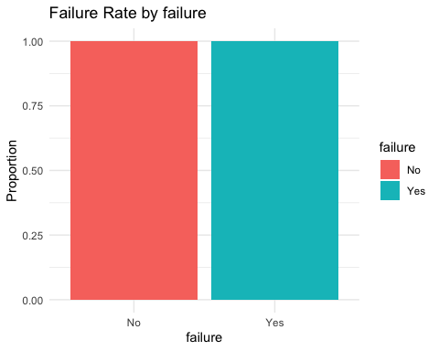
mean_diff <- product %>%
group_by(failure) %>%
summarise(across(all_of(numeric_vars), mean, na.rm = TRUE)) %>%
pivot_longer(-failure) %>%
pivot_wider(names_from = failure, values_from = value) %>%
mutate(diff = abs(`No` - `Yes`)) %>%
arrange(desc(diff))
mean_diff
## # A tibble: 21 × 4
## name No Yes diff
## <chr> <dbl> <dbl> <dbl>
## 1 measurement_17 699. 710. 11.3
## 2 loading 126. 136. 10.9
## 3 measurement_0 7.41 7.47 0.0672
## 4 measurement_6 17.5 17.6 0.0668
## 5 measurement_2 6.20 6.26 0.0555
## 6 measurement_5 17.1 17.2 0.0544
## 7 measurement_4 11.7 11.7 0.0421
## 8 measurement_7 11.7 11.7 0.0406
## 9 measurement_14 16.0 16.1 0.0305
## 10 attribute_2 6.77 6.75 0.0221
## # ℹ 11 more rows
mean_diff %>%
ggplot(aes(x = reorder(name, diff), y = diff)) +
geom_col() +
coord_flip() +
labs(title = "Largest Average Difference Between Failure and Non-Failure",
x = "Variable",
y = "Difference in Average Value")
