UNIVERSITI TUNKU ABDUL RAHMAN
Faculty of Information and Communication Technology



UCCD3223 Mobile Applications Development
(Feb 2025 Trimester)

Individual Practical Assignment

Name | Heah Jun Bin
Student ID | 2103101
Course | CS
Practical Group | P3
Lecturer | Mr. Tan Chiang Kang

Marking scheme | Marks | Remarks
Correctness | × 2.5
Design | × 3.5
User Friendliness | × 2
Neat Program Documentation
Report Format
TOTAL

Main Page:
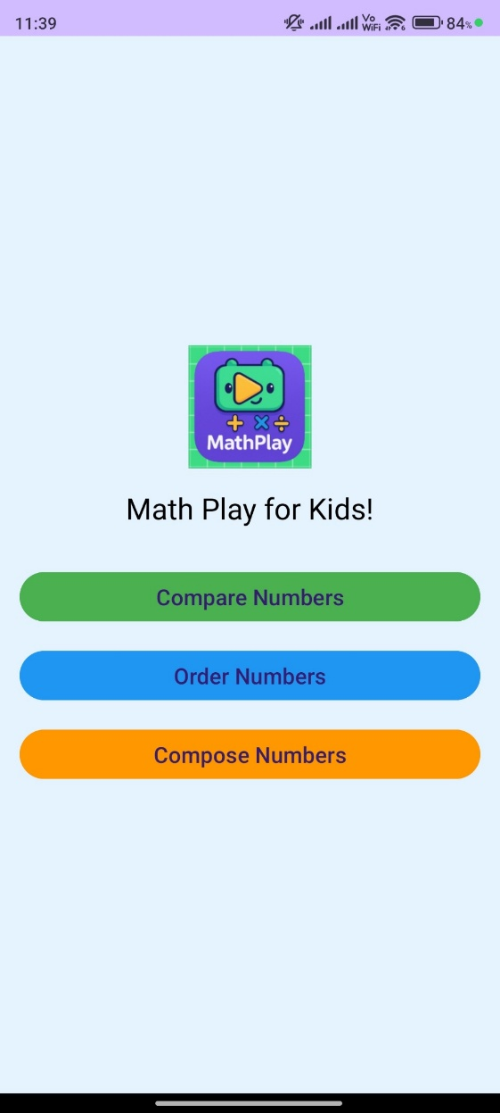
This is the home page that user will see when entering the application. When the user clicked on the “Compare Numbers” button, it will switch to the page for comparing the numbers. Besides, when the user clicked on the “Order Numbers” button, it will switch to the page for arranging the numbers by order. Lastly, when the user clicked on the “Compose Numbers” button, it will switch to the page for composing a target number by using number 1 to number 9.

Compare Number:
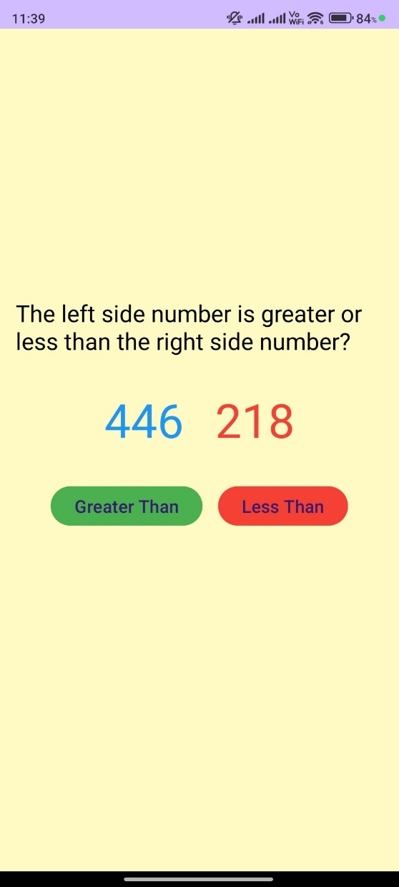
This is the page for comparing numbers. The user will be asked to compare the left-side number which in blue colour and right-side number which is in red colour. They need to press on “Greater Than” button or “Less Than” button as the answer.

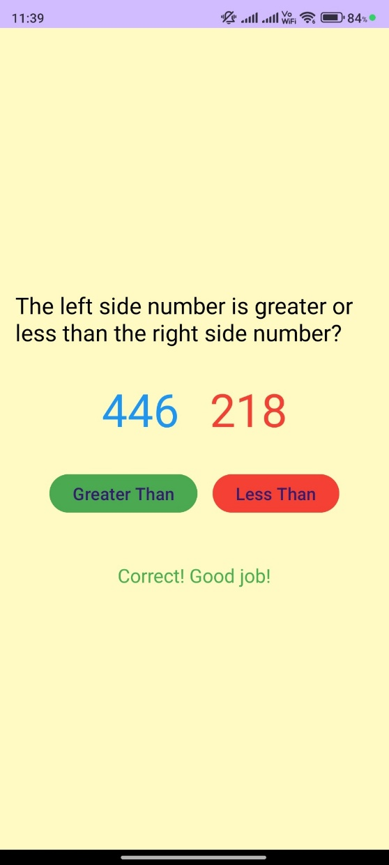
When the button clicked is correct answer, then will show the text “Correct! Good job!”. After that, both side number will change randomly and the user can continue select the answer.

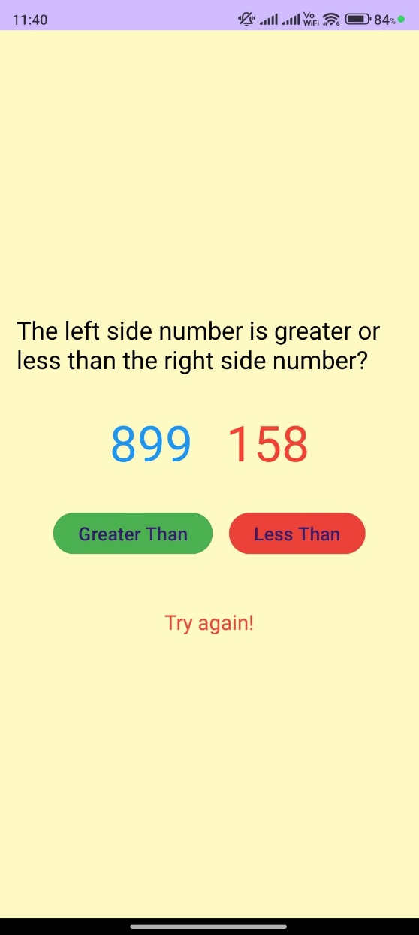
Otherwise, when the button clicked is wrong answer, then will show the text “Try again!”. Then, the user needs to reselect the button to click.

Order Numbers:
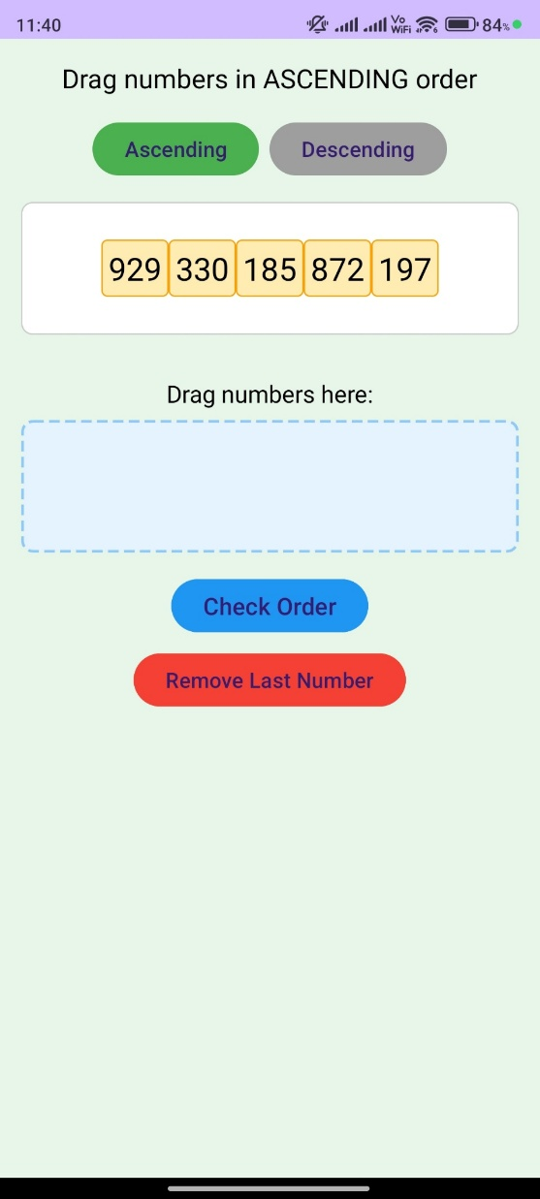
The rules of playing the order numbers are choosing ascending or descending by clicking the button of “Ascending” or “Descending”. The default order is ascending, and it will generate random 5 numbers that no more than 3 digits. The user needs to drag the numbers according to the order into the drop area which is the space of blue colour.

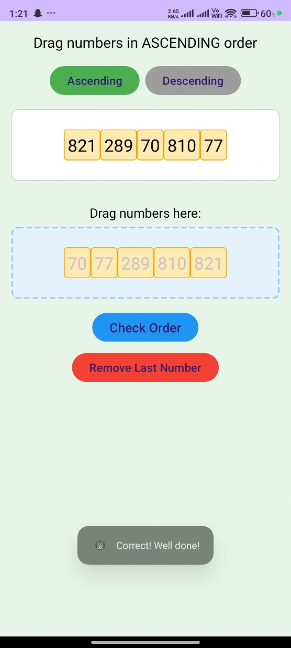
When the numbers are dragged into the drop area, they can check the order by clicking the “Check Order” button. The “Check Order” button will check that the order is correct or not. If correct, it will show a toast that having the text “Correct! Well done!”.

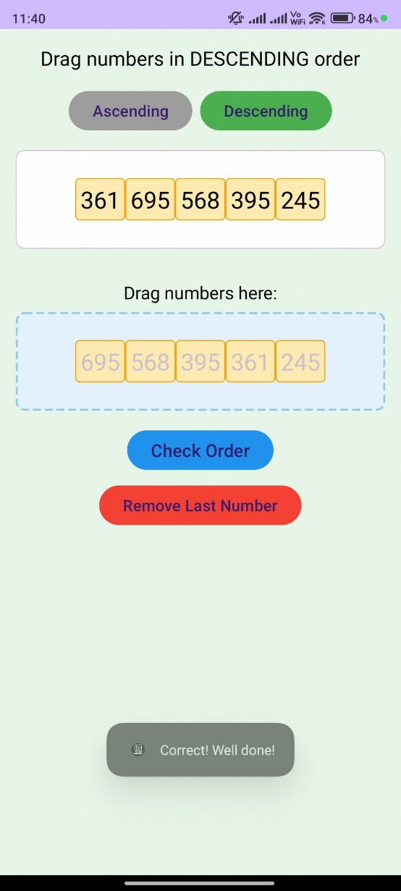
This is how the descending order look like when the numbers are arranged according to the order in the drop area. When the order is correct, then the toast will be shown.

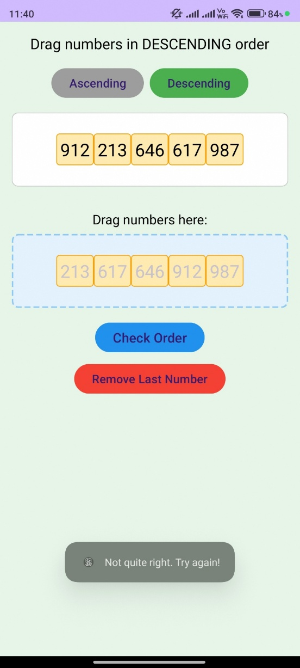
When the numbers are arranged in the drop area and found that the order is wrong, then it will show a toast that having the text “Not quite right. Try again!”.

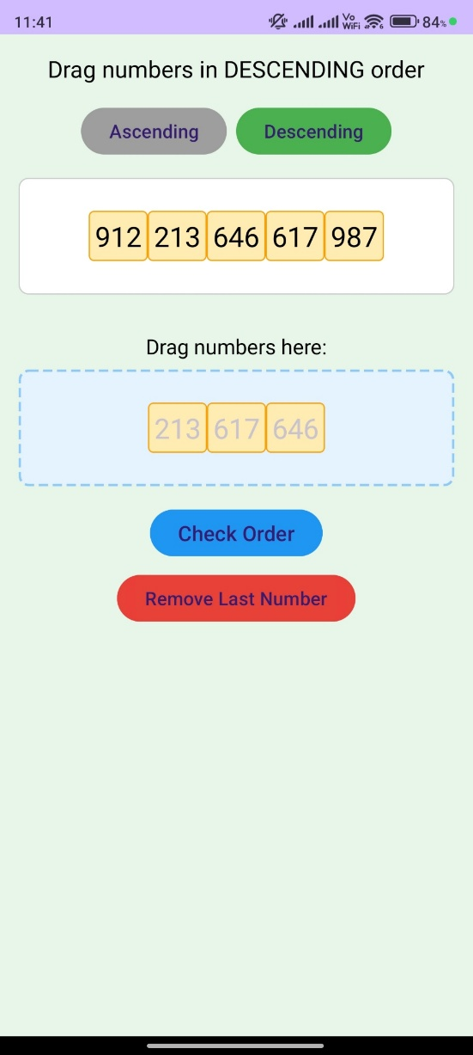
When the user wants to try again, they need to click on the “Remove Last Number” button to remove the last number in the array in drop area.

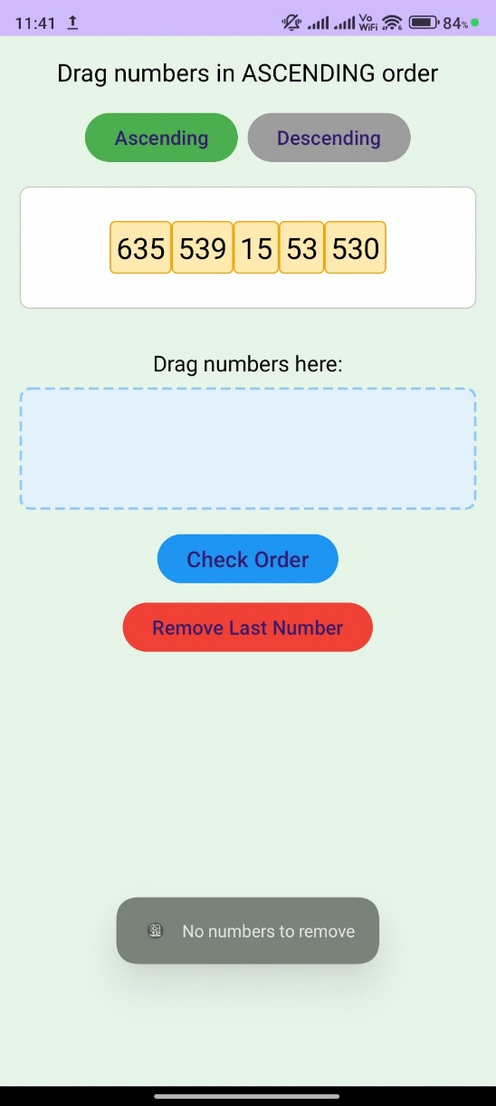
When there is no number in the drop area and the user keep clicking on the “Remove Last Number” button, it will show a toast that having the text “No numbers to remove”.

Compose Number:
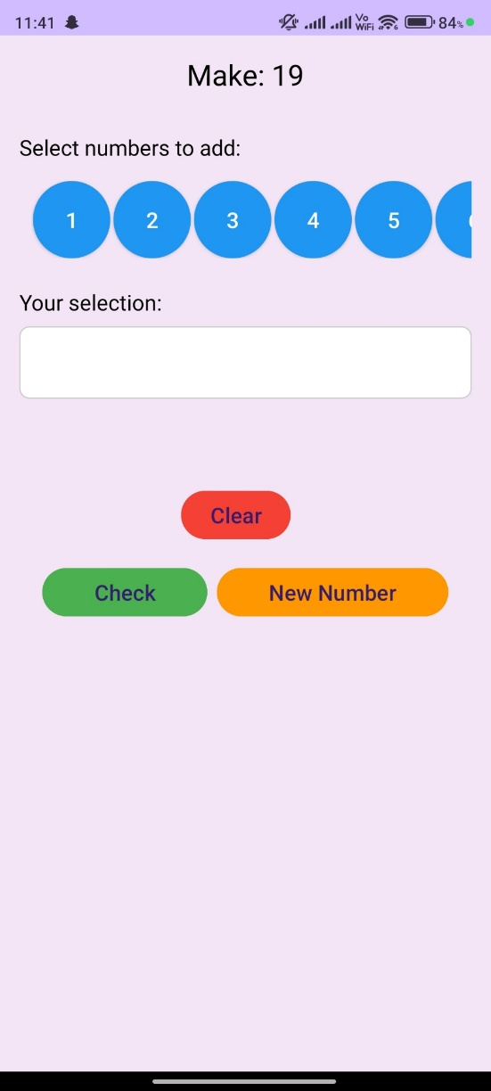
The rules of playing with compose numbers are select the small numbers which are numbers 1 to number 9 to compose the target numbers. For example, when the target number is 19, the user can select 5+5+9 to reach the target number by clicking twice on number 5 button and once on number 9 button.

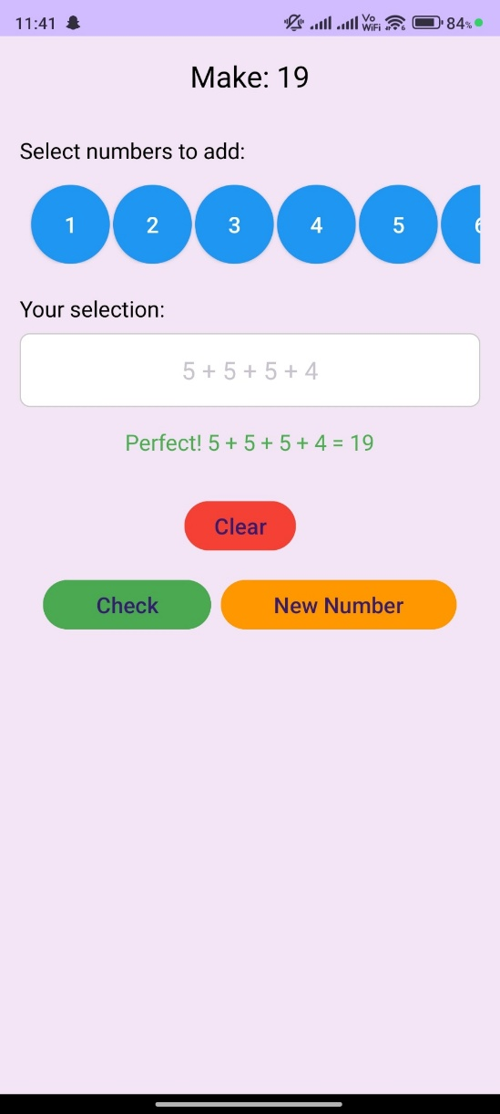
When the user selected the numbers by clicking on the number buttons, they can check their answer by clicking the “Check” button. If the answer is correct, It will show the text “Perfect!” and the equation of the selected numbers.

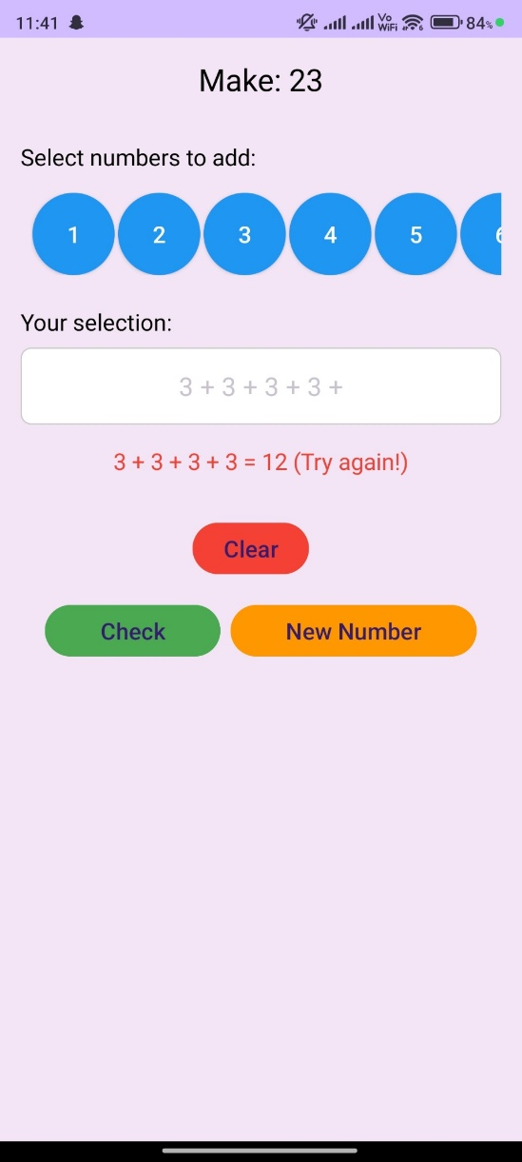
Otherwise, if the answer is incorrect, it will show the answer for the equation of selected numbers and ask them to try again just as the picture above.

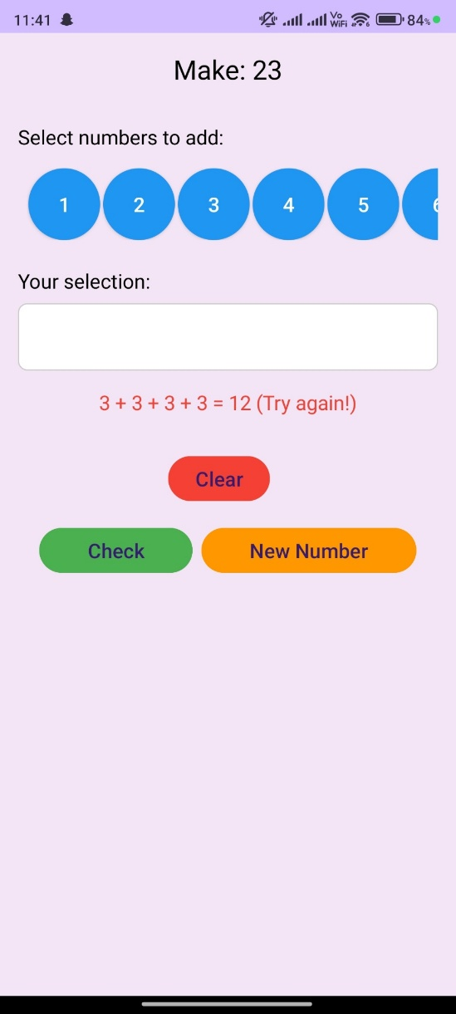
If the user wants to try again, they need to click on the “Clear” button to clear the selected numbers. After that, they can reselect the numbers that wanted.

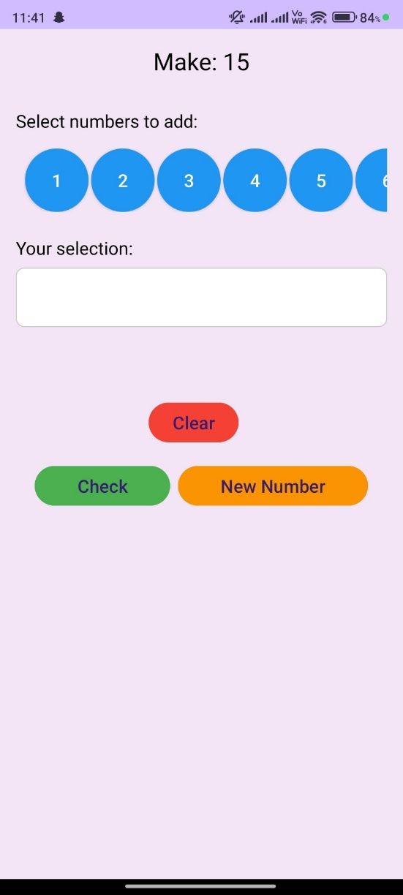
If the target number too difficult for the user, the user can request a new target number by clicking the “New Number” button.

Appendix
MainActivity.java:
package my.edu.utar.mathplay;
import androidx.appcompat.app.AppCompatActivity;
import android.content.Intent;
import android.os.Bundle;
import android.widget.Button;
public class MainActivity extends AppCompatActivity {
@Override
protected void onCreate(Bundle savedInstanceState) {
super.onCreate(savedInstanceState);
setContentView(R.layout.activity_main);
Button btnCompare = findViewById(R.id.btnCompare);
Button btnOrder = findViewById(R.id.btnOrder);
Button btnCompose = findViewById(R.id.btnCompose);
btnCompare.setOnClickListener(v -> {
Intent intent = new Intent(MainActivity.this, CompareActivity.class);
startActivity(intent);
});
btnOrder.setOnClickListener(v -> {
Intent intent = new Intent(MainActivity.this, OrderActivity.class);
startActivity(intent);
});
btnCompose.setOnClickListener(v -> {
Intent intent = new Intent(MainActivity.this, ComposeActivity.class);
startActivity(intent);
});
}
}

CompareActivity.java:
package my.edu.utar.mathplay;
import androidx.appcompat.app.AppCompatActivity;
import androidx.core.content.ContextCompat;
import android.os.Bundle;
import android.os.Handler;
import android.widget.Button;
import android.widget.TextView;
import java.util.Random;
public class CompareActivity extends AppCompatActivity {
private TextView num1Text, num2Text, resultText;
private Button greaterBtn, lessBtn;
private int num1, num2;
@Override
protected void onCreate(Bundle savedInstanceState) {
super.onCreate(savedInstanceState);
setContentView(R.layout.activity_compare);
num1Text = findViewById(R.id.num1);
num2Text = findViewById(R.id.num2);
resultText = findViewById(R.id.result);
greaterBtn = findViewById(R.id.greaterBtn);
lessBtn = findViewById(R.id.lessBtn);
generateNewNumbers();
greaterBtn.setOnClickListener(v -> checkAnswer(true));
lessBtn.setOnClickListener(v -> checkAnswer(false));
}
private void generateNewNumbers() {
Random random = new Random();
num1 = random.nextInt(1000);
num2 = random.nextInt(1000);
// Ensure numbers are different
while(num1 == num2) {
num2 = random.nextInt(1000);
}
num1Text.setText(String.valueOf(num1));
num2Text.setText(String.valueOf(num2));
resultText.setText("");
}
private void checkAnswer(boolean isGreater) {
boolean correct = (isGreater && num1 > num2) || (!isGreater && num1 < num2);
if(correct) {
resultText.setText("Correct! Good job!");
resultText.setTextColor(ContextCompat.getColor(this, R.color.green));
// Delay before next question
new Handler().postDelayed(this::generateNewNumbers, 1500);
} else {
resultText.setText("Try again!");
resultText.setTextColor(ContextCompat.getColor(this, R.color.red));
}
}
}

OrderActivity.java:
package my.edu.utar.mathplay;
import androidx.appcompat.app.AppCompatActivity;
import androidx.core.content.ContextCompat;
import android.content.ClipData;
import android.os.Bundle;
import android.os.Handler;
import android.view.DragEvent;
import android.view.MotionEvent;
import android.view.View;
import android.widget.Button;
import android.widget.LinearLayout;
import android.widget.TextView;
import android.widget.Toast;
import java.util.ArrayList;
import java.util.Collections;
import java.util.List;
import java.util.Random;
public class OrderActivity extends AppCompatActivity {
private LinearLayout numbersContainer, dropArea;
private Button checkBtn, ascendingBtn, descendingBtn, removeBtn;
private TextView instructionText;
private boolean isAscending = true;
@Override
protected void onCreate(Bundle savedInstanceState) {
super.onCreate(savedInstanceState);
setContentView(R.layout.activity_order);
numbersContainer = findViewById(R.id.numbersContainer);
dropArea = findViewById(R.id.dropArea);
checkBtn = findViewById(R.id.checkBtn);
ascendingBtn = findViewById(R.id.ascendingBtn);
descendingBtn = findViewById(R.id.descendingBtn);
removeBtn = findViewById(R.id.removeBtn);
instructionText = findViewById(R.id.instruction);
// Initialize the drag listener for the drop area
dropArea.setOnDragListener(new MyDragListener());
setupOrderMode(true);
generateNumbers();
ascendingBtn.setOnClickListener(v -> setupOrderMode(true));
descendingBtn.setOnClickListener(v -> setupOrderMode(false));
removeBtn.setOnClickListener(v -> removeLastNumber());
checkBtn.setOnClickListener(v -> checkOrder());
}
private void setupOrderMode(boolean ascending) {
isAscending = ascending;
if(ascending) {
instructionText.setText("Drag numbers in ASCENDING order");
ascendingBtn.setBackgroundColor(ContextCompat.getColor(this, R.color.green));
descendingBtn.setBackgroundColor(ContextCompat.getColor(this, R.color.gray));
} else {
instructionText.setText("Drag numbers in DESCENDING order");
descendingBtn.setBackgroundColor(ContextCompat.getColor(this, R.color.green));
ascendingBtn.setBackgroundColor(ContextCompat.getColor(this, R.color.gray));
}
dropArea.removeAllViews();
generateNumbers();
}
private void removeLastNumber() {
if (dropArea.getChildCount() > 0) {
dropArea.removeViewAt(dropArea.getChildCount() - 1);
} else {
Toast.makeText(this, "No numbers to remove", Toast.LENGTH_SHORT).show();
}
}
private void generateNumbers() {
numbersContainer.removeAllViews();
Random random = new Random();
List<Integer> numbers = new ArrayList<>();
// Generate 5 unique random numbers
for(int i=0; i<5; i++) {
int num = random.nextInt(1000);
while(numbers.contains(num)) {
num = random.nextInt(1000);
}
numbers.add(num);
}
// Shuffle the numbers
Collections.shuffle(numbers);
// Create draggable number views
for(int num : numbers) {
TextView numberView = new TextView(this);
numberView.setText(String.valueOf(num));
numberView.setTextSize(24);
numberView.setTextColor(ContextCompat.getColor(this, R.color.black));
numberView.setPadding(16, 16, 16, 16);
numberView.setBackground(ContextCompat.getDrawable(this, R.drawable.number_bg));
// Set drag listener
numberView.setOnTouchListener(new MyTouchListener());
numbersContainer.addView(numberView);
}
}
private void checkOrder() {
boolean isCorrect = true;
int previous = isAscending ? Integer.MIN_VALUE : Integer.MAX_VALUE;
// First check if all numbers have been dragged over
if (dropArea.getChildCount() != 5) {
Toast.makeText(this, "Please arrange all 5 numbers!", Toast.LENGTH_SHORT).show();
return;
}
// Check the order
for (int i = 0; i < dropArea.getChildCount(); i++) {
TextView child = (TextView) dropArea.getChildAt(i);
int current = Integer.parseInt(child.getText().toString());
if ((isAscending && current < previous) || (!isAscending && current > previous)) {
isCorrect = false;
break;
}
previous = current;
}
if (isCorrect) {
Toast.makeText(this, "Correct! Well done!", Toast.LENGTH_SHORT).show();
// Clear the drop area with a slight delay
new Handler().postDelayed(() -> {
dropArea.removeAllViews();
generateNumbers(); // Generate new numbers
}, 1000); // 1 second delay before clearing
} else {
Toast.makeText(this, "Not quite right. Try again!", Toast.LENGTH_SHORT).show();
}
}
private final class MyTouchListener implements View.OnTouchListener {
public boolean onTouch(View view, MotionEvent motionEvent) {
if (motionEvent.getAction() == MotionEvent.ACTION_DOWN) {
// Create a shadow of the view being dragged
ClipData data = ClipData.newPlainText("", "");
View.DragShadowBuilder shadowBuilder = new View.DragShadowBuilder(view);
// Start the drag - the third parameter is the local state (the original view)
view.startDrag(data, shadowBuilder, view, 0);
// Make the original view invisible during drag
view.setVisibility(View.INVISIBLE);
return true;
}
return false;
}
}
public void onDragNumber(View view) {
dropArea.setOnDragListener(new MyDragListener());
}
class MyDragListener implements View.OnDragListener {
@Override
public boolean onDrag(View v, DragEvent event) {
switch (event.getAction()) {
case DragEvent.ACTION_DROP:
// Get the original dragged view
View draggedView = (View) event.getLocalState();
TextView dropped = (TextView) draggedView;
// Make the original view visible again (since we hid it on drag start)
draggedView.setVisibility(View.VISIBLE);
// Create a new copy for the drop area
TextView copy = new TextView(OrderActivity.this);
copy.setText(dropped.getText());
copy.setTextSize(24);
copy.setPadding(16, 16, 16, 16);
copy.setBackground(ContextCompat.getDrawable(OrderActivity.this, R.drawable.number_bg));
// Don't set the touch listener on the copy - we don't want it draggable
dropArea.addView(copy);
return true;
case DragEvent.ACTION_DRAG_ENDED:
// If the drop wasn't handled, make sure the original view becomes visible again
if (!event.getResult()) {
View view = (View) event.getLocalState();
view.setVisibility(View.VISIBLE);
}
return true;
default:
return true;
}
}
}
}

ComposeActivty.java:
package my.edu.utar.mathplay;
import androidx.appcompat.app.AppCompatActivity;
import androidx.core.content.ContextCompat;
import android.os.Bundle;
import android.os.Handler;
import android.widget.Button;
import android.widget.LinearLayout;
import android.widget.TextView;
import java.util.ArrayList;
import java.util.List;
import java.util.Random;
public class ComposeActivity extends AppCompatActivity {
private TextView targetNumberText;
private LinearLayout selectedNumbersContainer;
private TextView resultText;
private Button checkBtn, newNumberBtn, clearBtn;
private int targetNumber;
private List<Integer> selectedNumbers = new ArrayList<>();
@Override
protected void onCreate(Bundle savedInstanceState) {
super.onCreate(savedInstanceState);
setContentView(R.layout.activity_compose);
targetNumberText = findViewById(R.id.targetNumber);
selectedNumbersContainer = findViewById(R.id.selectedNumbers);
resultText = findViewById(R.id.result);
clearBtn = findViewById(R.id.clearBtn);
checkBtn = findViewById(R.id.checkBtn);
newNumberBtn = findViewById(R.id.newNumberBtn);
generateNewTarget();
setupNumberButtons();
clearBtn.setOnClickListener(v -> {
selectedNumbers.clear();
updateSelectedNumbersDisplay();
});
checkBtn.setOnClickListener(v -> checkCombination());
newNumberBtn.setOnClickListener(v -> generateNewTarget());
}
private void generateNewTarget() {
Random random = new Random();
targetNumber = random.nextInt(30) + 10; // 10-39
targetNumberText.setText("Make: " + targetNumber);
selectedNumbers.clear();
selectedNumbersContainer.removeAllViews();
resultText.setText("");
}
private void setupNumberButtons() {
LinearLayout numbersContainer = findViewById(R.id.numbersContainer);
numbersContainer.removeAllViews();
// Create buttons for numbers 1-9 with better styling
for(int i=1; i<=9; i++) {
Button numBtn = new Button(this);
numBtn.setText(String.valueOf(i));
numBtn.setTag(i);
// Set button styling
LinearLayout.LayoutParams params = new LinearLayout.LayoutParams(
(int) getResources().getDimension(R.dimen.number_button_width),
(int) getResources().getDimension(R.dimen.number_button_height));
params.setMargins(4, 0, 4, 0);
numBtn.setLayoutParams(params);
numBtn.setBackground(ContextCompat.getDrawable(this, R.drawable.number_button_bg));
numBtn.setTextColor(ContextCompat.getColor(this, R.color.white));
numBtn.setTextSize(18);
numBtn.setOnClickListener(v -> {
int num = (int) v.getTag();
selectedNumbers.add(num);
updateSelectedNumbersDisplay();
});
numbersContainer.addView(numBtn);
}
}
private void updateSelectedNumbersDisplay() {
selectedNumbersContainer.removeAllViews();
for(int num : selectedNumbers) {
TextView numView = new TextView(this);
numView.setText(String.valueOf(num));
numView.setTextSize(20);
numView.setPadding(8, 8, 8, 8);
selectedNumbersContainer.addView(numView);
// Add "+" between numbers except after last
if(selectedNumbers.indexOf(num) < selectedNumbers.size()-1) {
TextView plusView = new TextView(this);
plusView.setText("+");
plusView.setTextSize(20);
plusView.setPadding(8, 8, 8, 8);
selectedNumbersContainer.addView(plusView);
}
}
}
private void checkCombination() {
if(selectedNumbers.isEmpty()) {
resultText.setText("Please select some numbers!");
resultText.setTextColor(ContextCompat.getColor(this, R.color.red));
return;
}
int sum = 0;
for(int num : selectedNumbers) {
sum += num;
}
if(sum == targetNumber) {
resultText.setText("Perfect! " + getEquationText() + " = " + targetNumber);
resultText.setTextColor(ContextCompat.getColor(this, R.color.green));
// Delay before next question
new Handler().postDelayed(() -> {
generateNewTarget();
setupNumberButtons();
}, 2000);
} else {
resultText.setText(getEquationText() + " = " + sum + " (Try again!)");
resultText.setTextColor(ContextCompat.getColor(this, R.color.red));
}
}
private String getEquationText() {
StringBuilder sb = new StringBuilder();
for(int i=0; i<selectedNumbers.size(); i++) {
sb.append(selectedNumbers.get(i));
if(i < selectedNumbers.size()-1) {
sb.append(" + ");
}
}
return sb.toString();
}
}

