**Computer Vision Assignment_3 Report**

**Name: Shang-Yung Hsu**

1. **Dataset:**

**Positive:**

I use the point form contour in the xml file from sunny dataset to segment the image to be my dataset. I change half of image size to 40 x40 from my positive dataset. **(Figure 1.1)** Others are image with different size. **(Figure 1.2)**

At the first time, I only use image with different size, but the result is not good and the training speed is slow.



**Figure 1.1**

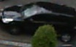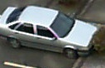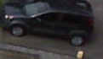

**Figure 1.2**

**Negative:**

I use the empty parking lot at the first time **(Figure 1.3)** but the result is not good. Therefore, I use the negative dataset from the internet which are all without the tree and the part of the body of the car. **(Figure 1.4)**

 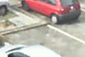 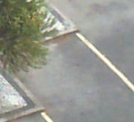

**(Figure1.3)**

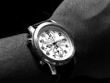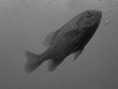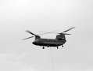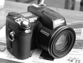

**(Figure 1.4)**

1. **Training Data**

I write two .bat file (cascade_sampe and training_sample) to training. (Figure 2.1 and 2.2)

The number of stage I use in **LBP** and **HAAR** are 20 and the **minHitRate** is 0.995 **maxFalseAlarmRate** is 0.5 **maxWeakCount** is 100

The number of **sample** is 6441 and **numPos** is 4000, **numNeg** is 1500

(Figure 2.3 and 2.4)



**(Figure 2.1)**



**(Figure 2.2)**

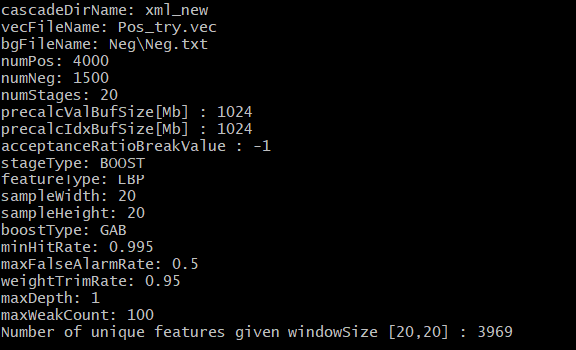

**(Figure 2.3)**

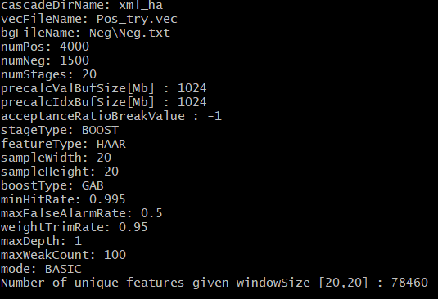

**(Figure 2.4)**

1. **Parking Lot Analysis**

|  |  |  |  |  |  |  |  |
| --- | --- | --- | --- | --- | --- | --- | --- |
| Test Image | Classifier  Feature | Stages | No. of Positives | No. of Negatives | TP | FP | Accuracy |
| Parking_2 | | | | | | | |
| parking2\rainy\2012-10-26\ 2012-10-26_06_19_24 | **HAAR** | **20** | **4000** | **1500** | **3** | **0** | **75%** |
| parking2\rainy\2012-10-26\ 2012-10-26_06_19_24 | **LBP** | **20** | **4000** | **1500** | **3** | **0** | **75%** |
| parking2\rainy\2012-10-26\ 2012-10-26_07_24_27 | **HAAR** | **20** | **4000** | **1500** | **18** | **0** | **94.37%** |
| parking2\rainy\2012-10-26\ 2012-10-26_07_24_27 | **LBP** | **20** | **4000** | **1500** | **18** | **1** | **94.37%** |
| parking2\cloudy\2012-10-31\2012-10-31_11_28_13 | **HAAR** | **20** | **4000** | **1500** | **58** | **2** | **82.85%** |
| parking2\cloudy\2012-10-31\ 2012-10-31_11_28_13 | **LBP** | **20** | **4000** | **1500** | **158** | **1** | **82.85%** |
| parking2\cloudy\2012-10-31\ 2012-10-31_14_48_21 | **HAAR** | **20** | **4000** | **1500** | **39** | **2** | **62.9%** |
| parking2\cloudy\2012-10-31\ 2012-10-31_14_48_21 | **LBP** | **20** | **4000** | **1500** | **39** | **1** | **62.9%** |
| parking2\cloudy\2012-10-31\ 2012-10-31_08_13_04 | **HAAR** | **20** | **4000** | **1500** | **47** | **0** | **51.08%** |
| parking2\cloudy\2012-10-31\ 2012-10-31_08_13_04 | **LBP** | **20** | **4000** | **1500** | **47** | **0** | **51.08%** |
| parking2\cloudy\2012-10-31\ 2012-10-31_16_33_26 | **HAAR** | **20** | **4000** | **1500** | **52** | **0** | **82.53%** |
| parking2\cloudy\2012-10-31\ 2012-10-31_16_33_26 | **LBP** | **20** | **4000** | **1500** | **52** | **0** | **82.53%** |
| parking2\rainy\2012 - 09 - 16\2012-09-16_06_22_55 | **HAAR** | **20** | **4000** | **1500** | **0** | **0** | **100%** |
| parking2\rainy\2012 - 09 - 16\2012-09-16_06_22_55 | **LBP** | **20** | **4000** | **1500** | **0** | **1** | **100%** |
| parking2\cloudy\2012-11-08\2012-11-08_07_20_27 | **HAAR** | **20** | **4000** | **1500** | **11** | **3** | **91.66%** |
| parking2\cloudy\2012-11-08\2012-11-08_07_20_27 | **LBP** | **20** | **4000** | **1500** | **10** | **0** | **83.33%** |
| parking2\cloudy\2012-11-08\2012-11-08_12_00_40 | **HAAR** | **20** | **4000** | **1500** | **60** | **1** | **90.90%** |
| parking2\cloudy\2012-11-08\2012-11-08_12_00_40 | **LBP** | **20** | **4000** | **1500** | **51** | **1** | **77.27%** |
| Parking_a | | | | | | | |
| parking1a\cloudy\2013-01-16\2013-01-16_07_40_03 | LBP | 20 | 4000 | 1500 | 0 | 1 | 100% |
| parking1a\cloudy\2013-01-16\2013-01-16_07_40_03 | **HAAR** | **20** | **4000** | **1500** | **0** | **5** | **100%** |
| parking1a\cloudy\2013-01-16\2013-01-16_17_45_14 | LBP | 20 | 4000 | 1500 | 8 | 3 | 47.05% |
| parking1a\cloudy\2013-01-16\2013-01-16_17_45_14 | **HAAR** | **20** | **4000** | **1500** | **8** | **2** | **47.05%** |
| parking1a\cloudy\2012-12-12\2012-12-12_10_00_05 | LBP | 20 | 4000 | 1500 | 12 | 0 | 42.58% |
| parking1a\cloudy\2012-12-12\2012-12-12_10_00_05 | **HAAR** | **20** | **4000** | **1500** | **13** | **0** | **46.42%** |
| parking1a\cloudy\2012-12-12\2012-12-12_11_10_06 | LBP | 20 | 4000 | 1500 | 11 | 0 | 39.28% |
| parking1a\cloudy\2012-12-12\2012-12-12_11_10_06 | **HAAR** | **20** | **4000** | **1500** | **14** | **1** | **50%** |
| parking1a\rainy\2013-01-21\2013-01-21_07_40_02 | LBP | 20 | 4000 | 1500 | 0 | 3 | 100% |
| parking1a\rainy\2013-01-21\2013-01-21_07_40_02 | **HAAR** | **20** | **4000** | **1500** | **0** | **4** | **100%** |
| parking1a\rainy\2013-01-21\2013-01-21_09_25_04 | LBP | 20 | 4000 | 1500 | 11 | 0 | 39.28% |
| parking1a\rainy\2013-01-21\2013-01-21_09_25_04 | **HAAR** | **20** | **4000** | **1500** | **12** | **2** | **42.85%** |
| parking1a\rainy\2013-01-21\2013-01-21_08_15_03 | LBP | 20 | 4000 | 1500 | 3 | 1 | 37.85% |
| parking1a\rainy\2013-01-21\2013-01-21_08_15_03 | **HAAR** | **20** | **4000** | **1500** | **3** | **1** | **37.5%** |
| parking1a\rainy\2013-01-21\2013-01-21_10_30_05 | **LBP** | **20** | **4000** | **1500** | **11** | **2** | **39.28%** |
| parking1a\rainy\2013-01-21\2013-01-21_10_30_05 | **HAAR** | **20** | **4000** | **1500** | **11** | **2** | **39.28%** |
| Parking_b | | | | | | | |
| parking1b\cloudy\2013-03-15\2013-03-15_06_35_00 | LBP | 20 | 4000 | 1500 | 1 | 0 | 100% |
| parking1b\cloudy\2013-03-15\2013-03-15_06_35_00 | **HAAR** | **20** | **4000** | **1500** | **1** | **0** | **100%** |
| parking1b\cloudy\2013-03-15\2013-03-15_07_15_01 | LBP | 20 | 4000 | 1500 | 1 | 2 | 14.28% |
| parking1b\cloudy\2013-03-15\2013-03-15_07_15_01 | **HAAR** | **20** | **4000** | **1500** | **2** | **1** | **28.57%** |
| parking1b\cloudy\2013-03-15\2013-03-15_07_55_02 | LBP | 20 | 4000 | 1500 | 6 | 1 | 21.42% |
| parking1b\cloudy\2013-03-15\2013-03-15_07_55_02 | **HAAR** | **20** | **4000** | **1500** | **6** | **0** | **21.42%** |
| parking1b\cloudy\2013-03-15\2013-03-15_15_45_11 | LBP | 20 | 4000 | 1500 | 7 | 0 | 17.75% |
| parking1b\cloudy\2013-03-15\2013-03-15_15_45_11 | **HAAR** | **20** | **4000** | **1500** | **7** | **0** | **17.5%** |
| parking1b\rainy\2013-03-19\2013-03-19_06_30_00 | LBP | 20 | 4000 | 1500 | 0 | 3 | 100% |
| parking1b\rainy\2013-03-19\2013-03-19_06_30_00 | **HAAR** | **20** | **4000** | **1500** | **0** | **1** | **100%** |
| parking1b\rainy\2013-03-19\2013-03-19_07_25_01 | LBP | 20 | 4000 | 1500 | 6 | 0 | 25% |
| parking1b\rainy\2013-03-19\2013-03-19_07_25_01 | **HAAR** | **20** | **4000** | **1500** | **6** | **0** | **25%** |
| parking1b\rainy\2013-03-19\2013-03-19_12_50_07 | LBP | 20 | 4000 | 1500 | 7 | 1 | 17.5% |
| parking1b\rainy\2013-03-19\2013-03-19_12_50_07 | **HAAR** | **20** | **4000** | **1500** | **6** | **0** | **15%** |

1. **How to run the code**

In the car detection, use the detection_2.py.

First of all, user have to input which parking lot user want to detect **(input a or b or 2)**.

Secondly, user have to input the path of the image. ***(ex: C:\Users\Tommy\Desktop\Spring_2018\Computer_vision\assignment3_folder\PKLot\parking1b\rainy\2013-03-16\2013-03-16_16_45_12)***

Therefore, the program will tell user which cascade is better for this parking lot **(ex: cascade_LBP or cascade_HAAR)**

**(**Have to change from **cv2.CascadeClassifier )**

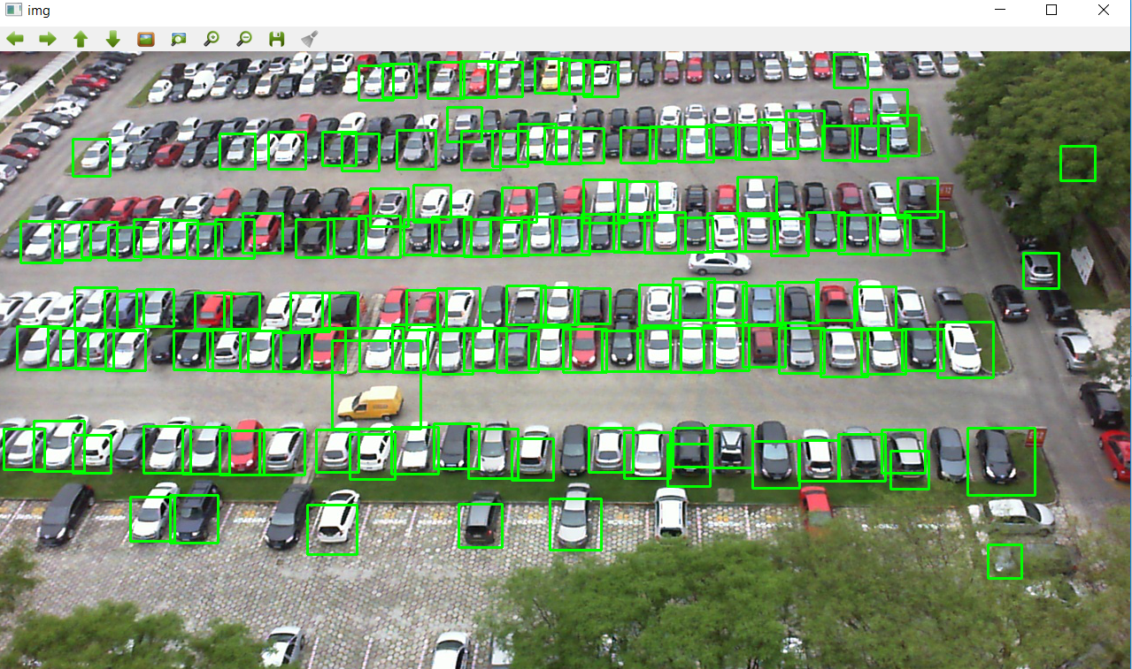

In the car analysis part, the step is the same as detection part. Only the result is different.

The car analysis part shows the parking space from ground true, which color is blue. The result of my detection will show green color if their overlap area satisfy the threshold > 50%.

For the FP, and the ignore part show yellow color.

And the result will tell user the number of true positive and the accuracy of detection.

