Visualize the correlation between hospital information technology (HIT) applications and the hospital patient safety final report

Guannan Cui, Shang-Yung Hsu, Dr. Guoning Chen

**Abstract----**In the field of the healthcare research, many find that it is difficult to demonstrate the research results which contain hundreds of factors. This project provides a visualization solution to represent the correlation results between a group of 109 individual HIT applications and the hospital patient safety. The project utilizes P5.JS as the programming platform and JavaScript as the scripting language. As a result, the project delivers a user-interactive program that allows the numerous correlation results to be displayed in a single page.

—————————— ◆ ——————————

# 1 Introduction

The study on the relationship between Hospital Information Technology Capacity (HIT) and the hospital service provides possible implementation to improve the quality of the healthcare service. HIT is defined as a measurement on all equipment in a hospital. This study has already found HIT is positively correlated with the quality of the hospital service. However, to provide a solid solution on how to improve the quality, this study needs to further analyze which types of machines in the hospital are most influential to the quality of the healthcare service. Therefore, the research proposes to use a visualization technique to cluster different facilities in the hospital by its correlation coefficient to the quality of the healthcare service.

# 2 Related Work

Gao et. al. conducted similar works on visualizing the correlation matrix of 22 variables with various geometric and topological complexities (Gao et. al., 2017). The research applied sorting to compute and display the average correlation matrix of the 22 datasets. A graph below demonstrates their visualization work.

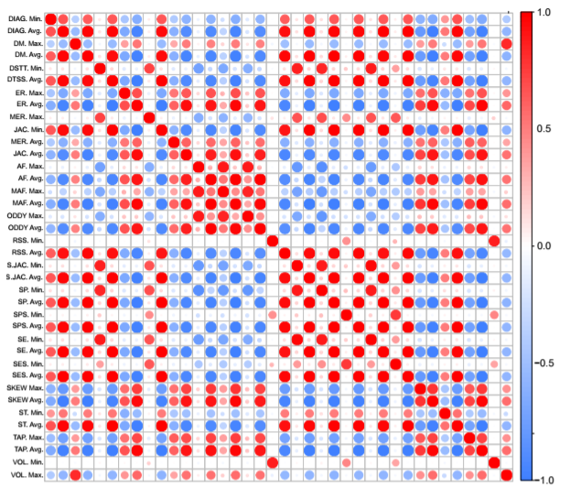

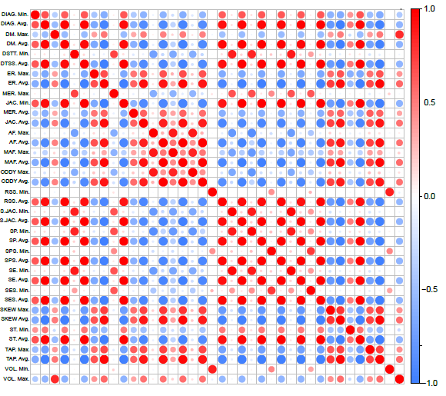Graph 1 the average correlation matrix of all 22 datasets.

# 3 Methodology and Implementation

* Calculate all correlation numbers between hospital equipment and hospital patient safety.
* Change all the correlation numbers to distance. (Distance = the inverse number of the absolute of correlation value)
* Calculate the angle for every point. Each point represents a unique equipment. The angle is computed by firstly counting the number of dots to be displayed on the circle. Secondly, the whole circle should be divided by the amount of dots to let each dot display mostly separately on the circle. Thus, the angle for each dot can be computed by using the formula below (Angle = 2π / dot counts).
* Since the correlations are either negatively oriented or positively oriented, a flag on each correlation is inserted in order to identify the correlation orientations.
* Use the angle θ and the distance d to determine every point. In here, the distance and angle coordinate system needs to be transformed into the x and y coordinate in order for the dots to be displayed on the x and y axes. The sine and cosine transformation is implemented here to convert the angle and the distance into the x and y coordinates. The angle direction has been selected as the angle between the line of the dot to center and the y axis. Then as a result, the new transformed x and y coordinates are presented by the formula below:

x = d × cos (θ)

y = d × sin (θ)

* 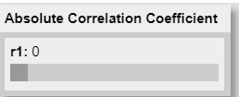Build a slider to change r1 (the correlation coefficient threshold) to show different range of point. The slider utilized the Martin Schneider’s P5.JS sample slider. The slider provides an input of the value r1 which is used in this project to control the range of distance limit to be displayed. A graph demonstrates the slider below.

Graph 2 Slider Display

* Draw the center and the x and y axes. The center dot represents the patient safety.
* Draw reference circles before the dots rendering. As a result, reference circles have been drawn in the graph.
* Draw all the dot on the graph using the x and y coordinates.
* 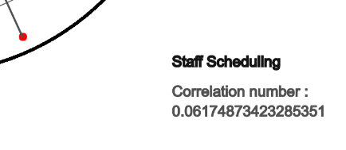Show the equipment name and accurate correlation number when cursor moves to the point. One graph below shown the effect.

Graph 3 Information Display when Cursor Moves to the Dot

* Change points color, using blue and red to distinguish negative correlation points and positive correlation points. Here, the flag created before is used to identify whether a dot is associated with positive or negative correlations.
* Draw a line aimed at the point when cursor move to the point.
* 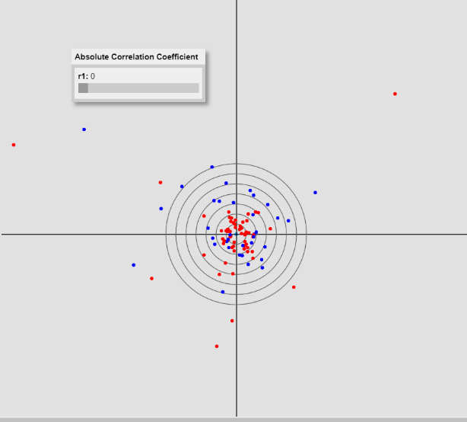Draw the peripheral circle when the r1 value changes. A graph below shown the display of the primary drawing.

Graph 4 Overall Visualization of the Dots

* When the overall display of all dots has been rendered, a display issue has been identified. The majority of the dots are concentrated near the center of the graph, making the user hard to distinguish each individual HIT application. Therefore, a zoom in display is considered. Regarding the display range of the dots, since the researchers only considered the dots that have significant statistic values, the threshold values of the correlation coefficient r1 needs to be computed. Based on this research’s data sample of 809 hospitals (N = 809), the critical values of r1 equal to 0.058 (*p* = 0.1), 0.069 (.*p* = 0.05), and 0.091 (*p* = 0.01). Thus, the new zoomed in display of the visualization should initiate r1 as 0.058 to make all dots displayed to be statistically correlation significant with 90% confidence rate. A zoom in time of 15 has been selected. As a result, the graph below demonstrates the zoom in version 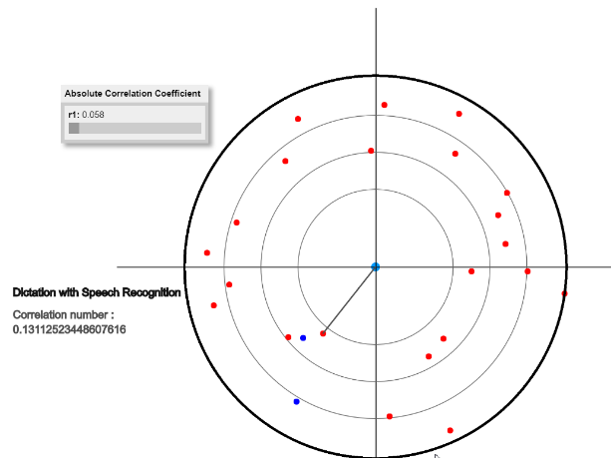of the visualization.

Graph 5 Zoom in Visualization

**Guannan Cui’s contribution:**

* Provide the data, change the data format to .JS format.
* Compute the correlation values between the hospital equipment and the patient safety.
* Design and implement the transfer function. (Distance = the inverse number of the absolute of correlation value)
* Design and implement the algorism to visualize the dots from the angle and distance coordinate system (Coordinate transformation)
* Implement a slider to control the r1 value in order to show different range of point.
* Program the interface to include another Zoom in display option with regard of the statistical representation.
* Compose, format, and finalize the report

**Shang-Yung Hsu’s contribution:**

* Show equipment name and accurate correlation number when cursor moves to the point.
* Change points color, using blue and red to distinguish negative correlation points and positive correlation points.
* Draw a line aimed at the point when cursor move to the point.
* Draw a circle, which is the most peripheral circle will change it size base on the different value of R.
* Draw three circles inside, which distribute the range of R.
* Beautify user interface to make it clearly to look.
* Prepare the power point.

# 4 Results and Discussions

The project delivers a user-interactive visualization solution that solves the problem of the redundant correlation representation. The interface is user-friendly. It enables the user to receive the dynamic correlation visualization results when the user toggles from different correlation coefficient thresholds.

The visualization solution contributes to the healthcare research by providing a feasible method to effectively display the results of the multi-variable analysis. Although it is not a one-solution-fix-all for the healthcare research representations, it demonstrates that the visualization techniques, if used properly, can ease the difficulties of the data representations in the healthcare researches.

The project also contributes to the understanding of hospital IT application clustering by empirically exploring all individual hospital IT components and finding the specific IT clusters of interest. The project results show that the Cardiology IT cluster plays significant roles among all IT clusters in influencing the hospital care quality. In fact, significant correlations have been tested and validated between the cardiology IT capacity and the patient safety or the care outcome. Furthermore, the data illustrates that the cardiology IT capacity mediates the effects between the patient safety and the care outcome, while the radiology IT capacity does not, pointing out the importance of the cardiology equipment in the hospital. Therefore, when the hospital considers to deploy new equipment, the cardiology related applications can be prioritized as they have been proved to be significantly positively correlated to the care quality.

# 5 Conclusion and Future Work

Overall, the project successfully deployed a visualization platform to effectively represent the correlation results between the HIT applications and the hospital patient safety. The platform is user-interactive and of statistical values. As a result, it allows the user to easily identify the significantly correlated HIT applications.

This method of visualization can be extended to other fields of the healthcare researches which have focuses on multi-variable correlation analysis. As an example, it can be stretched to include another correlation analysis on the HIT applications and the hospital care outcomes. In conclusion, the visualization in this project effectively solves the identified issue and paves ways for further research implementation.

# References

Gao, X., Huang, J., Xu, K., Pan, Z., Deng, Z., & Chen, G. (2017, August). Evaluating Hex‐mesh Quality Metrics via Correlation Analysis. In Computer Graphics Forum (Vol. 36, No. 5, pp. 105-116).