



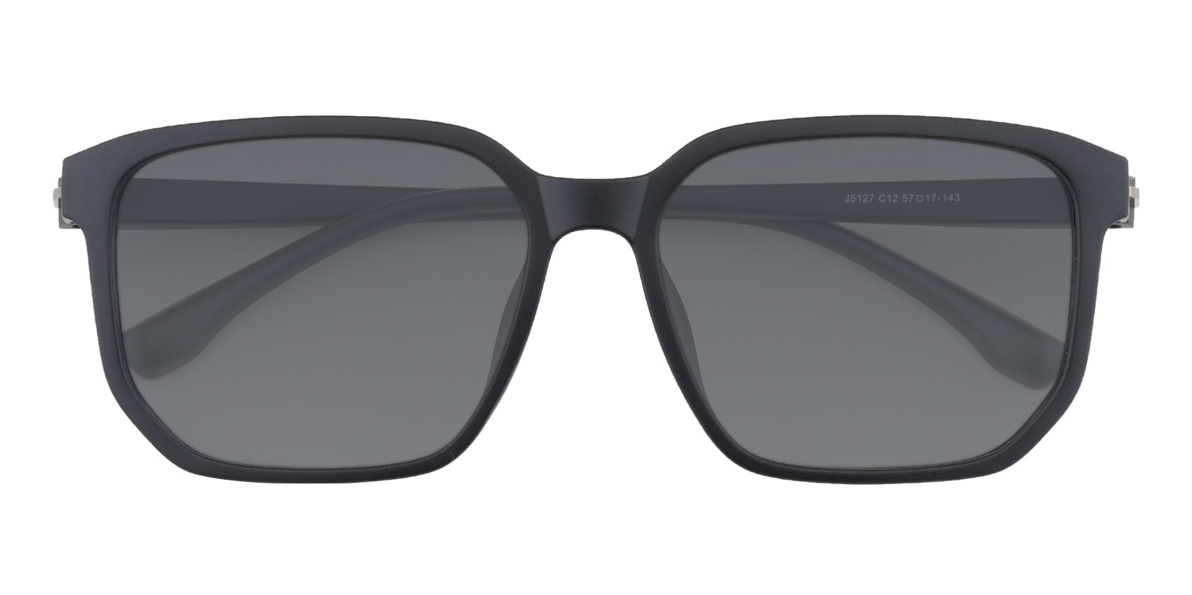

NIKE

Albany

## Rectangle Black Sunglasses

Price: $29.95

Color: **Black**

Promotion:

* Buy One Get One Free
* 30% Off Entire Order

SKU: SUP1017

Frame: Full

Shape: Rectangle

Weight: 18.3g (0.65 oz)

Gender: Women| Men

Material: TR90

Progressive: Yes

Description:

The Albany sunglasses bring an instant contemporary edge to whatever you are wearing, thanks to the oversized rectangular frames and simple, clean lines. Integrated nose pads and slim TR90 arms cut a modern silhouette that still has a classic appeal, making them a great choice for daily wear.

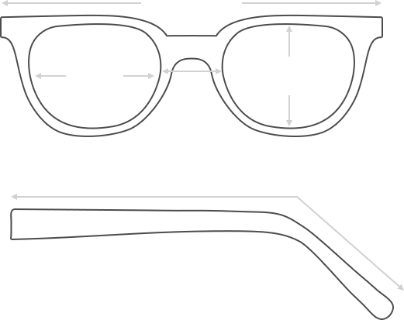

Lens Height

43.3 mm

Frame Width

142 mm

Bridge

18 mm

Diagonal 43 mm

Temple Length 145 mm

Lens Width

52 mm



 **MANUFACTURE TIME:**

|  |
| --- |
| Glasses Type Time |
| Progressive 3 – 5 business days |

 **SHIPPING TIME:**

|  |
| --- |
| Country/Region Shipping Method Rate Time |
| UNITED STATES AIRMAIL $5.8 7-9 business days |
| CANADA UPS/FEDEX $24.5 10-12 business days |
| VIETNAM EXTRASHIP $3.0 4-6 business days |



 **HOW TO RETURN YOUR GLASSES:**



1. Contact our Customer Service Department at [service@eyeconic.com](mailto:service@eyeconic.com) to approve the return.

2. All returns must be returned in their unworn, original, condition, in the original case include an eyeglass case and lens cleaning cloth. Package your glasses securely and make sure to include your name, contact information order number and why you returned the glasses.

3. We recommend shipping your return by a traceable method. (eyeconic.com is not responsible for shipping damages or lost shipments.)

4. Once your return is received, we will process refund in 7 working days. Your refund will be credited back to your original method of payment. Once your refund has been processed, it will take 7 to 10 business days for your bank to process the credit and apply it to your account.

Questions? Concerns? Email us at [service@eyeconic.com](mailto:service@eyeconic.com) or call our Customer Service Department at Toll Free 1-855-202-0123 or contact us via live chat. Our hours are 9:00 AM to 5:00 PM Mon to Fri. (EST)