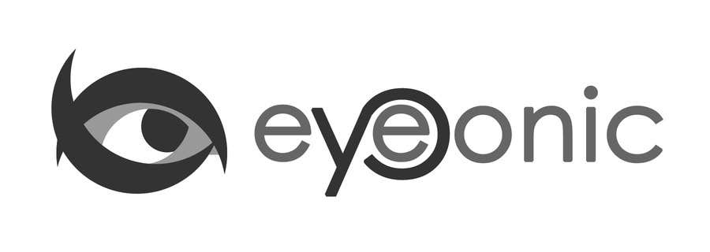



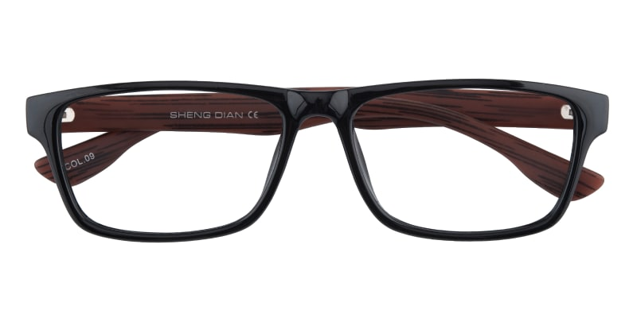

LACOSTE

BowlingGreen

## Rectangle Black Eyeglasses

Price: $29.95

Color: **Black**

Promotion:

* Buy One Get One Free
* 30% Off Entire Order

SKU: FP0917

Frame: Full

Shape: Rectangle

Weight: 11g (0.39 oz)

Gender: Women | Men

Material: TR90 | Acetate

Progressive: Yes

Description:

BowlingGreen Rectangle eyeglasses is crafted from lightweight and comfortable TR-90, fit for both men and women. Tortoise, Black, Black/Brown and Black/Blue colors are available in this type of eyewear. Besides, this pair of full rectangle is a great choice for those who need large glasses or who have strong prescription and rectangular shaped lenses suit most faces.

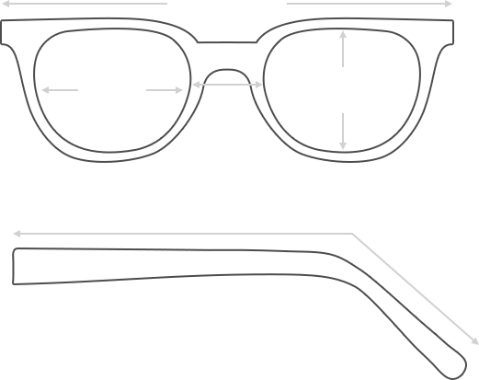

Lens Height

36 mm

Frame Width

140 mm

Bridge

16 mm

Diagonal 55 mm

Temple Length 147 mm

Lens Width

54 mm

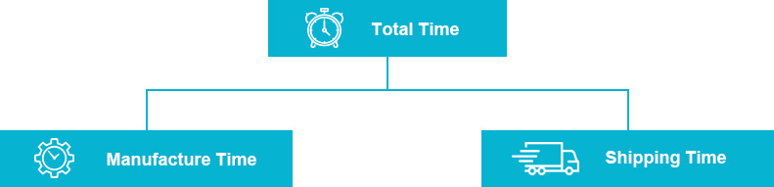

 **MANUFACTURE TIME:**

|  |
| --- |
| Glasses Type Time |
| Progressive 3 – 5 business days |

 **SHIPPING TIME:**

|  |
| --- |
| Country/Region Shipping Method Rate Time |
| UNITED STATES AIRMAIL $5.8 7-9 business days |
| CANADA UPS/FEDEX $24.5 10-12 business days |
| VIETNAM EXTRASHIP $3.0 4-6 business days |



 **HOW TO RETURN YOUR GLASSES:**



1. Contact our Customer Service Department at [service@eyeconic.com](mailto:service@eyeconic.com) to approve the return.

2. All returns must be returned in their unworn, original, condition, in the original case include an eyeglass case and lens cleaning cloth. Package your glasses securely and make sure to include your name, contact information order number and why you returned the glasses.

3. We recommend shipping your return by a traceable method. (eyeconic.com is not responsible for shipping damages or lost shipments.)

4. Once your return is received, we will process refund in 7 working days. Your refund will be credited back to your original method of payment. Once your refund has been processed, it will take 7 to 10 business days for your bank to process the credit and apply it to your account.

Questions? Concerns? Email us at [service@eyeconic.com](mailto:service@eyeconic.com) or call our Customer Service Department at Toll Free 1-855-202-0123 or contact us via live chat. Our hours are 9:00 AM to 5:00 PM Mon to Fri. (EST)