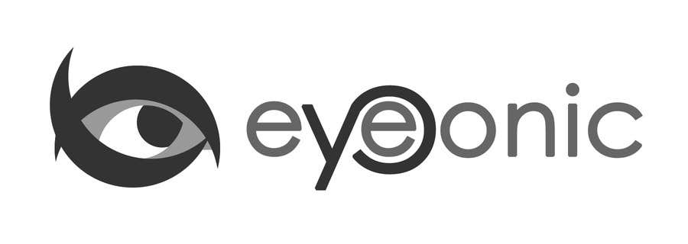



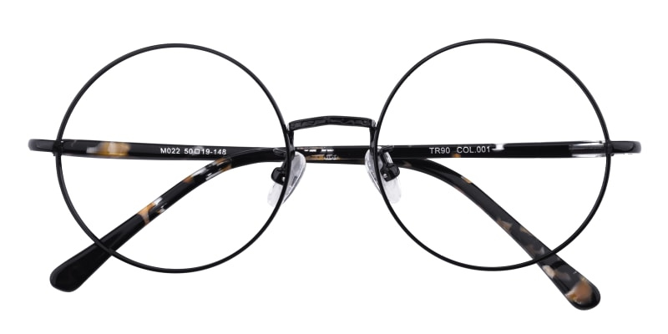

LACOSTE

Brunswick

## Round Black Eyeglasses

Price: $29.95

Color: **Black Tiger**

Promotion:

* Buy One Get One Free
* 30% Off Entire Order

SKU: FM1017

Frame: Full

Shape: Round

Weight: 13g (0.46 oz)

Gender: Women | Men

Material: Mental

Progressive: Yes

Description:

Brunswick eyeglasses provide a classic rounded frame in a solid black tone. Crafted from high-quality metal materials, the Brunswick features adjustble nose pads and a thin build, resulting in a barely there feel and increased comfort. Perfect for the quirky individual and for any occasion.   
  
OUR RECOMMENDATION:  
Rounded eyewear looks great on square shaped faces. The softness of the frame complements and balances sharp features for a winning look. Of course, you know yourself best, so if you like them, we're sure you can rock them!

Frame Width

135 mm

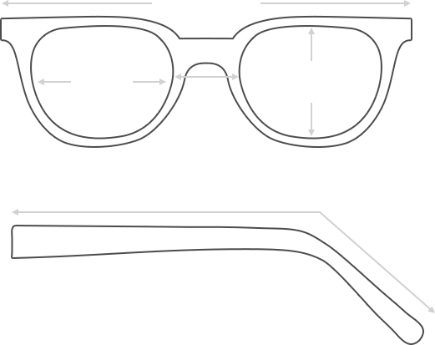

Lens Height

50 mm

Bridge

18 mm

Diagonal 50 mm

Temple Length 135 mm

Lens Width

50 mm

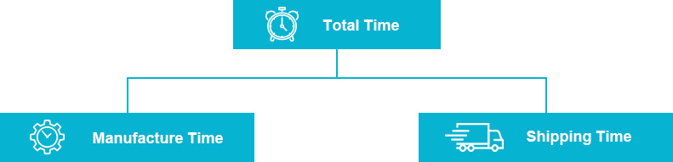

 **MANUFACTURE TIME:**

|  |
| --- |
| Glasses Type Time |
| Progressive 3 – 5 business days |

 **SHIPPING TIME:**

|  |
| --- |
| Country/Region Shipping Method Rate Time |
| UNITED STATES AIRMAIL $5.8 7-9 business days |
| CANADA UPS/FEDEX $24.5 10-12 business days |
| VIETNAM EXTRASHIP $3.0 4-6 business days |



 **HOW TO RETURN YOUR GLASSES:**



1. Contact our Customer Service Department at [service@eyeconic.com](mailto:service@eyeconic.com) to approve the return.

2. All returns must be returned in their unworn, original, condition, in the original case include an eyeglass case and lens cleaning cloth. Package your glasses securely and make sure to include your name, contact information order number and why you returned the glasses.

3. We recommend shipping your return by a traceable method. (eyeconic.com is not responsible for shipping damages or lost shipments.)

4. Once your return is received, we will process refund in 7 working days. Your refund will be credited back to your original method of payment. Once your refund has been processed, it will take 7 to 10 business days for your bank to process the credit and apply it to your account.

Questions? Concerns? Email us at [service@eyeconic.com](mailto:service@eyeconic.com) or call our Customer Service Department at Toll Free 1-855-202-0123 or contact us via live chat. Our hours are 9:00 AM to 5:00 PM Mon to Fri. (EST)