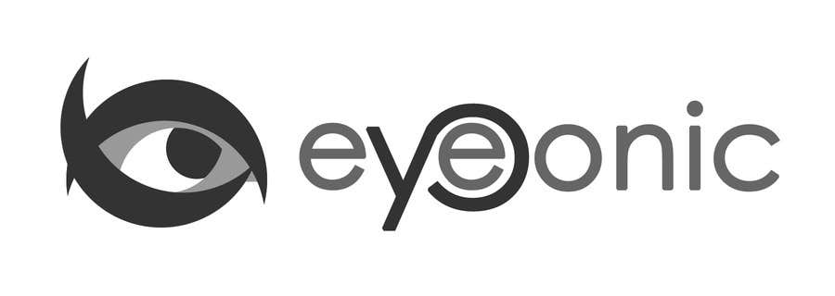

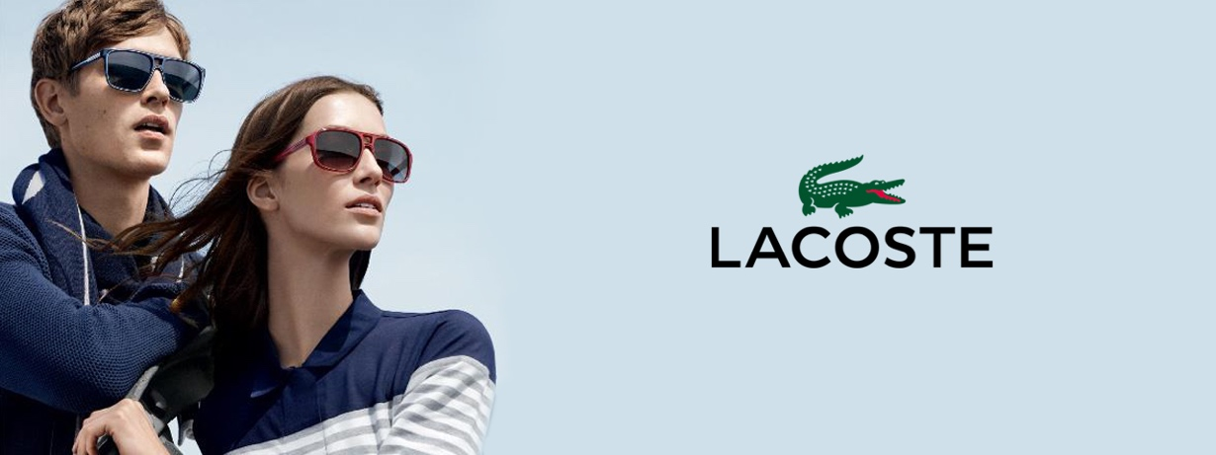

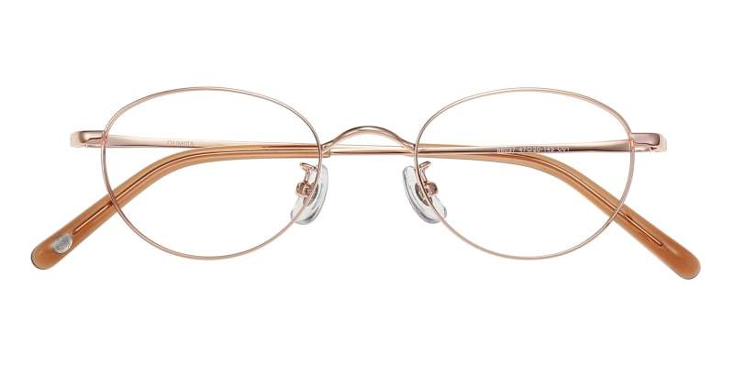

LACOSTE

Cythia

## Oval Rose Gold Eyeglasses

Price: $34.95

Color: **Glod**

Promotion:

* Buy One Get One Free
* 30% Off Entire Order

SKU: FM1481

Frame: Full

Shape: Oval

Weight: 10.6g (0.37 oz)

Gender: Women

Material: Mental

Progressive: Yes

Description:

These finely oval metal frames with water-waved detail are instantly elevating, whatever your wardrobe mood. The curved bridge, adjustable nose pads, and acetate-tipped slimline arms offer a comfortable, adjustable fit.

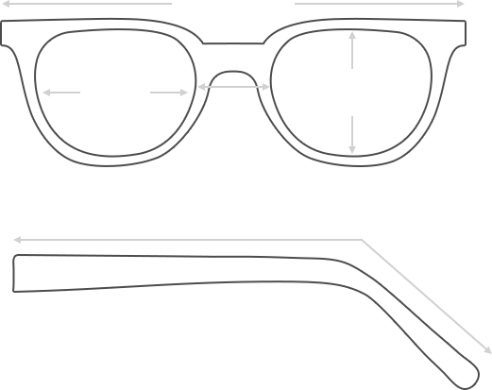

Lens Height

36 mm

Frame Width

130 mm

Bridge

21 mm

Diagonal 45 mm

Temple Length 140 mm

Lens Width

47 mm

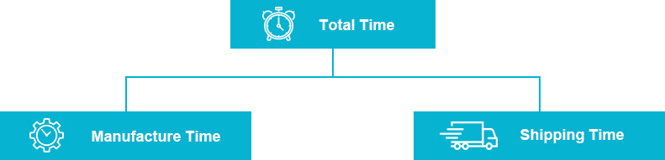

 **MANUFACTURE TIME:**

|  |
| --- |
| Glasses Type Time |
| Progressive 3 – 5 business days |

 **SHIPPING TIME:**

|  |
| --- |
| Country/Region Shipping Method Rate Time |
| UNITED STATES AIRMAIL $5.8 7-9 business days |
| CANADA UPS/FEDEX $24.5 10-12 business days |
| VIETNAM EXTRASHIP $3.0 4-6 business days |



 **HOW TO RETURN YOUR GLASSES:**



1. Contact our Customer Service Department at [service@eyeconic.com](mailto:service@eyeconic.com) to approve the return.

2. All returns must be returned in their unworn, original, condition, in the original case include an eyeglass case and lens cleaning cloth. Package your glasses securely and make sure to include your name, contact information order number and why you returned the glasses.

3. We recommend shipping your return by a traceable method. (eyeconic.com is not responsible for shipping damages or lost shipments.)

4. Once your return is received, we will process refund in 7 working days. Your refund will be credited back to your original method of payment. Once your refund has been processed, it will take 7 to 10 business days for your bank to process the credit and apply it to your account.

Questions? Concerns? Email us at [service@eyeconic.com](mailto:service@eyeconic.com) or call our Customer Service Department at Toll Free 1-855-202-0123 or contact us via live chat. Our hours are 9:00 AM to 5:00 PM Mon to Fri. (EST)