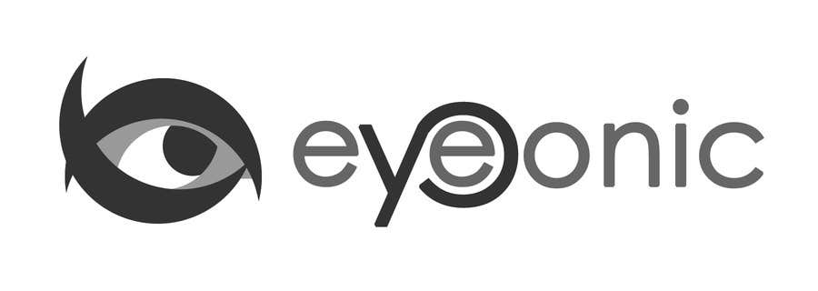



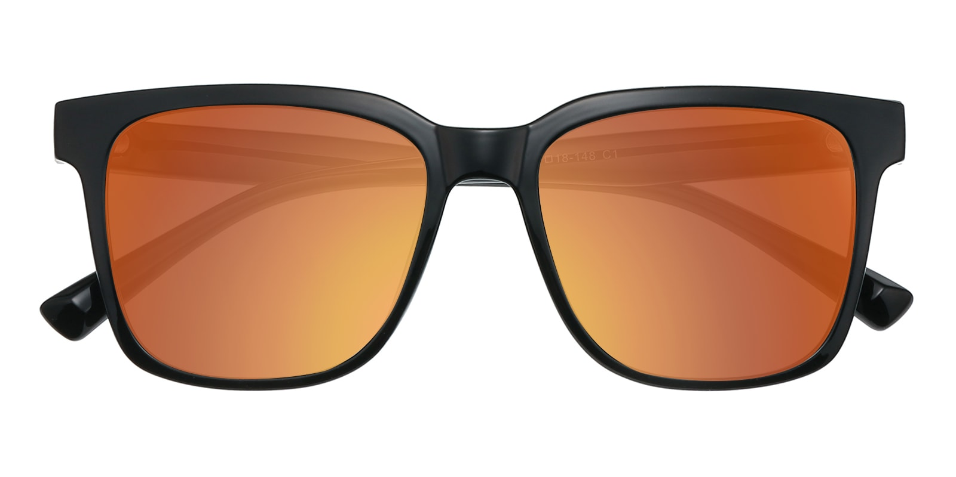

CALVIN KLEIN

Ely

## Horn Black Sunglasses

Price: $29.95

Color: **Black**

Promotion:

* Buy One Get One Free
* 30% Off Entire Order

SKU: SUP0997

Frame: Full

Shape: Horn

Weight: 161g (0.57 oz)

Gender: Women | Men

Material: TR90

Progressive: Yes

Description:

Are you looking for a pair of affordable and chic mirrored sunglasses? Glassesshop offers 4 colors mirrored sunglasses. Add a timeless touch to your look with these mirrored sunglasses, a must have accessory for anyone who likes to make a striking and lasting impression.

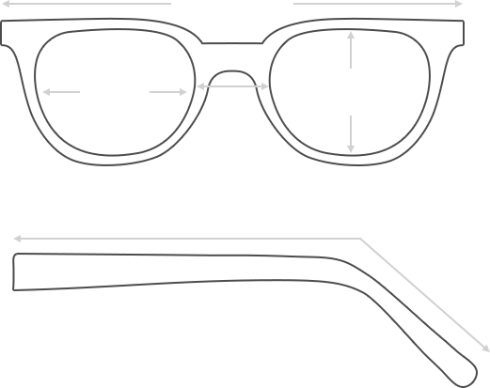

Lens Height

46 mm

Frame Width

146 mm

Bridge

18 mm

Diagonal 57 mm

Temple Length 148 mm

Lens Width

54 mm



 **MANUFACTURE TIME:**

|  |
| --- |
| Glasses Type Time |
| Progressive 3 – 5 business days |

 **SHIPPING TIME:**

|  |
| --- |
| Country/Region Shipping Method Rate Time |
| UNITED STATES AIRMAIL $5.8 7-9 business days |
| CANADA UPS/FEDEX $24.5 10-12 business days |
| VIETNAM EXTRASHIP $3.0 4-6 business days |



 **HOW TO RETURN YOUR GLASSES:**



1. Contact our Customer Service Department at [service@eyeconic.com](mailto:service@eyeconic.com) to approve the return.

2. All returns must be returned in their unworn, original, condition, in the original case include an eyeglass case and lens cleaning cloth. Package your glasses securely and make sure to include your name, contact information order number and why you returned the glasses.

3. We recommend shipping your return by a traceable method. (eyeconic.com is not responsible for shipping damages or lost shipments.)

4. Once your return is received, we will process refund in 7 working days. Your refund will be credited back to your original method of payment. Once your refund has been processed, it will take 7 to 10 business days for your bank to process the credit and apply it to your account.

Questions? Concerns? Email us at [service@eyeconic.com](mailto:service@eyeconic.com) or call our Customer Service Department at Toll Free 1-855-202-0123 or contact us via live chat. Our hours are 9:00 AM to 5:00 PM Mon to Fri. (EST)