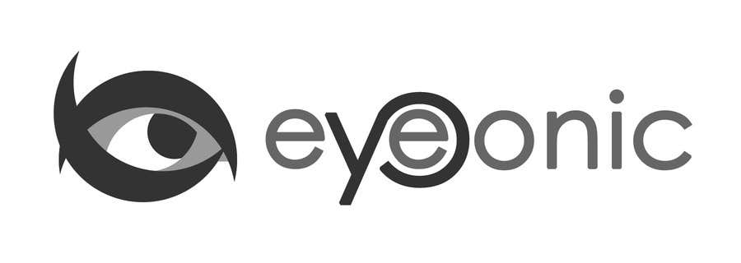



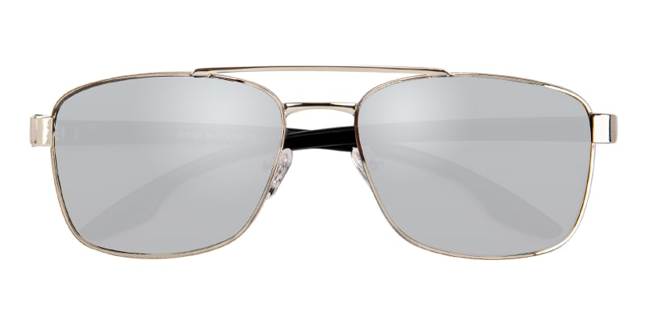

CALVIN KLEIN

Marshall

## Aviator Silver/Silver mirror-coating Sunglasses

Price: $29.95

Color: **Gold Black**

Promotion:

* Buy One Get One Free
* 30% Off Entire Order

SKU: SUP08242

Frame: Full

Shape: Aviator

Weight: 20.6g (0.73 oz)

Gender: Men

Material: Mental

Progressive: Yes

Description:

Using classical retro aviator frame design, Marshall Sunglasses are made of new TR90 material. Without complicated decoration, it fits prescription sunglasses and no-prescription sunglasses. Featured with polarized lenses protecting your eyes from the hurt of strong sunlight, adjustable nose pads, double-bridge design, the polished and sophisticated sunglasses are a must have for men.

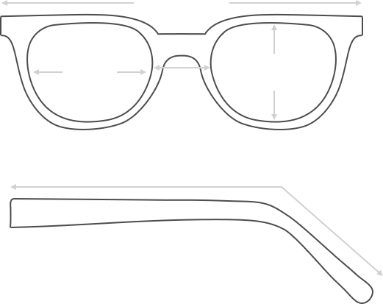

Lens Height

44 mm

Frame Width

150 mm

Bridge

18 mm

Diagonal 62 mm

Temple Length 138 mm

Lens Width

62 mm

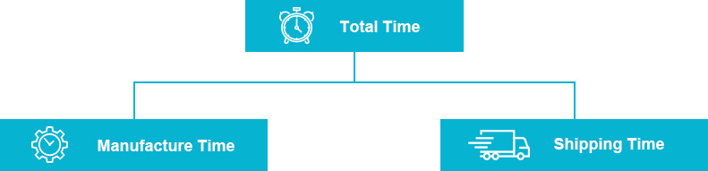

 **MANUFACTURE TIME:**

|  |
| --- |
| Glasses Type Time |
| Progressive 3 – 5 business days |

 **SHIPPING TIME:**

|  |
| --- |
| Country/Region Shipping Method Rate Time |
| UNITED STATES AIRMAIL $5.8 7-9 business days |
| CANADA UPS/FEDEX $24.5 10-12 business days |
| VIETNAM EXTRASHIP $3.0 4-6 business days |



 **HOW TO RETURN YOUR GLASSES:**



1. Contact our Customer Service Department at [service@eyeconic.com](mailto:service@eyeconic.com) to approve the return.

2. All returns must be returned in their unworn, original, condition, in the original case include an eyeglass case and lens cleaning cloth. Package your glasses securely and make sure to include your name, contact information order number and why you returned the glasses.

3. We recommend shipping your return by a traceable method. (eyeconic.com is not responsible for shipping damages or lost shipments.)

4. Once your return is received, we will process refund in 7 working days. Your refund will be credited back to your original method of payment. Once your refund has been processed, it will take 7 to 10 business days for your bank to process the credit and apply it to your account.

Questions? Concerns? Email us at [service@eyeconic.com](mailto:service@eyeconic.com) or call our Customer Service Department at Toll Free 1-855-202-0123 or contact us via live chat. Our hours are 9:00 AM to 5:00 PM Mon to Fri. (EST)