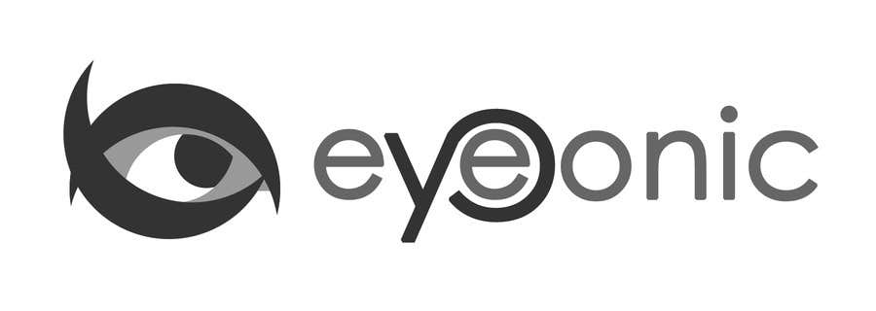



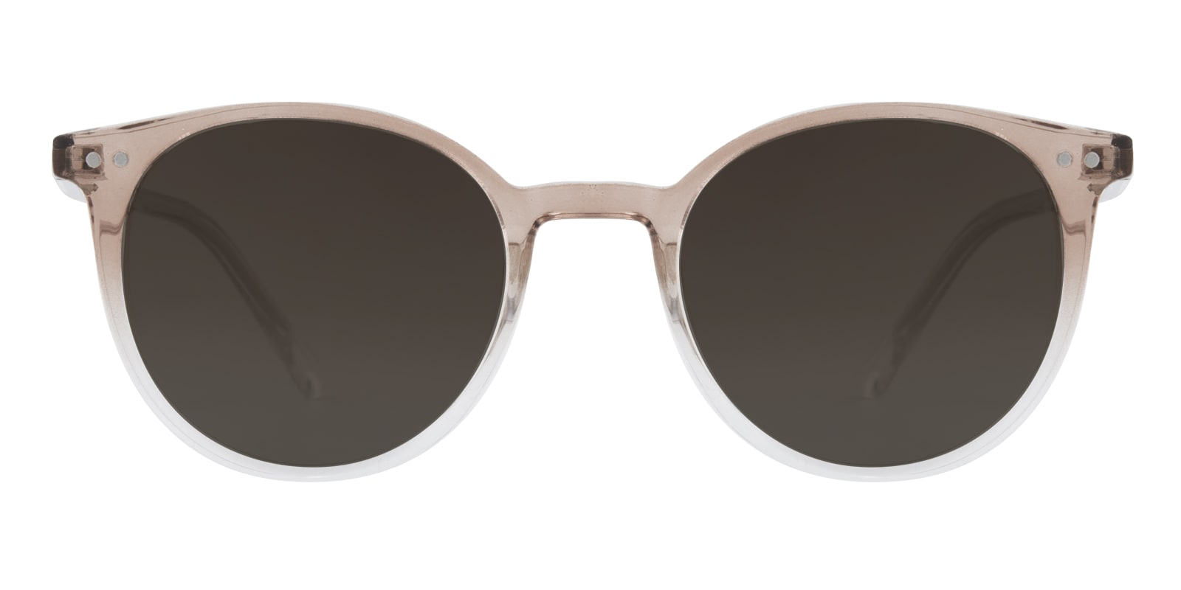

GUCCI

MOIRA

## Round Champagne/Crystal Sunglasses

Price: $29.5

Color: **Black**

Promotion:

* Buy One Get One Free
* 30% Off Entire Order

SKU: SUP1040

Frame: Full

Shape: Round

Weight: 20.5g(0.72 oz)

Gender: Women

Material: TR90

Progressive: Yes

Description

The Moira sunglasses bring vintage details and minimalistic influences together to create a cool, casual pair of frames. Throwback touches like the round shaped frame and gradient color have serious retro appeal, while the slim arms and integrated nose pads keep things simple and fresh. Made from TR90, the Moira frames are ultra-lightweight and comfortable, ready to match up with your favourite jeans-and-sneakers combination and head out the door with you!

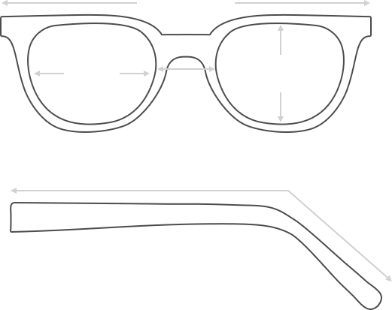

Lens Height

43.3 mm

Frame Width

139 mm

Bridge

21 mm

Diagonal 50 mm

Temple Length 152mm

Lens Width

50mm

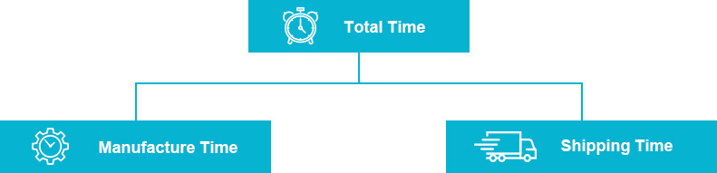

 **MANUFACTURE TIME:**

|  |
| --- |
| Glasses Type Time |
| Progressive 3 – 5 business days |

 **SHIPPING TIME:**

|  |
| --- |
| Country/Region Shipping Method Rate Time |
| UNITED STATES AIRMAIL $5.8 7-9 business days |
| CANADA UPS/FEDEX $24.5 10-12 business days |
| VIETNAM EXTRASHIP $3.0 4-6 business days |



 **HOW TO RETURN YOUR GLASSES:**



1. Contact our Customer Service Department at [service@eyeconic.com](mailto:service@eyeconic.com) to approve the return.

2. All returns must be returned in their unworn, original, condition, in the original case include an eyeglass case and lens cleaning cloth. Package your glasses securely and make sure to include your name, contact information order number and why you returned the glasses.

3. We recommend shipping your return by a traceable method. (eyeconic.com is not responsible for shipping damages or lost shipments.)

4. Once your return is received, we will process refund in 7 working days. Your refund will be credited back to your original method of payment. Once your refund has been processed, it will take 7 to 10 business days for your bank to process the credit and apply it to your account.

Questions? Concerns? Email us at [service@eyeconic.com](mailto:service@eyeconic.com) or call our Customer Service Department at Toll Free 1-855-202-0123 or contact us via live chat. Our hours are 9:00 AM to 5:00 PM Mon to Fri. (EST)