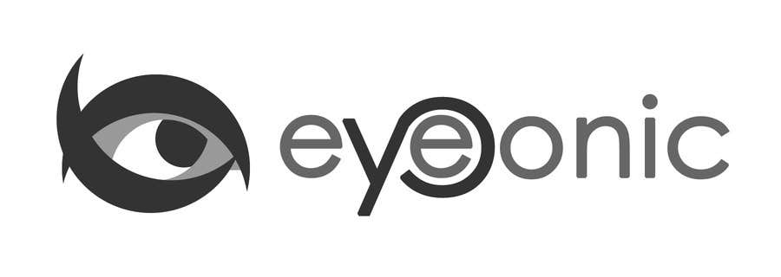



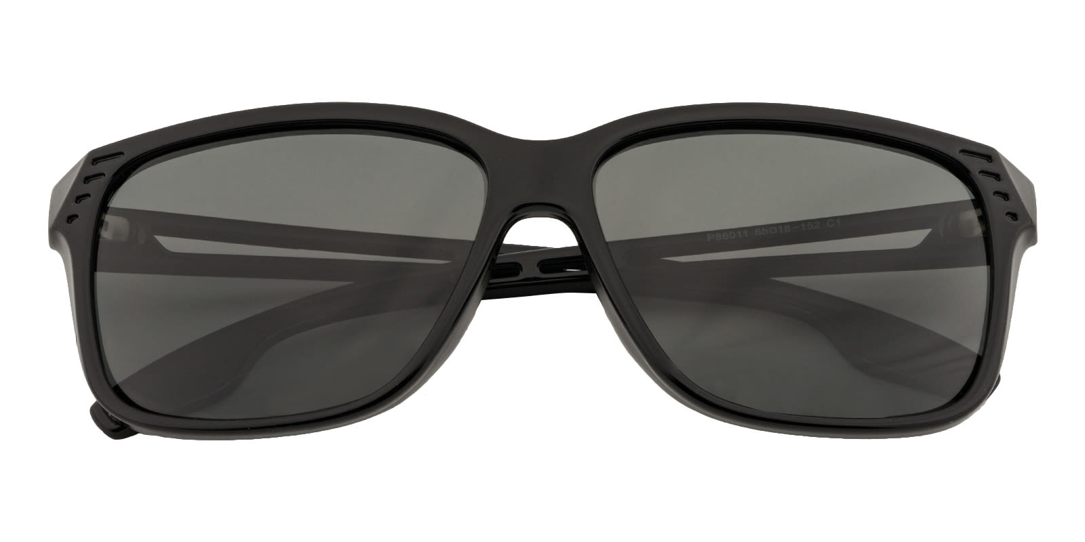

NIKE

Nodia

## Rectangle Black Sunglasses

Price: $29.99

Color: **Black**

Promotion:

* Buy One Get One Free
* 30% Off Entire Order

SKU: SUP0700

Frame: Full

Shape: Rectangle

Weight: 27.4g (0.97 oz)

Gender: Men

Material: Acetate

Progressive: Yes

Description:

The Nike Hyper force Elite sunglasses have the Nike Elite one-piece lens for superior coverage and clarity. The Nike + Zeiss Optics provide extraordinary clarity and perception. Ventilated, self-adjusting nose bridge provides an individualized fit. Super-lightweight, aerodynamic combined lens-frame reduces wind resistance. Rubber channels in temple arms increase airflow and grip. Ventilated temple arms prevent fogging and moisture accumulation. Frame accommodates Interchange lenses for any light conditions. Secondary lens included. Nike Vision tints are scientifically tuned for specific environments. Using light transmission analysis, optimization of colors and light levels are dynamically filtered through each lens.

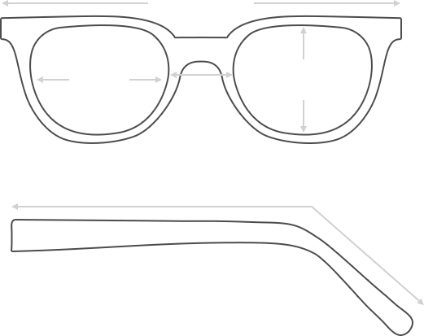

Lens Height

43.3 mm

Frame Width

142 mm

Bridge

18 mm

Diagonal 43 mm

Temple Length 145 mm

Lens Width

52 mm

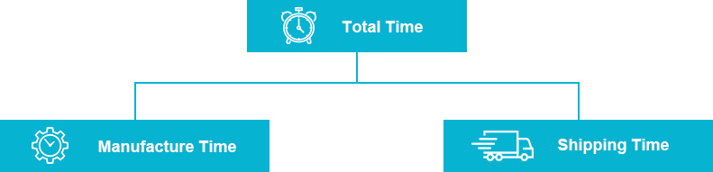

 **MANUFACTURE TIME:**

|  |
| --- |
| Glasses Type Time |
| Progressive 3 – 5 business days |

 **SHIPPING TIME:**

|  |
| --- |
| Country/Region Shipping Method Rate Time |
| UNITED STATES AIRMAIL $5.8 7-9 business days |
| CANADA UPS/FEDEX $24.5 10-12 business days |
| VIETNAM EXTRASHIP $3.0 4-6 business days |



 **HOW TO RETURN YOUR GLASSES:**



1. Contact our Customer Service Department at [service@eyeconic.com](mailto:service@eyeconic.com) to approve the return.

2. All returns must be returned in their unworn, original, condition, in the original case include an eyeglass case and lens cleaning cloth. Package your glasses securely and make sure to include your name, contact information order number and why you returned the glasses.

3. We recommend shipping your return by a traceable method. (eyeconic.com is not responsible for shipping damages or lost shipments.)

4. Once your return is received, we will process refund in 7 working days. Your refund will be credited back to your original method of payment. Once your refund has been processed, it will take 7 to 10 business days for your bank to process the credit and apply it to your account.

Questions? Concerns? Email us at [service@eyeconic.com](mailto:service@eyeconic.com) or call our Customer Service Department at Toll Free 1-855-202-0123 or contact us via live chat. Our hours are 9:00 AM to 5:00 PM Mon to Fri. (EST)