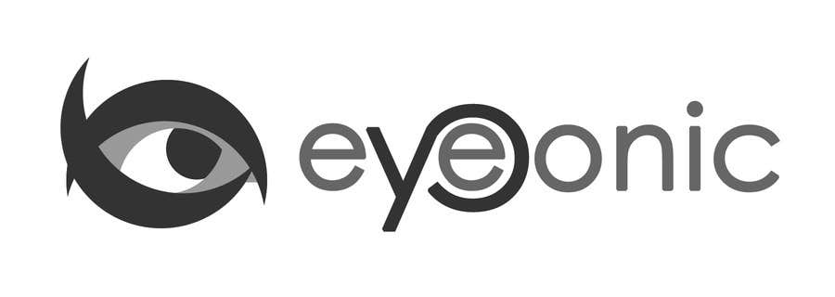



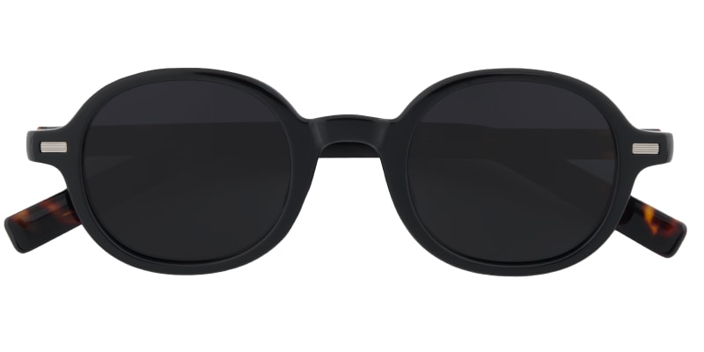

GUCCI

Pascagoula

## Round Black/Tortoise Sunglasses

Price: $30.99

Color: **Black Tiger**

Promotion:

* Buy One Get One Free
* 30% Off Entire Order

SKU: SUP1033

Frame: Full

Shape: Round

Weight: 27g (0.95 oz)

Gender: Women | Men

Material: TR90 | Acetate

Progressive: Yes

Description

Large faces with angled features will enjoy the impactful look of the Pascagoula frame. The round glasses borrow retro elements, like tapered wingtips, for some fun quirkiness. In addition, the angular brow-line makes this a great option for showing off your brows. The light TR90 frame is complete with slim acetate temple arms.

Please note, the actual pattern on eyeglasses may vary slightly from the one pictured

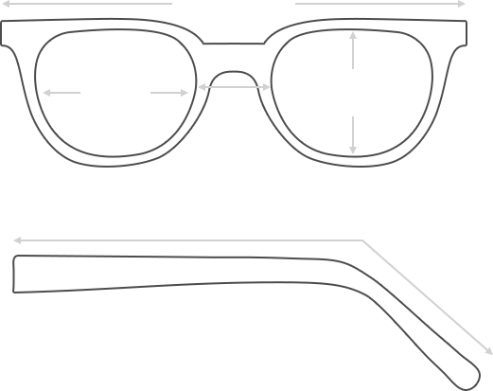

Lens Height

41 mm

Frame Width

142 mm

Bridge

25 mm

Diagonal 46 mm

Temple Length 153 mm

Lens Width

46 mm



 **MANUFACTURE TIME:**

|  |
| --- |
| Glasses Type Time |
| Progressive 3 – 5 business days |

 **SHIPPING TIME:**

|  |
| --- |
| Country/Region Shipping Method Rate Time |
| UNITED STATES AIRMAIL $5.8 7-9 business days |
| CANADA UPS/FEDEX $24.5 10-12 business days |
| VIETNAM EXTRASHIP $3.0 4-6 business days |



 **HOW TO RETURN YOUR GLASSES:**



1. Contact our Customer Service Department at [service@eyeconic.com](mailto:service@eyeconic.com) to approve the return.

2. All returns must be returned in their unworn, original, condition, in the original case include an eyeglass case and lens cleaning cloth. Package your glasses securely and make sure to include your name, contact information order number and why you returned the glasses.

3. We recommend shipping your return by a traceable method. (eyeconic.com is not responsible for shipping damages or lost shipments.)

4. Once your return is received, we will process refund in 7 working days. Your refund will be credited back to your original method of payment. Once your refund has been processed, it will take 7 to 10 business days for your bank to process the credit and apply it to your account.

Questions? Concerns? Email us at [service@eyeconic.com](mailto:service@eyeconic.com) or call our Customer Service Department at Toll Free 1-855-202-0123 or contact us via live chat. Our hours are 9:00 AM to 5:00 PM Mon to Fri. (EST)