



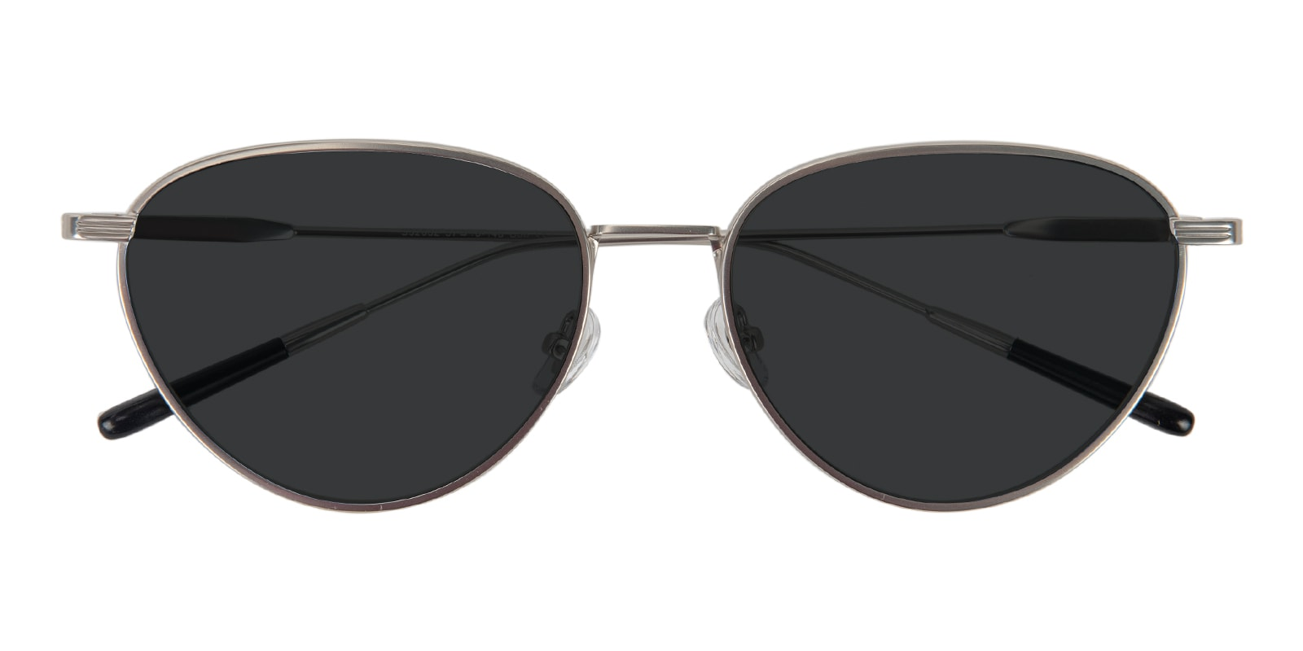

LACOSTE

Pueblo

## Cat Eye Silver Sunglasses

Price: $19.95

Color: **Light**

Promotion:

* Buy One Get One Free
* 30% Off Entire Order

SKU: SUP0967

Frame: Full

Shape: Cat Eye

Weight: 23.2g (0.82 oz)

Gender: Women | Men

Material: Mental

Progressive: Yes

Description:

Playfully sweet, Pueblo is a delicate cat-eye frame that will beautifully flatter triangle and heart shape faces with adjustable nose pads. The subtle curves on these glasses add softness to sharp facial features. This refined pair provides all-day comfort for large to oversized faces.

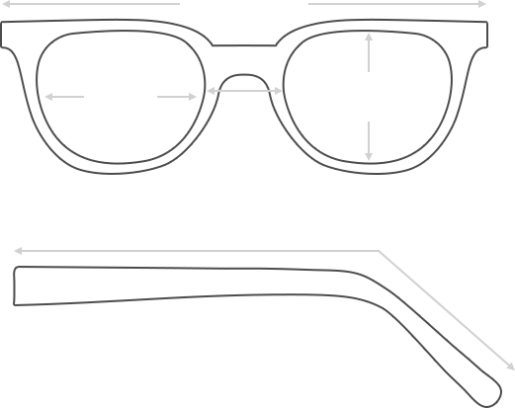

Lens Height

45 mm

Frame Width

149 mm

Bridge

19 mm

Diagonal 54 mm

Temple Length 147 mm

Lens Width

57 mm



 **MANUFACTURE TIME:**

|  |
| --- |
| Glasses Type Time |
| Progressive 3 – 5 business days |

 **SHIPPING TIME:**

|  |
| --- |
| Country/Region Shipping Method Rate Time |
| UNITED STATES AIRMAIL $5.8 7-9 business days |
| CANADA UPS/FEDEX $24.5 10-12 business days |
| VIETNAM EXTRASHIP $3.0 4-6 business days |



 **HOW TO RETURN YOUR GLASSES:**



1. Contact our Customer Service Department at [service@eyeconic.com](mailto:service@eyeconic.com) to approve the return.

2. All returns must be returned in their unworn, original, condition, in the original case include an eyeglass case and lens cleaning cloth. Package your glasses securely and make sure to include your name, contact information order number and why you returned the glasses.

3. We recommend shipping your return by a traceable method. (eyeconic.com is not responsible for shipping damages or lost shipments.)

4. Once your return is received, we will process refund in 7 working days. Your refund will be credited back to your original method of payment. Once your refund has been processed, it will take 7 to 10 business days for your bank to process the credit and apply it to your account.

Questions? Concerns? Email us at [service@eyeconic.com](mailto:service@eyeconic.com) or call our Customer Service Department at Toll Free 1-855-202-0123 or contact us via live chat. Our hours are 9:00 AM to 5:00 PM Mon to Fri. (EST)