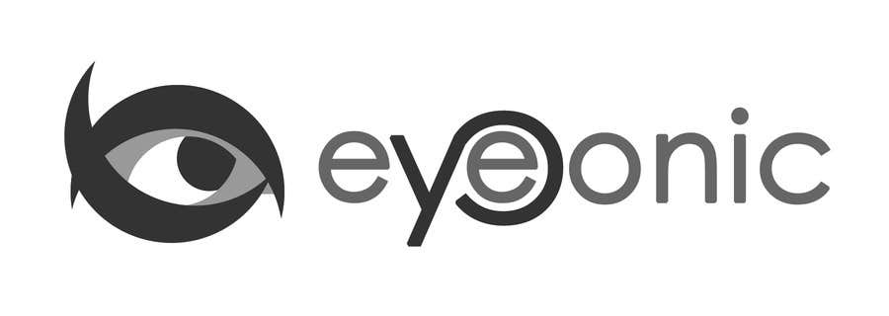



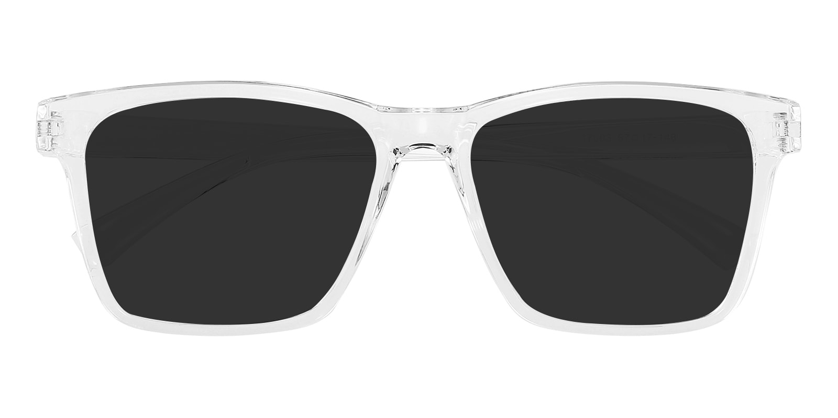

NIKE

Spender

## Square Crystal Sunglasses

Price: $19.95

Color: **White**

Promotion:

* Buy One Get One Free
* 30% Off Entire Order

SKU: SUP0632

Frame: Full

Shape: Square

Weight: 27.4g (0.97 oz)

Gender: Women | Men

Material: TR90

Progressive: Yes

Description:

Spender by GlassesShop features a large square frame available in two colors. A great unisex option that offers simple and stylish comfort for everyday wear.  
OUR RECOMMENDATION:  
Square shaped frames look great a round-shaped face. This shape adds defnition while sharper lines complement softer facial features. Square eyewear also provides a slimming effect!

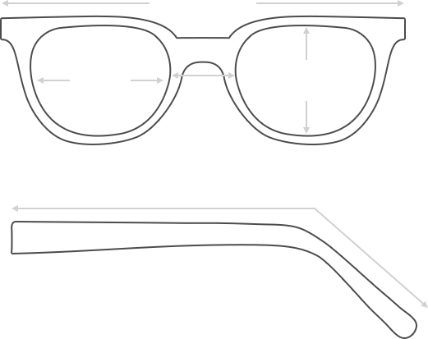

Lens Height

43.3 mm

Frame Width

152 mm

Bridge

18 mm

Diagonal 59 mm

Temple Length 150 mm

Lens Width

56 mm

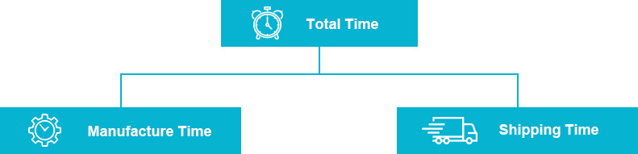

 **MANUFACTURE TIME:**

|  |
| --- |
| Glasses Type Time |
| Progressive 3 – 5 business days |

 **SHIPPING TIME:**

|  |
| --- |
| Country/Region Shipping Method Rate Time |
| UNITED STATES AIRMAIL $5.8 7-9 business days |
| CANADA UPS/FEDEX $24.5 10-12 business days |
| VIETNAM EXTRASHIP $3.0 4-6 business days |



 **HOW TO RETURN YOUR GLASSES:**



1. Contact our Customer Service Department at [service@eyeconic.com](mailto:service@eyeconic.com) to approve the return.

2. All returns must be returned in their unworn, original, condition, in the original case include an eyeglass case and lens cleaning cloth. Package your glasses securely and make sure to include your name, contact information order number and why you returned the glasses.

3. We recommend shipping your return by a traceable method. (eyeconic.com is not responsible for shipping damages or lost shipments.)

4. Once your return is received, we will process refund in 7 working days. Your refund will be credited back to your original method of payment. Once your refund has been processed, it will take 7 to 10 business days for your bank to process the credit and apply it to your account.

Questions? Concerns? Email us at [service@eyeconic.com](mailto:service@eyeconic.com) or call our Customer Service Department at Toll Free 1-855-202-0123 or contact us via live chat. Our hours are 9:00 AM to 5:00 PM Mon to Fri. (EST)