



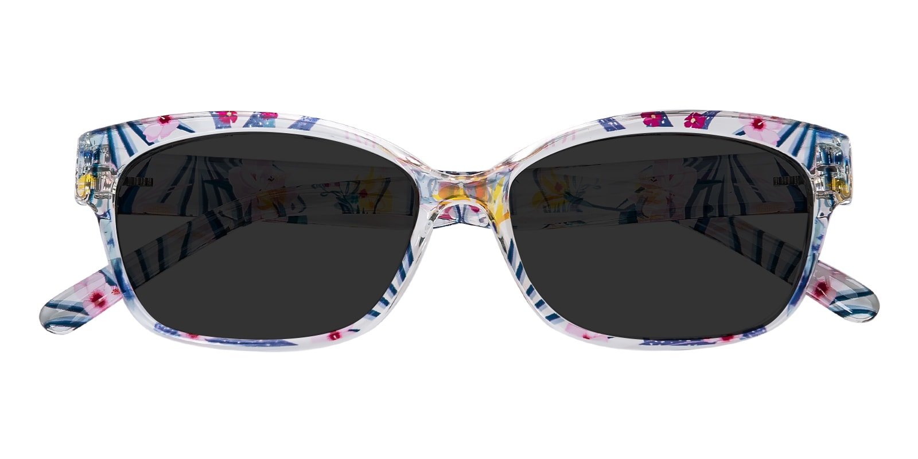

GUCCI

Tabitha

## Rectangle Flora Sunglasses

Price: $15.95

Color: **Pink**

Promotion:

* Buy One Get One Free
* 30% Off Entire Order

SKU: SUP1068

Frame: Full

Shape: Rectangle

Weight: 13.1g (0.46 oz)

Gender: Women

Material: TR90

Progressive: Yes

Description:

It is all about class in these Tabitha sunglasses. The Rectangle shape will add instant retro charm to your ensemble, finishing off your look with pure sophistication. Elegant and effortless, they have a true city-chic vibe. Made from TR90, slide them on for a lightweight and durable fit for your commute, your weekend, or days spent in the sun.

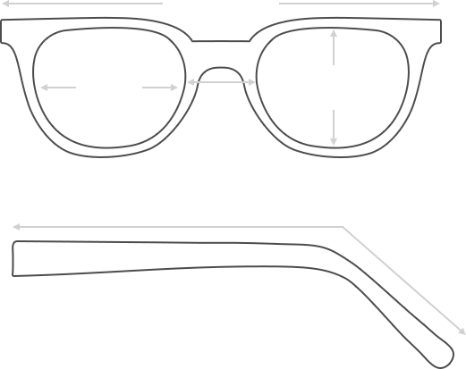

Lens Height

36 mm

Frame Width

135 mm

Bridge

15 mm

Diagonal 51 mm

Temple Length 143 mm

Lens Width

53 mm



 **MANUFACTURE TIME:**

|  |
| --- |
| Glasses Type Time |
| Progressive 3 – 5 business days |

 **SHIPPING TIME:**

|  |
| --- |
| Country/Region Shipping Method Rate Time |
| UNITED STATES AIRMAIL $5.8 7-9 business days |
| CANADA UPS/FEDEX $24.5 10-12 business days |
| VIETNAM EXTRASHIP $3.0 4-6 business days |



 **HOW TO RETURN YOUR GLASSES:**



1. Contact our Customer Service Department at [service@eyeconic.com](mailto:service@eyeconic.com) to approve the return.

2. All returns must be returned in their unworn, original, condition, in the original case include an eyeglass case and lens cleaning cloth. Package your glasses securely and make sure to include your name, contact information order number and why you returned the glasses.

3. We recommend shipping your return by a traceable method. (eyeconic.com is not responsible for shipping damages or lost shipments.)

4. Once your return is received, we will process refund in 7 working days. Your refund will be credited back to your original method of payment. Once your refund has been processed, it will take 7 to 10 business days for your bank to process the credit and apply it to your account.

Questions? Concerns? Email us at [service@eyeconic.com](mailto:service@eyeconic.com) or call our Customer Service Department at Toll Free 1-855-202-0123 or contact us via live chat. Our hours are 9:00 AM to 5:00 PM Mon to Fri. (EST)