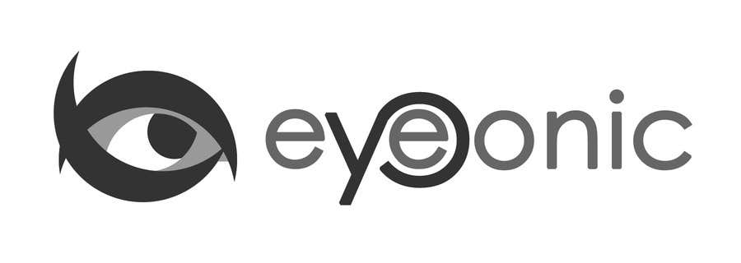



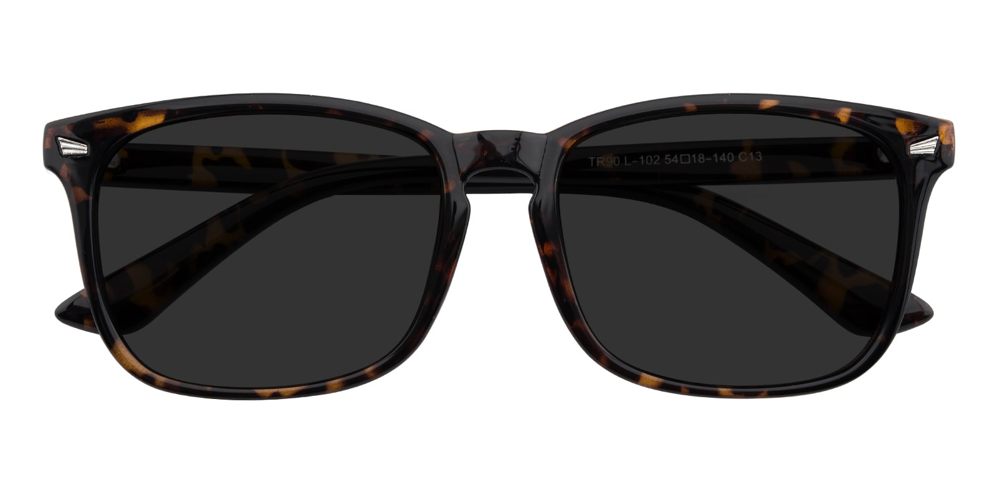

GUCCI

Uvalde

## Rectangle Tortoise Sunglasses

Price: $9.59

Color: **Black**

Promotion:

* Buy One Get One Free
* 30% Off Entire Order

SKU: SUP1074

Frame: Full

Shape: Rectangle

Weight: 14g (0.49 oz)

Gender: Women | Men

Material: TR90

Progressive: Yes

Description:

Slim, simple, and sophisticated, the Uvalde sunglasses will bring a smart edge to whatever you are wearing today. The TR90 has a modern, rectangular finish, to create a contemporary yet classy silhouette. Minimalistic detailing such as integrated nose pads and silver metal rivets ensure a versatile finish, so it is easy to slip the Uvalde frames and conquer your day.

Please note, the actual pattern on eyeglasses may vary slightly from the one pictured.

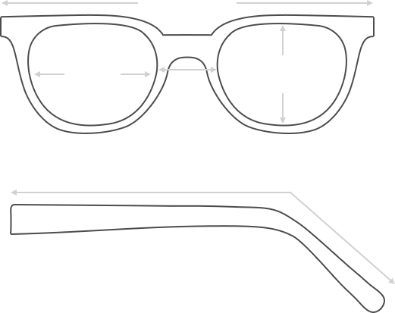

Lens Height

42 mm

Frame Width

143 mm

Bridge

18 mm

Diagonal 55 mm

Temple Length 146 mm

Lens Width

54 mm



 **MANUFACTURE TIME:**

|  |
| --- |
| Glasses Type Time |
| Progressive 3 – 5 business days |

 **SHIPPING TIME:**

|  |
| --- |
| Country/Region Shipping Method Rate Time |
| UNITED STATES AIRMAIL $5.8 7-9 business days |
| CANADA UPS/FEDEX $24.5 10-12 business days |
| VIETNAM EXTRASHIP $3.0 4-6 business days |



 **HOW TO RETURN YOUR GLASSES:**



1. Contact our Customer Service Department at [service@eyeconic.com](mailto:service@eyeconic.com) to approve the return.

2. All returns must be returned in their unworn, original, condition, in the original case include an eyeglass case and lens cleaning cloth. Package your glasses securely and make sure to include your name, contact information order number and why you returned the glasses.

3. We recommend shipping your return by a traceable method. (eyeconic.com is not responsible for shipping damages or lost shipments.)

4. Once your return is received, we will process refund in 7 working days. Your refund will be credited back to your original method of payment. Once your refund has been processed, it will take 7 to 10 business days for your bank to process the credit and apply it to your account.

Questions? Concerns? Email us at [service@eyeconic.com](mailto:service@eyeconic.com) or call our Customer Service Department at Toll Free 1-855-202-0123 or contact us via live chat. Our hours are 9:00 AM to 5:00 PM Mon to Fri. (EST)