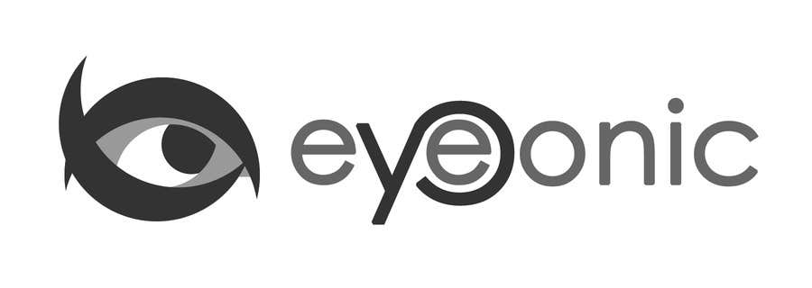





CALVIN KLEIN

Vera

## Polygon Rose Gold Sunglasses

Price: $24.95

Color: **Light Gold**

Promotion:

* Buy One Get One Free
* 30% Off Entire Order

SKU: SUP1078

Frame: Full

Shape: Polygon

Weight: 11.00g (0.39 oz)

Gender: Women

Material: Mental

Progressive: Yes

Description:

The Vera sunglasses provide an effortless look that will make you the envy of everyone around you. Featuring a sleek metal construction,With adjustable nose pads and heart ornaments decorated temple arm, these thin wire glasses boast a chic design to bring attention to your eyes.

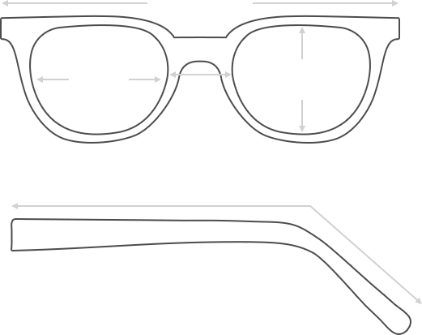

Lens Height

48 mm

Frame Width

136 mm

Bridge

20 mm

Diagonal 51 mm

Temple Length 148 mm

Lens Width

50 mm



 **MANUFACTURE TIME:**

|  |
| --- |
| Glasses Type Time |
| Progressive 3 – 5 business days |

 **SHIPPING TIME:**

|  |
| --- |
| Country/Region Shipping Method Rate Time |
| UNITED STATES AIRMAIL $5.8 7-9 business days |
| CANADA UPS/FEDEX $24.5 10-12 business days |
| VIETNAM EXTRASHIP $3.0 4-6 business days |



 **HOW TO RETURN YOUR GLASSES:**



1. Contact our Customer Service Department at [service@eyeconic.com](mailto:service@eyeconic.com) to approve the return.

2. All returns must be returned in their unworn, original, condition, in the original case include an eyeglass case and lens cleaning cloth. Package your glasses securely and make sure to include your name, contact information order number and why you returned the glasses.

3. We recommend shipping your return by a traceable method. (eyeconic.com is not responsible for shipping damages or lost shipments.)

4. Once your return is received, we will process refund in 7 working days. Your refund will be credited back to your original method of payment. Once your refund has been processed, it will take 7 to 10 business days for your bank to process the credit and apply it to your account.

Questions? Concerns? Email us at [service@eyeconic.com](mailto:service@eyeconic.com) or call our Customer Service Department at Toll Free 1-855-202-0123 or contact us via live chat. Our hours are 9:00 AM to 5:00 PM Mon to Fri. (EST)