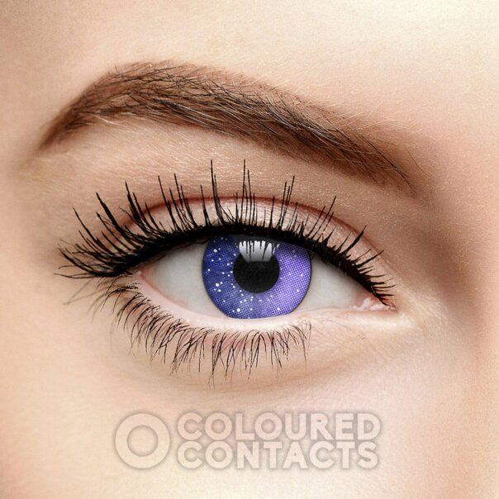

# VIOLET GALAXY COLORED CONTACT LENSES (90 DAY)

The VIOLET GALAXY COLORED CONTACT LENSES (90 DAY)have a golden brown tone that is sure to enhance your eye color. These natural contact lenses give you the chance to try a new everyday or special occasion look.

Add an enhancing golden tone to your eyes with the Air Optix Colors Honey Prescription Colured Contact Lenses in 30 Day. This unusual color is designed to look like a natural iris for a style that is sure to have people doing a double take.

The light golden shade of these **Air Optix contact lenses**is perfect for either lightening dark brown eyes or trying a completely new color. The detailed design gives the lenses a natural look. These monthly contact lenses can be reused as long as they are correctly stored and maintained.

The **Air Optix Colors Honey Prescription Contacts**are an exciting way to take a step up with your natural colored contacts. Whether you want to save for special occasions or wear as an everyday look, the unusual color is not to be missed.

Contact Lens Essential Information:

For Cosmetic Use Only  
Doesn't Impair Visibility   
Sold As Pair  
Suitable For Up To 30 Days Once Opened  
Made From 33% Water  
High O2 Permeable Lenses  
Stored In Sterile Buffered Saline Solution

|  |  |
| --- | --- |
| **SPECS** | |
| **Brand** | Air Optix |
| **Manufacturer** | Air Optix |
| **Color** | Brown / Hazel / Honey |
| **Style** | Natural |
| **Duration** | 30 Day |
| **Quantity** | 2 Per Pack (Pair) |
| **Prescription / Corrective Lens** | Yes |
| **Type** | Prescription |
| **Diameter** | 14.2 |
| **Base Curve** | 8.6 |
| **Water Content** | 33% |
| **Made From** | Lotrafilcon B |



**Not Included In 3 for 2**

Unfortunately, this product is currently not included in our site-wide 3 for 2 multi buy offer.



**Smart Shield Technology**

The unique SmartShield Technology of Air Optix contact lenses provides an ultra thin layer that helps prevent against irritating deposits to enhance comfort during wear.



**Maintains Moisture**

The patented SmartShield Technology layer locks in moisture to keep the surface of the eye feeling fresh and hydrated during wear.



**Improved Breathability**

These premium oxygen permeable lenses allows for a continuous flow of oxygen to the eye, maintaining healthy color.



**Freshlook Aesthetics**

Enhance your eye colour with the premium and vibrant colors from Air Optix with FreshLook Aesthetic. Give your eyes increased color vibrancy across their distinguished styles and shades.



**Alternative Everyday Use**

If you are a regular contact lens wearer seeking a new look then these will make a perfect new coloured lens alternative.



**Natural Look Lenses**

Transform your everyday eye color and enhance your style.



**Prescription Contact Lenses**

Choose your exact prescription for clear vision.

## NEED HELP WITH YOUR COLOURED CONTACTS ORDER?

Over the phone, our Customer Services Team can deal with urgent changes to orders and quick website questions; we are in the office Monday to Friday (8:30am to 4:30pm GMT).

**Call: (+44) 020 3318 1459**

Send a message: Fill in our customer message form if you need to contact us for any reason about your order or website questions on our [Contact Us](https://www.colouredcontacts.com/en_US/contact-forms/contact-us) Page.

Need help with delivery and tracking? Make sure to check our [Delivery Page](https://www.colouredcontacts.com/en_US/page/delivery-information) and Tracking Page for help. Please note that some postage methods will require you to track your parcel on the courier’s website.

## FAQ HELP & USEFUL LINKS

Have a question about using our coloured contact lenses? Make sure to visit our [Care Guides](https://www.colouredcontacts.com/en_US/colored-contacts-care-guides) to find frequently asked questions, step by step guides, and RX information all in one place.  
To help you choose the right lenses for you, when you are looking at a product you will see:

* Transparency Guide: Each product is rated Enhancing, Vibrant, or Full Colour to help you choose a style to cover your natural eye colour.
* Product Measurements: In the product details, we list diameter and base curve so you can ensure that the lens measurements match your latest prescription.
* Product Duration: Some lenses such as 30 day and 90 day types are re-usable whereas daily lenses are designed for a single use only.
* Type: You are ordering either Plano (non-prescription) or Prescription contact lenses. Make sure to choose your prescription strength when you add the product to your basket, if you are ordering a prescription product. Prescription strengths are not added afterwards.

Remember: You should always consult your optician for a contact lens fitting, even if you are wearing non-prescription coloured contacts.