**300COM Individual Project**

**Topic: cinema booking system**

Name: Lo Cheuk Man

Student ID: 11412052

Course: Informatics - ECU098

Supervisor: Leon Smalov

Submission date: 19-APR-2022

Name of institution: School of Computing, Engineering and Mathematics, Coventry University

**Table of Content**

**Declaration of Originality** **4**

**Abstract** **5**

**Introduction** **6**

Aims and objectives 6

Brief description of the report 7

**Literature Review** **8**

Problem facing 8

Solution to the problem 9

**Research Methods** **10**

Agile software development 10

Scrum 10

Kanban 11

Extreme Programming 11

**Tools and Techniques** **13**

Programming language 13

HTML 13

JavaScript(DENO) 13

Source code editor 14

Codio 14

Database 15

MySQL 15

Template 16

Handlebars 16

Style sheet 16

CSS 16

Website hosting platform 17

Heroku 17

Software testing 17

Unit testing 17

**System Prototype** **18**

System design 18

Guideline 22

User manual 22

Staff manual 26

Administrator manual 31

Host manual 32

**Project Management** **35**

Workflow of the project 35

Kanban board 35

**Conclusion** **36**

**Appendix** **39**

Live website(Appendix 1) 39

GitHub(Appendix 2) 39

Ethics Certificate(Appendix 3) 40

Declaration of Originality(Appendix 4) 45

Project proposal(Appendix 5) 46

Progress report(Appendix 6) 47

# Declaration of Originality

**Declaration of Originality**

I declare that this project is all my own work and has not been copied in part or in whole from any other source except where duly acknowledged. As such, all use of previously published work (from books, journals, magazines, internet etc.) has been acknowledged by citation within the main report to an item in the References or Bibliography lists. I also agree that an electronic copy of this project may be stored and used for the purposes of plagiarism prevention and detection.

**Statement of copyright**

I acknowledge that the copyright of this project report, and any product developed as part of the project, belong to Coventry University. Support, including funding, is available to commercialise products and services developed by staff and students. Any revenue that is generated is split with the inventor/s of the product or service. For further information please see [www.coventry.ac.uk/ipr](http://www.coventry.ac.uk/ipr) or contact ipr@coventry.ac.uk.

**Statement of ethical engagement**

I declare that a proposal for this project has been submitted to the Coventry University ethics monitoring website (https://ethics.coventry.ac.uk/) and that the application number is listed below (Note: Projects without an ethical application number will be rejected for marking)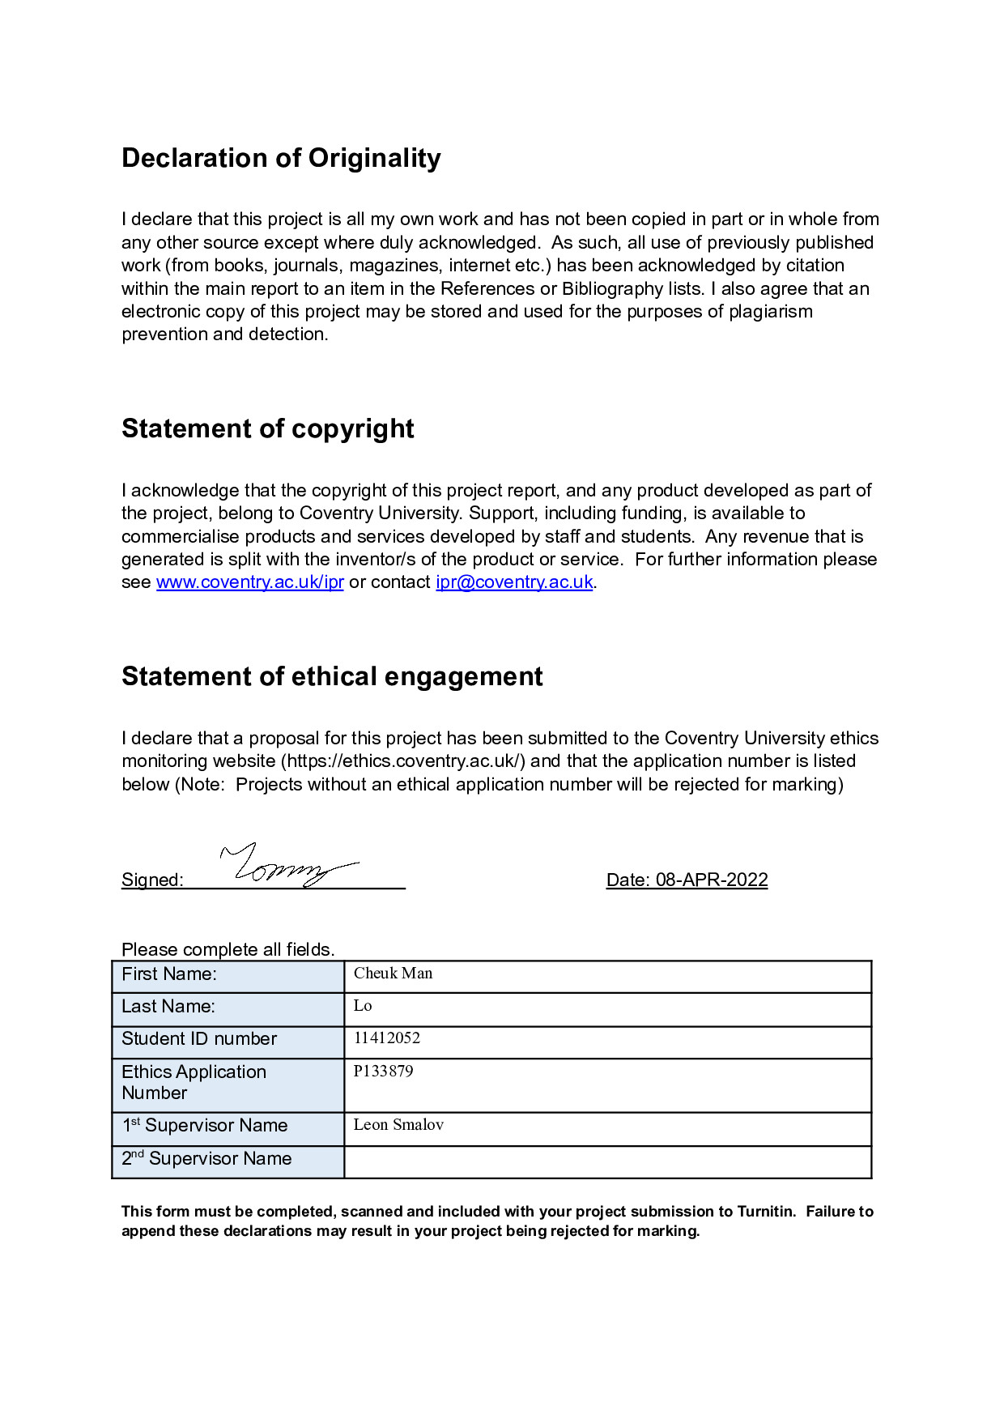

Signed: Date: 08-APR-2022

Please complete all fields.

| First Name: | Cheuk Man |
| --- | --- |
| Last Name: | Lo |
| Student ID number | 11412052 |
| Ethics Application Number | P133879 |
| 1st Supervisor Name | Leon Smalov |
| 2nd Supervisor Name |  |

**This form must be completed, scanned and included with your project submission to Turnitin. Failure to append these declarations may result in your project being rejected for marking.**

# Abstract

# 

Currently, most of the cinemas have and only have provided their information online within their own website or their own application. Those websites or apps also appear to not have any review/comment section or rating system and only have a brief description for the movies. So in order to find any detailed information for a specific movie, users will have to read through many different websites to find the showtime of the movie in different cinemas or to find reviews and ratings for the movie.

In order to solve this problem, I will build a web-based cinema booking system where users can use the system to do many things related to movies and cinemas such as searching for details of movies and cinemas, leaving comments and ratings of movies and booking seats in cinemas.

The goal of the system is to provide an all-in-one cross-cinema website with a home page, login/register function, search function, details page(including a comment section and rating function) and a booking function in it so that movie lovers can use to do all kinds of things that are movie-related online at once without the need of hopping through different websites.

# Introduction

## Aims and objectives

The aim of the work described in this report is to provide a web-based cinema booking system with which users can use it to do things such as searching for details of movies and cinemas, leaving comments and ratings of movies and booking seats in cinemas.

The problem with existing movie related websites and applications is that most of the cinema websites have only provided movie information of their own cinema and do not have any review/comment section or rating system, while the movie review websites only have comment and rating sections that are not sharing the comments and ratings between different review websites. This makes it very annoying when someone wants to do some research before choosing which movie to watch and to book a seat at the cinema as the user will have to surf through different websites in order to do so.

Besides, the cinema industry has already turning down these years deal to the rise of streaming media like Netflix and Disney+. This becomes much worse after the pandemic which cinemas are forced to close during lockdown while streaming media grow drastically as people are staying at home most of the time, leading many cinemas to close down permanently.

Although it is much more convenient to watch movies at home using streaming platforms, there are still people who prefer to watch movies in the cinema because of the atmosphere of cinemas or the feeling of watching a movie with a big screen in general.

So in order to do good for both the movie lovers and the cinemas, I decided to develop an all-in-one cross-cinema website which can help users to do many things related to movies and cinemas, such as searching for details of movies and cinemas, leaving comments and ratings of movies and booking seats in cinemas, without accessing other websites to make it much more convenient for users to use, so that movie lovers can now check information of movie and share their opinions much easier and hopefully attract more people to go watch movies at the cinema to save the cinema industry.

## Brief description of the report

In the following of the report, I will cover the process of how I do the project and the product prototype in four sections, namely Literature Review, Research Methods, Tools and Techniques, System Prototype and Project Management.

For the Literature Reviewsection, I will describe the literature that I have read through and how is it related back to the project.

For the Research Methods section, I will describe the methods of software development that are being used in this project, how I apply those methods when I am developing the system.

For the Tools and Techniques section, I will describe the programming languages and plug-ins as well as the editor that are being used to develop the system and explain briefly the reason why I choose to use those tools for the development of the system.

For the System Prototype section, I will describe the design and the structure of the system prototype and provide guidelines and manuals that explain and teach the user all the functions of the system prototype in detail.

For the Project Management section, I will describe tools and techniques that I use specifically for managing the project development process. I will also describe the work I have done with a brief timeline using the progress report.

# Literature Review

Recently, some of the subjects in the field of cinema have come into prominence more than before. “Digitalization” is one of the subjects in question. Apart from the development and changes of electronic devices, digitalization, which progresses in parallel with the technological developments, also performs as a driving force for change and transformation taking or to take place in the society(Ormanlı, 2019).

## Problem facing

This trend of digitalization also occurs in the movie industry and changing the medium of movies from showing it in cinemas(analog) to broadcasting it on online streaming platforms(digital). Although there are different pros and cons between cinemas and online streaming platforms and that many different issues and conflicts have come up between cinemas and online streaming platforms, the process of digitalization of the whole society will not stop and cannot stop by anyone.

Even though having many issues and problems are needed to be fixed and improved since digitalization is relatively new and immature to the society, the technique of it will improve and enhance and eventually become an overall better option than the traditional way and may as well replace it completely within the next few years.

Yet, there are still some advantages of the traditional way that cannot be surpassed by the digital way when it comes to showing movies such as large scale equipment that improve the watching experience and the overall atmosphere of cinemas. There are also nostalgias of watching movies in the cinema for most of the people which is irreplaceable by online streaming platforms.

## Solution to the problem

So, in order to prevent the movie industry from falling behind in the digital society, actions are needed to be taken for the movie industry to keep up with the digital era.

For example, cinemas and film studios start playing movies exclusively in theaters for anywhere from 12 to 45 days before jumping to digital platforms after the pandemic to test if this would help cinemas to survive and also for film studios to earn more profit. After a year of trial and error, Hollywood has concluded the theatrical window might not be worth writing off entirely. It’s harder to generate excitement for a film that doesn’t have that kind of exclusivity, and it’s even harder to generate a profit. That’s why most blockbuster hopefuls from major studios are expected to screen in cinemas for an exclusive period (around 45 days for most, but more in some cases and less in others) of time before jumping to streaming platforms or digital rental options(Lang, Rubin, 2021).

Also, during the pandemic, the UK Government and governments in the devolved nations put in place a number of measures to support the cinema sector(UK CINEMA association, 2022). Although this support is meant to compensate for the effect of lockdown on cinemas during the pandemic, I think that the sponsorship can be used to support the industry as if other endangered cultures since movie theaters are already part of the childhood memories of many people.

While that being said, it is impossible for an individual like me to solve the problem or even provide a little help using the above methods, so I have to come up with providing help from a different perspective instead. After doing the above research, I found that the main reason that people tend to use online streaming platforms rather than going to the cinema is because of the convenience of online streaming platforms compare to cinemas, so in order to attract people to go to the cinema again, I decided to develop a website to integrate existing movie related websites and applications to make different information of movies become more accessible and convenient to use and hopefully will help to solve the problem that the cinemas are now facing.

# Research Methods

The research method that is being used in this project, in this case the methodology I used to develop the prototype since I am developing a website-based system as the solution to the problem, is the Agile software development.

## Agile software development

Agile is the ability to create and respond to change. It is a way of dealing with, and ultimately succeeding in, an uncertain and turbulent environment(Agile Alliance, 2013). Agile software development includes sets of methodologies and frameworks such as Scrum, Kanban, Extreme Programming, Dynamic Systems Development Method, Crystal Methods, Feature-Driven Development, etc., to help to develop a system with high quality maintainable code within a short period of time and on a low budget.

The agile methodologies I used to develop the system are Scrum, Kanban and Extreme Programming.

### Scrum

Scrum is a lightweight framework that helps people, teams and organizations generate value through adaptive solutions for complex problems. In a nutshell, Scrum requires a Scrum Master to foster an environment where: A Product Owner orders the work for a complex problem into a Product Backlog. The Scrum Team turns a selection of the work into an Increment of value during a Sprint. The Scrum Team and its stakeholders inspect the results and adjust for the next Sprint. Repeat the steps(Schwaber, Sutherland, 2020).

Since Scrum is originally designed for teamwork, I alter it slightly so that it can fit in my development cycle, which I will explain in detail in the project management

section.

### Kanban

Kanban is a popular Lean workflow management method for defining, managing and improving services that deliver knowledge work. It helps you visualize work, maximize efficiency, and improve continuously. Work is represented on Kanban boards, allowing you to optimize work delivery across multiple teams and handle even the most complex projects in a single environment(Kanbanize, 2021).

In the project, I use a Kanban board as the Kanban method to manage the workflow of the project, which I will also explain in detail in the project management section.

### Extreme Programming

Extreme Programming is an agile software development framework that aims to produce higher quality software and higher quality of life for the development team(Agile Alliance, 2017). Extreme Programming includes methods such as Pair programming, Planning game, Test-driven development, Whole team, Coding standard, etc.

In the project, since I am developing the system by myself instead of developing it as a team which Pair programming and Whole team are not suitable for the project, and I am doing the planning using Scrum and Kanban which Planning game are not suitable, the methodologies of Extreme Programming I used in this project are Test-driven development and Coding standard.

Test-driven development is a workflow that developers use when writing code with test cases before the system is fully developed in order to get quick feedback whether the function you just write works.Further detail on the code testing will be mentioned in the Tools and Techniques section.

Coding standards are a set of guidelines, best practices, programming styles and conventions that developers follow when writing source code for a project. Developers should follow these standards in order to, among other things: keep code maintainable, keep code transparent and readable, and keep code scalable(University of St Andrews, 2016). In this project, I have create a simple githook which helps me to run the linter, formatter and unit testing before I do a commit to the Git repository in order to make the code become more readable and prevent commiting bad code to the Git repository so that I can fix any problem immediately to prevent maintenance problems such as fixing bug in codes that are being written several months before. I also leave some comments between the codes to identify what that code is doing to improve the maintainability of the system.

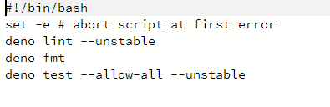

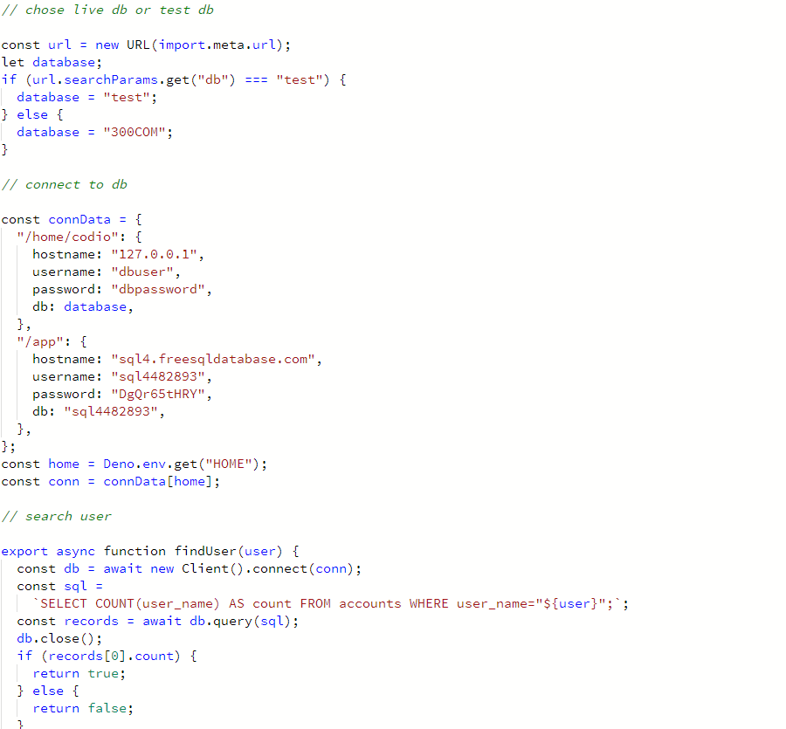

# Tools and Techniques

In this section, I will list all the programming languages and plug-ins as well as the code editor that are being used to develop the system and explain briefly the reason why I choose to use those tools for the development of the system.

## Programming language

Programming language is a notation for writing programs. The syntax of a programming language refers to the structure or form of programs. The semantics of a programming language describes the relationship between a program and the model of computation(Aaby, 2004).

### HTML

HyperText Markup Language(HTML) is the most basic building block of the Web. It defines the meaning and structure of web content. "Hypertext" refers to links that connect web pages to one another, either within a single website or between websites. Links are a fundamental aspect of the Web. By uploading content to the Internet and linking it to pages created by other people, you become an active participant in the World Wide Web(mdn web doc, 2022).

In order to develop a system or program, the first thing we need to do is to decide which Programming language we should use in the project. There are many Programming languages with different pros and cons such as C language which is hard to learn but can do many things that other languages cannot do, Java which is commonly used for developing both Android applications and PC softwares, HTML which is used on web page development, etc.

Among all those Programming languages, I chose to use HTML as the Programming language that I will use to develop a website for the project. The reason for choosing HTML is because among all Programming languages, HTML is the one that I am most familiar with and experienced in. I also just learned some new things on web page development in earlier modules in this course so I want to try those things using this project.

### JavaScript(DENO)

ECMAScript, also known as JavaScript, is a lightweight, interpreted, or just-in-time compiled programming language with first-class functions. While it is most well-known as the scripting language for Web pages, many non-browser environments also use it, such as Node.js, Apache CouchDB and Adobe Acrobat. JavaScript is a prototype-based, multi-paradigm, single-threaded, dynamic language, supporting object-oriented, imperative, and declarative (e.g. functional programming) styles(mdn web doc, 2022). Since JavaScript is a client side language, which means that it is run on the user’s computer, Ryan Dahl has developed a server side version of JavaScript which is Node.js and Deno(an updated version of Node.js that was released in 2018).

After deciding to use HTML as the Programming language to use in the project, the next thing I need to do is to decide which Scripting language I should use to do the back-end stuff for the web page. So the choice of Scripting languages for the web page that I am considering to use are JavaScript and PHP which I have previous experience in and Python which I am completely new to but is easy to learn.

So, after balancing the risk of learning a new Programming language and using it immediately in a project and the benefits of learning new things, I decided to use JavaScript as the Scripting language for the web page. The reason of choosing JavaScript is that for PHP, I am already familiar and well experience in it and have not thing big to learn to use, while for Python, even though it is known as a easy to learn language, I am still not sure if I can learn how to use it to the extent for finishing this project in time. Besides, the last time I developed a website, I am still using JavaScript 5 and Node.js. So, by using JavaScript and DENO as the Scripting language, not only can I minimize the risk of learning new things, but I can also learn how to use stuff that are new in JavaScript 6 and DENO.

## Source code editor

A source code editor is a text editor that is specialized in writing software. A source code editor may be a stand-alone program or part of an integrated development environment (IDE). They make writing and reading the source code easier by differentiating the elements and routines so programmers can more easily look at their code(PCMag, 2013).

### Codio

Codio is a website-based system which aims to deliver a teaching and learning experience that stimulates this creative potential in every student, developing the next generation of creators, not just consumers(Codio, 2011). Codio can let users start projects within Linux servers they provide.

After choosing all the languages I am using in the project, the next thing to do is to choose what source code editor I should use. There are many different source code editors that do different things and are used to develop different programs. For example, Vs code and Notepad++ can be used to develop all kinds of programs, Unity is used to develop games, Android Studio is used to develop Android applications, Dreamweaver is used to develop web pages, etc.

The reason that I choose to use Codio is because that it can provide an online Linux server for my project. Since I am doing a live website that is supposed to be accessible to anyone at any time, I will need to host the website on a server in the first place. As most of the web hosting platforms on the Internet are using Linux as their server’s operating system, in order to test the code locally before pushing the system to the web hosting platform, I will first need to set up a local webserver to host and test the website.

Normally, since I am running a Windows operating system on my computer, I will have to deploy a virtual machine running a Linux operating system and set up the local server in the virtual machine, however, by using Codio, not only can I use the Linux server that is set in the Codio server and host the local webserver in Codio, but I can also access my code easily using both my desktop and my notebook since my code is on an online server.

## Database

A database is an organized collection of structured information, or data, typically stored electronically in a computer system. A database is usually controlled by a database management system. Data within the most common types of databases in operation today is typically modeled in rows and columns in a series of tables to make processing and data querying efficient. The data can then be easily accessed, managed, modified, updated, controlled, and organized. Most databases use structured query language (SQL) for writing and querying data(Oracle, 2019).

### MySQL

MySQL databases are relational. A relational database stores data in separate tables rather than putting all the data in one big storeroom. The database structures are organized into physical files optimized for speed. MySQL is also open source, which means that it is possible for anyone to use and modify the software. Anybody can download the MySQL software from the Internet and use it without paying anything. If you wish, you may study the source code and change it to suit your needs(MySQL, 2012).

Because my website needs to store and process data, I will need to choose what database I am going to use in the project between MS SQL Server which integrates well with Microsoft’s stuff, Oracle which has great scalability, SQLite which usually being used on smartphones and MySQL which is open source and popular.

I choose to use MySQL for the project is because it is open source and is popular. For my website, since I am hosting a local version of the website and a live version of the website, I will need to choose a database that can be used on both servers. First, MySQL being open source means that I can use it for free in my local testing server. Second, MySQL as an open source popular database means that there will be many free to use online database hosting services for me to use for the live website.

## Template

A template is a document typically HTML with embedded markers which are replaced, manipulated, or evaluated via a template engine API to produce an output document. A Template View uses a template to implement the View portion of the Model View Controller pattern(phpwact, 2012).

### Handlebars

Handlebars is an extension to the Mustache templating language. Handlebars provides the power necessary to let you build semantic templates effectively with no frustration. Handlebars compiles templates into JavaScript functions. This makes the template execution faster than most other template engines(Handlebars, 2019).

Since I need to pass data from the database to the website and passing data from the server to the website using JavaScript is kind of annoying and complicated, I decided to implement a template in the website to help handle the data. I have to choose between several popular templates such as Mustache, Handlebars, EJS, doT.js, Nunjucks, etc.

I choose to use Handlebars as the template for the website as it is the only one template that I have used so far and the performance of it was pretty well according to my previous experience.

## Style sheet

Style sheets represent a major breakthrough for Web page designers, expanding their ability to improve the appearance of their pages. As people from wider walks of life discovered the Web, the limitations of HTML became a source of continuing frustration and authors were forced to sidestep HTML's stylistic limitations. These techniques include: Using proprietary HTML extensions, Converting text into images, Using images for white space control, Use of tables for page layout and Writing a program instead of using HTML(W3C, 2001).

### CSS

Cascading Stylesheets(CSS) is used to style it and lay out the structure and semantics of your content defined by HTML. For example, you can use CSS to alter the font, color, size, and spacing of your content, split it into multiple columns, or add animations and other decorative features(mdn web doc, 2015).

Since I am developing a website, Style sheets are needed for obvious reasons, to make the website more readable and improve the user experience of the website.

The reason that I choose to use CSS for my project is because CSS is the only language I know that can use to style HTML so I have to use CSS for my website.

## Website hosting platform

A web hosting service is a type of Internet hosting service that hosts websites for clients, i.e. it offers the facilities required for them to create and maintain a site and makes it accessible on the World Wide Web. Companies providing web hosting services are sometimes called web hosts(Wikipedia, 2021).

### Heroku

Heroku is a cloud platform for Ruby, Node.js, Python, Scala, Clojure, Go, PHP, and JVM-based applications. It features Git-based, GitHub, and API deployment strategies, a large number of services offered as add-ons, and a full API(Stack Overflow, 2016).

Since my goal of the system prototype is to create a live website, I need to find a server to host the live website. Since hosting a live web server will take me a lot of extra effort and I will have to keep my computer on all day, I decided to host the website using Website hosting platforms. There are many different Website hosting platforms like Bluehost, SiteGround, Cloudways, Google Web Server, Heroku, etc.

I choose Heroku as the Website hosting platform of the website is because I also tried to deploy a website to Heroku in my previous project, but it somehow fail to host the website and since I do not have time to figure out what is the problem back then, I want to try it again this time.

## Software testing

Software testing is the process of evaluating and verifying that a software product or application does what it is supposed to do. The benefits of testing include preventing bugs, reducing development costs and improving performance(IBM, 2019).

### Unit testing

Unit testing is a software development process in which the smallest testable parts of an application, called units, are individually and independently scrutinized for proper operation. This testing methodology is done during the development process by the software developers and sometimes QA staff. The main objective of unit testing is to isolate written code to test and determine if it works as intended(TechTarget, 2019).

Since I am using the Test-driven development method to develop the system, Software testing is needed.

The reason for using Unit testing as the Software testing method is because Unit testing is usually used in Test-driven development.

# System Prototype

## System design

For the system, I set up the website by using the Application module first.

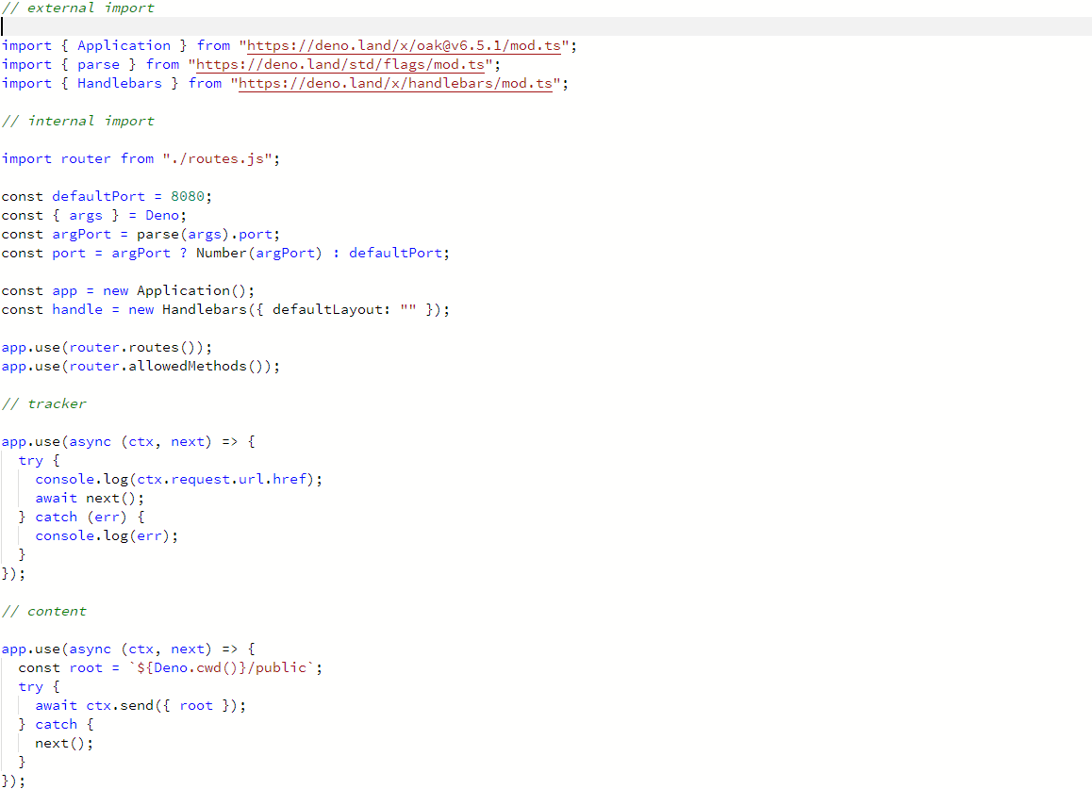

I then import the Handlebars and Router module to render different pages of the website.

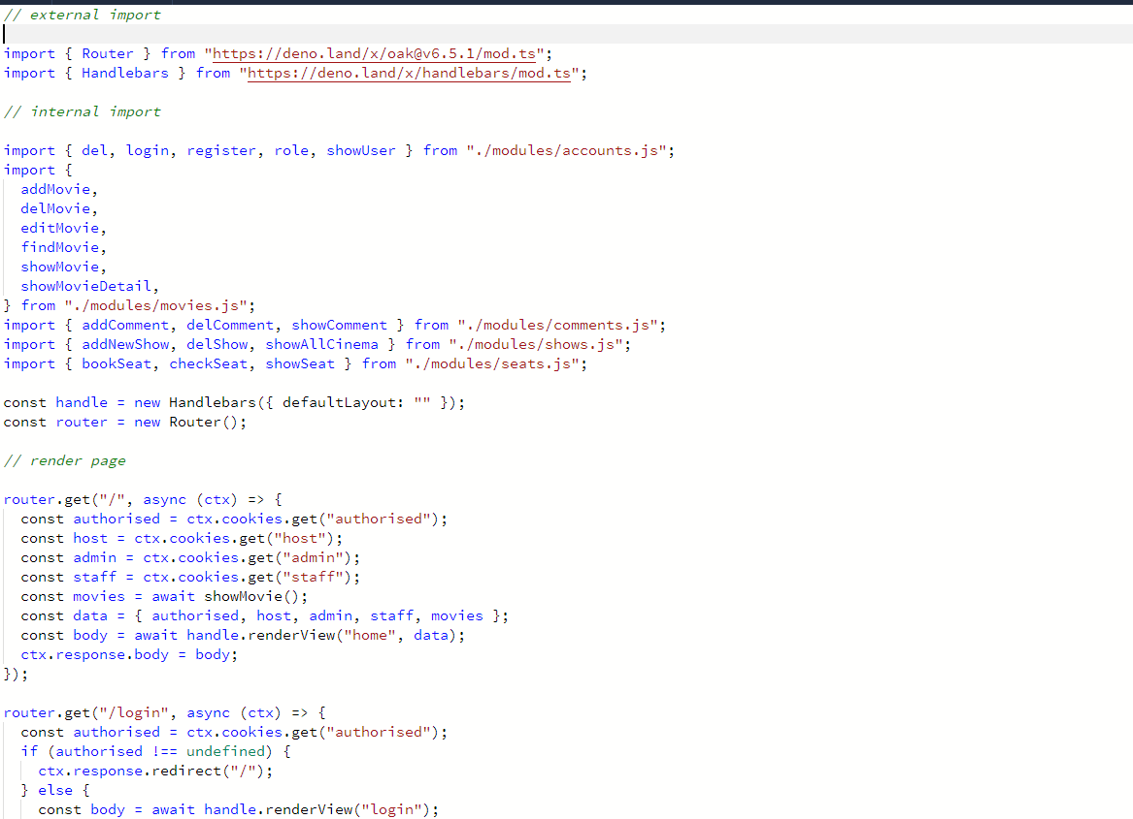

After that, I design the database of the website.

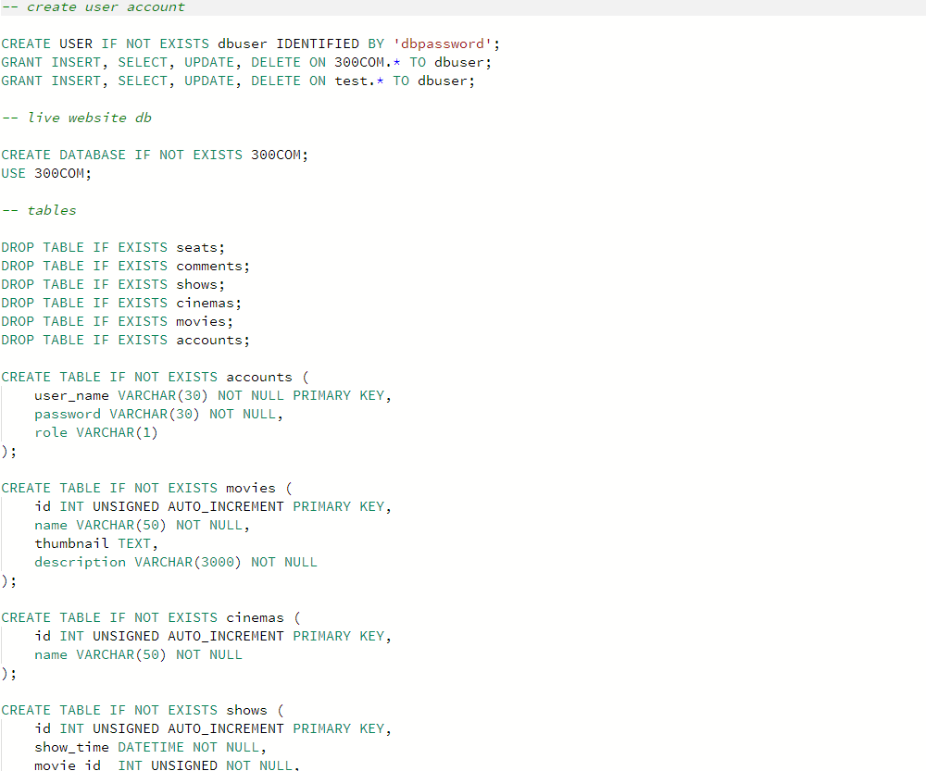

And I follow the Test-driven development to implement different functions to the website.

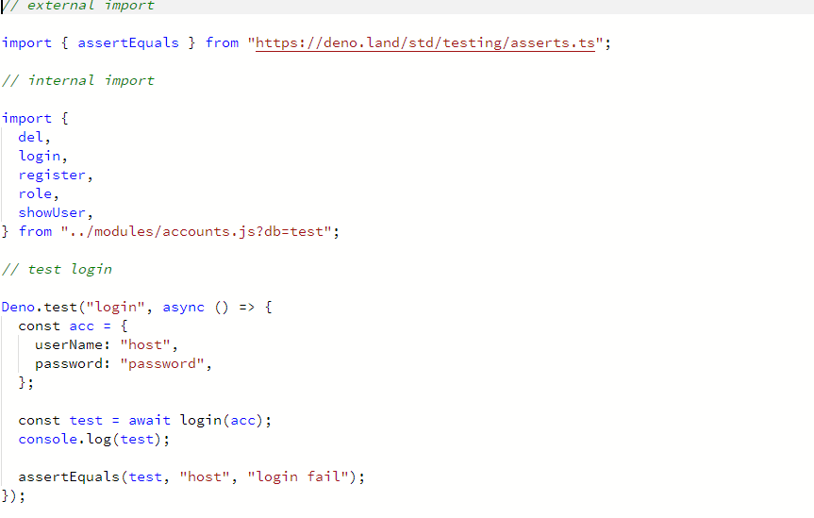

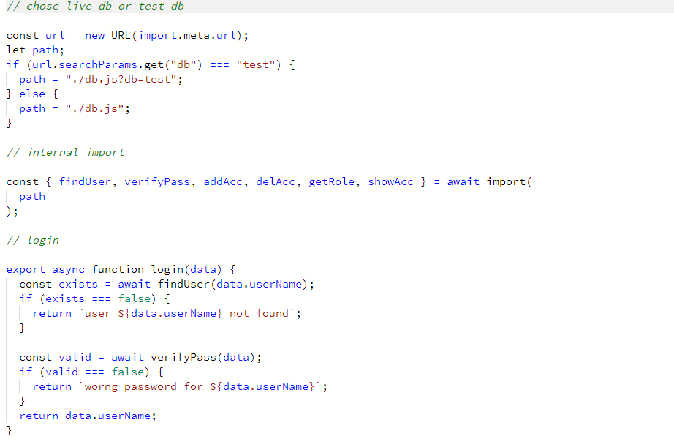

At last, I write the pages for the website.

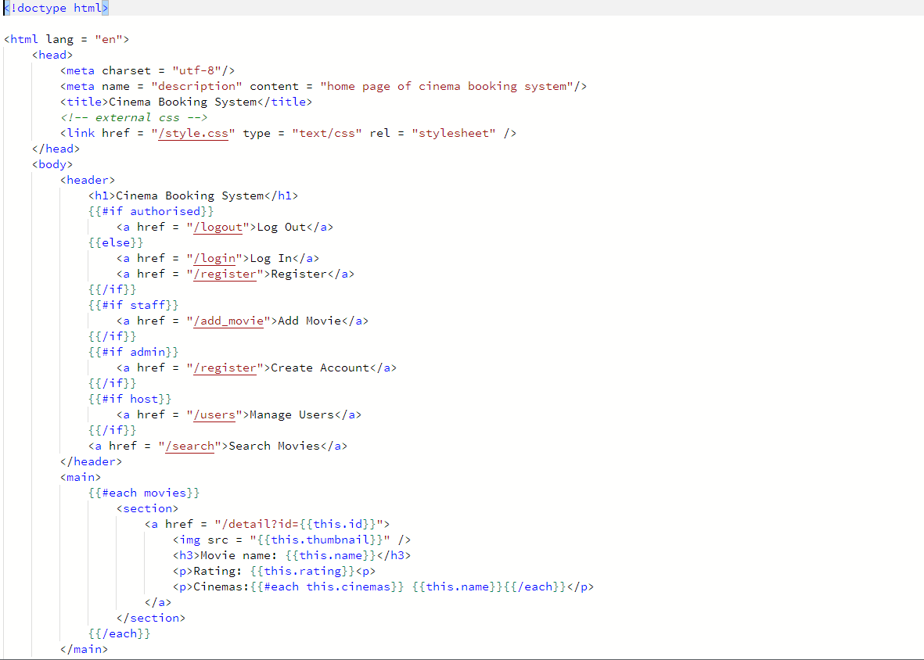

## Guideline

Sample accounts with different roles are added into the database and can be found in the readme file.

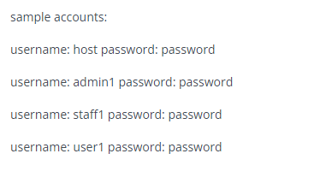

### User manual

Before login, users can see the movie on the home page.

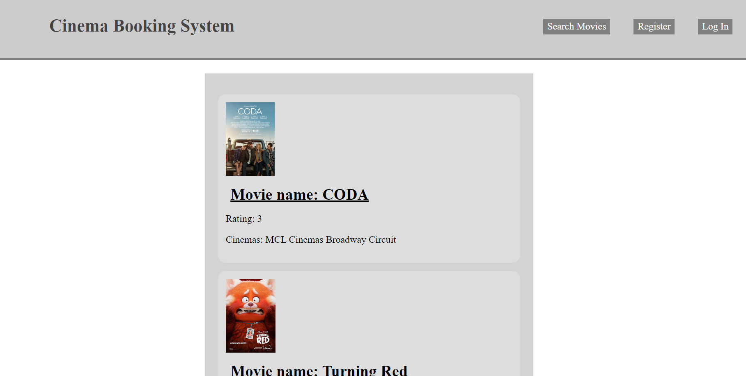

And by clicking the movie name, users can go into the detail page of the movie to see details of the movie, cinemas and show time of the movie, and comments of the movie.

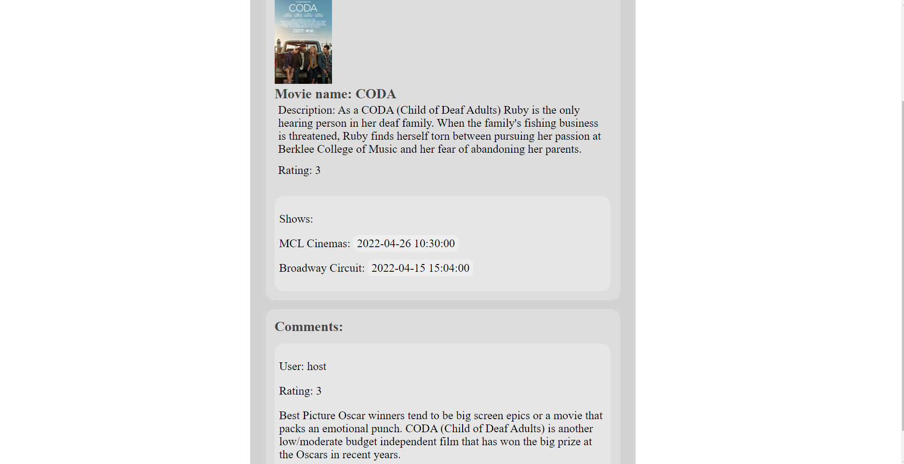

Users can also search movies by clicking the search movie button to search movie by name or by cinema.

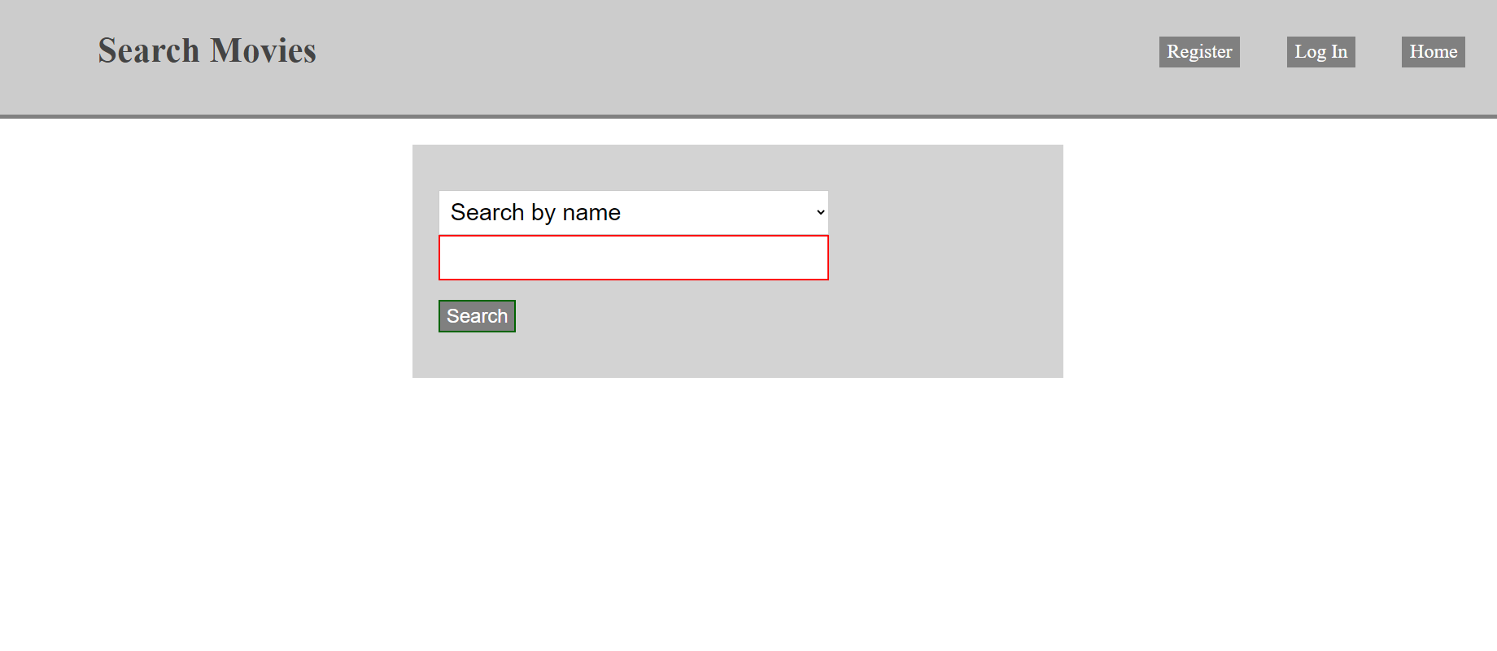

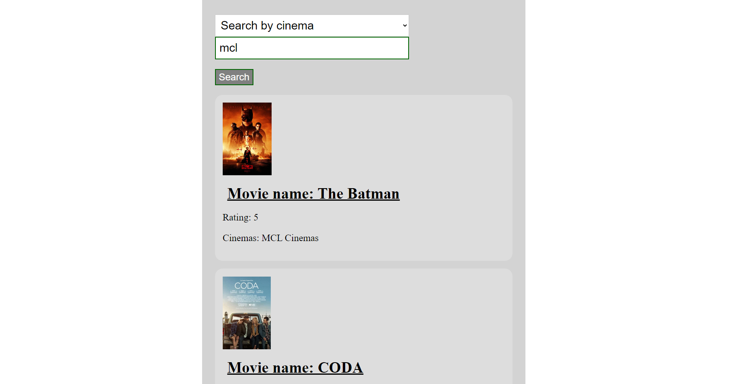

Users can also register an account by clicking the register button and login by clicking the login button after registering an account.

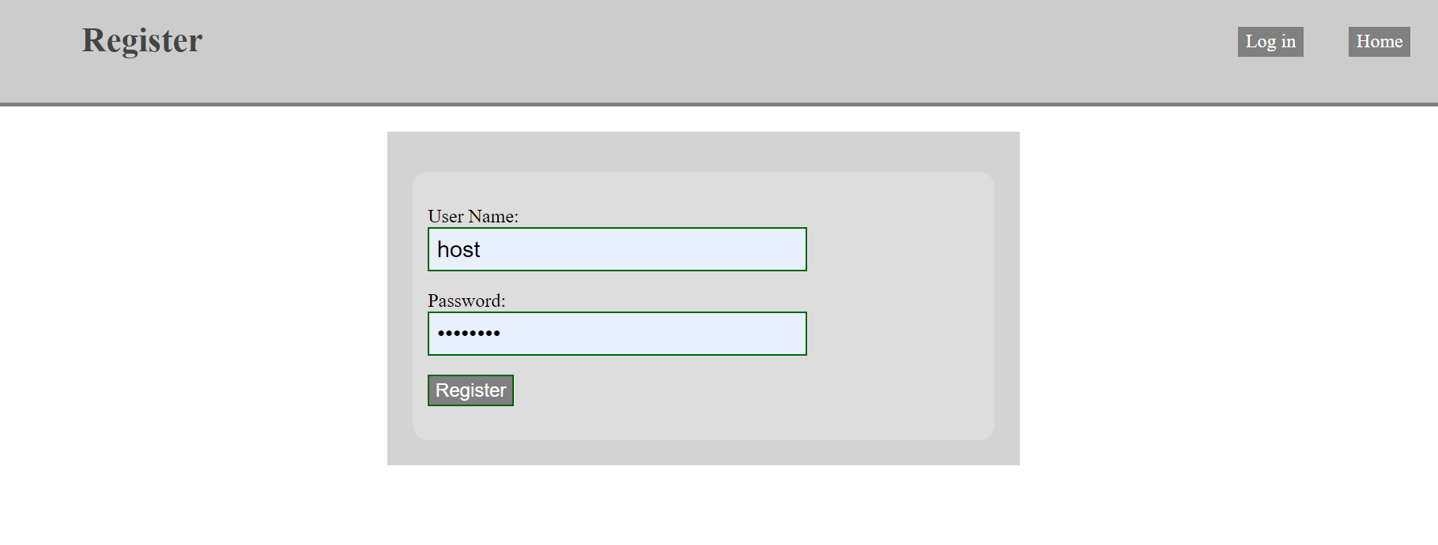

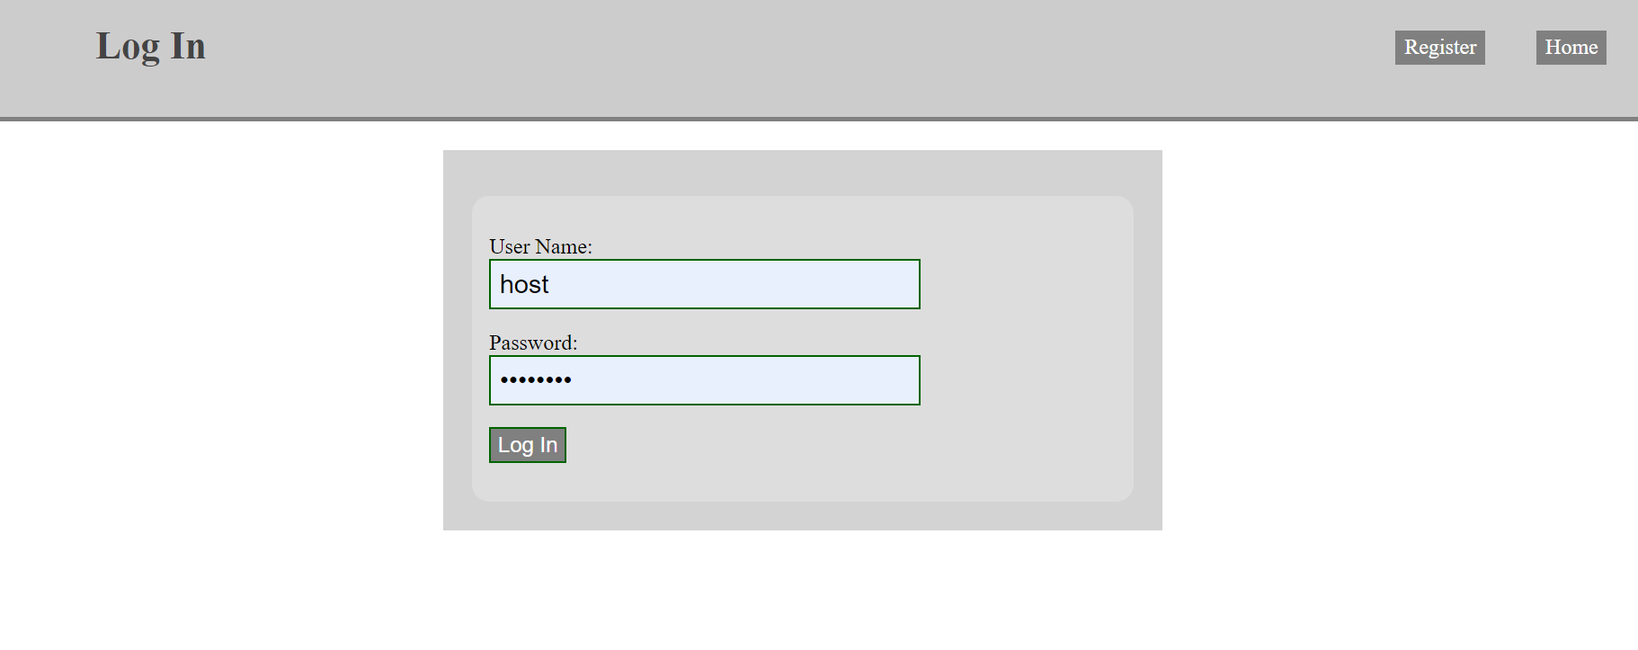

After logging in, users can now leave comments in the detail page.

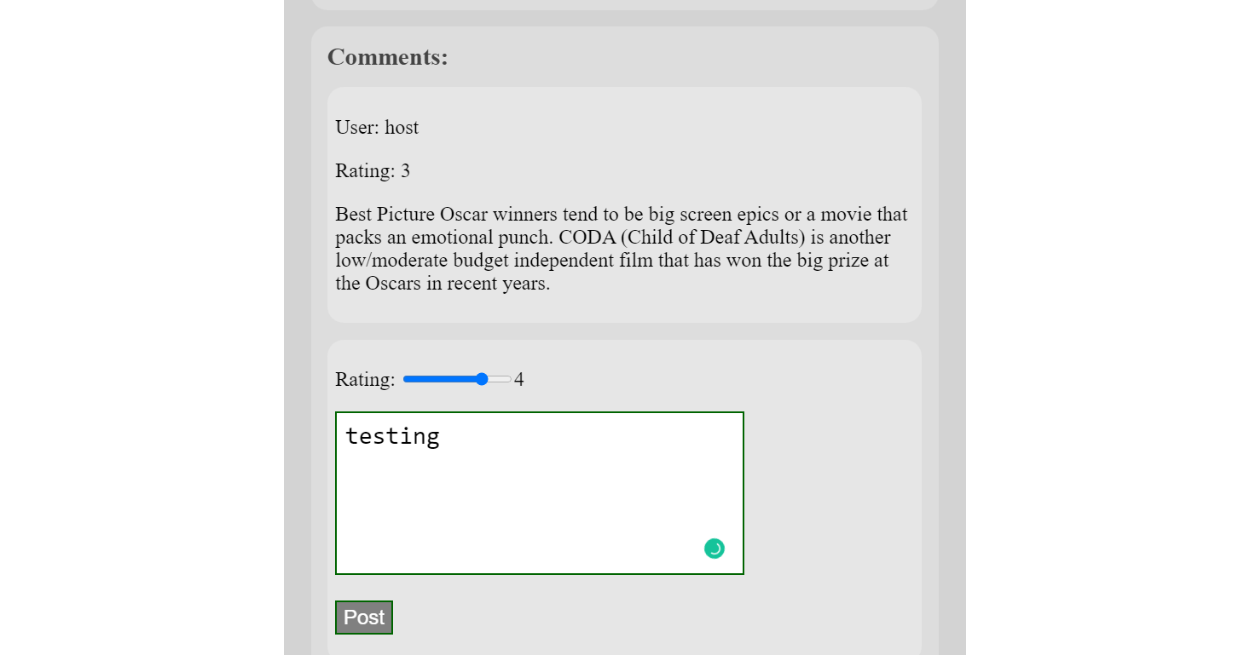

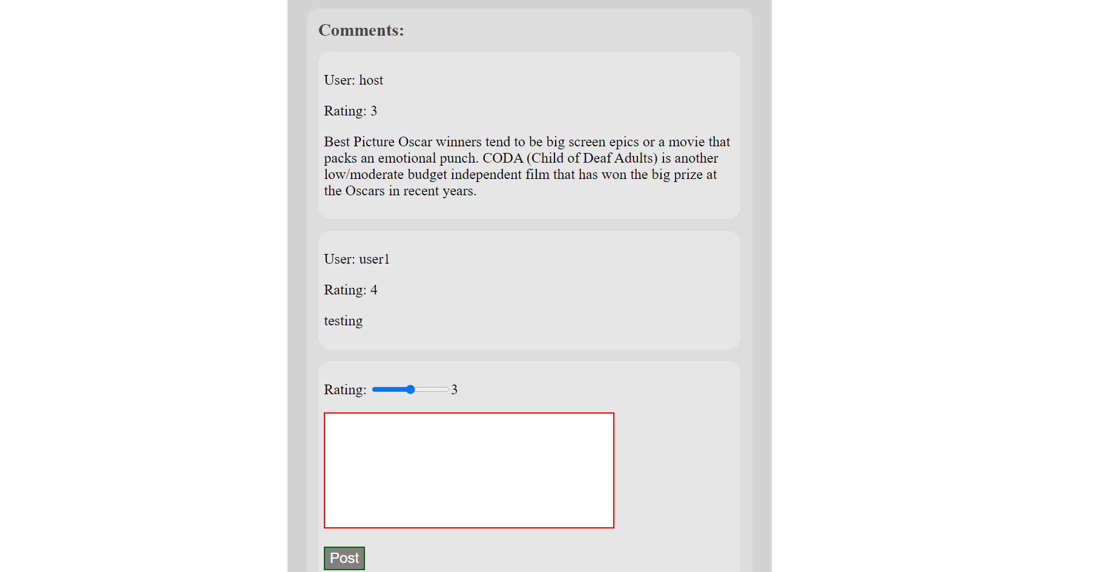

Users can also book seats and cancel booking of the cinema by clicking the show time that they want to book.

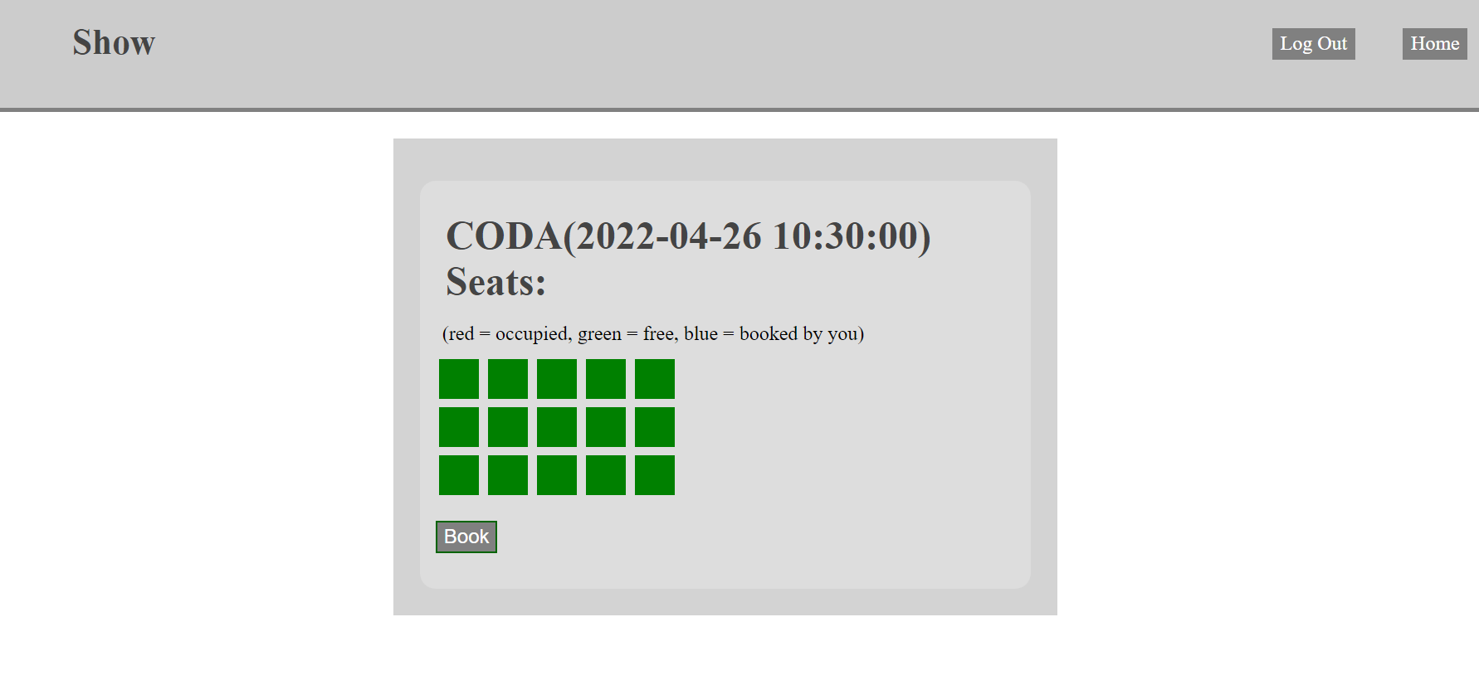

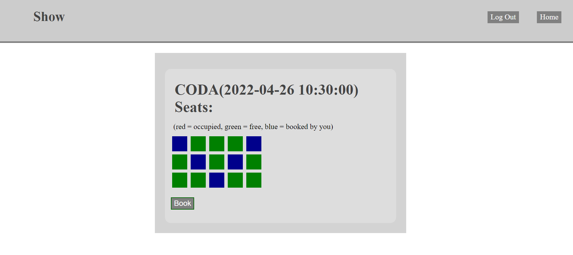

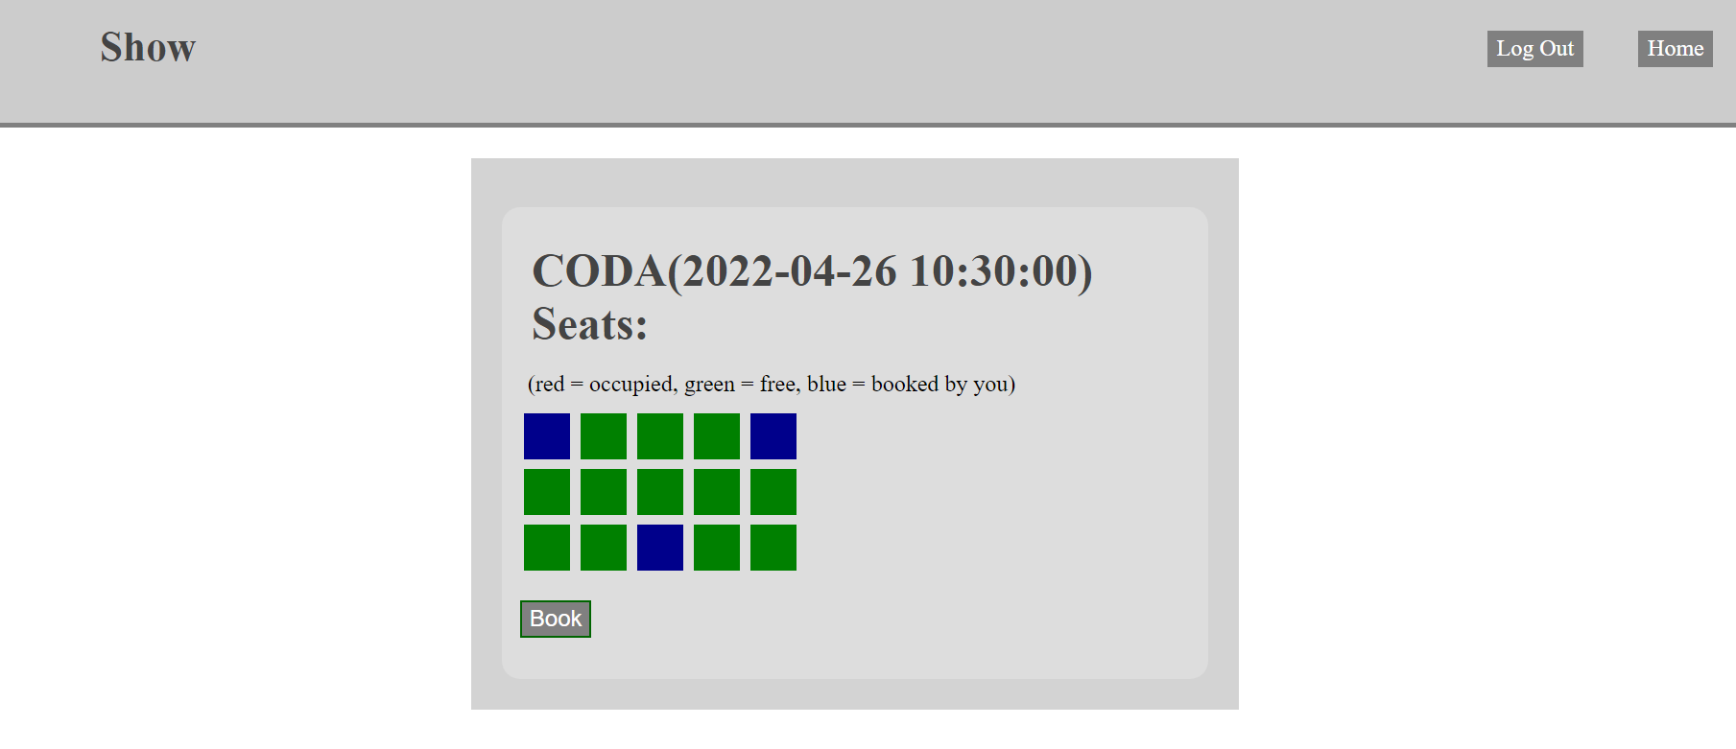

### Staff manual

After logging in as staff, the staff will see an add movie button.

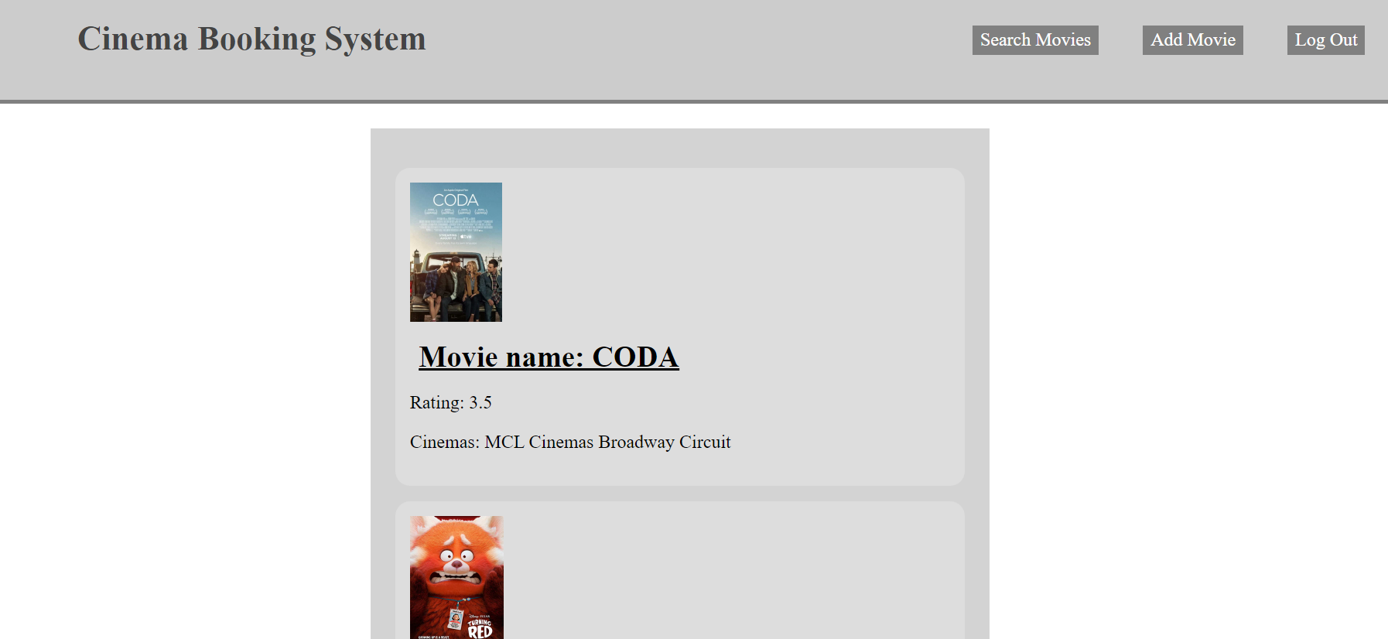

By clicking the add movie button, staff can add a new movie into the system.

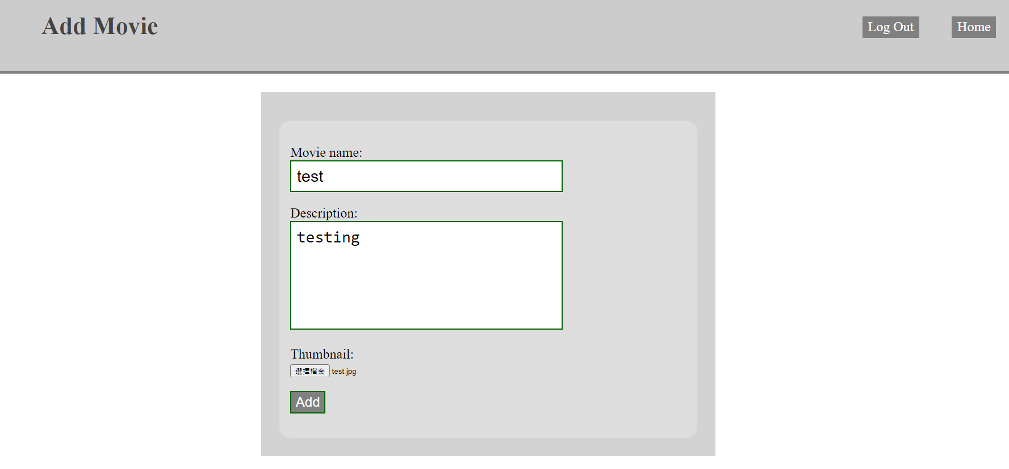

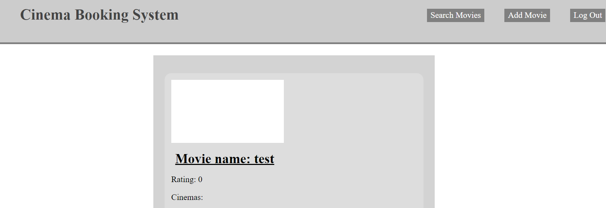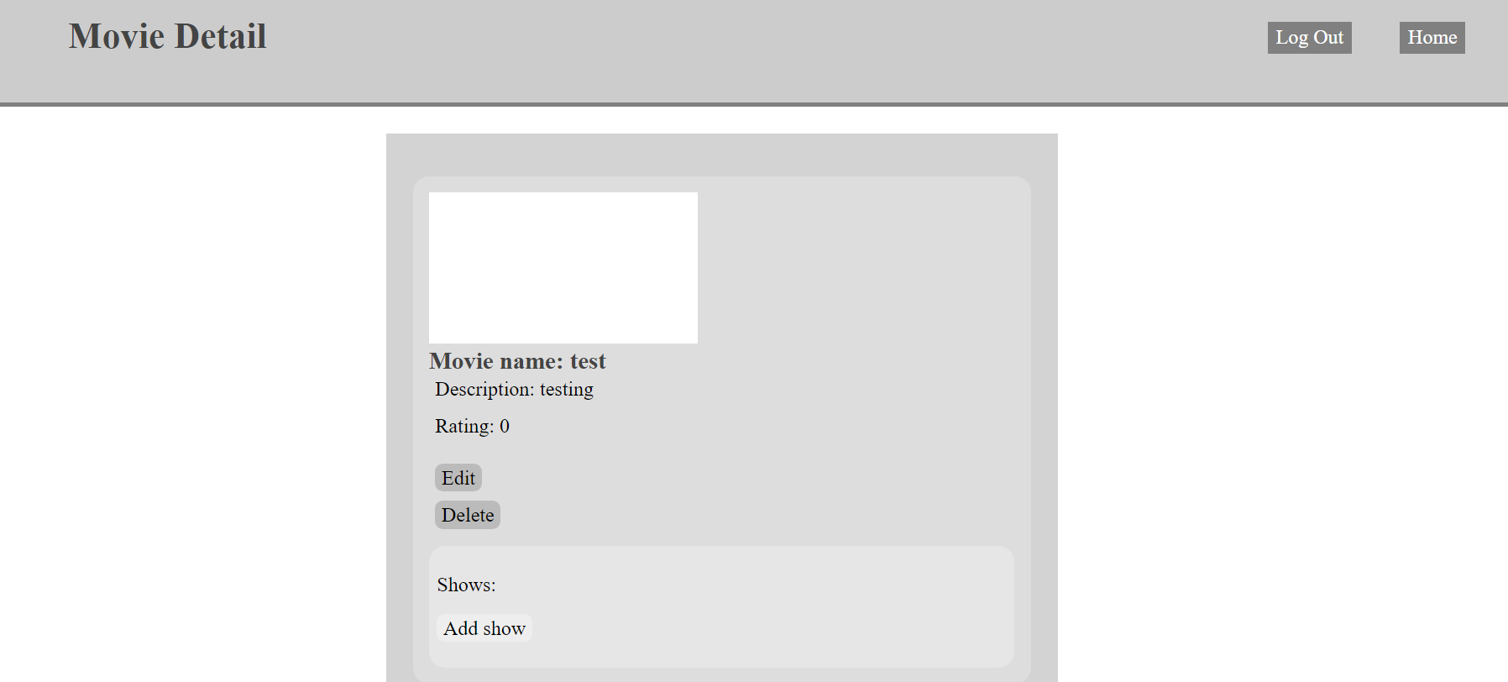

Staff can edit the details of the movie by clicking the edit button.

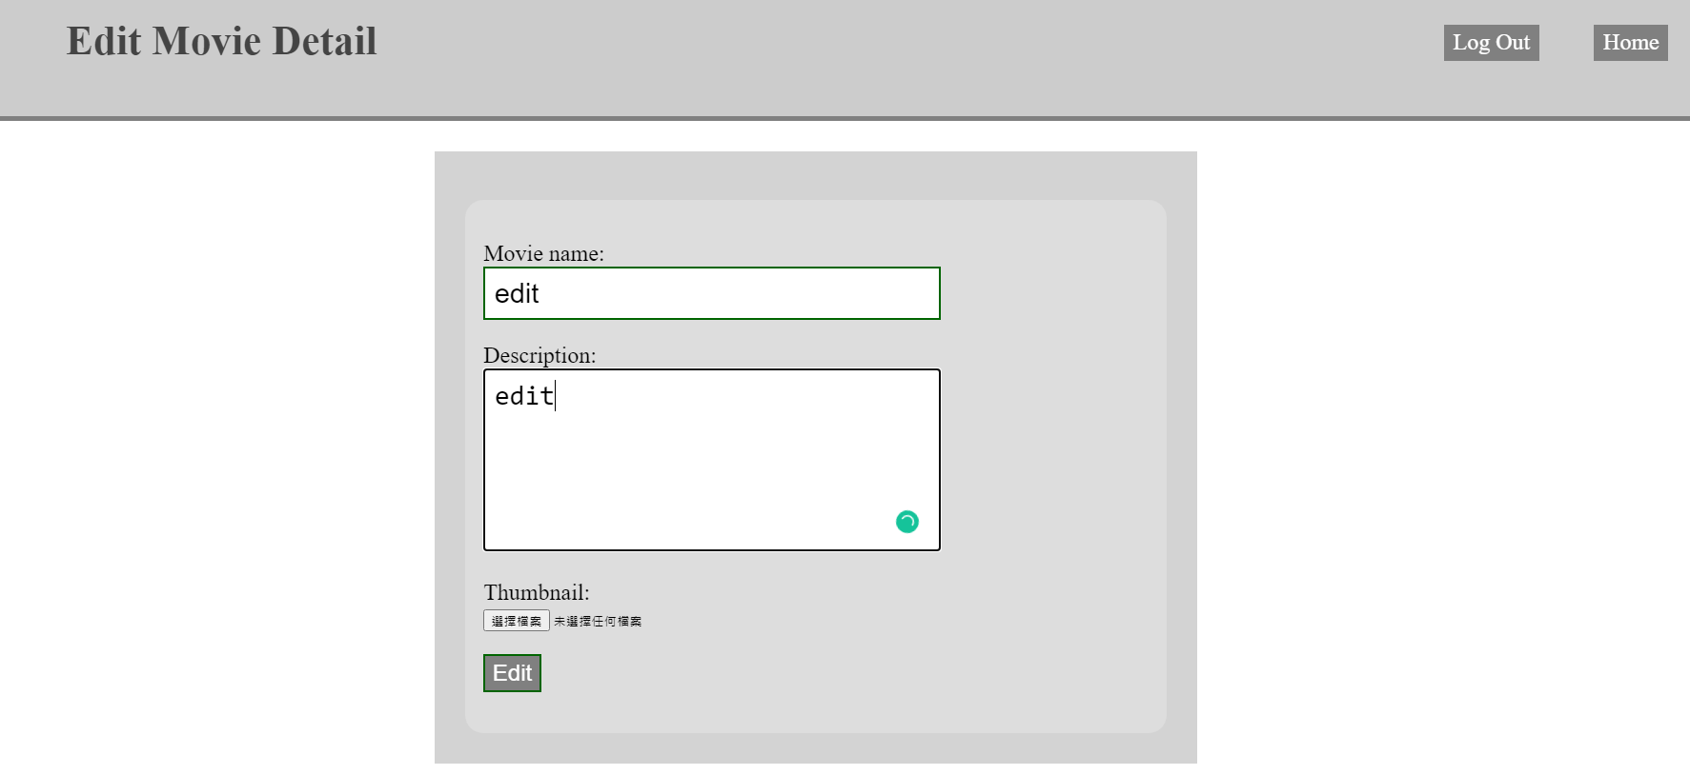.

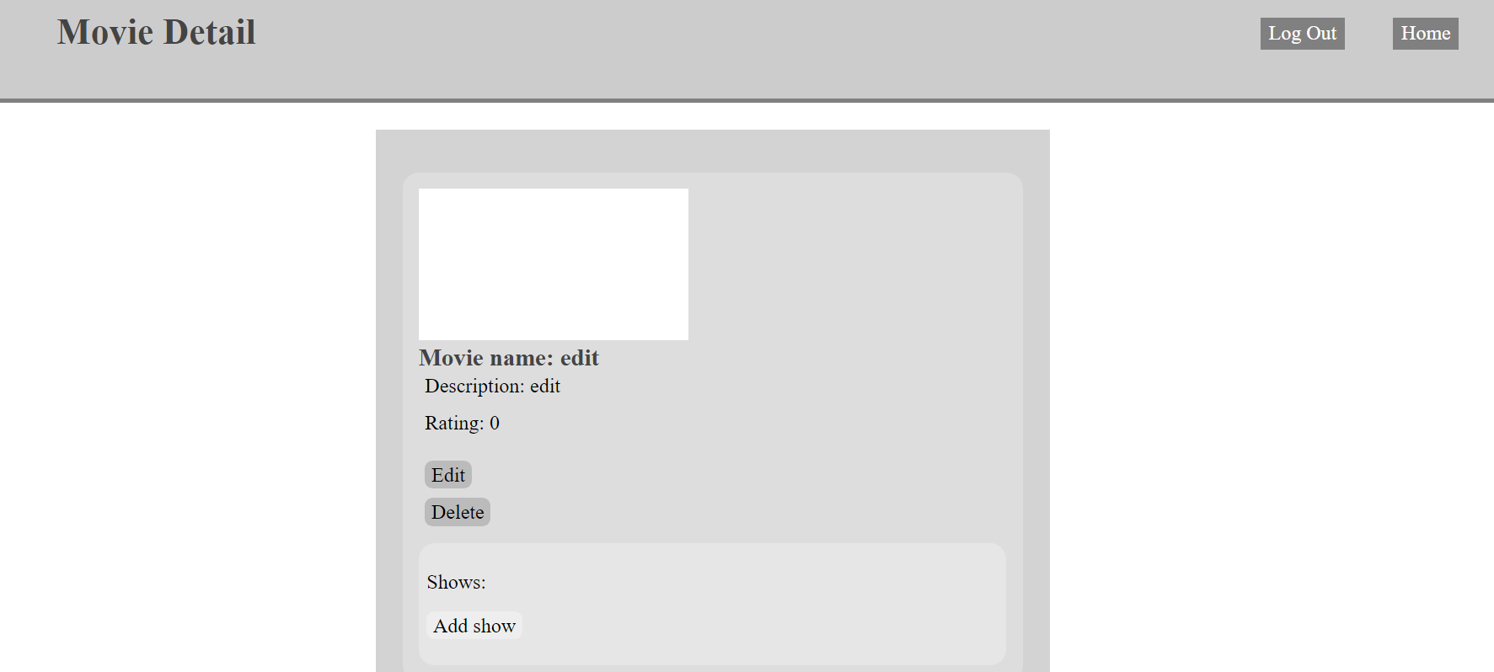

Staff can add a new show to the movie by clicking the add show button.

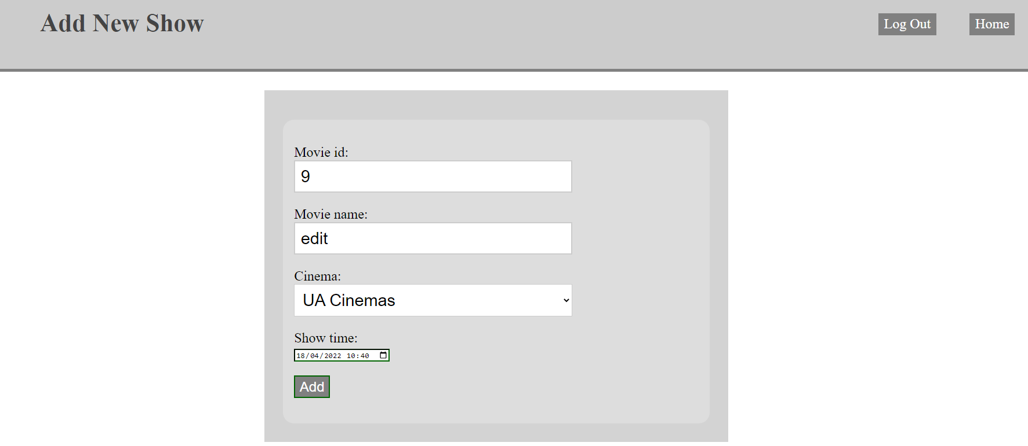

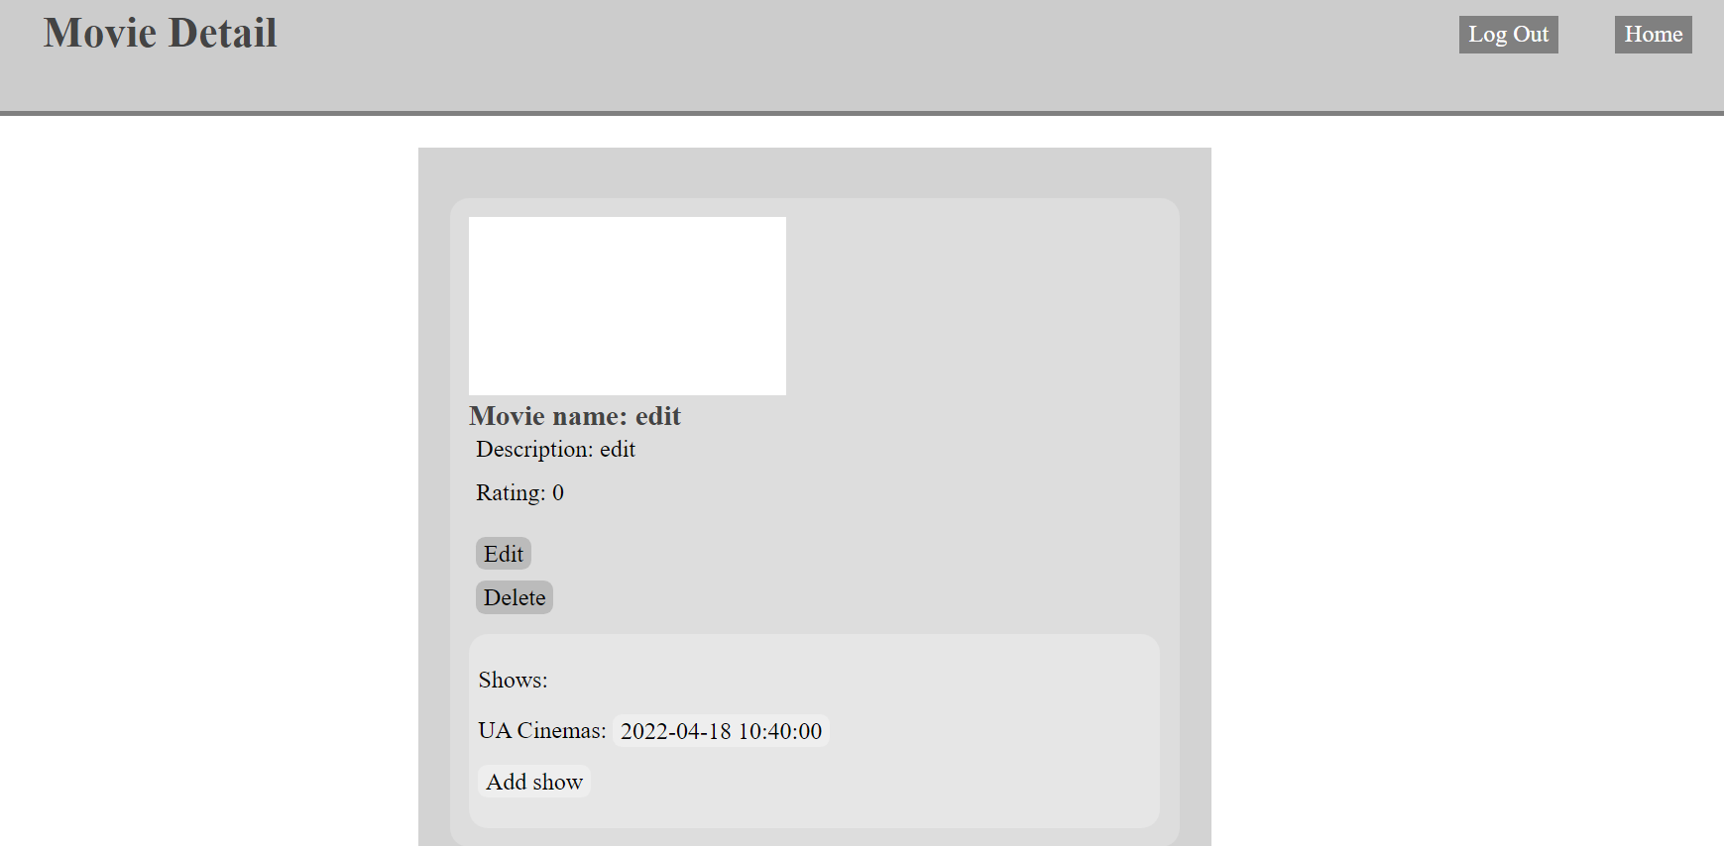

Staff can also delete a show by clicking the show time to go to the show page and click the delete show button on the show page.

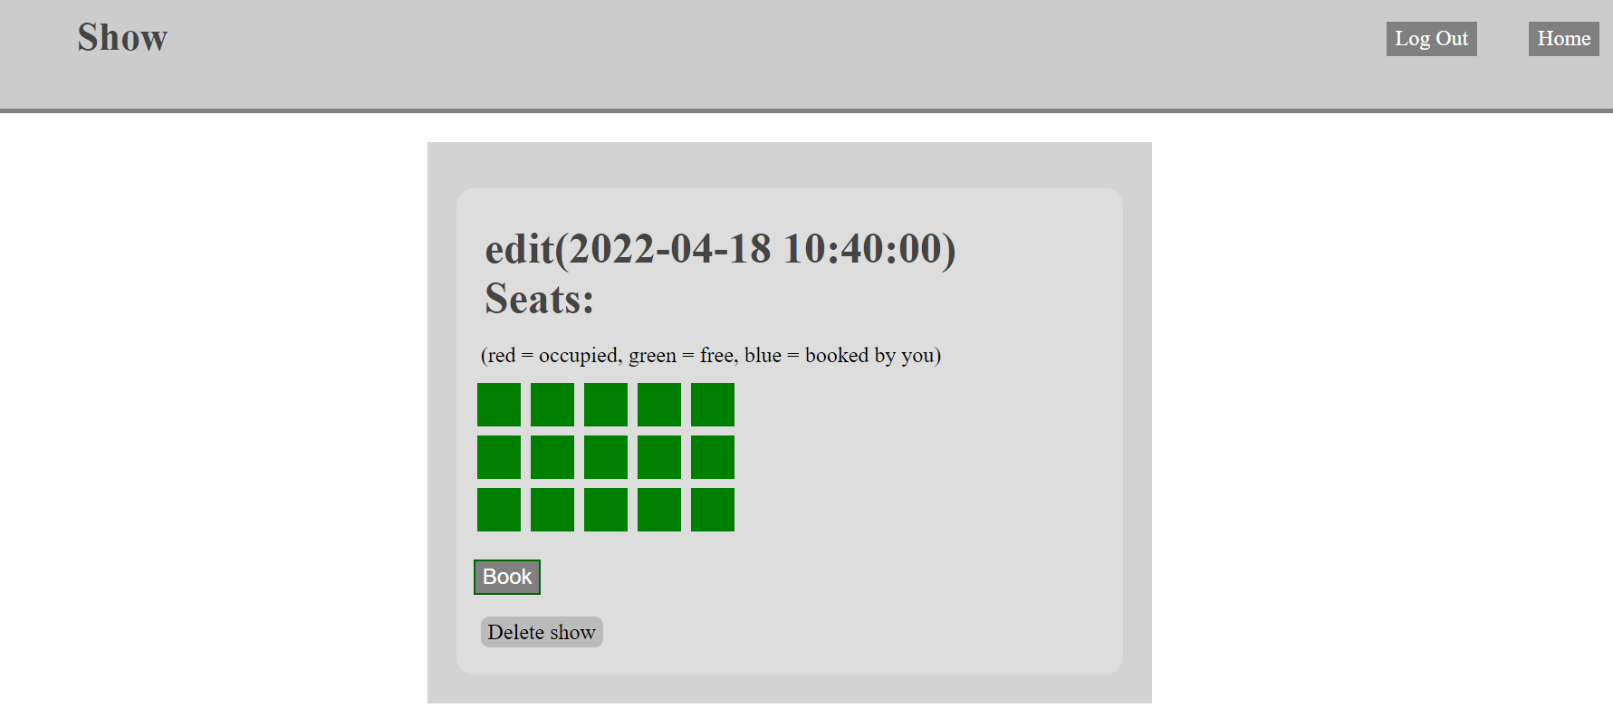

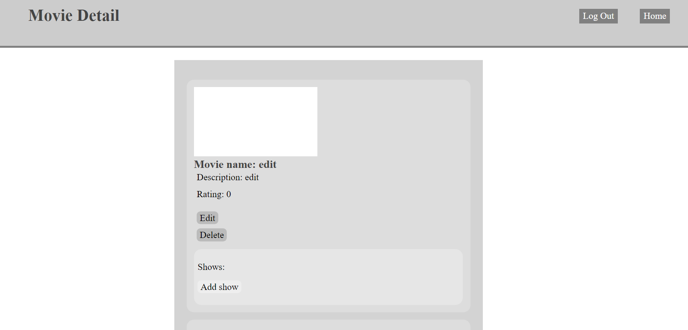

Staff can delete a movie by clicking the delete button in the detail section.

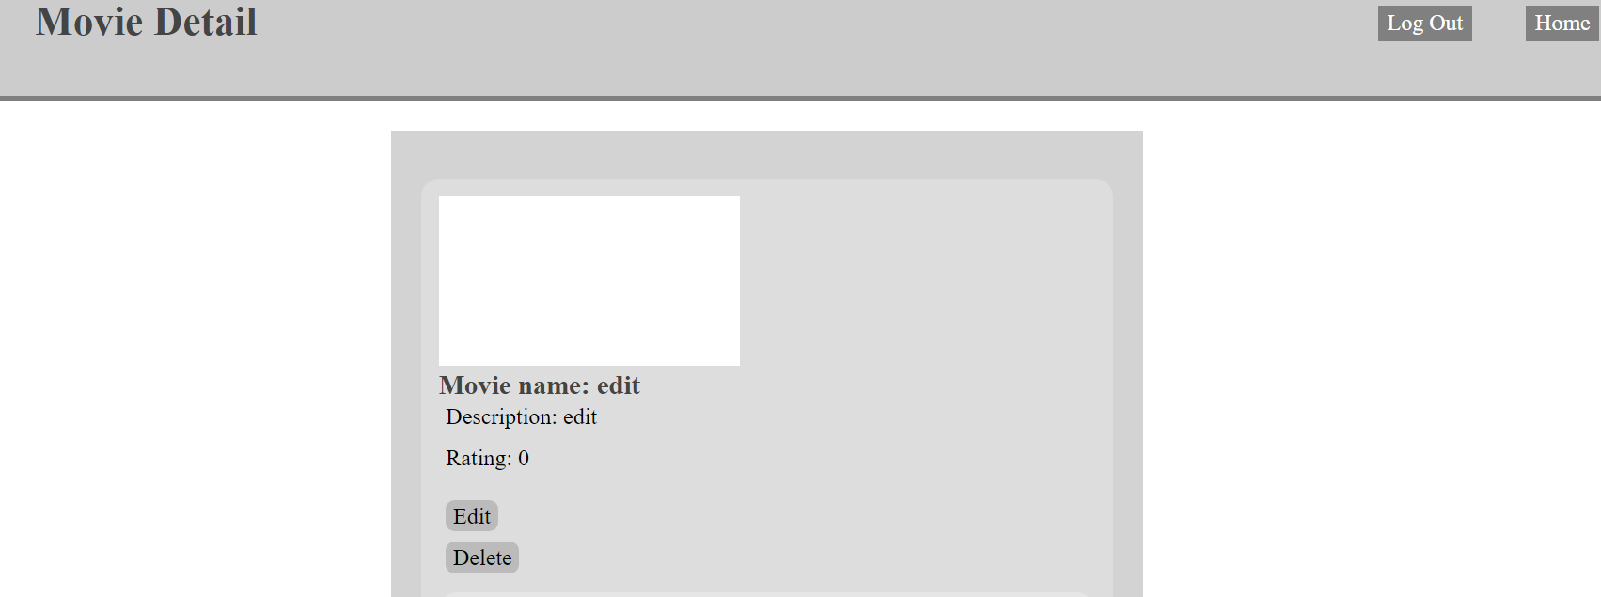

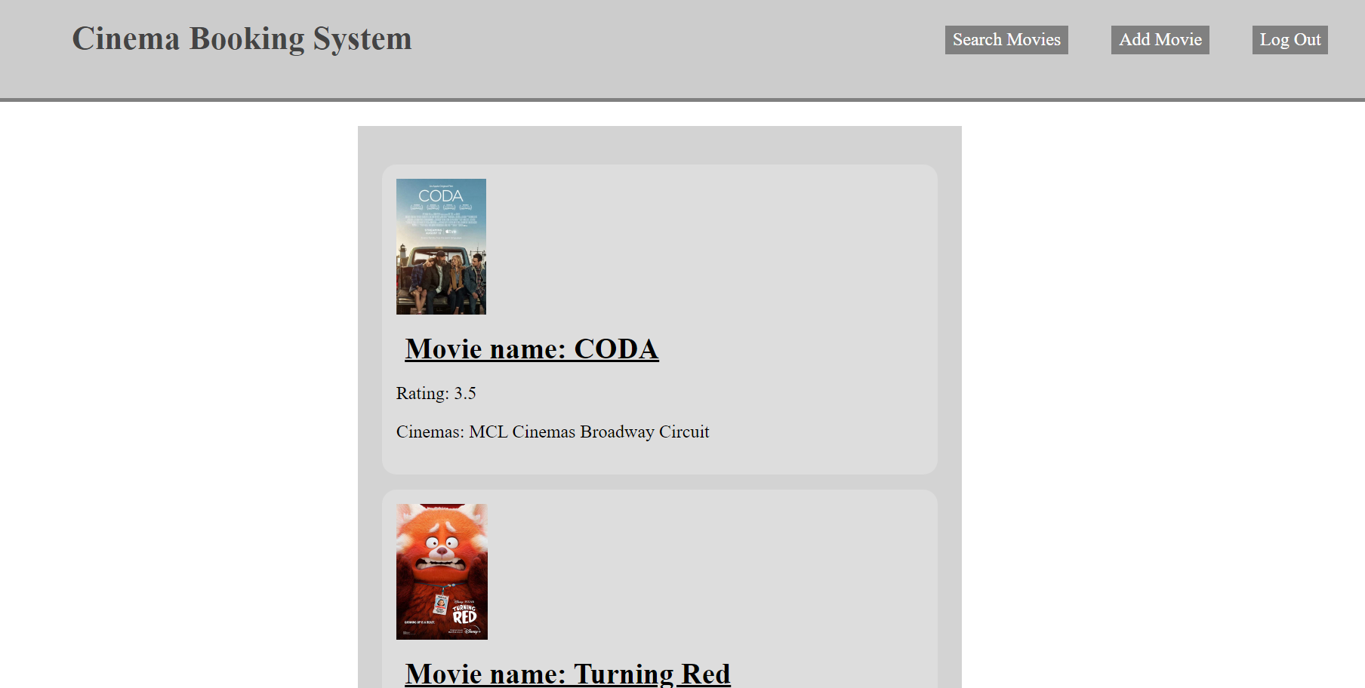

Staff can delete a comment by clicking the delete button in that comment.

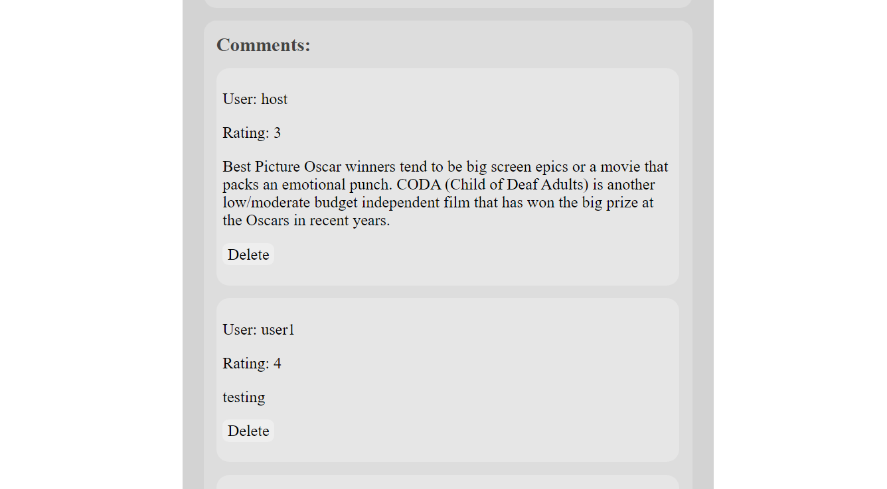

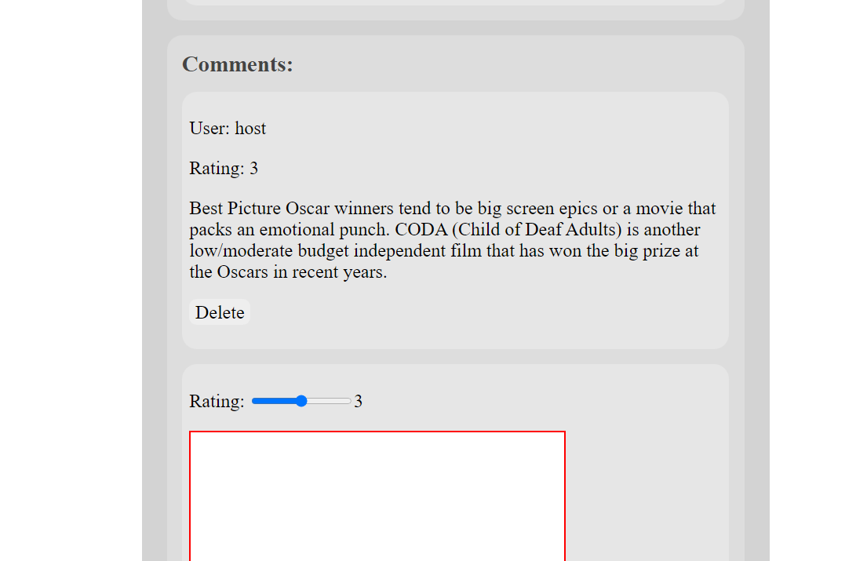

### Administrator manual

After logging in as Administrator, the Administrator can see a create account button.

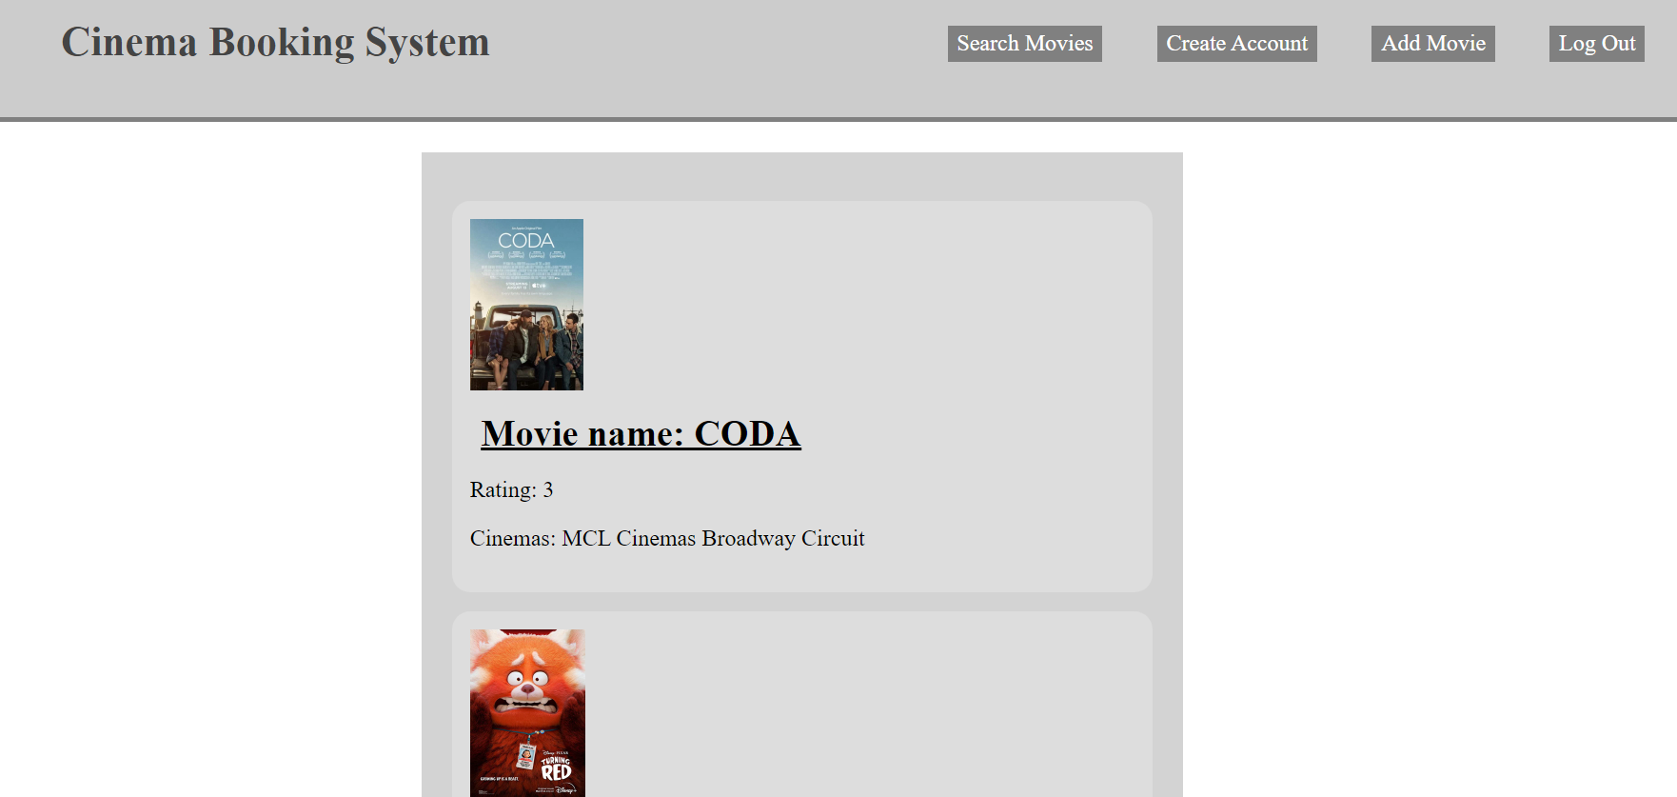

By clicking the create account button, Administrator can create a new staff account.

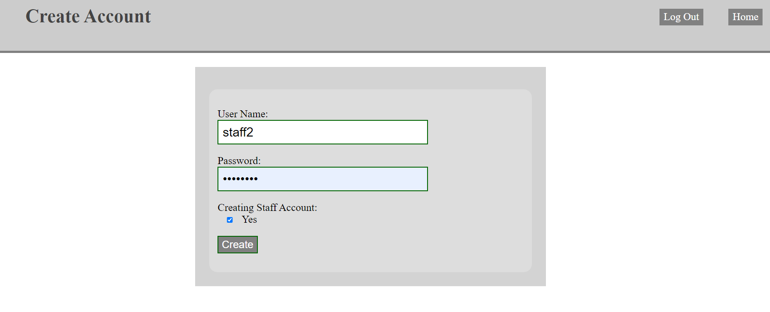

Administrator can also do all the things that staff can do.

### Host manual

After logging in as Host, the Host can see a manage users button.

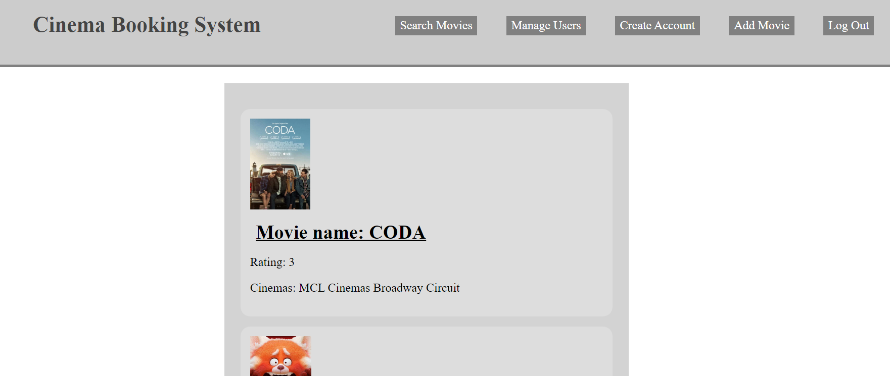

By clicking the manage users button, Host can check the accounts that are in the system.

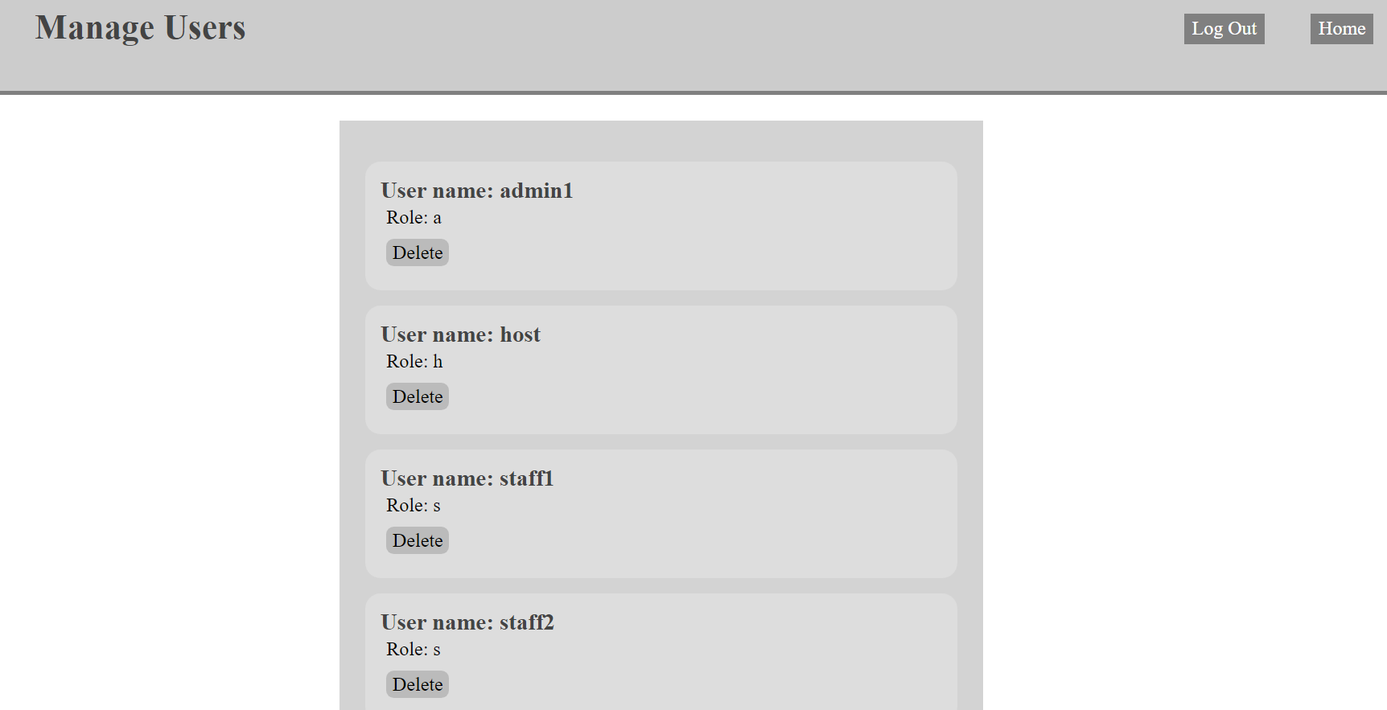

Host can delete accounts in the system by clicking the delete button.

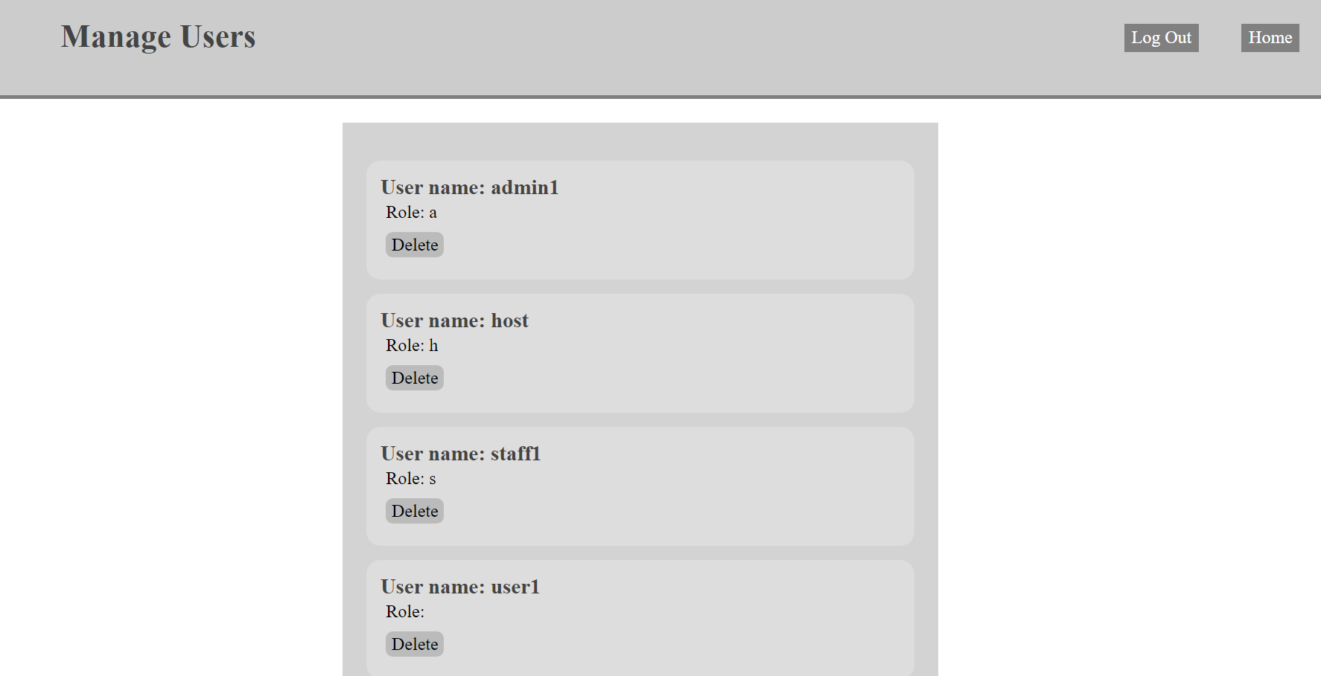

Host can also do all the things that Administrator and staff can do.

# Project Management

## Workflow of the project

As I mentioned in the previous section, I alter the Scrum methods slightly so that it can fit in my development cycle. Basically, I use a Kanban Board(which will explain in detail later in this section) as the Product Backlog and have a weekly Sprint in which I will explain works that I have done this week to the Supervisor, ask questions and take advice from the Supervisor and decide what to do in the next Sprint base on the discussion with the Supervisor. Details of the meeting with the Supervisor are in the progress report(Appendix 6).

## Kanban board

Kanban board, which is one of the tools that can be used to implement kanban to manage work at a personal or organizational level, visually depict work at various stages of a process using cards to represent work items and columns to represent each stage(usually in three columns, To do, In progress and Done) of the process(Wikipedia, 2021).

In the project, I implement a Kanban board through GitHub by setting up issues, which are basically functions or things that needed to be done for the project, and use those issues as the cards to represent work items in the Kanban board and manage the development progress using the Kanban board.

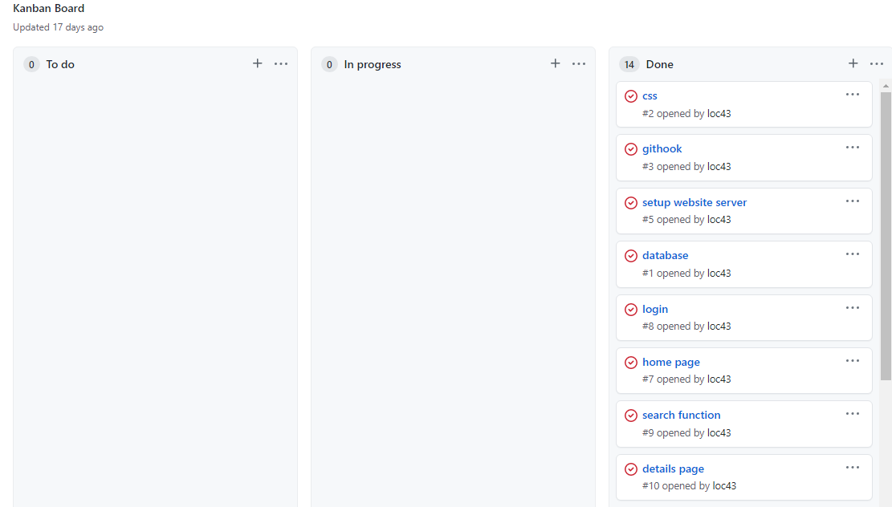

# Conclusion

To conclude, the system that I developed can help users to find movie information, leave comments, and book seats in the cinema, which improves the user experience of people who wanted to do all of the above things in one website instead of hopping through different websites and making it much more convenient for users to use. By doing so, hopefully people using online streaming platforms to watch movies because of its convenience can turn to watch movies in the cinema.References

Ormanlı, O. (2019). Online film platforms and the future of the cinema. *CTC 2019*. <https://d1wqtxts1xzle7.cloudfront.net/61965691/C41720200202-52018-wmwcvt-with-cover-page-v2.pdf?Expires=1650105737&Signature=If~Bl3PEa3fdhoJRHlYrydwJDrrGezOMLFA-Am82iuL5c2MvVC23U2nLxs1z2zSfL3fdZGYWpb3l2fuRATmkTaEgTGd9JHN9~fuVIpO0oEEfuUAlkB~Jl81X1nOxv8w-qYQqKMpxfQy-Vrj2kFhW~Ifvq9oAfy2LfpMhkgAWoZsyWyQYwh641kRv37rT9zOAaioZ20bKAmatGtOzOjoT3QslbvrhQIq6z324Eh7BZiDKEjxzNk0GYlld0pGOAG1~ik5-jLe3uApmUiyR0bMEahS3ywqgST0yJqrpOf~LiVYv8Q6WDqQrBEVKfpaXJF3sdLJJn3z4XewebZcGjHLihg__&Key-Pair-Id=APKAJLOHF5GGSLRBV4ZA#page=242>

Brent Lang, Rebecca Rubin. (2021). How Movie Theaters Fought to Survive (Another) Year of Turbulence and Change. <https://variety.com/2021/film/news/movie-theaters-box-office-2021-pandemic-omicron-1235142992/>

UK CINEMA association. (2022). COVID-19 - support for cinemas. <https://www.cinemauk.org.uk/coronavirus-covid-19/support-for-cinemas/>

Agile Alliance. (2013). What is Agile. <https://www.agilealliance.org/agile101/>

Ken Schwaber, Jeff Sutherland. (2020). The 2020 Scrum GuideTM. <https://scrumguides.org/scrum-guide.html>

Kanbanize. (2021). What Is Kanban? Explained for Beginners. <https://kanbanize.com/kanban-resources/getting-started/what-is-kanban>

Agile Alliance. (2017). What is Extreme Programming (XP). <https://www.agilealliance.org/glossary/xp/#q=~>

University of St Andrews. (2016). Code style and standards guides. <https://www.st-andrews.ac.uk/digital-standards/code-standards/>

Anthony Aaby. (2004). Introduction to Programming Languages. <https://web.archive.org/web/20121108043216/http://www.emu.edu.tr/aelci/Courses/D-318/D-318-Files/plbook/intro.htm>

mdn web doc. (2022). HTML: HyperText Markup Language. <https://developer.mozilla.org/en-US/docs/Web/HTML>

mdn web doc. (2022). JavaScript. <https://developer.mozilla.org/en-US/docs/Web/JavaScript>

PCMag. (2013). Definition of source code editor. <https://www.pcmag.com/encyclopedia/term/source-code-editor>

Codio. (2011). About Codio. <https://www.codio.com/about-us>

Oracle. (2019). What Is a Database. <https://www.oracle.com/database/what-is-database/>

MySQL. (2012). What is MySQL. <https://dev.mysql.com/doc/refman/8.0/en/what-is-mysql.html>

phpwact. (2012). Template View. <https://web.archive.org/web/20121204081204/http://www.phpwact.org/pattern/template_view>

Handlebars. (2019). Handlebars. <https://handlebarsjs.com/>

W3C. (2001). Style Sheets in HTML documents. <https://www.w3.org/TR/html401/present/styles.html>

mdn web doc. (2015). Learn to style HTML using CSS. <https://developer.mozilla.org/en-US/docs/learn/css>

Wikipedia. (2021). Web hosting service. <https://en.wikipedia.org/wiki/Web_hosting_service>

Stack Overflow. (2016). About Heroku. <https://stackoverflow.com/tags/heroku/info>

IBM. (2019). What is Software Testing and How Does it Work. <https://www.ibm.com/topics/software-testing>

TechTarget. (2019). What is Unit Testing. <https://www.techtarget.com/searchsoftwarequality/definition/unit-testing>

Wikipedia. (2021). Kanban board. <https://en.wikipedia.org/wiki/Kanban_board>

# Appendix

## Live website(Appendix 1)

<https://loc-300com.herokuapp.com>

## GitHub(Appendix 2)

<https://github.coventry.ac.uk/loc43/300COM>

## Ethics Certificate(Appendix 3)

## Declaration of Originality(Appendix 4)

**Declaration of Originality**

I declare that this project is all my own work and has not been copied in part or in whole from any other source except where duly acknowledged. As such, all use of previously published work (from books, journals, magazines, internet etc.) has been acknowledged by citation within the main report to an item in the References or Bibliography lists. I also agree that an electronic copy of this project may be stored and used for the purposes of plagiarism prevention and detection.

**Statement of copyright**

I acknowledge that the copyright of this project report, and any product developed as part of the project, belong to Coventry University. Support, including funding, is available to commercialise products and services developed by staff and students. Any revenue that is generated is split with the inventor/s of the product or service. For further information please see [www.coventry.ac.uk/ipr](http://www.coventry.ac.uk/ipr) or contact ipr@coventry.ac.uk.

**Statement of ethical engagement**

I declare that a proposal for this project has been submitted to the Coventry University ethics monitoring website (https://ethics.coventry.ac.uk/) and that the application number is listed below (Note: Projects without an ethical application number will be rejected for marking)

Signed: Date: 08-APR-2022

Please complete all fields.

| First Name: | Cheuk Man |
| --- | --- |
| Last Name: | Lo |
| Student ID number | 11412052 |
| Ethics Application Number | P133879 |
| 1st Supervisor Name | Leon Smalov |
| 2nd Supervisor Name |  |

**This form must be completed, scanned and included with your project submission to Turnitin. Failure to append these declarations may result in your project being rejected for marking.**

## Project proposal(Appendix 5)

**Project proposal**

**Project idea**

For the project, I want to build a web-based cinema booking system using the agile development cycle. Users can use the system to do many things related to movies and cinemas such as searching for details of movies and cinemas, leaving comments and ratings of movies and booking seats in cinemas.

**Target client and Motivation**

The target client for the system is people who love movies. Most of the cinemas have and only have their own website so movie lovers will have to go to many different websites to find information of movies. So the aim of the system is to provide an all-in-one cross-cinema system that movie lovers can use to do all kinds of things that are movie-related online at once.

**Project schedule**

I will deploy a local web server using DENO first and set up a MySQL database. Then I will build the website using Handlebars and JavaScript following the test-driven development cycle. The system will be back up using GitHub and after finishing all the functions of the system, I will try to deploy the system to Heroku to make the system go-live (not sure if it is going to work since last time I try to deploy my previous project to Heroku it fails for no reason).

**Intended Project Outcome**

Basically, the system will have three roles in it (host/administrator, staff, user). User can search details of movies, reserve seats of different movies, leave comments and ratings under movies. Staff can add new movies into the system, alter movies details and remove inappropriate comments**.** Host/administrator can create/delete staff accounts, delete movies and everything that staff can do.

The system should have a home page, login/register function, search function, details page and a booking function in it. For the home page, it will display different movies with their name, thumbnail, rating and cinemas that will show the movie. For the login/register function, guests can only register a user account and staff accounts can only be created by the host and administrator while administrator accounts can only be created by the host. For the search function, users can search movies by name or cinemas. For the details page, it should have the details of the movie (name, thumbnail, rating, cinemas, timetable) and should have a review section for users to leave comments and ratings. For the booking function, users should see which seat is available and which is not and can reserve seats.

## Progress report(Appendix 6)

**Record of supervisor meeting**

Supervisor: Leon Smalov Student: Lo Cheuk Man

**Date of meeting: 11-FEB-2022**

**Weekly progress report**

Brainstorm project idea

**Key Topics Discussed:**

Discussion on project idea:

Develop a website of a cinema booking system

Three roles (host/administrator, staff, user)

Users can search for details of movies, reserve seats of different movies, leave comments and ratings under movies

Staff can add new movies, alter movies details, remove inappropriate comments

Host/administrators can create/delete staff accounts, delete movies, and everything that staff can do

Movies can be sorted by different cinemas, 2D/3D, and next available time

**Date of meeting: 18-FEB-2022**

**Weekly progress report**

Setup the Codio box:

Install required tools (DENO, MySQL)  
  
**Key Topics Discussed:**What tool to use for deploying the website

**Date of meeting: 25-FEB-2022**

**Weekly progress report**

Design the database  
  
Setup GitHub

**Key Topics Discussed:**

Discussion on writing project proposal

**Date of meeting: 04-MAR-2022**

**Weekly progress report**

Finish writing project proposal

Set up for the local webserver and routing system

Set a git hook

**Key Topics Discussed:**

Review of project proposal

**Date of meeting: 11-MAR-2022**

**Weekly progress report**

Log in system(log in, log out, register, create staff account)

**Key Topics Discussed:**

Rules of using external resources and previous works

**Date of meeting: 18-MAR-2022**

**Weekly progress report**

Delete accounts function

Home page(show movies in the system)

**Key Topics Discussed:**

Discussion on importing a list of movies from external sources as sample data

**Date of meeting: 25-MAR-2022**

**Weekly progress report**

Details page(show information of the movie, edit detail of the movie, delete movie)

Search function(search by name or search by cinema)

Add new Movie page

Comment section(show comments, add comment, delete comment)

**Key Topics Discussed:**

Review of the prototype of the system(not yet finished)

**Date of meeting: 01-APR-2022**

**Weekly progress report**

Add new show page

Book seat function(show seats state, book seats, cancel booking)

Deploy live website(Heroku)

**Key Topics Discussed:**

Review of the finished prototype of the system

**Date of meeting: 08-APR-2022**

**Weekly progress report**

Start writing the report(Table of Content)

**Key Topics Discussed:**

Review of the structure of the report(things to include)

**Date of meeting: 15-APR-2022**

**Weekly progress report**

Finish writing the report