Prepared by: Buzz IT Company Limited

Author: Steven Chen

Date: 13/01/2017

Version: 0.9

Maxim’s POS Polling Enterprise Service Bus Implementation Service

**EL-FY16-902**

**Sales/Master/Pricing Data Exchange**

Impact Analysis Report

# Document Control

## Document History

| Version | Date | Author | Revision Remark |
| --- | --- | --- | --- |
| 0.9 | 13/01/2017 | Steven Chen | 1st draft |

## Document/Design Owner

| Name | Title |
| --- | --- |
| Steven Chen | System Analyst |
| Edward Leung | System Analyst |
| Tommy Leung | System Analyst |

## Key Comments

| Name/Title |  | |
| --- | --- | --- |
| # | Comments |
| Comment | 1 |  |
| Response | 1 |  |

# Table of Content

Document Control 2

Document History 2

Document/Design Owner 2

Key Comments 2

Table of Content 3

1 Background 4

1.1 Document Purpose 4

1.2 Document Scope 4

1.3 Document Audience 4

1.4 Terms & Abbreviations 5

1.5 Reference Materials 5

2 Executive Summary 6

3 Impact Details 7

3.1 IT51/52/53 Cut-over 7

3.2 Sales Data Flows 10

3.3 Pricing/Master Data Flows 13

4 Cutover Consideration 16

4.1 Sales Data 16

4.2 Pricing/Master Data 19

5 Appendix 22

5.1 In Scope Data 22

5.2 Out Scope Data 24

6 Sign Off 27

# Background

## Document Purpose

The purpose of the Impact Analysis Report (IAR) is to highlight the impact of system implementation for a project and its main aim is to provide impact analysis on the rolling out of the system to the existing infrastructure of the client. It will provide the input for system implementation such as migration planning and system rollout planning.

The Impact Analysis Report is part of the deliverables in the Business Case Development phase of Project Delivery Lifecycle.

## Document Scope

The scope of the Impact Analysis Report (IAR) is to describe the impact for the system implementation. It has section such as existing data flow, implementation strategy, contingency and work around approach, etc.

## Document Audience

The audience of this Impact Analysis Report (IAR) is the technical staff of the IT department of the project owner.

## Terms & Abbreviations

|  |  |
| --- | --- |
| **Abbreviation** | **Description** |
| ESB | Enterprise Service Bus |
| API | Application Programming Interface |
| EDW | Enterprise Data Warehouse |
| EOD | End of Day |
| POS Client | One Database Owner on the Sales side, provided by the POS machine vendor/manufacturer |
| DB | Database |
| POS | Point of Sales |
| Staging DB | The service bus database to stage the polling data |

## Reference Materials

| Document Names |
| --- |
| Maxim’s POS Polling ESB Implementation Service Proposal EL-FY16-902-v3.docx |
| POS Polling User Requirement Confirmation-20161121-Discussion Note.xlsx |
| Maxim_POS_Polling_ESB_RDD-v1.3.xlsx |

# Executive Summary

The aim of the ESB project is to migrate three data processing flows in Maxim’s current enterprise architecture using database provided technologies (linked server & stored procedure) to a new platform using Oracle Enterprise Services Bus technology. In the new ESB polling system (ESB system), three data processing flows will be implemented:

* Sales data real time processing to EDW
* Sales data EOD processing to EDW
* Synchronize master data to POS clients (e.g. Pricing/Master)

The ESB system will use JDBC to connect to the databases of existing POS clients in outlets by pre-configured connection information in order to collect sales data from the existing POS systems and update the pricing/master data back to the existing POS clients. Referring to the polling logic found in the production IT51 server, for any connection error, the ESB system will log down the error and retry data synchronization. After reaching maximum retry count, the ESB system will halt the synchronization for that particular POS client and generate alert to related parties for follow up.

All POS clients’ connection settings are configurable and maintainable by Maxim’s IT. It makes the adding of new POS client easy and no alteration of programming code is required. The ESB system can invoke several configurable concurrent threads to poll/push the data to/from POS clients concurrently for maximizing system performance.

# Impact Details

## IT51/52/53 Cut-over

### Purpose

The implementation of service bus will take over below functionalities of the existing polling servers group

1. POS client “sales data real-time” polling includes SQL server data from linked server, DBF files and text files.
2. POS client “sales data EOD” polling includes SQL server data from linked server and DBF. (TXT)???
3. The master/pricing data distribution to POS client (SQL server data only)
4. The master/pricing data generation process

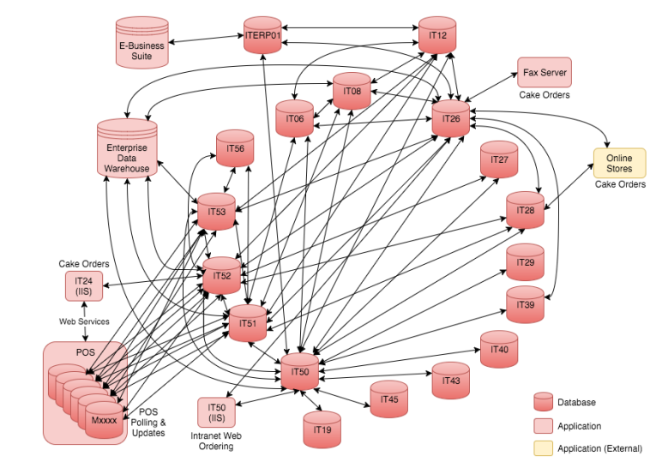

1. As-Is Architecture



2. Expected Architecture

### Impacts to architecture

|  |  |  |
| --- | --- | --- |
| Impact # | Name | Description |
| IMP-01-01 | Linked Server relationship removal | 1. After IT51/52/53’s actual production cutover, which also represent the service bus has become operational smoothly; the linked server connection between them and other existing SQL Server DB in Maxim’s internal will become obsolete and unnecessary. 2. Same as #1, the linked server relationship between IT51/52/53 and the SQL Server DB owned by external parties. |
| IMP-01-02 | File system in IT51/52/53 removal | 1. If there is any file system or shared folders existing in IT51/52/53 machines (which is highly possible to be utilized as working directories of the data processing), the impact is provided. |

### Impacts to application

|  |  |  |
| --- | --- | --- |
| Impact # | Name | Description |
| IMP-01-03 | Application data source impact | Overall system needs to be investigated during the development period (by Maxim’s) whether there are any applications has introducing any of IT51/52/53 as data source, no matter the applications utilize the data in IT51/52/53 by linked server, remote connection or post data synchronization  Target review applications:   * Cake orders * Octopus Card * Finance * Customer Relationship Management (CRMs) * Enterprise Data Warehouse * How about Event Order??? - should be included |
| IMP-01-04 | Table relationship impact | The database instances which has maintained a relationship with all tables in IT51/52/53, shall be investigated, especially views and stored procedures  Target review database   * POS client database (sample)   + MITPOS * IT06 * IT08 * IT12 * IT24 (for IT52 only) * IT26 * IT27 * IT28 * IT50 * IT56   *assume the database on POS client is same as another as long as they are from same vendor. |

## Sales Data Flows

### Purpose

As the cutover of IT51/52/53, the sales data processing to EDW, which is handled by Polling Servers, will be re-developed into service bus application. The polling server has been used of POS data centralization purpose, so the aim of the project is the substitute the POS polling service with the service bus applications collaborating with service bus services.

The existing POS sales data processing logic is as below

* Each member of the polling group (IT51/52/53) deals with a certain set of branches, which provides data feed in linked server, DBF file or text file.
* The polling servers handle both the inbound and outbound data against POS client, includes:
  + Sales real-time data (inbound) – collect POS transaction data from outlets during business hours at regular time interval
  + Sales End of Day data (inbound) - Collect End of Day (EOD) data from outlets after business hours
  + Pricing/master data (outbound)
  + All of above to EDW (outbound)
* The implementation of service bus application not only replaces the data process of existing polling server (stored procedures), but also the related database objects, will be replaced by the application’s staging database.

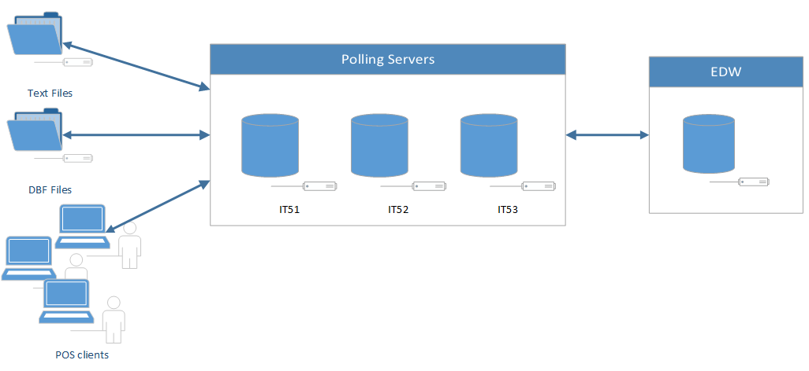

3 Flow As-Is

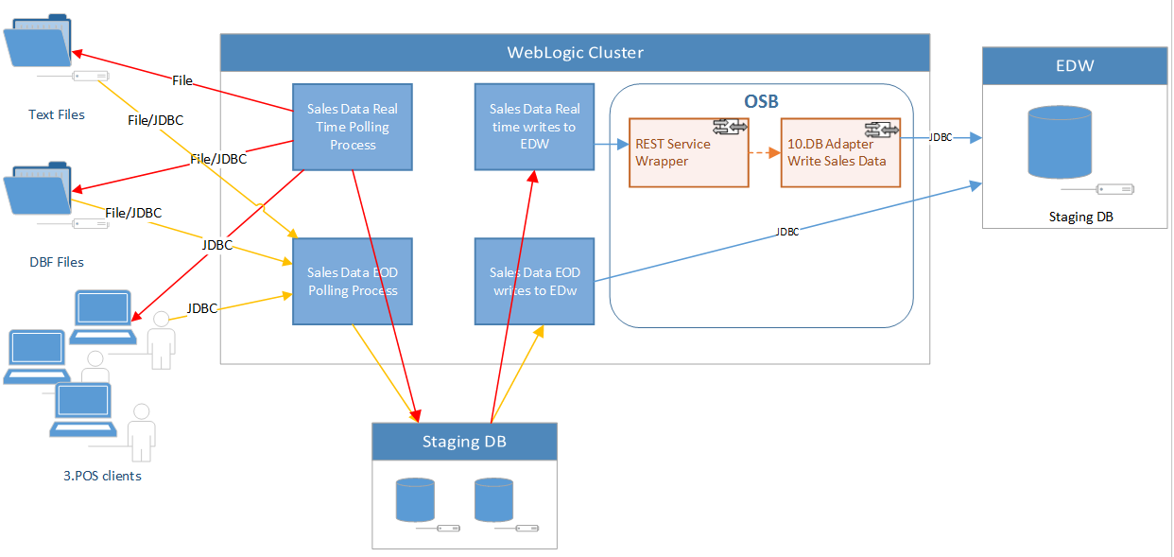

4 Flow To-Be

### Impacts to application

| Impact # | Name | Description |
| --- | --- | --- |
| IMP-01-03 | Data flow impacts | To preservation of the pricing/master data generation requires the job udj_gen_pricing and its related stored procedure udsp_gen_pricing_group to be maintained elsewhere after IT51/52/53 have been cutover.  In latter session, there show be details of below approaches of the workaround   1. Migrate all the database objects (job, stored procedures, tables, view, etc.) in IT51 which relates to the pricing/master data generation, into the newly set up temporary DB server*, and use the temporary server’s schedule job to substitute the generation process. (recommended) 2. Use application to simulate the whole generation process and scheduler logic and prepare data within new service bus staging database   *Temporary DB server: details explained in session 4.2 |
| IMP-01-04 | Database objects impact | The database instances which has maintained a relationship with pricing/master data tables in IT51, shall be investigated, especially views and stored procedures. When the IT51 will be removed from the linked server network, corresponding the T-SQL of related database objects will be affected.  Target review databases as shown as follows:   * IT06 * IT08 * IT26 * IT27 * IT28 * IT56 |

## Pricing/Master Data Flows

### Purpose

Because of the change of session 3.1, it will have impact to one of the key data flows of the service bus in the data generation stage.

The existing pricing/master data generation flow as shown as follows:

1. The SQL server agent job IT51.hopos.dbo.udj_gen_pricing will be triggered by scheduler
2. The job executes the main stored procedure IT51.hopos.dbo.udsp_gen_pricing_group to process the pricing/master data generation
3. After the parameter overriding step, executes the actual process IT51.hopos.dbo.udsp_gen_pricing
4. Within udsp_gen_pricing, it eventually executes a series of stored procedures in IT12 and IT50, and copies the prepared data into IT51
   1. IT12.pricing.dbo.udsp_check_sys_brh
   2. IT12.pricing.dbo.udsp_gen_itemcata
   3. IT12.pricing.dbo.udsp_gen_menu
   4. IT12.pricing.dbo.udsp_gen_menuitem_exclude_itemseq
   5. IT12.pricing.dbo.udsp_gen_menuitem_extra
   6. IT12.pricing.dbo.udsp_gen_menuitem_seq
   7. IT12.pricing.dbo.udsp_gen_payment10_instant_scan
   8. IT12.pricing.dbo.udsp_gen_payment_seq10
   9. IT12.pricing.dbo.udsp_gen_payment_extra
   10. IT12.pricing.dbo.udsp_gen_pos_access
   11. IT50.security.dbo.udsp_gen_pos_employee_new
   12. IT50.security.dbo.view_onhouse
   13. IT50.security.dbo.udsp_gen_itemanly_new
   14. IT50.security.dbo.udsp_gen_pmt_hdr
   15. IT50.security.dbo.udsp_gen_pmt_condition
   16. IT50.security.dbo.udsp_gen_pmt_action
   17. IT50.security.dbo.udsp_gen_coupon_control
   18. IT50.security.dbo.udsp_gen_coupon_range
   19. [Process of itself] Currency, Options, Syssettings, Tabletotext, Transtype

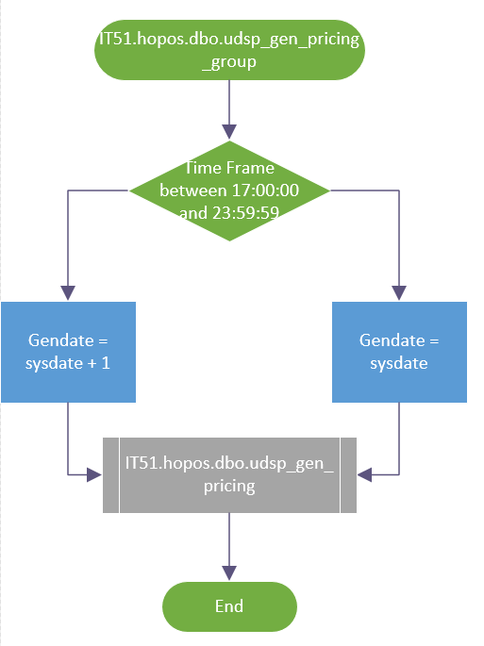

### Impacts to application

| Impact # | Name | Description |
| --- | --- | --- |
| IMP-01-03 | Data flow impacts | To preservation of the pricing/master data generation requires the job udj_gen_pricing and its related stored procedure udsp_gen_pricing_group to be maintained elsewhere after IT51/52/53 have been cutover.  In latter session, there show be details of below approaches of the workaround   1. Migrate all the database objects (job, stored procedures, tables, view, etc.) in IT51 which relates to the pricing/master data generation, into the newly set up temporary DB server*, and use the temporary server’s schedule job to substitute the generation process. (recommended) 2. Use application to simulate the whole generation process and scheduler logic and prepare data within new service bus staging database   *Temporary DB server: details explained in session 4.2 |
| IMP-01-04 | Database objects impact | The database instances which has maintained a relationship with pricing/master data tables in IT51, shall be investigated, especially views and stored procedures. When the IT51 will be removed from the linked server network, corresponding the T-SQL of related database objects will be affected.  Target review databases as follows:   * IT06 * IT08 * IT26 * IT27 * IT28 * IT56 |

# Cutover Consideration

From the impacts listed out in previous section, we propose selecting pilot POS clients for migration. Each time a select number of POS client will migrated to new system until all branches polling operation migrated to new system.

## Sales Data

### Existing Data Flow

IT51, 52, 53



Staging to EDW

Sales Data to Staging Server

* The data copied from POS Client to the existing server.
* Existing server update process log to control polling execution.
* The existing server will update the process log / record status after finish.
* The data in existing staging server copied to EDW.
* We target to migrate the process to new stating server.

There are phases defined for cut over:

1. Parallel run on selected branch for real time / EOD sales data.
2. Cut over on selected branch for real Time / EOD sales data.
3. Repeat Step 1 and step 2 until all branches finished cut over process.

### Parallel Run on Selected Branch



EDO can select some branches for testing / monitoring / health check / Data Patch Approach

Consider using re-run instead of patching

Start using new ESP to put data

Service Bus not update process log

* Data still copied from POS Client to the existing server.
* ESP and Store Procedure co-exist to responsible for data polling for migrated branches and non-migrated branches respectively.
* Existing server will update the process log / record status after finish.
* Data in existing staging server copied to EDW.
* New real time data service triggered to copy the data (selected branch) from POS client to new Staging Server.
* No process log updated from new staging server.
* No data copied to EDW from new staging server.

### Cut Over on Selected Branch



Store Procedure revised for  
 switch over

Start using new ESP to put data

Service Bus update process log

* Amend existing production store procedures to suspend selected branch.
* Data copied from POS Client to the existing server for non-migrated branch.
* Existing server will update the process log / record status after finish for non-migrated branch.
* Data in existing staging server will copied to EDW for non-migrated branch.
* New real time data service triggered to copy data (selected branch) from POS client to new Staging Server.
* The new system will update the process log after data copy task completed for selected branch.
* Data in new staging server will copy to EDW for selected branch.

## Pricing/Master Data

### Existing Data Flow



* Pricing/Master data generated by store procedure and kept in IT12 and IT50 server.
* Data will copied to POS Client.

There are phases defined for cut over:

1. Parallel run on selected branch for pricing/master data.
2. Cut over on selected branch for pricing/master data.
3. Repeat Step 1 and step 2 until all branches finished cut over process.

### Parallel Run on Selected Branch



Store procedure revised to put data to two staging server. Similar approach such as setting data publishing server can be considered

* Developed New Store Procedure to make data copied to IT20, IT50 respectively.
* Pricing/Master data generated by store procedure and kept in IT12 and IT50 server.
* Data will copied to POS Client to non-migrated branches.
* Data will copied to POS Client to selected branches.

### After Cut Over



Existing link can keep for other applications referring. It is also fine to obsolete the data synchronization to old servers

* Pricing/Master data generated by store procedure and kept in IT12 and IT50 server for systems referral.
* Data will copied to POS Client to selected branches.

# Appendix

## In Scope Data

Referring to the user requirement definition documents the following data are included.

### POS Client Polling Tables

| **Table** | **Type** | **Update Freq.** | **Server** |
| --- | --- | --- | --- |
| ACCOUNTS | Master | Every Polling | IT51/52/53.hopos |
| COUPON_CONTROL | Master | Every Polling | IT51/52/53.hopos |
| COUPON_RANGE | Master | Every Polling | IT51/52/53.hopos |
| CURRENCY | Master | Every Polling | IT51/52/53.hopos |
| EMPLOYEE | Master | Every Polling | IT51/52/53.hopos |
| HIST_CHECK_LOGS | HIST | EOD | IT51/52/53.hopos |
| HIST_COUPON_SALES | HIST | EOD | IT51/52/53.hopos |
| HIST_ITEM | HIST | EOD | IT51/52/53.hopos |
| HIST_ITEMSTOCK | HIST | EOD | IT51/52/53.hopos |
| HIST_ORDERS | HIST | EOD | IT51/52/53.hopos |
| HIST_ORDERS_EXTRA | HIST | EOD | IT51/52/53.hopos |
| HIST_ORDERS_PAY | HIST | EOD | IT51/52/53.hopos |
| HIST_ORDERS_PAY_PROGRESS | HIST | EOD | IT51/52/53.hopos |
| HIST_PAYFIG | HIST | EOD | IT51/52/53.hopos |
| HIST_PAYSUM | HIST | EOD | IT51/52/53.hopos |
| HIST_POSSYSTEM | HIST | EOD | IT51/52/53.hopos |
| HIST_REDEEMED_COUPON | HIST | EOD | IT51/52/53.hopos |
| HIST_SAFEBOXCHECK | HIST | EOD | IT51/52/53.hopos |
| HIST_SAFEBOXCHECKTENDER | HIST | EOD | IT51/52/53.hopos |
| HIST_SAFEBOXINOUT | HIST | EOD | IT51/52/53.hopos |
| HIST_SAFEBOXINOUTEXTENDINFO | HIST | EOD | IT51/52/53.hopos |
| HIST_SAFEBOXPICKUP | HIST | EOD | IT51/52/53.hopos |
| HIST_SESSIONINFO | HIST | EOD | IT51/52/53.hopos |
| HIST_SESSIONTENDER | HIST | EOD | IT51/52/53.hopos |
| HIST_STOCK_MOVEMENT | HIST | EOD | IT51/52/53.hopos |
| HIST_SUPP | HIST | EOD | IT51/52/53.hopos |
| HIST_TRANS | HIST | EOD | IT51/52/53.hopos |
| HIST_TRANS_ECARD | HIST | EOD | IT51/52/53.hopos |
| HIST_TRANS_MODIFIER | HIST | EOD | IT51/52/53.hopos |
| INVITATION | Master | Every Polling | IT51/52/53.hopos |
| ITEM | Master | Every Polling | IT51/52/53.hopos |
| ITEM_BARCODE | Master | Every Polling | IT51/52/53.hopos |
| ITEM_MODIFIER | Master | Every Polling | IT51/52/53.hopos |
| ITEMANLY | Master | Every Polling | IT51/52/53.hopos |
| ITEMDEPT | Master | Every Polling | IT51/52/53.hopos |
| MENU | Master | Every Polling | IT51/52/53.hopos |
| MENUITEM | Master | Every Polling | IT51/52/53.hopos |
| MESSAGES | Master | Every Polling | IT51/52/53.hopos |
| MODIFIER | Master | Every Polling | IT51/52/53.hopos |
| MODIFIER_GRP | Master | Every Polling | IT51/52/53.hopos |
| MODIFIER_LIST | Master | Every Polling | IT51/52/53.hopos |
| ONHOUSE | Master | Every Polling | IT51/52/53.hopos |
| OPTIONS | Master | Every Polling | IT51/52/53.hopos |
| ORDERS | Sales Data | Every Polling | IT51/52/53.hopos |
| ORDERS_EXTRA | Sales Data | Every Polling | IT51/52/53.hopos |
| ORDERS_PAY | Sales Data | Every Polling | IT51/52/53.hopos |
| PAYCAT | Master | Every Polling | IT51/52/53.hopos |
| PAYMENT | Master | Every Polling | IT51/52/53.hopos |
| PMT_ACTION | Master | Every Polling | IT51/52/53.hopos |
| PMT_CONDITION | Master | Every Polling | IT51/52/53.hopos |
| PMT_HDR | Master | Every Polling | IT51/52/53.hopos |
| POSBUSDATE | Master | Every Polling | IT51/52/53.hopos |
| ROLE | Master | Every Polling | IT51/52/53.hopos |
| ROLE_PERMISSION | Master | Every Polling | IT51/52/53.hopos |
| SUPP | Sales Data | Every Polling | IT51/52/53.hopos |
| SYSSETTINGS | Master | Every Polling | IT51/52/53.hopos |
| TRANS | Sales Data | Every Polling | IT51/52/53.hopos |
| TRANS_ECARD | Sales Data | Every Polling | IT51/52/53.hopos |
| TRANS_MODIFIER | Sales Data | Every Polling | IT51/52/53.hopos |
| TRANS_TYPE | Master | Every Polling | IT51/52/53.hopos |
| USER_PERMISSION | Master | Every Polling | IT51/52/53.hopos |
| USER_ROLE | Master | Every Polling | IT51/52/53.hopos |
| WIFI CODE | Master | Every Polling | IT51/52/53.hopos |

## Out Scope Data

The data not listed in IT51, IT52 & IT53 belongs to out of scope data.

Take IT51.hopos as reference, below tables require Maxim’s further clarification

|  |  |
| --- | --- |
| attendance | md_hist_paysum |
| branch_inventory_info | md_hist_supp |
| cake_event_disc_coupon_payment_table | md_hist_trans |
| cake_orders | md_hist_trans_ecard |
| cake_trans | md_hist_trans_modifier |
| cal_item_move_simulation_log | messages_wifi_codes |
| check_logs | mhist_check_logs |
| check_payment | mhist_coupon_sales |
| chk_repl | mhist_item |
| conv_gb_table | mhist_itemstock |
| convert_log | mhist_orders |
| convert_pool | mhist_orders_extra |
| csl_wifi_code | mhist_orders_pay |
| cvp_interval | mhist_orders_pay_progress |
| cvp_receipt | mhist_payfig |
| daily_bankin | mhist_paysum |
| daily_coupon_order | mhist_possystem |
| daily_coupon_tran | mhist_redeemed_coupon |
| daily_item_move | mhist_stock_movement |
| daily_linux_supp | mhist_supp |
| daily_movement | mhist_trans |
| daily_movement_pre | mhist_trans_ecard |
| daily_movement_redo_branch | mhist_trans_modifier |
| daily_movement_simulation | mhist_transsummary |
| daily_movement_suspend_branch | mitpos_branch |
| daily_sales_addition_detail | MMX_branch |
| daily_sales_item | mpoll_log |
| daily_sales_order | onhouse_predel |
| daily_sales_pay | payment_extra |
| daily_sales_payfig | paysum |
| daily_sales_supp | pmt_disc |
| daily_trans_ecard | pmt_disc_pmt |
| daily_vip_reference | pmt_disc_tmp |
| daily_voiditem | poll_branch_info |
| daily_voidord | poll_branch_scheme |
| emfc_trans_log | poll_log |
| event_extra | poll_scheme_control_table |
| event_extra_Qualicom  - Required / In-scope | poll_scheme_HC |
| event_extra_wansync | poll_scheme_info |
| event_orders | possystem |
| event_orders_ffs | product_movement |
| event_orders_Qualicom | redeemed_coupon |
| event_orders_sync_logs | safebox |
| event_orders_wansync | safebox_account_mapping |
| event_trans | safebox_amount |
| hist_cls_wifi_code | safeboxcheck |
| hist_event_orders | safeboxchecktender |
| hist_linux_supp | safeboxinout |
| hist_possystem_predel | safeboxinoutextendinfo |
| hist_redeemed_coupon_ARO | safeboxpickup |
| hist_transsummary | SBUX_U01 |
| hist_voidorders | SBUX_U01_branch |
| hist_voidorders_extra | SBUX_U01_tmp |
| hist_voidorders_pay | sessioninfo |
| hist_voidtrans | sessiontender |
| instant_scan | tabletotext |
| invitation_scheduler | temp_for_upload_SBS_item_cost |
| iposs_itemticket | temp_for_upload_sbs_item_cost_bk |
| iposs_sysprtq | temp_for_upload_sbs_item_sec_price |
| iposs_sysprtqp | temp_for_upload_sbs_item_sec_price_bk  Required |
| iposs_tillset | temp_paysum |
| itembackup | trans_tmp |
| itemstock | txt_hist_check_logs |
| linux_drsupp | txt_hist_coupon_sales |
| load_balancer_control_table | txt_hist_item |
| MA_accounts | txt_hist_itemstock |
| MA_check_payment | txt_hist_orders |
| MA_coupon_control | txt_hist_orders_extra |
| MA_coupon_range | txt_hist_orders_pay |
| MA_currency | txt_hist_orders_pay_progress |
| MA_item_barcode | txt_hist_payfig |
| MA_messages | txt_hist_paysum |
| MA_onhouse | txt_hist_possystem |
| MA_options | txt_hist_redeemed_coupon |
| MA_paycat | txt_hist_stock_movement |
| MA_pmt_hdr | txt_hist_supp |
| MA_pos_layout | txt_hist_trans |
| MA_posfunction | txt_hist_trans_ecard |
| MA_posfunction_control | txt_hist_trans_modifier |
| MA_posfunction_mapping | user_profile |
| MA_syssettings | xmitpos_branch_predel |
| MA_tabletotext | XML_result |
| MA_trans_type | XOP_branch_summary |
| md_dayend_control_table | XOP_pos_layout |
| md_hist_check_logs | XOP_posfunction |
| md_hist_coupon_sales | XOP_posfunction_control |
| md_hist_orders | XOP_syssettings |
| md_hist_orders_extra | md_hist_orders_pay_progress |
| md_hist_orders_pay | md_hist_payfig |

Required

- End –

# Sign Off

|  |  |  |
| --- | --- | --- |
| Description of Deliverable: System Design Document  The requirements specification for the application. | | |
| POS Part Sign-Off | | |
| Name (Print or Type) | Date | Signature |
| CARL CHOW |  |  |
|  | | |
| Staging to EDW Part Sign-Off | | |
| Name (Print or Type) | Date | Signature |
| POLLY KAM |  |  |
|  | | |
| Others Sections Sign-Off | | |
| Name (Print or Type) | Date | Signature |
| CHOI KA WING |  |  |
|  | | |
| Project Director | | |
| Name (Print or Type) | Date | Signature |
| LOUIS MAH |  |  |
|  | | |