Prepared by: Buzz IT Company Limited

Author: Steven Chen

Date: 13/02/2017

Version: 1.0

Maxim’s POS Polling Enterprise Service Bus Implementation Service

**EL-FY16-902**

**Sales/Master/Pricing Data Exchange**

System Design Specification

# Document Control

## Document History

| Version | Date | Author | Revision Remark |
| --- | --- | --- | --- |
| 0.9 | 13/01/2017 | Steven Chen | 1st draft |
| 1.0 | 13/02/2017 | Steven Chen | Released Copy |

## Document/Design Owner

| Name | Title |
| --- | --- |
| Steven Chen | System Analyst |
| Edward Leung | System Analyst |
| Tommy Leung | System Analyst |

## Key Comments

| Name/Title | General Comments from Maxim’s IT. | |
| --- | --- | --- |
| # | Comments |
| Comment | 1 | 1. Cosmetic on spelling, inconsistent use of term. 2. Term used in the documents are confusing on items such as task log. 3. NO overview / flow for the whole ESB Polling system. 4. Schema for the tables. 5. Add the document version to the footer. |
| Response | 1 | 1. Revised on terms mentioned during the review meetings. 2. Difference between task job log and schedule job log mentioned in database schema. 3. Add section 3.2 to describe the whole and design concern of ESB polling system. 4. Add database schema to appendix B. 5. Version number added on each page footer. |

# Table of Content

Document Control 2

Document History 2

Document/Design Owner 2

Key Comments 2

Table of Content 3

1 Background 5

1.1 Document Purpose 5

1.2 Document Scope 5

1.3 Document Audience 5

1.4 Terms & Abbreviations 6

1.5 Reference Materials 6

1.6 User Requirement Traceability Matrix 6

2 Executive Summary 7

3 Architecture Design 8

3.1 Overall Architecture 8

3.2 System Design Overview 9

4 Data Model Design 12

4.1 POS Client Data Source Data Model 12

4.2 EDW Data Model 12

4.3 Pricing/Master Data Model 12

4.4 Staging Table Data Model 12

4.5 Polling Application Work Tables 13

4.6 Data Scheme of Working Table 14

5 High Level Interface Design 15

6 Functional Design 16

6.1 System Functional Overview 16

6.2 Technology Used 18

6.3 Branch Info Maintenance 19

6.4 Scheduler Jobs Maintenance 26

6.5 Branch Scheme Maintenance 29

6.6 Job Logs View 45

6.7 Sales Data Real Time Polling Batch Job 52

6.8 Sales Data EOD Polling Batch Job (POS-Staging) 64

6.9 Pricing/Master Data Generation (Pricing Server - Staging) 75

6.10 Pricing/Master Data Distribution Batch Job (Staging-POS) 78

6.11 System Dashboard View 85

6.12 System Parameter Maintenance 91

6.13 Export Daily Report 94

7 Interface Design 96

7.1 Sales Data Web Service 96

7.2 Pricing Data Web Service 108

7.3 EDW Checksum Web Service 110

8 Appendix A – Staging Table Data Model 112

9 Appendix B – Database Schema of Working Table 114

10 Appendix C – User Requirement Traceability Matrix 114

11 Sign Off 117

# Background

## Document Purpose

The purpose of the System Design Specification (SDS) is to describe the detailed system design specification for a project and its main aim is to provide system design context for the project and its objectives. It will provide the input for high-level development activities.

The System Design Specification is part of the deliverables in the Business Case Development phase of Project Delivery Lifecycle.

## Document Scope

The scope of the System Design Specification (SDS) is to describe the architectural view of the system. It has section such as architecture design, data model design, high-level interface design, report design, etc. The technical designs and specifications of the impacted applications are not included in this document.

## Document Audience

The audience of this System Design Specification (SDS) is the technical staff of the IT department of the project owner.

## Terms & Abbreviations

|  |  |
| --- | --- |
| **Abbreviation** | **Description** |
| ESB | Enterprise Service Bus |
| API | Application Programming Interface |
| EDW | Enterprise Data Warehouse |
| EOD | End of Day |
| POS Client | One Database Owner on the Sales side, provided by the POS machine vendor/manufacturer |
| DB | Database |
| POS | Point of Sales |
| Staging DB | The service bus database to stage the polling data |

## Reference Materials

| Document Names |
| --- |
| Maxim’s POS Polling ESB Implementation Service Proposal EL-FY16-902-v3.docx |
| POS Polling User Requirement Confirmation-20161121-Discussion Note.xlsx |
| Maxim_POS_Polling_ESB_RDD-v1.3.docx |

## User Requirement Traceability Matrix

Please refer to Appendix C.

# Executive Summary

The aim of the ESB project is to migrate three data processing flows in Maxim’s current enterprise architecture using database provided technologies (linked server & stored procedure) to a new platform using Oracle Enterprise Services Bus technology. In the new ESB polling system (ESB system), it will have three data processing flows implemented.

* Sales data real time processing to EDW
* Sales data EOD processing to EDW
* Synchronize master data to POS clients (e.g. Pricing/Master)

The ESB system will use JDBC to connect to the databases of existing POS clients in outlets by pre-configured connection information in order to collect sales data from the existing POS systems and update the pricing/master data back to the existing POS clients. Referring to the polling logic found in the production IT51 server, for any connection error, the ESB system will log down the error and retry data synchronization. After reaching maximum retry count, the ESB system will halt the synchronization for that particular POS client and generate alert to related parties for follow up.

All POS clients’ connection settings are configurable and maintainable by Maxim’s IT. It makes the adding of new POS client easy and no alteration of programming code is required. The ESB system can invoke several configurable concurrent threads to poll/push the data to/from POS clients concurrently for maximizing system performance.

# Architecture Design

## Overall Architecture

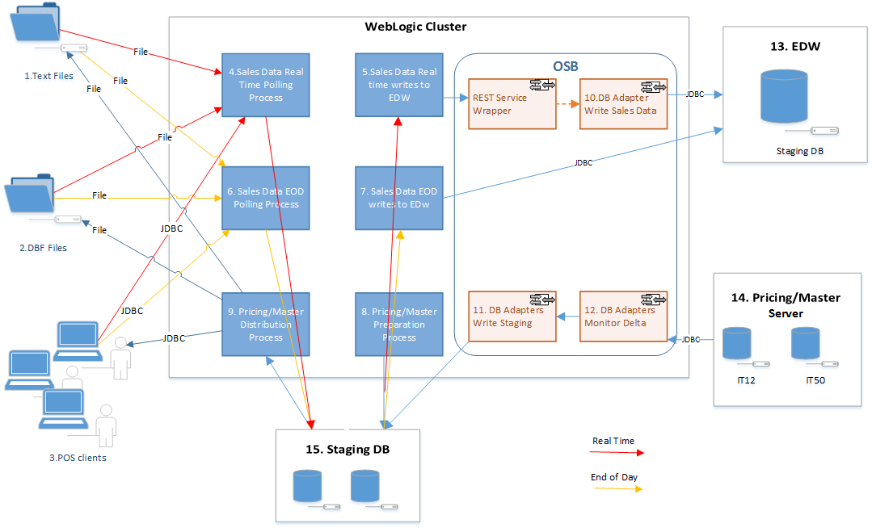

**Key Data Sources**

1. Sales Data Text File
2. Sales Data DBF Files
3. Sales Data POS Client SQL Server Database

13. EDW Database

14. Pricing/Master Database

15. Staging Database

**Key Process**

1. Sales Data Real Time Polling (POS -> Staging)
2. Sales Data Real Time to EDW (Staging -> EDW, depend on #4 completion)
3. Sales Data EOD (POS -> Staging)
4. Sales Data EOD to EDW (Staging –> EDW, depend on #6 completion)
5. Pricing/Master Generation/Preparation (Pricing/Master servers -> Staging)
6. Pricing/Master Distribution (Staging –> POS clients, depending on #8 completion)

**Key OSB components**

1. Write EDW tables service (Virtual Branch Sales Inbound tables)
2. DB Adapter monitoring pricing/master tables delta
3. DB Adapter write Pricing/Master data to staging (triggered by #12)

## System Design Overview

The ESB has two core modules: polling module and master update module developed to achieve the goal of the system implementation. Both modules read system configurations defined in the working database that define the polling behaviors in different modules for different scenarios.

In polling module, it is responsible for the pulling of POS data to the staging database followed by transferring those data to the staging database of EDW. The system will have different commitment and work flow process defined specially to real time and end-of-date polling. In short, the ESB system will constantly monitor the log table and configuration table to determine whether to trigger polling process. Section 6.7 and 6.8 in this document will have detailed information provided to describe the logic in detail.

In master data download module, it is response for the update of POS master data (e.g. Price and other master records). The module will make use of the data adapter and service bus to monitor the need to trigger pricing/master data update to POS client. Section 6.9 and 6.10 in this document will have detailed information provided to describe the logic in detail.

The figure and table below outlines the ESB system design considerations.

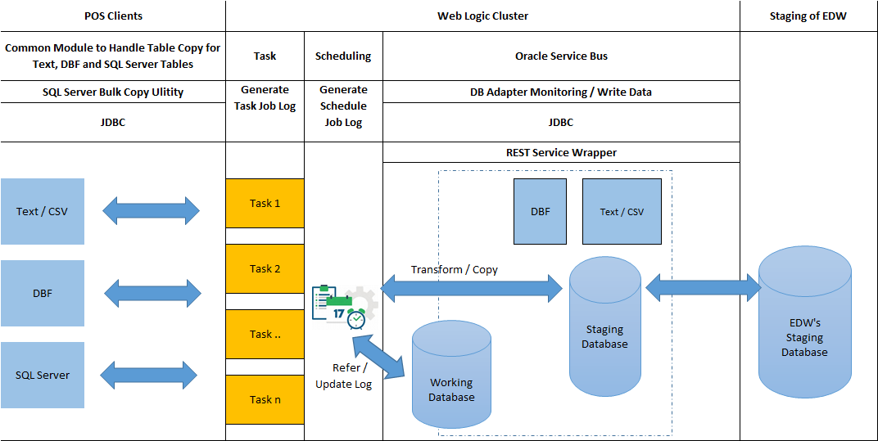

The table below summarize the design components and related design consideration for the polling system.

| **No.** | **Design Component / Consideration** | **Description / Explanation** |
| --- | --- | --- |
| 1 | Source Data Type | 1. Text / CSV: Text or Delimiter Text file 2. DBF: *.DBF file 3. SQL Server: Tables store in SQL Server 2000   To allow data copying, information such as user id, password, share drive location and port number to access database should be stored in database tables. When the system establish JDBC connection, the system should get the connection information accordingly.  The system will use AES 256 or above to store the password information in the system database. |
| 2 | SQL Server Bulk Copy Utility | There are large number of Maxim’s POS clients requires uploading sales data to headquarters. The system design should also consider fast and large amount of data copying to SQL Server. Using Bulk Copy Utility of SQL Server can speed up the data upload/download process. At the same time, all data transformation process should avoid creating large number of database log space. |
| 3 | Common JDBC Utility | By making use of object-oriented design technology, top-level module will be design for task handling while bottom level module will be design for heterogeneous data source handling. The system is design to provide room for adopting future data sources and related variation of data handling requirement. |
| 4 | Task | Task is the minimal unit of work in the ESB system to copy data from source to destination. For example, a task can be:   1. Copying a group of tables of a particular Maxim’s branch (e.g. Sales Data of a Starbucks café shop) with pre-defined number of columns to the destination (e.g. Tables in Staging DB).   2. Update a group of tables of a particular Maxim’s branch (e.g. Price data of the items of a Starbucks café shop) with pre-defined number of columns from source (e.g. Tables in Staging DB).  3. Export a group of tables/file of a particular Maxim’s branch (e.g. Price data of the items of a Starbucks café shop) with pre-defined number of columns from source (e.g. Tables in Staging DB).  Execution thread in Web Logic will responsible for the execution tasks while the number of concurrent thread can be increased by allocating sufficient server resources such as CPU and memory to achieve desirable data copying performance. |
| 5 | Scheduling | The system will have scheduler to monitor how many tasks should trigger. To avoid multiple and un-necessary triggering of task (duplicate data copy), the system will check against task job log table.  To let system administrator to understand the execution status, system dashboard will present task-running status and provide means for task re-run. |
| 6 | DB Adapter | DB Adapter will be used to monitor any changes on source data (such as new data inserted, data updated). The ESB system can monitor delta changes on source table to “publish” the changes to destination.  As it allows adding or updating table source information by setting up related configuration files, no system amendment is required.  ** It is assumes that there is no record deletion in Pricing/Master record. Deletion of record refer to marking of a specific table column (e.g. Set DelFlag = Y) to a certain value.  ** The ESB system will also provide housekeeping logic to out of retention period records. |
| 7 | JDBC | The ESB system will use JDBC technology for database operation. The task described will call the JDBC bulk insert / update function for data upload or download. |

# Data Model Design

## POS Client Data Source Data Model

Please refer to Appendix D in Requirement Definition Document.

## EDW Data Model

Please refer to Appendix E in Requirement Definition Document.

## Pricing/Master Data Model

Please refer to Type equal “Master” in Appendix D in Requirement Definition Document.

## Staging Table Data Model

Please refer to Appendix B.

## Polling Application Work Tables

**Polling Schemes**

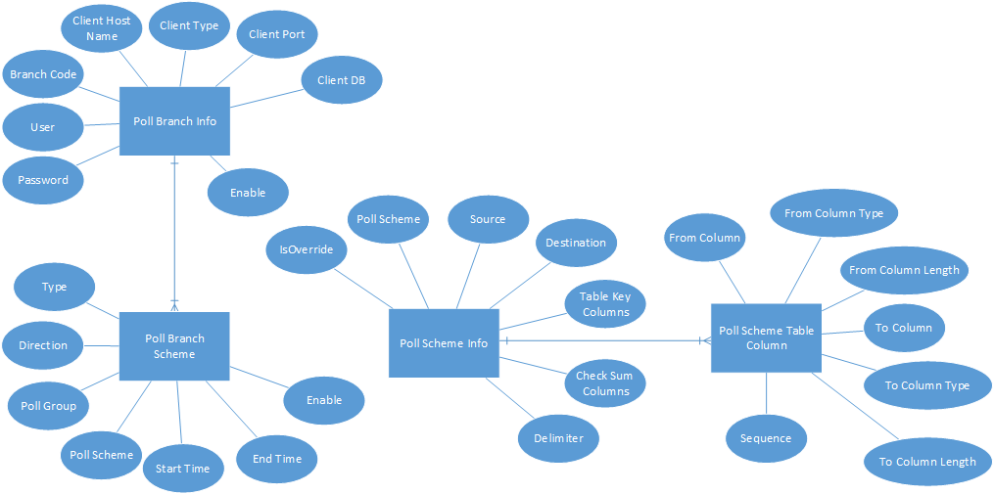

**Job Control (Job Logs, Exceptional Data)**

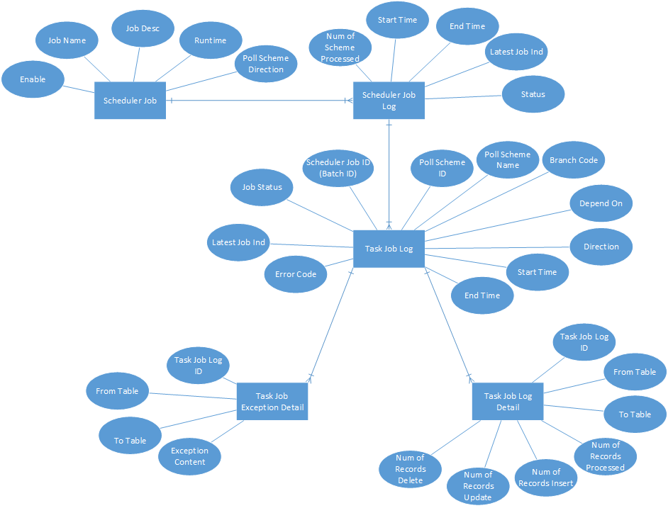

## Data Scheme of Working Table

Please refer to Appendix B.

# High Level Interface Design

POS Client

POS DB

POS Client

POS File

Web Logic Application

FTP

JDBC

Sales Data Real Time Service

Sales Data EOD Service

HTTP

File System

Oracle Service Bus

wWsdssadsadsad

Pricing / Master Service

Sales Data Web Service

Administrative Service

Pricing / Master Data Web Service

Job Monitor Service

JDBC

EDW Checksum Web Service

Report Service

POS Server Synchronization

JDBC

JDBC

Staging Database

Staging Database  
of EDW

Pricing Database

IT12 / IT51

STORE-P

# Functional Design

## System Functional Overview

### Site Map

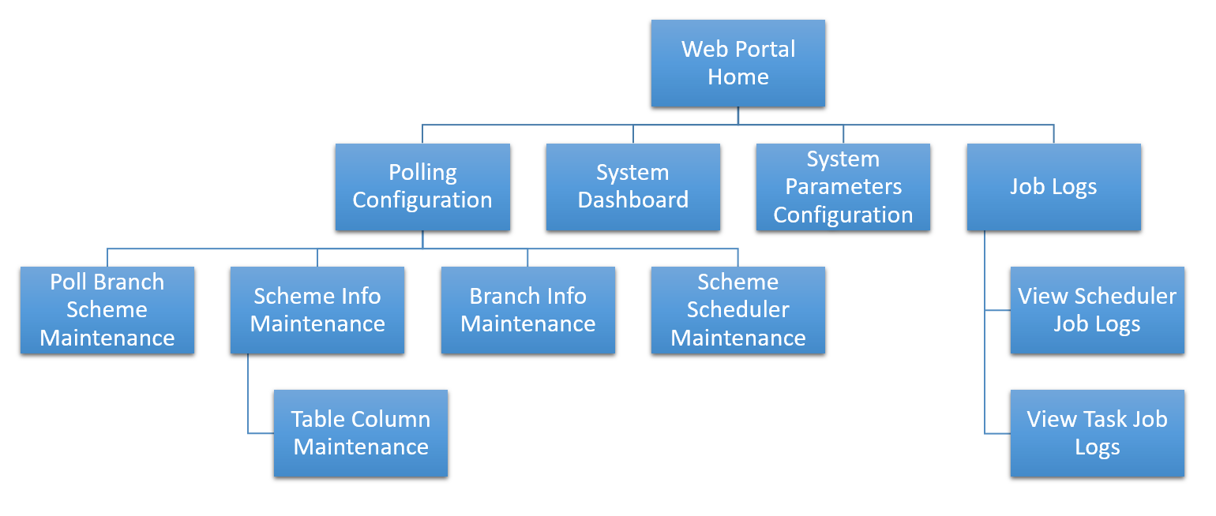

### Use Case

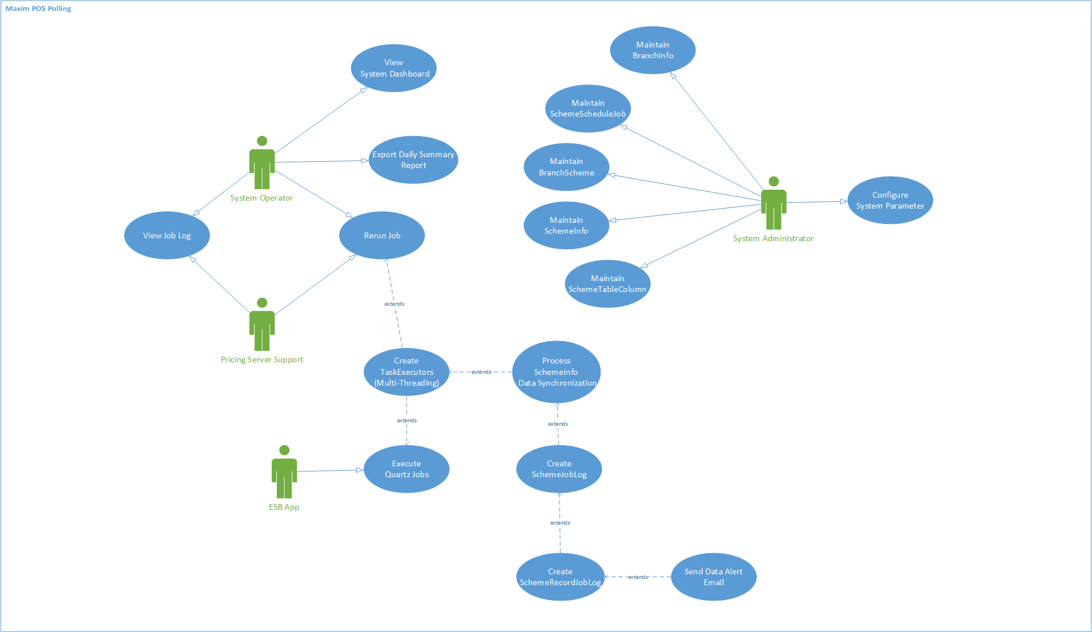

## Technology Used

Application Server side:

*Oracle WebLogic 12c, Oracle Service Bus 12c, JAVA (With JRE V1.8)*

Database Server side:

*MS SQL Server 2012, Oracle 11.2g (PL/SQL), MS SQL Server 2000*

Client Side Browser:

*Chrome 55 or above*

*Internet Explorer 11 or above*

## Branch Info Maintenance

### Description

The “Branch Info Maintenance” function allows the maintenance of POS client information such as branch code, host IP and Client DB Name. The data should be initially input based on current polling server. The view of these data are available for the access from both Service Bus User and POS User, but Service Bus user are allowed to use operations including Create, Edit and Delete. On the Add or Modification of the branch info data, the data source connectivity will be validated upon saving.

Use Case functions

# Maintain Branch Info (List)

# Maintain Branch Info (Create/Edit/Delete)

### Input

N/A

### Output

N/A

### Maintain Branch Info (List)

#### Process/Work Flow

This function is to display branch info records according the user input criteria. The branch info will display into the table within the page, and specific columns will display on screen, as some of them enabled as sorting function upon user’s requirements.

**Business Logic**

The branch info is to describe the data source configuration of the POS clients sales data, which affect sales data polling process described in the latter session. Each record represents a single data source, which could be in type of SQL connection, database file or fixed format text file.

By default, when the page is accessed, there is no searching criteria provided and all branch info will display on the page with pagination

1. User could conduct manipulations on searched-out records such as page switching, sorting by specific columns and refining.
2. User could conduct operational functions upon searched-out records such as Edit/Delete and view its details in the “Operation” column. (details included in session 6.2.5)

#### Screen

**Maintain Branch Info (List)**

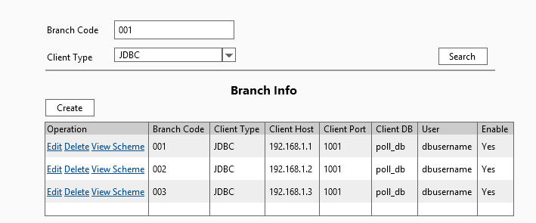

#### Data Fields & Presentation Logic

1. Default Sorting of Branch Info List, Priority from top to bottom

* Branch Code (ascending)

1. Layout

| **Field** | **Object**  **Type** | **Default**  **Value** | **Mandatory**  **(M/O/C)** | **Format**  **A-character**  **N-number** | **Action / Event / Response** | **Description** |
| --- | --- | --- | --- | --- | --- | --- |
| **Branch Code** | Read-only text | Prefilled | - | A(10) | - | Branch Code |
| **Client Type** | Read-only text | Prefilled | - | A(10) | - | Options:   * SQL Server * DBF * Text file |
| **Client Host** | Read-only text | Prefilled | - | A(200) | - | The location of the client, it could be a URL with host name, IP address or file directory. |
| **Client Port** | Read-only text | Prefilled | - | N(5,0) | - | Client port number, will be blank if the client access does not require a port, e.g. shared folder |
| **Client DB** | Read-only text | Prefilled | - | A(50) | - | Database name if the client is a DB Connection |
| **User** | Read-only text | Prefilled | - | A(50) | - | A username to access the client |
| **Enable** | Read-only text | Prefilled | - | A(1) | - | Whether the branch info is enabled or not |

#### Screen Objects & Action

|  |  |  |  |
| --- | --- | --- | --- |
| **Screen Object** | **Object Type** | **Action / Event / Response** | **Remarks** |
| Create | Button | Create a new entry of branch info | N/A |
| Operation -**Edit** | Button | Edit the corresponding branch info record | N/A |
| Operation -**Delete** | Button | Delete the corresponding branch info | N/A |
| Operation -**Detail** | Button | View the corresponding branch info detail | N/A |

#### User/Security Group

This function is accessible to the following user(s):

* System Administrator

#### Assumptions/Constraints

N/A

#### Error & Exception List

N/A

### Maintain Branch Info (Create/Edit/Delete)

#### Process/Work Flow

**Maintain Branch Info (Create)**

A pop-up dialog will appear to receive input from the user by clicking the “Create” button. On clicking the “save” button, the system will first validate the source’s connectivity, and save to the branch info table upon successful validation. User could also click on the “test” button to validate its connectivity separately after input all mandatory fields before saving them

**Maintain Branch Info (Edit)**

A pop-up dialog contain in original branch info detail values will appear to receive input from the user by clicking the “Edit” button. Same as record creation, on clicking the “save” button, the system also validate the source’s connectivity, and save the record’s update. “Test” button works for the same validation.

**Maintain Branch Info (Delete)**

Home> Polling Configuration> Branch Scheme> Search Record> Delete

A pop-up dialog will appear to asking the user for the confirmation of the deletion of the corresponding record. Once user clicks yes, the system will check whether the record has relations to other data, if no, the target record will be deleted.

#### Screen

**Maintain Branch Info (Create/Edit)**

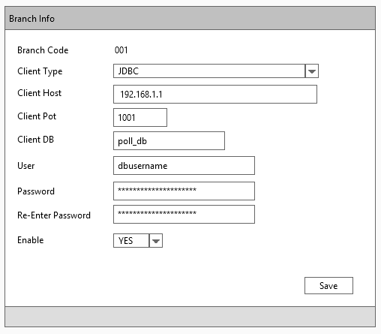

#### Data Fields & Presentation Logic

**Create Branch info Layout**

| **Field** | **Object Type** | **Default Value** | **Mandatory (M/O/C)** | **Format** | **Action / Event / Response** | **Description** |
| --- | --- | --- | --- | --- | --- | --- |
| **Branch Code** | Textbox | Blank | M | A(10) | - | Branch Code. |
| **Client Type** | Dropdown box | Blank | M | A(20) | - | Options:   * SQL Server * DBF * Text file |
| **Client Host** | Textbox | Blank | M | A(200) | - | Must be a valid location of the client, it could be a URL with host name, IP address or file directory. |
| **Client Port** | Textbox | Blank | O | N(5,0) | - | Client port number will be blank if the client access does not require a port, e.g. shared folder. |
| **Client DB** | Textbox | Blank | O | A(50) | Only allow characters [a-zA-Z0-9_] | Database name if the client is a DB Connection. |
| **User** | Textbox | Blank | M | A(50) | Only allow characters [a-zA-Z0-9-_] | A username to access the client. |
| **Password** | Textbox | Blank | M | A(20) | The password length cannot longer than 20 digits | The value of this textbox will be masked. |
| **Re-enter password** | Textbox | Blank | M | A(20) | The password length cannot longer than 20 digits;  The re-enter password must be the same as password. | The value of this textbox will be masked. |
| **Enable** | Check Box | Blank | O | A(3) |  | Enable indicator for the system to determine whether to pick this branch’s scheme for processing or not.  Yes – Enable  No – Disable |

#### Screen Objects & Action

|  |  |  |  |
| --- | --- | --- | --- |
| **Screen Object** | **Object Type** | **Action / Event / Response** | **Remarks** |
| **Test** | Button | Test the connectivity of the source | N/A |
| **Save** | Button | Save the created/edited content of the corresponding record | N/A |

#### User/Security Group

This function is accessible to the following user(s):

* System Administrator

#### Assumptions/Constraints

N/A

#### Error & Exception List

|  |  |  |
| --- | --- | --- |
| **Error Code** | **Severity** | **Error Message** |
| S0001 | N/A | Connection Test Failed! |
| S0002 | N/A | This branch info has maintained relationship with other data. |
| S0003 | N/A | Mandatory fields not input. Please verify! |
| S0004 | N/A | Re-enter password does not match. |
| Successful message | N/A | Branch info saved successfully. |
| Successful message | N/A | Branch info deleted successfully. |

* Final error and exception list to be specified in technical design document.

## Scheduler Jobs Maintenance

### Description

The “Scheduler Job Maintenance” function allows the maintenance of service bus scheduling jobs running for the data processing between POS client and staging, staging and EDW, staging and pricing server. Because the job running is a customized and standalone service, the jobs cannot be created or deleted by user. However, user is able to change the scheduler triggering time, job names or enable/disable the jobs.

Use Case function

# Maintain Scheduler Jobs (List/Edit)

### Input

N/A

### Output

N/A

### Maintain Scheduler Jobs (List/Edit)

#### Process/Work Flow

This function is to display all scheduler jobs details. The scheduler job records will display into the table within the page, and only specific columns allow editing.

**Business Logic**

The branch scheme is to describe the POS polling process-scheduling details. Each scheduler will run upon target polling branch scheme to take on data processing. Each record represents a single schedule tasks and triggered by its configured time to submit separate tasks upon multiple poll schemes.

1. By default, all scheduler jobs will display in the table within the page.
2. User could conduct “Edit” functions to the selected scheduler job records by clicking “Edit” in the “Operation” column to open a job detail panel to edit. (Details included in session 6.4.5).

#### Screen

**Maintain Scheduler Jobs (List/Edit)**

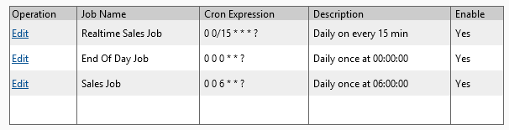

#### Data Fields & Presentation Logic

1. Default Sorting of Branch Info List, Priority from top to bottom

* Job Group (ascending)
* Job Name (ascending)

1. Layout

|  |  |  |  |  |  |  |
| --- | --- | --- | --- | --- | --- | --- |
| **Field** | **Object Type** | **Default Value** | **Mandatory (M/O/C)** | **Format**  **A-character**  **N-number** | **Action / Event / Response** | **Description** |
| **Job Name** | Read-only text | Prefilled | - | A(50) | - | Job name |
| **Cron Expression** | Read-only text | Prefilled | - | A(50) | - | The Cron Expression represents the job’s running time |
| **Description** | Read-only text | Prefilled | - | A(200) | - | Cron expression description |
| **Enable** | Read-only text | Prefilled | - | A(3) | - | * Yes (enabled) * No (disabled) |

#### Screen Objects & Action

|  |  |  |  |  |
| --- | --- | --- | --- | --- |
| **Screen Object** | **Object Type** | | **Action / Event / Response** | **Remarks** |
| Operation -**Edit** | | Button | Popup dialog to display corresponding scheduler job record for editing. | N/A |

#### User/Security Group

This function is accessible to the following user(s):

* System Administrator
* System Operator

#### Data Fields & Presentation Logic

N/A

#### Assumptions/Constraints

N/A

#### Error & Exception List

N/A

## Branch Scheme Maintenance

### Description

The “Branch Scheme Maintenance” function allows the maintenance of POS client data processing logic data by the System Administrator. The data is inputted/configured by service bus administrator according to the poll branch’s scheme data in the current polling server. Actors such as Service Bus, System Service and Administrator will base on the branch scheme data defined in this maintenance program to execute data processing on each branch.

Use Case functions

# Maintain Branch Scheme (List)

# Maintain Branch Scheme (Create/Edit/Delete)

# Maintain Scheme Info (List)

# Maintain Scheme Info (Create/Edit/Delete)

# Maintain Table Column (List)

#Maintain Table Column (Create/Edit/Delete)

### Input

N/A

### Output

N/A

### Maintain Branch Scheme (List)

#### Process/Work Flow

This function is to display branch scheme records according the user input criteria. The branch scheme records will display into the table within the page, and specific columns will display on screen, as some of them enabled as sorting function upon user’s requirements.

**Business Logic**

The branch scheme is to describe the POS polling data process configuration upon a certain POS client (branch), which affect data process jobs of both inbound and outbound to the POS client. Each record represents a single data processing logic in field level definition.

1. By default, when the page is accessed, there is no searching criteria provided and all branch scheme records will display on the page with pagination.
2. User is allowed to input search criteria to filter and display the result.
3. User could conduct manipulations on searched-out records such as page switching, sorting by specific columns and refining.
4. User could conduct operational functions upon searched-out records such as Edit/Delete and view its details in the “Operation” column. (details included in session 6.4.5)

#### Screen

**Maintain Branch Scheme (List)**

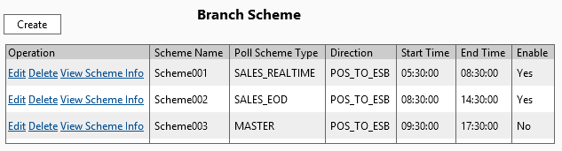

#### Data Fields & Presentation Logic

1. Default Sorting of Branch Info List, Priority from top to bottom

* Scheme Name (ascending)

1. Layout

| **Field** | **Object Type** | **Default Value** | **Mandatory (M/O/C)** | **Format** | **Action / Event / Response** | **Description** |
| --- | --- | --- | --- | --- | --- | --- |
| **Search Criteria** | | | | | | |
| **Scheme Name** | Text box | Blank | O | A(100) | - | Scheme name |
| **Direction** | Dropdown box | Blank | O | A(40) | - | Options  - STG_TO_EDW  - POS_TO_STG  - STG_TO_POS |
| **Start Time From** | Time picker | Blank | O | Time – hh:mm:ss | - | Lower range filter of start time |
| **Start Time To** | Time picker | Blank | O | Time – hh:mm:ss | - | Upper range filter of start time |
| **End Time From** | Time picker | Blank | O | Time – hh:mm:ss | - | Lower range filter of end time |
| **End Time To** | Time picker | Blank | O | Time – hh:mm:ss | - | Upper range filter of end time |
| **Enable** | Dropdown box | Blank | O | A(3) | - | Options  - Yes  - No |
| **Data Table** | | | | | | |
| **Poll Scheme Name** | Read-only text | Prefilled | - | A(100) | - | Poll scheme name |
| **Poll Scheme Type** | Read-only text | Prefilled | - | A20 | - | Poll Scheme Type is used to defined the set of tables this scheme will be covered   * SALES_REALTIME * SALES_EOD * MASTER |
| **Direction** | Read-only text | Prefilled | - | A(40) | - | Describe the direction of the data |
| **Start Time** | Read-only text | Prefilled | - | Time – hh:mm:ss | - | Start time of the poll scheme |
| **End Time** | Read-only text | Prefilled | - | Time – hh:mm:ss | - | Start time of the poll scheme |
| **Enable** | Read-only text | Prefilled | - | A(1) | - | * Yes * No |

#### Screen Objects & Action

|  |  |  |  |
| --- | --- | --- | --- |
| **Screen Object** | **Object Type** | **Action / Event / Response** | **Remarks** |
| Search | Button | Search out poll scheme records according to the input criteria. | N/A |
| Clear | Button | Reset all search criteria to blank. | N/A |
| Create | Button | Create a new entry of poll scheme. | N/A |
| Operation -**Edit** | Button | Edit the corresponding poll scheme record. | N/A |
| Operation -**Delete** | Button | Delete the corresponding poll scheme. | N/A |
| Operation -**Detail** | Button | View the corresponding poll scheme detail. | N/A |

#### User/Security Group

This function is accessible to the following user(s):

* System Administrator

#### Data Fields & Presentation Logic

N/A

#### Assumptions/Constraints

N/A

#### Error & Exception List

N/A

### Maintain Branch Scheme (Create/Edit/Delete)

#### Process/Work Flow

This function is to manipulate the detail of branch scheme records. The branch scheme records will display into the table within the page, and specific columns will display on screen, as some of them enabled as sorting function upon user’s requirements.

**Business Logic**

**Maintain Branch Scheme (Create)**

Home> Polling Configuration> Branch Scheme> Create

A pop-up dialog will appear to receive input from the user by clicking the “Create” button. On clicking the “save” button, the system will first validate fields’ mandatory and validity, and save to the branch scheme table upon successful validation.

**Maintain Branch Scheme (Edit)**

Home> Polling Configuration> Branch Scheme> Search Record> Edit

A pop-up dialog contain in original branch info detail values will appear to receive input from the user by clicking the “Edit” button. Same as record creation, on clicking the “save” button, the system also validate upon the values, and save the record’s update.

**Maintain Branch Scheme (Delete)**

Home> Polling Configuration> Branch Scheme> Search Record> Delete

A pop-up dialog will appear to asking the user for the confirmation of the deletion of the corresponding record. Once user clicks yes, the system will check whether the record has relations to other data, if no, the target record will be deleted.

#### Screen

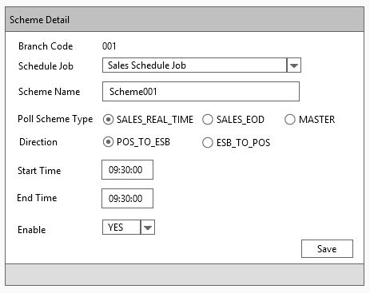

#### Data Fields & Presentation Logic

1. Default Sorting of Branch Info List, Priority from top to bottom

* Scheme Name (ascending)

1. Layout

|  |  |  |  |  |  |  |
| --- | --- | --- | --- | --- | --- | --- |
| **Field** | **Object Type** | **Default Value** | **Mandatory (M/O/C)** | **Format**  **A-character**  **N-number** | **Action / Event / Response** | **Description** |
| **Poll Scheme Name** | Textbox | Create-Blank  Edit- Prefilled | M | A(100) | Only allow  [a-zA-Z0-9-_] | Poll scheme name |
| **Poll Scheme Type** | Dropdown box | Create-Blank  Edit- Prefilled | M | A(20) | - | Poll Scheme Type is used to defined the set of tables this scheme will be covered   * SALES_REALTIME * SALES_EOD * MASTER |
| **Direction** | Dropdown box | Create-Blank  Edit- Prefilled | M | A(40) | - | Describe the direction of the data  - POS to Staging  - Staging to POS  - Staging to EDW  - EDW to Staging |
| **Start Time** | Time picker | Create-Blank  Edit- Prefilled | M | Time – hh:mm:ss | - | Start time of the poll scheme |
| **End Time** | Time picker | Create-Blank  Edit- Prefilled | M | Time – hh:mm:ss | - |  |
| **Enable** | Radio box | Create-Blank  Edit- Prefilled | M | A(3) | - | * Yes (enabled) * No (disabled) |

#### Screen Objects & Action

|  |  |  |  |
| --- | --- | --- | --- |
| **Screen Object** | **Object Type** | **Action / Event / Response** | **Remarks** |
| Save | Button | Save the created/edited content of the corresponding record | N/A |
| Close | Button | Cancel and discard all changes of corresponding created/edited record and back to the list page | - |

#### User/Security Group

This function is accessible to the following user(s):

* System Administrator

#### Data Fields & Presentation Logic

N/A

#### Assumptions/Constraints

N/A

#### Error & Exception List

|  |  |  |
| --- | --- | --- |
| **Error Code** | **Severity** | **Error Message** |
| S0003 | N/A | Mandatory fields not input. Please verify! |
| S0006 | N/A | Start time must be earlier than end time. |

### Maintain Scheme Info (List)

#### Process/Work Flow

This function is to display scheme information record according to user’s input criteria. The scheme info records will display into the table within the page, and specific columns will display on screen, as some of them enabled as sorting function upon user’s requirements.

**Business Logic**

The scheme info is to describe the set of table to be processed in a branch scheme under the category of field “poll scheme type”, so the poll branch scheme could use its poll scheme types to find tables to process according to the poll scheme type. Each scheme info record represents a single table processing logic.

1. By default, when the page is accessed, there’s no search criteria provided and all branch info will display on the page with pagination
2. User could conduct manipulations on searched-out records such as page switching, sorting by specific columns and refining.
3. User could conduct operational functions upon searched-out records such as Edit/Delete and view its details in the “Operation” column. (details included in session 6.4.7)

#### Screen

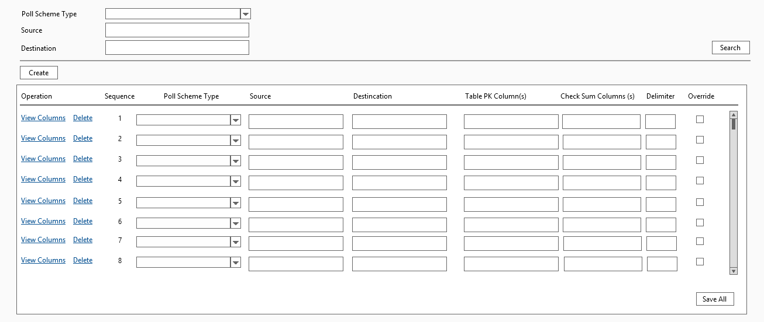

#### Data Fields & Presentation Logic

1. Default Sorting of Branch Info List, Priority from top to bottom

* Poll scheme type (ascending)
* From table (ascending)
* To table (ascending)

1. Layout

|  |  |  |  |  |  |  |
| --- | --- | --- | --- | --- | --- | --- |
| **Field** | **Object Type** | **Default Value** | **Mandatory (M/O/C)** | **Format** | **Action / Event / Response** | **Description** |
| **Search Criteria** | | | | | | |
| **Poll Scheme type** | Dropdown box | Blank | O | A(20) | - | Options  - Sales Real Time  - Sales EOD  - Master |
| **Source** | Textbox | Blank | O | A(100) | - | Like search |
| **Destination** | Textbox | Blank | O | A(100) | - | Like search |
| **Data Table** | | | | | | |
| **Poll Scheme Type** | Read-only text | Prefilled | - | A(20) | - | Poll scheme type |
| **Source** | Read-only text | Prefilled | - | A(100) | - | From table name |
| **Destination** | Read-only text | Prefilled | - | A(100) | - | To table name |
| **Table PK columns** | Read-only text | Prefilled | - | A(200) | - | Primary key column names |
| **Check Sum Columns** | Read-only text | Prefilled | - | A(200) | - | Check sum column names |
| **Delimiter** | Read-only text | Prefilled | - | A(1) | - | Delimiter for Test File Related Files in this scheme. E.g Tab, Comma |
| **Override** | Read-only text | Prefilled | - | A(3) | - | * Yes * No |

#### Screen Objects & Action

|  |  |  |  |
| --- | --- | --- | --- |
| **Screen Object** | **Object Type** | **Action / Event / Response** | **Remarks** |
| Search | Button | Search out poll scheme info records according to the input criteria | N/A |
| Clear | Button | Reset all search criteria to blank | N/A |
| Operation -**Add** | Button | Add a new entry of poll scheme info at the top of the data table | N/A |
| Operation -**Edit** | Button | Edit the corresponding poll scheme info record | N/A |
| Operation -**Delete** | Button | Delete the corresponding poll scheme info record | N/A |
| Operation -**Detail** | Button | Open a new penal to view and edit the corresponding poll scheme detail | N/A |

#### User/Security Group

This function is accessible to the following user(s):

* System Administrator

#### Assumptions/Constraints

N/A

#### Error & Exception List

N/A

### Maintain Scheme Info (Create/Edit/Delete)

#### Screen

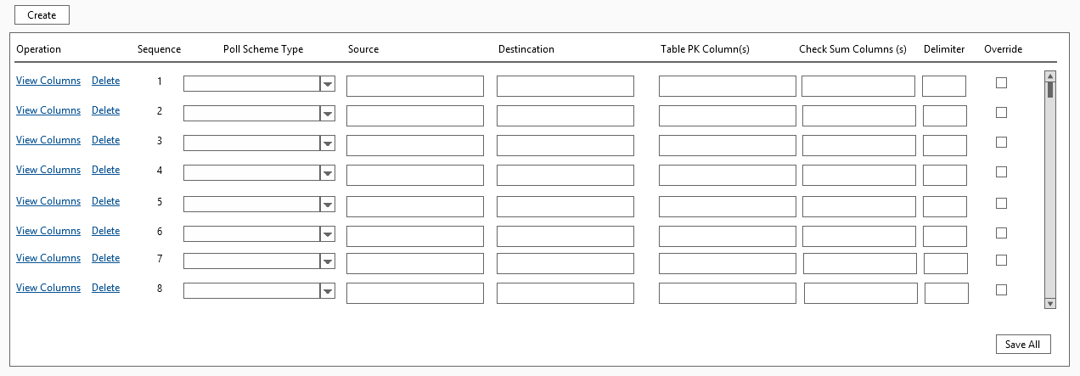

#### Data Fields & Presentation Logic

1. Layout

| **Field** | **Object Type** | **Default Value** | **Mandatory (M/O/C)** | **Format** | **Action / Event / Response** | **Description** |
| --- | --- | --- | --- | --- | --- | --- |
| **Poll Scheme Type** | Dropdown box | Prefilled | M | A(20) | - | Pre-configured options   * SALE_REALTIME * SALES_EOD * MASTER |
| **From table** | Textbox | Prefilled | M | A(100) | Only allow [a-zA-Z0-9_] | Free text table name |
| **To table** | Textbox | Prefilled | M | A(100) | Only allow [a-zA-Z0-9_] | Free text table name |
| **PK columns** | Textbox | Prefilled | C | A(200) | Only allow [a-zA-Z0-9_] | Free text primary key column names on table, separated by ‘,’ |
| **Check Sum Columns** | Textbox | Prefilled | O | A(200) | Only allow [a-zA-Z0-9_] | Free text check sum column names on target able, separated by ‘,’ |
| **Delimiter** | Textbox | Prefilled | O | A(1) | - | Delimiter for Test File Related Files in this scheme. E.g Tab, Comma |
| **Override** | Dropdown box | Prefilled | M | A(3) | When override = “Y”, PK columns must be blank and disabled | * Yes * No |

#### Screen Objects & Action

|  |  |  |  |
| --- | --- | --- | --- |
| **Screen Object** | **Object Type** | **Action / Event / Response** | **Remarks** |
| **Save** | Button | Save the created/edited content of the corresponding record | N/A |

#### User/Security Group

This function is accessible to the following user(s):

* System Administrator

#### Assumptions/Constraints

N/A

#### Error & Exception List

|  |  |  |
| --- | --- | --- |
| **Error Code** | **Severity** | **Error Message** |
| S0002 | N/A | This record has maintained relationship with other data. |
| S0003 | N/A | Mandatory fields not input. Please verify! |

### Maintain Table Column Info (List/Create/Edit/Delete)

#### Process/Work Flow

This function is to display the table’s column detail record of the corresponding poll scheme info. The scheme table columns details will display when user opens the detail panel of a single scheme info. Within the scheme detail panel, the table of table columns allows user to view the full list of table column, as well as create/edit and delete each row.

**Business Logic**

The table columns of a scheme info is to describe the column mapping from table to table of a scheme info. Therefore, the poll scheme info could use these columns to format a SQL string for the certain polling process on a table. Each table column represents a from table to table column mapping in the polling process.

1. By default, when the table columns table is displayed, the detail panel of a poll scheme info appears.
2. User could edit the from column to column to define the details of the table column, which represents the column mapping for the poll data process. Column mapping here is limited to one-to-one mapping.
3. User could conduct operational functions including “Add” “Edit” or “Remove” upon each row of a table column, from the “Operation” column.

#### Screen

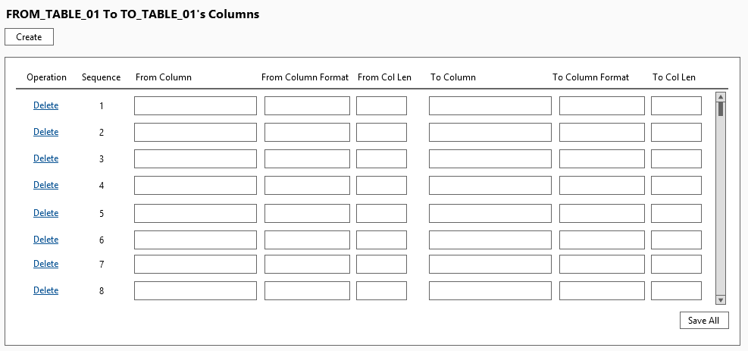

#### Data Fields & Presentation Logic

1. Default Sorting of Branch Info List, Priority from top to bottom

* Sequence (ascending)

1. Layout

|  |  |  |  |  |  |  |
| --- | --- | --- | --- | --- | --- | --- |
| **Field** | **Object Type** | **Default Value** | **Mandatory (M/O/C)** | **Format** | **Action / Event / Response** | **Description** |
| **Sequence** | Read-only text | Prefilled | - | N(*) | - | A Sequence for display and reference only |
| **From column** | Textbox | Original Value  /Blank | M | A(100) | Only allow input [a-zA-Z0-9_] | The from-column name (e.g STAFFID) |
| **From column format** | Textbox | Original Value  /Blank | M | A(20) | Only allow input [a-zA-Z0-9_] | The format of the column (e.g NUMEBER, YYYMMDD, STRING) |
| **From column length** | Textbox | Original Value  /Blank | O | A(10) | Only allow input [0-9]*(,)[0-9]* | The length of the column (e.g: 12,3) |
| **To Column** | Textbox | Original Value  /Blank | M | A(100) | Only allow input [a-zA-Z0-9_] | The to-column name |
| **To column format** | Textbox | Original Value  /Blank | M | A(20) | Only allow input [a-zA-Z0-9_] | The format of the column (e.g NUMEBER, YYYMMDD, STRING) |
| **To column length** | Textbox | Original Value  /Blank | O | A(10) | Only allow input [0-9]*(,)[0-9]* | The length of the column (e.g: 12,3) |

##### Screen Objects & Action

|  |  |  |  |
| --- | --- | --- | --- |
| **Screen Object** | **Object Type** | **Action / Event / Response** | **Remarks** |
| Create | Button | Append a new and empty table column setting record at the bottom of the table | N/A |
| Delete | Button | Remove the corresponding table column setting record from the table | N/A |
| Save | Button | Save the created/edited tables columns list for the editing poll scheme info | N/A |

#### User/Security Group

This function is accessible to the following user(s):

* System Administrator

#### Assumptions/Constraints

N/A

#### Error & Exception List

|  |  |  |
| --- | --- | --- |
| **Error Code** | **Severity** | **Error Message** |
| S0003 | N/A | Mandatory fields not input. Please verify! |

## Job Logs View

### Description

The “Job Logs View” function will display the status of the batch job.

Use Case functions

# Job Logs View (List)

# Job Logs View (Detail)

### Input

N/A

### Output

N/A

### Job Logs View (List)

#### Process/Work Flow

This function is to display the job logs records according the user input criteria. The log info will display into the table within the page, and specific columns will display on screen, as some of them enabled as sorting function upon user’s requirements.

**Business Logic**

The job logs view is to describe the status of the schedule jobs. Each record represents a scheduled job.

1. By default, when the page is accessed there is no search criteria selected and all job logs will display on the page with pagination. By clicking the search button, the filtered records will display in the table within the page.
2. User could conduct manipulations on searched-out records such as page switching, sorting by specific columns and refining.
3. User could view its details in the “Operation” column. (details included in session 6.5.5)

#### Screen

**Job Logs View (List)**

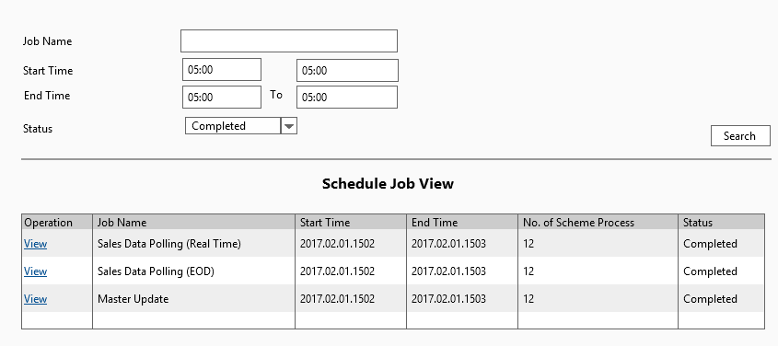

#### Data Fields & Presentation Logic

1. Default Sorting of Job Logs View List, Priority from top to bottom

* Start Time (descending)

1. Layout

| **Field** | **Object Type** | **Default Value** | **Mandatory (M/O/C)** | **Format** | **Action / Event / Response** | **Description** |
| --- | --- | --- | --- | --- | --- | --- |
| **Search Criteria** | | | | | | |
| **Job Name** | Textbox | Blank | O | A(50) | - |  |
| **Start Time From** | Date picker | Blank | O | Datetime  yyyy-mm-dd hhmm:ss | - | The lower range of job start time |
| **Start Time To** | Date picker | Blank | O | Datetime  yyyy-mm-dd hhmm:ss | - | The upper range of job start time |
| **End Time From** | Date picker | Blank | O | Datetime  yyyy-mm-dd hhmm:ss | - | The lower range of job end time |
| **End Time To** | Date picker | Blank | O | Datetime  yyyy-mm-dd hhmm:ss | - | The upper range of job end time |
| **Status** | Multiple select box | Blank | O | A(20) | - | Job status filter |
| **Data Table** | | | | | | |
| **Job Name** | Read-only text | Prefilled | - | A(50) | - | Job Name |
| **Start Time** | Read-only text | Prefilled | - | Datetime  yyyy-mm-dd hhmm:ss | - | The Start Time of the Job |
| **End Time** | Read-only text | Prefilled | - | Datetime  yyyy-mm-dd hhmm:ss | - | The End Time of the Job |
| **Status** | Read-only text | Prefilled | - | A(20) | - | The Status of the Job |
| **# Scheme** | Read-only text | Prefilled | - | N(10) | - | The number of the scheme of the job |

#### Screen Objects & Action

|  |  |  |  |
| --- | --- | --- | --- |
| **Screen Object** | **Object Type** | **Action / Event / Response** | **Remarks** |
| Operation -View | Button | View the corresponding job log detail | N/A |
| Search | Button | Search out schedule job log records according to the input criteria | N/A |

#### User/Security Group

This function is accessible to the following user(s):

* System Administrator
* System Operator

#### Assumptions/Constraints

N/A

#### Error & Exception List

N/A

### Job Logs View (Detail)

#### Process/Work Flow

**Job Logs View (Detail)**

This function is to display the detail log of a job according to the user selected. The details will be shown and the related job log info will display into the table and the specific columns will display on screen, as some of them enabled as sorting function upon user’s requirements.

**Business Logic**

The job logs view detail is to describe the status of the detail information of the schedule jobs. Each record represents a scheduled job.

#### Screen

**Job Logs View (Detail)**

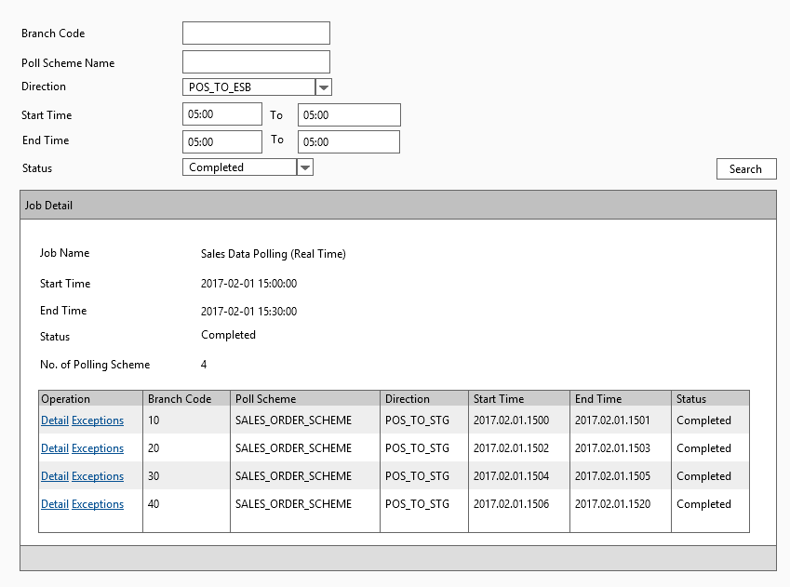

#### Data Fields & Presentation Logic

1. Default Sorting of the task list, Priority from top to bottom

* Start Time (descending)

1. Layout

| **Field** | **Object Type** | **Default Value** | **Mandatory (M/O/C)** | **Format** | **Action / Event / Response** | **Description** |
| --- | --- | --- | --- | --- | --- | --- |
| **Search Criteria** | | | | | | |
| **Branch Code** | Textbox | Blank | O | A(20) | - |  |
| **Poll Scheme Name** | Textbox | Blank | O | A(50) | - |  |
| **Direction** | Dropdown box | Blank | O | A(50) | - | Options  - STG_TO_POS  - POS_TO_STG  - STG_TO_EDW  - EDW_TO_STG |
| **Start Time From** | Date Picker | Blank | O | Datetime  yyyy-mm-dd hhmm:ss | - | The lower range of job start time |
| **Start Time To** | Date Picker | Blank | O | Datetime  yyyy-mm-dd hhmm:ss | - | The upper range of job start time |
| **End Time From** | Date Picker | Blank | O | Datetime  yyyy-mm-dd hhmm:ss | - | The lower range of job end time |
| **End Time To** | Date Picker | Blank | O | Datetime  yyyy-mm-dd hhmm:ss | - | The upper range of job end time |
| **Status** | Combo Box | Blank | O | A(20) | - | Job status filter |
| Data Table | | | | | | |
| **Job Name** | Read-only text | Prefilled | - | A(50) | - | Job Name |
| **Branch Code** | Read-only text | Prefilled | - | A(20) | - | The Branch Code of the Task |
| **Poll Scheme Name** | Read-only text | Prefilled | - | A(50) | - | The Poll Scheme Name of the Task |
| **Direction** | Read-only text | Prefilled | - | A(50) | - | Options  - STG_TO_POS  - POS_TO_STG  - STG_TO_EDW  - EDW_TO_STG |
| **Start Time** | Read-only text | Prefilled | - | Datetime  yyyy-mm-dd hhmm:ss | - | The Start Time of the Job |
| **End Time** | Read-only text | Prefilled | - | Datetime  yyyy-mm-dd hhmm:ss | - | The End Time of the Job |
| **Status** | Read-only text | Prefilled | - | A(20) | - | The Status of the Job |

#### Screen Objects & Action

|  |  |  |  |
| --- | --- | --- | --- |
| **Screen Object** | **Object Type** | **Action / Event / Response** | **Remarks** |
| Search | Button | Search out task job log info records according to the input criteria | N/A |
| Clear | Button | Reset all search criteria to blank | N/A |
| Detail | Button | Display the task run detail in the pop-up panel | N/A |
| Exceptions | Button | Display the task exceptions in the pop-up panel and format it in simple data table. | N/A |

#### User/Security Group

This function is accessible to the following user(s):

#### Assumptions/Constraints

N/A

#### Error & Exception List

N/A

## Sales Data Real Time Polling Batch Job

### Description

The scheduled batch job runs in the configurable time interval (e.g. 15 mins) to download POS client sales data from all active POS clients into the staging database. This is the pre-requisite batch job of the other batch which push real time sales data from staging database into EDW.

The job is triggered by a scheduler and it works as a task controller, submitting separated standalone tasks. Each task handles one available branch scheme. The job will handle the data in the pre-defined tables under the scheme according to the scheme configuration (e.g. direction, override logic, and validation).

In below session there will be the details descriptions about

1. Sales Data Real Time (POS - Staging) Scheduler
2. Sales Data Real Time (POS - Staging) Task

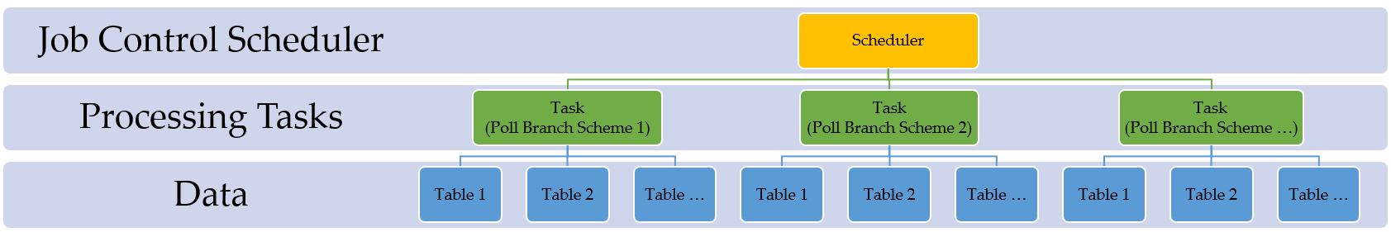

### Input

POS Client Sales Data (Real time)

### Output

Staging Sales Data (Real time)

### Sales Data Real Time (POS - Staging) Scheduler

#### Process/Work Flow

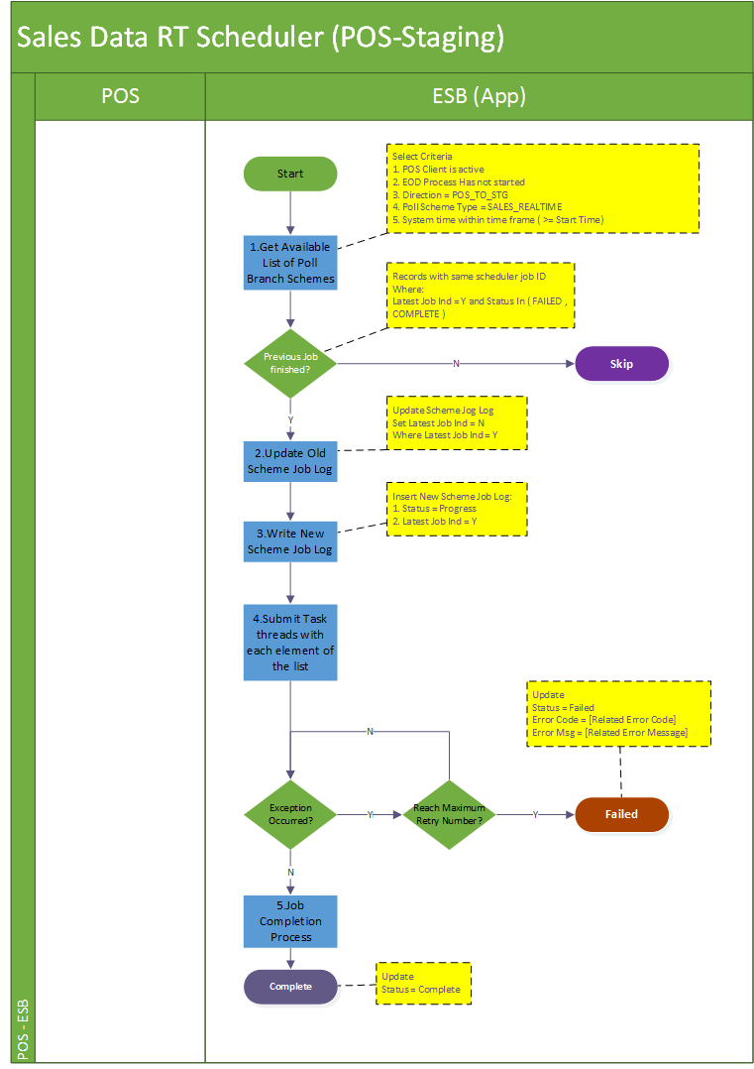

**Job Details**

The scheduler job is considered as the commander to handle the life cycle of poll scheme tasks for which it is responsible. With a proper criteria selection, the scheduler is supposed to submit a series of tasks into the pull and queue up for their own process and it logs down the running process in job logs and log files.

Summarily the schedule executes in below steps:

Step 1: This batch job will be triggered every 15 mins (configured). It would iterate all available data accumulated in poll branch scheme table (with condition POS client is enabled, the POS client has not yet conducted EOD process and the current time is greater or equal to the start time)

Step 2: Update scheduler job log. Firstly, update the previous job log’s latest job indicator from ‘Y’ to ‘N’. Onwards newly create scheduler job log is having the status “PROGRESS”. The latest batch indicator for the new record will be marked as “Y”, and that of the current batch will be marked as “P”.

Step 3: Submit processing tasks for all eligible poll branch schemes, which are selected in step 1.

Step 4: Upon any errors in the task submission and cannot be resolved (e.g. by retry). The job will abort and keep the job status to reflect the problematic stage “FAILED”.

Step 5: If all tasks of the poll branch schemes submitted successfully, the scheduler jobs will be regarded as complete and status will be updated “COMPLETE” with a record number of schemes processed.

|  |  |  |
| --- | --- | --- |
| **Job Name** | **Status** | **Description** |
| Sales Real Time Polling Scheduler | “PROGRESS”  “FAILED”  “COMPLETE” | “PROGRESS” when scheduler is invoked and started  “FAILED” when encounter errors reading poll scheme data from database or errors submitting tasks.  “COMPLETE” when scheduler job iterates all available poll schemes and submit related tasks of them and all these tasks are either completed or failed. |

**Logging**

Log directory: /repos/esb/polling/log/sales_rt_yyyymmdd.log

Upon each “poll branch scheme task” submission, the scheme info will be written into below format:

[INFO] [Timestamp] [Job Name] [Scheme name]-[branch code]-[scheme type]-[direction]

Upon any exceptions the process encounters, the exceptions will be written into follow format:

[ERROR] [Timestamp] [Job Name] [Scheme Name]-[branch code]-[scheme type]-[direction] [Error Code]-[Severity]-[Error Message]

**Entry & Exit Criteria**

The processing job starts once the schedule job invokes.

In the process of the scheduler job, it will be regarded as job failure and send alert email to IT support according to the error’s severity. For example:

1. Error occurs when error reading poll branch scheme data from staging database.
2. Error occurs when submitting the task of polling branch scheme into subsystem.

#### Screen

N/A

#### Data Fields & Presentation Logic

N/A

#### Screen Objects & Action

N/A

#### User/Security Group

This is a batch process belonging to the SYSTEM. So all auditable fields

#### Assumptions/Constraints

N/A

#### Error & Exception List

|  |  |  |
| --- | --- | --- |
| **Error Code** | **Severity** | **Error Message** |
| S0007 | HIGH | Failed to read poll scheme data. |
| S0008 | HIGH | Failed submit poll scheme processing task. |
| S0009 | HIGH | Failed to download target file. |
| S0010 | HIGH | Failed to process records into staging database. |

### Sales Data Real Time (POS - Staging) Task

#### Process/Work Flow

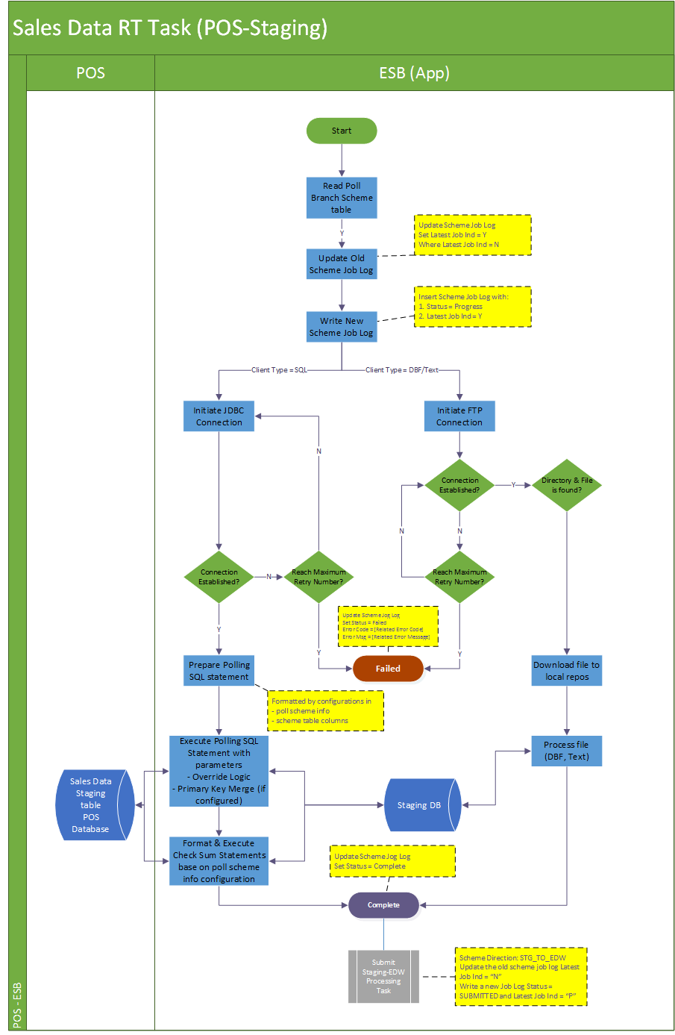

**Job Details**

The scheduler job is considered as the commander to handle the life cycle of poll scheme tasks for which it is responsible. With a proper criteria selection, the scheduler is supposed to submit a series of tasks into the pull and queue up for their own process and it logs down the running process in job logs and log files.

Summarily the task executes in below steps:

Step 1: Firstly, it will update the previous job log’s latest job indicator from ‘Y’ to ‘N’. Onwards newly create scheduler job log is having the status “PROGRESS”. The latest batch indicator for the new record will be marked as “Y”.

Step 2: Initiate the JDBC connection or file input from target source according to the client type.

Step 3: When the client type is SQL, use the poll scheme info and relevant table columns to format the polling SQL statement to processing the polling. If the client type is DBF, copy the file to local source folder, and initiate a JDBC connection upon the file and carry on the similar SQL statement process as SQL type. If the client type is text file, also copy the file to local source folder and use program to convert the text data into database column data.

Step 4: After polling SQL is successfully executed, a check sum will check upon the processed record upon the total record counts. The check sum columns will refer to the configuration in the poll scheme info.

Step 5: Upon any errors in the task submission and cannot be resolved (e.g. by retry). The job will abort and keep the job status to reflect the problematic stage “FAILED”. If the processing source is file-based, move the file to error folder.

Step 6: If all tasks successfully submitted, the task will be regarded as complete and job status will update to “COMPLETE” with a record number of schemes processed. If the processing source is file-based, move the file to backup folder.

Before the successful completion of the poll scheme task ends, it will select another poll scheme from DB with same features but different direction “STG_TO_EDW”. With the newly selected poll scheme info, status = “SUBMITTED”, latest job indicator = “P”, the “depend_on” field as current task’s job log ID, as well as the same scheduler ID (also regarded as batch ID), it submits a new task to process the data from staging to EDW (refer to session 6.7.6).

|  |  |  |
| --- | --- | --- |
| **Job Name** | **Status** | **Description** |
| Sales Real Time Polling Task | “PROGRESS”  “FAILED”  “COMPLETE” | “PROGRESS” when task is submitted and successfully insert log into DB.  “FAILED” when encounter errors processing the source and the poll branch scheme.  “COMPLETE” when the task completes the polling data against the target branch schemes without any errors. |

**Logging**

Log directory: /repos/esb/polling/log/sales_rt_yyyymmdd.log

Upon each “poll branch scheme task” submission: the scheme info will be written into the following format:

**File System**

/repos/esb/polling/input/dbf/source/filename_yyyymmddhhmmss.dbf

/repos/esb/polling/input/dbf/backup/filename_yyyymmddhhmmss.dbf

/repos/esb/polling/input/dbf/error/filename_yyyymmddhhmmss.dbf

/repos/esb/polling/input/text/source/filename_yyyymmddhhmmss.txt

/repos/esb/polling/input/text/backup/filename_yyyymmddhhmmss.txt

/repos/esb/polling/input/text/error/filename_yyyymmddhhmmss.txt

[INFO] [Timestamp] [Job Name] [Scheme name]-[branch code]-[scheme type]-[direction]

[ERROR] [Timestamp] [Job Name] [Scheme Name]-[branch code]-[scheme type]-[direction] [Error Code]-[Severity]-[Error Message]

**Entry & Exit Criteria**

The sales data real time processing task is submitted by the sales data real time scheduler job (session 6.6.4).

In the process of the task, it will be regarded as job failure and send alert email to IT support according to the error’s severity:

For example:

1. Error occurs when error initiating DB connection to target data source.
2. Error occurs when error retrieving target source file from target directory.
3. Error occurs when submitting the poll-branch-scheme-task of next step into subsystem.

#### Screen

N/A

##### Data Fields & Presentation Logic

N/A

##### Screen Objects & Action

N/A

##### User/Security Group

This is a batch process belonging to the SYSTEM. So all auditable fields of user will be “SYSTEM”

##### Assumptions/Constraints

N/A

##### Error & Exception List

|  |  |  |
| --- | --- | --- |
| **Error Code** | **Severity** | **Error Message** |
| S0011 | HIGH | Failed to establish FTP connection. |
| S0012 | HIGH | Target directory or file not found. |
| S0013 | HIGH | Failed to download target file. |
| S0014 | HIGH | Failed to establish JDBC connection. |
| S0015 | HIGH | Failed to process records into staging database. |
| S0016 | HIGH | Check sum failed on data in destination table [Table Name]. |

### Sales Data Real Time (Staging to EDW) Task

#### Process/Work Flow

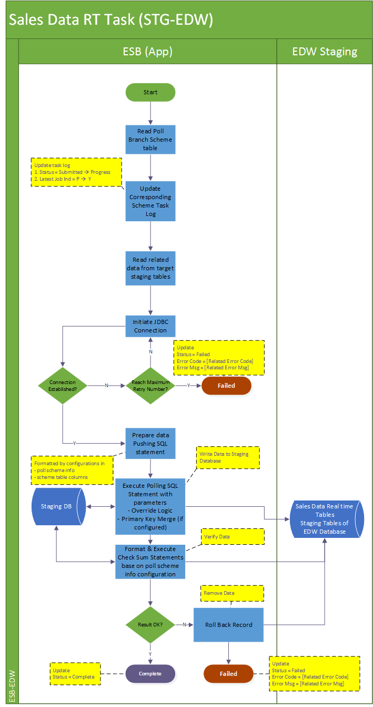

**Job Details**

The scheduler job is considered as the commander to handle the life cycle of poll scheme tasks for which it is responsible. With a proper criteria selection, the scheduler is supposed to submit a series of tasks into the pull and queue up for their own process and it logs down the running process in job logs and log files.

Summarily the task executes in below steps:

Step 1: Firstly, it will update the corresponding job log’s latest job indicator from ‘P’ to ‘Y’ and update the status from “SUBMITTED” to “PROGRESS” as the start of the execution.

Step 2: Initiate the JDBC connection towards the EDW data source.

Step 3: The task will select from staging tables with poll scheme info tables, and process the data which process ID = depend_on field value (processID exists in all polling data table in the staging which equals to the job log ID of the processing task, indicating which job has processed the record). Table by table, write the selected data into the corresponding table in EDW.

Step 4: After the process is successfully run for one table, a check sum will check upon the processed record upon the total record counts and the sum amount of the check sum column. The check sum columns will refer to the configuration in the poll scheme info. If the check sum process fails, the task will roll back all the records written or updated.

Step 5: Upon any errors in the task submission and cannot be resolved (e.g. by retry). The job will abort and keep the job status to reflect the problematic stage “FAILED”. If the processing source is file-based, move the file to error folder.

Step 6: If all steps of the task are successfully submitted, the task will be regarded as completed and it will update the job status to “COMPLETE” with a record number of schemes processed.

|  |  |  |
| --- | --- | --- |
| **Job Name** | **Status** | **Description** |
| Sales real time Polling Task (STG - EDW) | “SUBMITTED”  “PROGRESS”  “FAILED”  “COMPLETE” | “SUBMITTED” when the task is submitted into thread pool and queuing for execution  “PROGRESS” when task starts execution and successfully insert log into DB.  “FAILED” when encounter errors processing the source and the poll branch scheme.  “COMPLETE” when the task completes the polling data against the target branch schemes without any errors. |

**Logging**

Log directory: /repos/esb/polling/log/sales_rt_yyyymmdd.log

Upon each “poll branch scheme task” – (e.g POS to Staging or Staging to EDW) submission: the scheme info will be written into follow format:

**INFORMATION Related Log:**

[INFO] [Timestamp] [Job Name] [Scheme name]-[branch code]-[scheme type]-[direction]

**ERROR Related Log:**

[ERROR] [Timestamp] [Job Name] [Scheme Name]-[branch code]-[scheme type]-[direction] [Error Code]-[Severity]-[Error Message]

**Entry & Exit Criteria**

The sales data real time processing task (STG-EDW) is submitted by the prerequisite sales data real time processing task (POS-STG, refer to session 6.7.5).

In the process of the task, it will be regarded as job failure and send alert email to IT support according to the error’s severity

Error occurs when error initiating DB connection to EDW data source.

#### Screen

N/A

##### Data Fields & Presentation Logic

N/A

##### Screen Objects & Action

N/A

##### User/Security Group

This is a batch process belonging to the SYSTEM. So all auditable fields of user will refer to “SYSTEM”

##### Assumptions/Constraints

N/A

##### Error & Exception List

|  |  |  |
| --- | --- | --- |
| **Error Code** | **Severity** | **Error Message** |
| S0017 | HIGH | Failed to establish JDBC connection. |
| S0018 | HIGH | Failed to process records into EDW database. |
| S0019 | HIGH | Failed to read data from staging database |
| S0016 | HIGH | Check sum failed on data in destination table [Table Name]. |

##### Commitment Control

Whatever error will roll back the whole processing task.

## Sales Data EOD Polling Batch Job (POS-Staging)

### Description

The scheduled batch job runs in the configurable time interval (e.g. 5 mins) to monitor EOD indication data table (e.g. HIST_POSSYSTEM). This is the pre-requisite batch job of the other batch which push real time sales data from staging database into EDW.

The job is triggered by a scheduler and it works as a task controller, submitting separated standalone tasks. Each task handles one available branch scheme. The job will handle the data in the pre-defined tables under the scheme according to the scheme configuration (e.g. direction, override logic, and validation).

In below session there will be the details descriptions about:

1. Sales Data Real Time (POS - Staging) Scheduler
2. Sales Data Real Time (POS - Staging) Task

### Input

EOD Sales Data in POS client database

### Output

EOD Sales Data in staging database

### Sales Data EOD Scheduler

#### Process/Work Flow

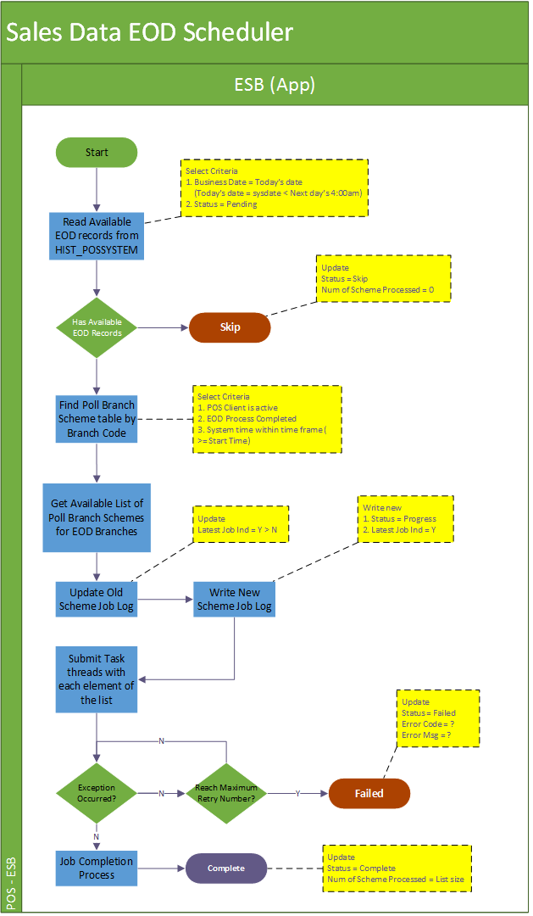

**Job Details**

The scheduler job is considered as the commander to handle the life cycle of EOD tasks for which it is responsible. It monitors the EOD tables’ records from POS client, when the EOD records is updated, the scheduler is supposed to submit the EOD task for the satisfied POS client and it logs down the running process in job logs and log files.

Summarily the schedule executes in below steps:

Step 1: This batch job will be triggered every 5 minutes (exact number of minutes configurable). It would iterate all available data source in “poll branch scheme” table for the EOD indicator. For SQL, there should be the business date record in HIST_POSSYSTEM table, for file-based data source, it should be the new EOD file is written in the target directory.

Step 2: Once the EOD indicator is available, it will update scheduler job log. To do so, it will firstly update the previous job log’s latest job indicator from ‘Y’ to ‘N’. Onwards newly create scheduler job log is having the status “PROGRESS”. The latest batch indicator for the new record will be marked as “Y”.

Step 3: Submit EOD processing tasks for all eligible poll branch schemes which has the EOD indicator available (verified in step 1).

Step 4: Upon any errors in the task submission and cannot be resolved (e.g. by retry). The job will abort and keep the job status to reflect the problematic stage “FAILED”.

Step 5: After the task completed submission, the scheduler will be regarded as completed and it will update the job status to “COMPLETE” with a record number of schemes processed.

|  |  |  |
| --- | --- | --- |
| **Job Name** | **Status** | **Description** |
| Sales EOD Polling Scheduler | “PROGRESS”  “FAILED”  “COMPLETE” | “PROGRESS” when scheduler is invoked and started  “FAILED” when encounter errors reading poll scheme data from database or errors submitting tasks.  “COMPLETE” when scheduler job iterates all available poll schemes and submit related tasks of them and all these tasks are either completed or failed. |

**Logging**

Log directory: /repos/esb/polling/log/sales_eod_yyyymmdd.log

Upon each poll branch scheme EOD task submission: the scheme info will be written into follow format:

[INFO] [Timestamp] EOD-[Scheme name]-[branch code]-[scheme type]-[direction]

**Entry & Exit Criteria**

The processing job starts once the schedule job invokes.

In the process of the scheduler job, it will be regarded as job failure and send alert email to IT support according to the error’s severity.

For example:

1. Error occurs when reading EOD indicator data from the target data sources.
2. Error occurs when looking up/downloading EOD file from target file directory.
3. Error occurs when error reading poll branch scheme data from staging database.
4. Error occurs when submitting EOD processing tasks into subsystem.

#### Screen

N/A

##### Data Fields & Presentation Logic

N/A

##### Screen Objects & Action

N/A

##### User/Security Group

This is a batch process belonging to the SYSTEM. So all auditable fields

##### Assumptions/Constraints

N/A

##### Error & Exception List

|  |  |  |
| --- | --- | --- |
| **Error Code** | **Severity** | **Error Message** |
| S0011 | HIGH | Failed to establish FTP connection. |
| S0013 | HIGH | Failed to download target file. |
| S0020 | HIGH | Failed to read target text/DBF file. File is broken. |
| S0017 | HIGH | Failed to establish JDBC connection. |

### Sales Data EOD (POS - STG) Task

#### Process/Work Flow

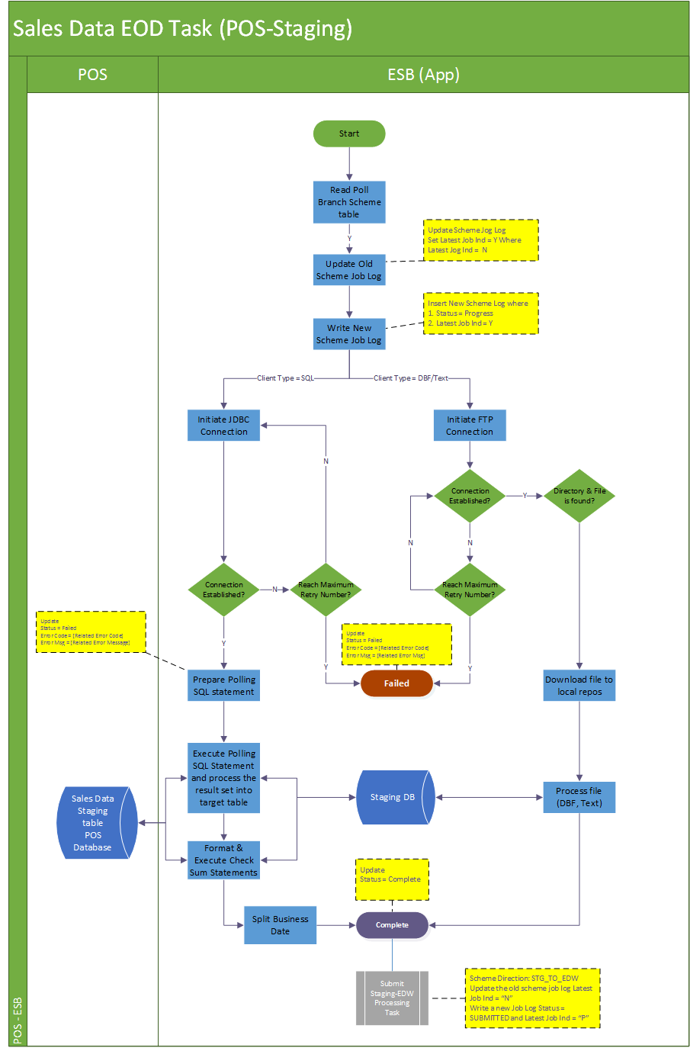

**Job Details**

The single EOD task job is considered as a single EOD process towards the target poll branch scheme, which is submitted by the EOD scheduler.

Summarily the task executes in below steps:

Step 1: Firstly, it will update the previous job log’s latest job indicator from ‘Y’ to ‘N’. Onwards newly create scheduler job log is having the status “PROGRESS”. The latest batch indicator for the new record will be marked as “Y”.

Step 2: Though the parent scheduler has already update the data source (SQL or file), because this is a separate process, the task will also try to initiate the JDBC connection or try to download the file from target source according to the client type.

Step 3: If the client type is SQL, use the poll scheme info to format the polling SQL statement to processing the polling. If the client type is DBF, copy the file to local source folder, and initiate a JDBC connection upon the file to process. If the client type is text file, also copy the file to local source folder and the system will process the source file. In this process, the split date process will carry out below checking and apply to all input data.

1. *When record transaction date < last cut-off time, then business date = transaction data - 1*
2. *When record transaction date > last cut-off time, then business date = transaction date*

*Example:*

|  |
| --- |
| EOD records in HIST_ORDER  Business Date, transaction date  25-Nov-2016, 25-Nov-2016 09:12 🡺 No change  25-Nov-2016, 25-Nov-2016 04:11 🡺 No change  ------ Cut off Time (04:00) ---------  Case 1: 25-Nov-2016, 25-Nov-2016 02:12 🡺 Business date changes to 24-Nov-2016  Case 2: 25-Nov-2016, 25-Nov-2016 06:33 🡺 Business date changes to 25-Nov-2016  Case 3: 25-Nov-2016, 24-Nov-2016 03:33 🡺 Business date changes to 23-Nov-2016 |

Step 4: After the polling SQL is successfully executed, a check sum will check upon the processed record upon the total record counts

Step 5: Upon any errors in the task submission and cannot be resolved (e.g. by retry). The job will abort and keep the job status to reflect the problematic stage “FAILED”. If the processing source is file-based, move the file to error folder.

Step 6: If all steps of the task successfully submitted, the task will be regarded as completed and it will update the job status to “COMPLETE” with a record number of schemes processed. If the processing source is file-based, move the file to backup folder. At the end of the successful completion process, the task will change the poll scheme’s direction to “STG_TO_EDW” and submit a new task upon it.

|  |  |  |
| --- | --- | --- |
| **Job Name** | **Status** | **Description** |
| Sales EOD Polling (POS-STG) Task | “PROGRESS”  “FAILED”  “COMPLETE” | “PROGRESS” when task is submitted and successfully insert log into DB.  “FAILED” when encounter errors processing the source and the poll branch scheme.  “COMPLETE” when the task completes the polling data against the target branch schemes without any errors. |

**Logging**

Log directory: /repos/esb/polling/log/sales_eod_yyyymmdd.log

Upon each EOD task submission: the scheme info will be written into follow format:

**File System**

/repos/esb/polling/input/dbf/source/[orginal file name].dbf

/repos/esb/polling /input/dbf/backup/eod_[orginal file name]_yyyymmddhhmmss.dbf

/repos/esb/polling/input/dbf/error/eod_[orginal file name]_yyyymmddhhmmss.dbf

/repos/esb/polling/input/text/source/[orginal file name].txt

/repos/esb/polling/input/text/backup/eod_[orginal file name]_yyyymmddhhmmss.txt

/repos/esb/polling/input/text/error/eod_[orginal file name]_yyyymmddhhmmss.txt

**Logging details**

[INFO] [Timestamp] [Job Name] [schemeName]-[branchCode]-[schemeType]-[direction] Start

[INFO] [Timestamp] [Job Name] [schemeType]-[fromTable]-[toTable]-[PK=?]-[checksum=?]-[override = ?] start execution

[INFO] [Timestamp] [Job Name] [schemeType]-[fromTable]-[toTable]-[PK=?]-[checksum=?]-[override = ?] processed = ?

[ERROR] [Timestamp] [Job Name] [schemeType]-[fromTable]-[toTable]-[PK=?]-[checksum=?]-[override = ?] SQL Error return Code = ?

….

[INFO] [Timestamp] [Job Name] [schemeName]-[branchCode]-[schemeType]-[direction] End

**Entry & Exit Criteria**

The sales data EOD processing task is submitted by the sales data EOD scheduler job (session 6.7.4) and triggered by corresponding EOD indicator the POS client from different kinds of data sources

In the process of the task, it will be regarded as job failure and send alert email to IT support according to the error’s severity.

1. Error occurs when error initiating DB connection to target data source.
2. Error occurs when error retrieving target source file from target directory.

Error occurs when submitting “poll branch scheme” tasks into subsystem.

#### Screen

N/A

##### Data Fields & Presentation Logic

N/A

##### Screen Objects & Action

N/A

##### User/Security Group

This is a batch process belonging to the SYSTEM. So all auditable fields

##### Assumptions/Constraints

N/A

##### Error & Exception List

|  |  |  |
| --- | --- | --- |
| **Error Code** | **Severity** | **Error Message** |
| S0011 | HIGH | Failed to establish FTP connection |
| S0012 | HIGH | Target directory or file not found |
| S0021 | HIGH | Failed to download target file |
| S0022 | HIGH | Failed to process records into staging database |

### Sales Data EOD (STG to EDW) Task

#### Process/Work Flow

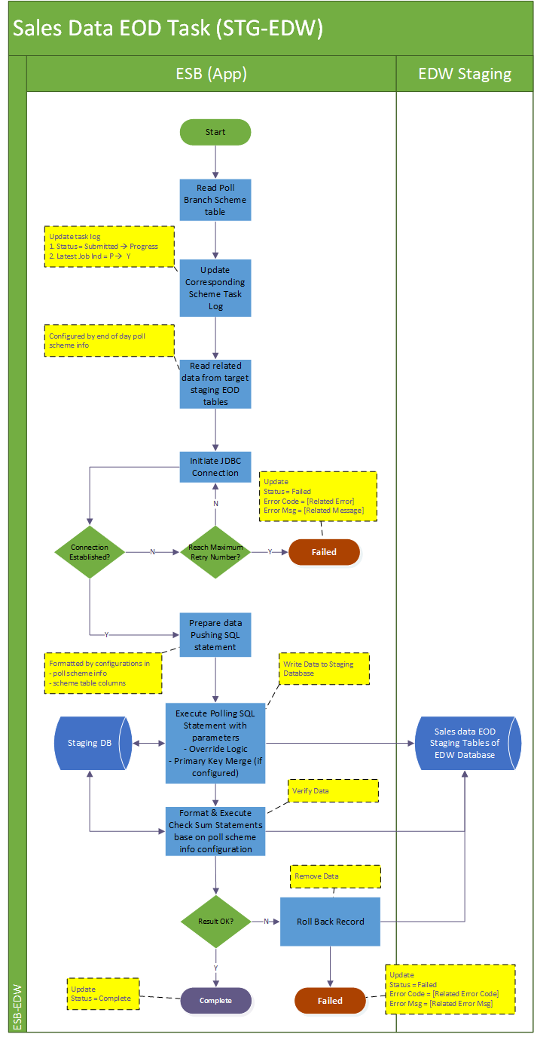

**Job Details**

This job is considered as standalone task to handle a single poll scheme for which it is responsible.

Summarily the task executes in below steps:

Step 1: It will update the corresponding job log’s latest job indicator from ‘P’ to ‘Y’ and update the status from “SUBMITTED” to “PROGRESS” as the start of the execution.

Step 2: Initiate the JDBC connection towards the EDW data source.

Step 3: The task will select from staging tables with poll scheme info tables (configure a set of history tables), and process the data which process ID = depend_on field value (processID exists in all polling data table in the staging which equals to the job log ID of the processing task, indicating which job has processed the record). Table by table, write the selected data into the corresponding table in EDW。 C

Step 4: After the process is successfully run for one table, a check sum will check upon the processed record upon the total record counts and the sum amount of the check sum column. The check sum columns will refer to the configuration in the poll scheme info.

Step 5: Upon any errors in the task submission and cannot be resolved (e.g. by retry). The job will abort and keep the job status to reflect the problematic stage “FAILED”. If the processing source is file-based, move the file to error folder.

Step 6: If all steps of the task are successfully submitted, the task will be regarded as completed and it will update the job status to “COMPLETE” with a record number of schemes processed.

|  |  |  |
| --- | --- | --- |
| **Job Name** | **Status** | **Description** |
| Sales EOD Polling Task (STG - EDW) | “SUBMITTED”  “PROGRESS”  “FAILED”  “COMPLETE” | “SUBMITTED” when the task is submitted into thread pool and queuing for execution  “PROGRESS” when task starts execution and successfully insert log into DB.  “FAILED” when encounter errors processing the source and the poll branch scheme.  “COMPLETE” when the task completes the polling data against the target branch schemes without any errors. |

**Logging**

Log directory: /repos/esb/polling/log/sales_eod_yyyymmdd.log

Upon each poll branch scheme task submission: the scheme info will be written into follow format:

[INFO] [Timestamp] [Job Name] [Scheme name]-[branch code]-[scheme type]-[direction]

[ERROR] [Timestamp] [Job Name] [Scheme Name]-[branch code]-[scheme type]-[direction] [Error Code]-[Severity]-[Error Message]

**Entry & Exit Criteria**

The sales data EOD processing task (STG-EDW) is submitted by the prerequisite sales data real time processing task (POS-STG, refer to session 6.7.5).

In the process of the task, it will be regarded as job failure and send alert email to IT support according to the error’s severity

Error occurs when error initiating DB connection to EDW data source.

#### Screen

N/A

##### Data Fields & Presentation Logic

N/A

##### Screen Objects & Action

N/A

##### User/Security Group

This is a batch process belonging to the SYSTEM. So all auditable fields of user will refer to “SYSTEM”

##### Assumptions/Constraints

N/A

##### Error & Exception List

|  |  |  |
| --- | --- | --- |
| **Error Code** | **Severity** | **Error Message** |
| S0014 | HIGH | Failed to establish JDBC connection. |
| S0018 | HIGH | Failed to process records into EDW database. |
| S0019 | HIGH | Failed to read data from staging database |
| S0016 | HIGH | Check sum failed on data in destination table [Table Name]. |

##### Commitment Control

Each successful insert of record will keep in database. In case error found, the re-run of EOD process will not process those successful committed records.

## Pricing/Master Data Generation (Pricing Server - Staging)

### Description

The generation of the pricing/master data will be considered to migrate the corresponding SQL server agent job from IT51/52/53 into a transitional database server (details described in impact analysis report).

The pricing/master generation process can be regarded as two main process

1. The original SQL server agent job which prepare the data in the pricing server tables
2. The oracle service bus DB adapter to monitor the delta changes of these tables
   1. DB adapters to monitor the master data table updates
   2. DB adapters to monitor the indicating data which represents the completion of the generation (impact provided and detail is explained in the impact analysis report)

### Input

Pricing/master data in pricing server

### Output

Pricing/master data in staging database

### Pricing/Master Data Process (Pricing - Staging)

#### Process/Work Flow

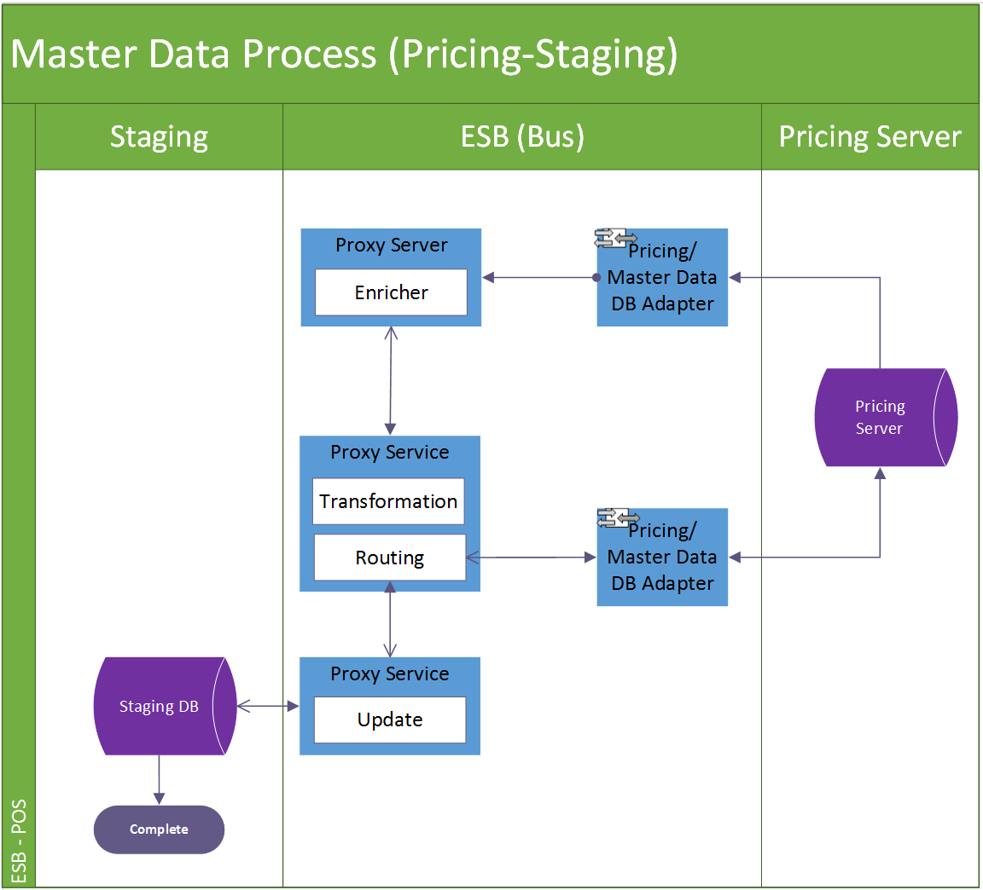

**Data process detail**

Step 1: DB adapters monitor in add/update in the target master tables. When there is new data coming in, capture the delta’s data sequencing ID as response.

Step 2: The pre-defined proxy service will use the captured ID to invoke a message enricher service to retrieve all details of the delta record.

Step 3. The enricher service will conduct a certain transformation and routing if necessary and eventually call the web service to update the delta data into staging DB.

#### Screen

N/A

##### Data Fields & Presentation Logic

N/A

##### Screen Objects & Action

N/A

##### User/Security Group

N/A

##### Assumptions/Constraints

N/A

##### Error & Exception List

N/A

## Pricing/Master Data Distribution Batch Job (Staging-POS)

### Description

While the pricing/master data is finished being updated into staging database, the main batch scheduler will run in every 15mins, to distribute the up-to-date pricing/master data into corresponding POS client according to their branch code as long as the pricing/master data generation is indicated with completion upon certain branch.

The pricing/master data distribution tasks is triggered by a proxy server and it works as a task controller, submitting separated standalone tasks. Each task handles one available branch scheme. The job will handle the data in the pre-defined tables under the scheme according to the scheme configuration (e.g. direction, override logic, and validation) and from table to table.

In below session there will be the details descriptions about

1. Pricing/Master data distribution (POS - Staging) Scheduler
2. Pricing/Master data distribution (POS - Staging) Task

### Input

Pricing/Master data in staging DB

### Output

Pricing/Master data in POS clients

### Pricing/Master Data Distribution Scheduler (MST-Staging)

#### Process/Work Flow

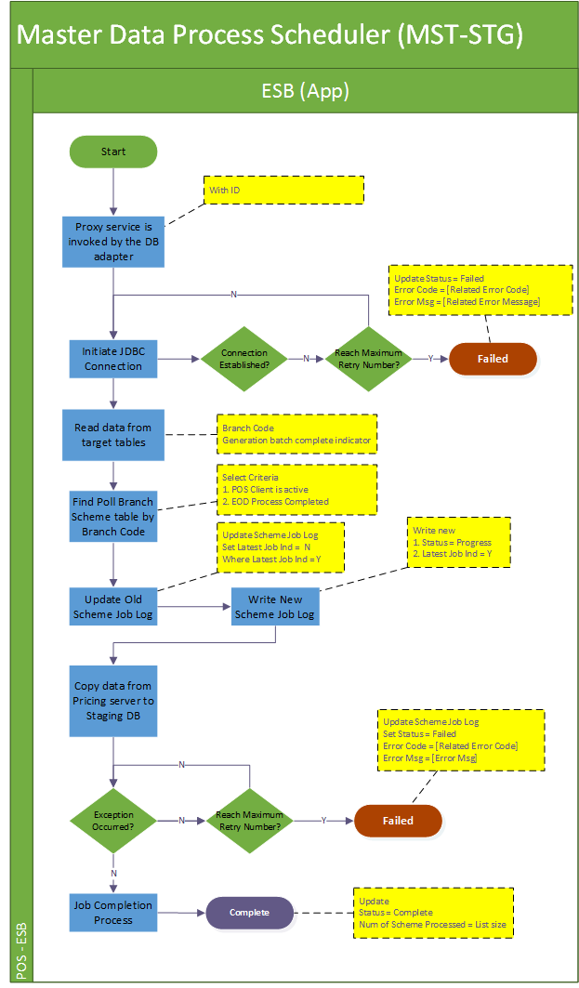

**Job Details**

The scheduler job is the main controller of all the pricing/master data distribution. It is invoked by a proxy service which is triggered by the OSB DB Adapter monitoring the indication data of the pricing/master data generation in pricing server. The scheduler not only submits pricing/master data distribution task upon specific poll branch scheme but also logs down the running process in job logs and log files.

Summarily the schedule executes in below steps:

Step 1: This batch job will be triggered every 15 mins (configured). It would iterate all available data source in poll branch scheme table which are under the poll scheme type = “MASTER” and direction = “STG_TO_POS”.

Step 2: Upon the scheduler job’s triggering, firstly it updates the previous job log’s latest job indicator from ‘Y’ to ‘N’. Onwards newly create scheduler job log is having the status “PROGRESS”. The latest batch indicator for the new record will be marked as “Y”.

Step 3: Submit pricing/master data distribution tasks for all eligible poll branch schemes selected in step 1.

Step 4: Upon any errors in the task submission and cannot be resolved (e.g. by retry). The job will abort and keep the job status to reflect the problematic stage “FAILED”.

Step 5: After the task submission, the scheduler will be regarded as complete and it will update the job status to “COMPLETE” with a record number of schemes processed.

|  |  |  |
| --- | --- | --- |
| **Job Name** | **Status** | **Description** |
| Sales EOD Polling Scheduler | “PROGRESS”  “FAILED”  “COMPLETE” | “PROGRESS” when scheduler is invoked and started  “FAILED” when encounter errors reading poll scheme data from database or errors submitting tasks.  “COMPLETE” when scheduler job iterates all available poll schemes and submit related tasks of them and all these tasks are either completed or failed. |

**Logging**

Log directory: /repos/esb/polling/log/master_yyyymmdd.log

Upon each poll branch scheme pricing/master distribution task submission: the scheme info will be written into follow format:

[INFO] [Timestamp] MASTER-[Scheme name]-[branch code]-[scheme type]-[direction]

**Entry & Exit Criteria**

The processing job starts once the schedule job is invoked by the proxy service.

In the process of the scheduler job, it will be regarded as job failure and send alert email to IT support according to the error’s severity as follows:

1. Error occurs when reading pricing/master data from the target data sources
2. Error occurs when error initiating JDBC connection toward poll branch scheme data source.
3. Error occurs when submitting distribution task into subsystem.

#### Screen

N/A

##### Data Fields & Presentation Logic

N/A

##### Screen Objects & Action

N/A

##### User/Security Group

This is a batch process belonging to the SYSTEM. So all auditable fields

##### Assumptions/Constraints

N/A

##### Error & Exception List

|  |  |  |
| --- | --- | --- |
| **Error Code** | **Severity** | **Error Message** |
| S0023 | HIGH | Failed to submit distribution task. |
| S0014 | HIGH | Failed to establish JDBC connection. |
| S0029 | HIGH | Failed to save the file %f to POS client. |

### Pricing/Master Data Distribution Task (Staging-POS)

#### Process/Work Flow

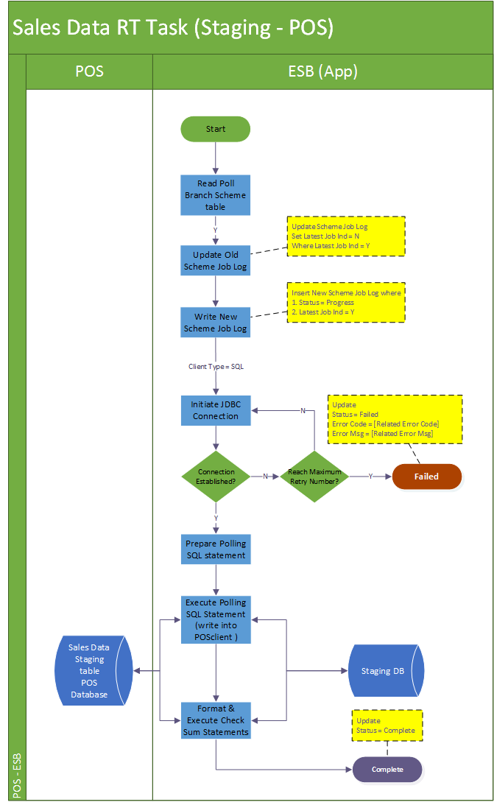

**Job Details**

The single distribution task job is designed to handle master data towards the target “poll branch scheme”.

Summarily the task executes in below steps:

Step 1: It will update the previous job log’s latest job indicator from ‘Y’ to ‘N’. Onwards newly create scheduler job log is having the status “PROGRESS”. The latest batch indicator for the new record will be marked as “Y”.

Step 2: The task will also try to initiate the JDBC connection toward the target POS client.

Step 3: Use the poll scheme info to format the polling SQL statement to processing the polling.

Step 4: after distribution-SQL is successfully executed and copy all wanted master data into POS client, update the corresponding indicator in the master data table in staging database representing the staging and POS client are synchronized.

Step 5: Upon any errors in the task submission and cannot be resolved (e.g. by retry). The job will roll back to discard the change, abort and keep the job status to reflect the problematic stage “FAILED”. If the processing source is file-based, move the file to error folder.

Step 6: If all steps of the task are run successfully, the task will be regarded as completed and it will update the job status to “COMPLETE” with a record number of schemes processed.

|  |  |  |
| --- | --- | --- |
| **Job Name** | **Status** | **Description** |
| Sales EOD Polling Task | “PROGRESS”  “FAILED”  “COMPLETE” | “PROGRESS” when task is submitted and successfully insert log into DB.  “FAILED” when encounter errors processing the source and the poll branch scheme.  “COMPLETE” when the task completes the polling data against the target branch schemes without any errors. |

**Logging**

Log directory: /repos/esb/polling/log/master_yyyymmdd.log

Upon each master distribution task processing: the scheme info will be written into follow format:

Logging details:

[INFO] [Timestamp] MASTER -[schemeName]-[branchCode]-[schemeType]-[direction] Start

[INFO] [Timestamp] MASTER -[schemeType]-[fromTable]-[toTable]-[PK=?]-[checksum=?]-[override = ?] Start Execution

[INFO] [Timestamp] MASTER -[schemeType]-[fromTable]-[toTable]-[PK=?]-[checksum=?]-[override = ?] Processed = ?

[ERROR] [Timestamp] MASTER -[schemeType]-[fromTable]-[toTable]-[PK=?]-[checksum=?]-[override = ?] SQL Error return Code = ?

….

[INFO] [Timestamp] MASTER-[schemeName]-[branchCode]-[schemeType]-[direction] End

**Entry & Exit Criteria**

The pricing/master data distribution task is submitted by the pricing/master data distribution scheduler job (session 6.10.4).

In the process of the task, it will regard as job failure and send alert email to IT support according to the error’s severity.

1. Error occurs when error initiating DB connection to target data source with retry.
2. Error occurs when executing distribution SQL statement to write pricing/master data into POS client.

#### Screen

N/A

##### Data Fields & Presentation Logic

Refer to Appendix C “Master Data Table Field Mapping”

##### Screen Objects & Action

N/A

##### User/Security Group

This is a batch process belonging to the SYSTEM. So all auditable fields

##### Assumptions/Constraints

N/A

##### Error & Exception List

|  |  |  |
| --- | --- | --- |
| **Error Code** | **Severity** | **Error Message** |
| S014 | HIGH | Failed to establish JDBC connection |
| S024 | HIGH | Failed to process records into target POS client [branch code = ?] [SQLCOD = ?]. |

## System Dashboard View

### Description

The “System Dashboard” function will display the running status active ESB job.

Use Case functions

#System Dashboard View (Active Scheduler Status)

#System Dashboard View (Current Date EOD Process)

### Input

N/A

### Output

N/A

### System Dashboard View (Active Scheduler Status)

#### Process/Work Flow

This function is to display the running status of ESB job.

**Business Logic**

The job logs view is to describe the running status of the scheduled job.

1. By default, all the active jobs and their running status will display

#### Screen

**System Dashboard View (Active Main Schedulers)**

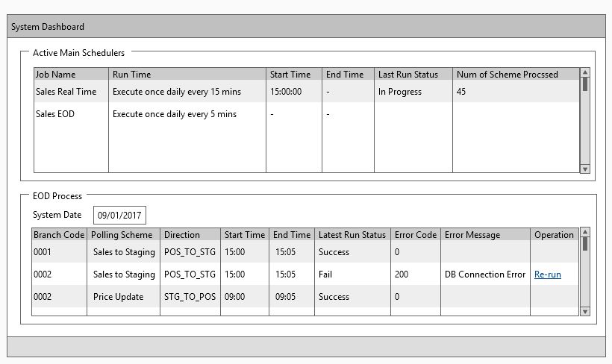

#### Data Fields & Presentation Logic

1. Default Sorting of Job Logs View List, Priority from top to bottom

* Name (Ascending)

1. Layout

| **Field** | **Object Type** | **Default Value** | **Mandatory (M/O/C)** | **Format** | **Action / Event / Response** | **Description** |
| --- | --- | --- | --- | --- | --- | --- |
| **Job Name** | Read-only text | Prefilled | - | A50 | - | Job Name |
| **Run Time** | Ready only text | Prefilled | - | A200 | - | Description of each job recurring pattern. (e.g. When it will start, re-run for every n minutes) |
| **Start Time** | Ready only text | Prefilled | - | Datetime  yyyy-mm-dd hhmm:ss | - | Start Time |
| **End Time** | Ready only text | Prefilled | - | Datetime  yyyy-mm-dd hhmm:ss | - | End Time |
| **Last Run Status** | Ready only text | Prefilled | - | A100 | - | Last Run Status |
| **No. of Scheme Processed** | Ready only text | Prefilled | - | N(*) | - | No. of Scheme Processed |

#### Screen Objects & Action

N/A

#### User/Security Group

This function is accessible to the following user(s):

* System Administrator
* System Operator

#### Assumptions/Constraints

N/A

#### Error & Exception List

N/A

### System Dashboard View (EOD Process)

#### Process/Work Flow

This function is to display the running status of EOD process.

**Business Logic**

The job logs view is to describe the running status of the scheduled EOD job.

1. By default, all the EOD jobs and their running status will display

#### Screen

**System Dashboard View (EOD Process)**



#### Data Fields & Presentation Logic

1. Default Sorting of Job Logs View List, Priority from top to bottom

* Polling Scheme (ascending)

1. Layout

| **Field** | **Object Type** | **Default Value** | **Mandatory (M/O/C)** | **Format** | **Action / Event / Response** | **Description** |
| --- | --- | --- | --- | --- | --- | --- |
| **Branch Code** | Read-only text | Prefilled | - | A17 | - | Branch Code |
| **Polling Scheme** | Ready only text | Prefilled | - | A100 | - | Polling Scheme |
| **Direction** | Ready only text | Prefilled | - | A10 | - | Direction |
| **Start Time** | Ready only text | Prefilled | - | Time – hh:mm:ss | - | Start Time |
| **End Time** | Ready only text | Prefilled | - | Time – hh:mm:ss | - | End Time |
| **Last Run Status** | Ready only text | Prefilled | - | A100 | - | Last Run Status |
| **Error Code** | Ready only text | Prefilled | - | N(*) | - | Error Code |
| **Error Message** | Ready only text | Prefilled | - | A200 | - | Error Message |

#### Screen Objects & Action

|  |  |  |  |
| --- | --- | --- | --- |
| **Screen Object** | **Object Type** | **Action / Event / Response** | **Remarks** |
| Operation–**Re-run** | Button | Re-run the selected Job | N/A |

#### User/Security Group

This function is accessible to the following user(s):

* System Administrator

#### Assumptions/Constraints

N/A

#### Error & Exception List

|  |  |  |
| --- | --- | --- |
| **Error Code** | **Severity** | **Error Message** |
| S0025 | N/A | Job Re-run failed with error message: %s |
| Successful message | N/A | EOD Job Re-run Successfully |

## System Parameter Maintenance

### Description

The “Scheduler Parameter Maintenance” function allows system administrator to update and retrieve the parameter of ESB system.

Use Case functions

# Maintain System Parameter (List)

# Maintain System Parameter (Create/Edit)

### Input

N/A

### Output

N/A

### Maintain System Parameter (List) / (Create/Edit)

#### Process/Work Flow

This function is to display the application parameters.

**Business Logic**

The job logs view is to describe the status of the web logic running status.

1. By default, all system parameter information of the system will display.

#### Screen

**System Parameter View (List)**

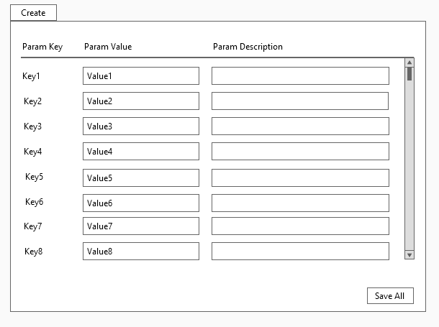

#### Data Fields & Presentation Logic

1. Default Sorting of System Parameter View List, Priority from top to bottom

* Param Key (ascending)

1. Layout

| **Field** | **Object Type** | **Default Value** | **Mandatory (M/O/C)** | **Format** | **Action / Event / Response** | **Description** |
| --- | --- | --- | --- | --- | --- | --- |
| **Param Key** | Read-only text | Prefilled | - | N(*) | - | Parameter Key ID (System Generated) |
| **Param**  **Value** | Textbox |  | M | A100 | - | Parameter Value |
| **Param Description** | Textbox |  | M | A500 | - | Parameter Description |

#### Screen Objects & Action

|  |  |  |  |
| --- | --- | --- | --- |
| **Screen Object** | **Object Type** | **Action / Event / Response** | **Remarks** |
| Create | Button | Click to add new parameter with largest parameter key | N/A |
| Save All | Button | Click to save all system parameter | N/A |

#### User/Security Group

This function is accessible to the following user(s):

* System Administrator

#### Assumptions/Constraints

Parameter settings will be effective immediately.

#### Error & Exception List

|  |  |  |
| --- | --- | --- |
| **Error Code** | **Severity** | **Error Message** |
| S0026 | N/A | Empty parameter value inputted. |
| S0027 | N/A | Empty parameter description inputted. |

## Export Daily Report

### Description

The “Export Daily Report” function allows system administrator/system operator to export the daily report.

Use Case functions

# Export Daily Report

### Input

N/A

### Output

To be specified in technical specification.

### Maintain System Parameter (List) / (Create/Edit)

#### Process/Work Flow

This function is to display the application parameters.

**Business Logic**

The export function to describe the daily running status to users.

1. By default, all system parameter information of the system will display.

#### Screen

**System Parameter View (List)**

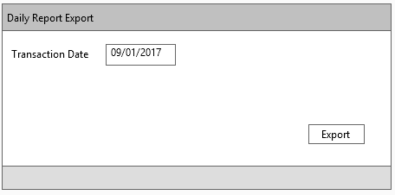

#### Data Fields & Presentation Logic

N/A

1. Layout

| **Field** | **Object Type** | **Default Value** | **Mandatory (M/O/C)** | **Format** | **Action / Event / Response** | **Description** |
| --- | --- | --- | --- | --- | --- | --- |
| **Transaction Date** | Date picker | Current Date | M | D | - | Transaction Date |

#### Screen Objects & Action

|  |  |  |  |
| --- | --- | --- | --- |
| **Screen Object** | **Object Type** | **Action / Event / Response** | **Remarks** |
| Export | Button | Click to export daily report | N/A |

#### User/Security Group

This function is accessible to the following user(s):

* System Administrator
* System Operator

#### Assumptions/Constraints

Parameter settings will be effective immediately.

#### Error & Exception List

N/A

# Interface Design

## Sales Data Web Service

### Process/Work Flow

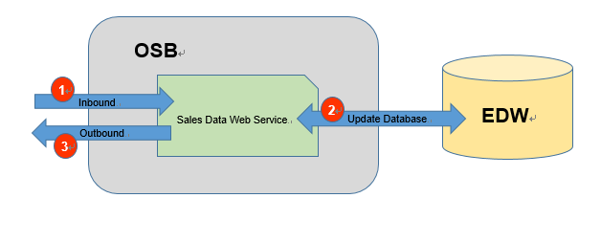

Staging Tables of

1. Send the request the OSB Restful Sales Data Web Service through HTTP.
2. The service will update the staging tables of EDW by the request content.
3. The Service will return the status to indicate whether the update is success.

Interface Design

Inbound Interface Format (Remarks and JSON Example to be provided)

<salesOrder>

| **#** | **Field Name** | **Description** | **Is Required** | **Format** | **Remarks** | **XML Example** | **JSON Example** |
| --- | --- | --- | --- | --- | --- | --- | --- |
| 1 | branchId | Maxim’s Branch ID | Y | String |  | <branchId>MXM  </branchId> | {“branchId”:”MXM”} |
| 2 | businessDate | Transaction Business Date | Y | Date |  | <businessDate>2016-01-01</businessDate> | {“businessDate”:”2016-01-01”} |
| 3 | orderNo | Transaction order no. | Y | String |  | <orderNo>OR12345  </orderNo> | {“orderNo”:”OR12345”} |
| 4 | orderSequence | Transaction order sequence | Y | Numeric (5,0) |  | < orderSequence>1  </orderSequence> | {“orderSequence”:”1”} |
| 5 | eventNo | Event Order no. | N | String |  | <eventNo>  </eventNo> | {"eventNo":""} |
| 6 | tableNo | Table no. | Y | String |  | <tableNo>  </tableNo> | {"tableNo":""} |
| 7 | guest | Number of guests | Y | Numeric (5,0) |  | <guest>  </guest> | {"guest":""} |
| 8 | printTimes | Number of times the pay check is printed | Y | Numeric (5,0) |  | <printTimes>  </printTimes> | {"printTimes":""} |
| 9 | printUserId1 | Print User ID 1 | N | String |  | <printUserId1>  </printUserId1> | {"printUserId1":""} |
| 10 | printUserId2 | Print User ID 2 | N | String |  | <printUserId2>  </printUserId2> | {"printUserId2":""} |
| 11 | printUserId3 | Print User ID 3 | N | String |  | <printUserId3>  </printUserId3> | {"printUserId3":""} |
| 12 | currencyCode | Currency Code | Y | String |  | <currencyCode>  </currencyCode> | {"currencyCode":""} |
| 13 | bevamt | Beverage Sales Amount | Y | Numeric (19,4) |  | <bevamt>  </bevamt> | {"bevamt":""} |
| 14 | foodamt | Food Sales Amount | Y | Numeric (19,4) |  | <foodamt>  </foodamt> | {"foodamt":""} |
| 15 | servamt | Service Charge Amount | Y | Numeric (19,4) |  | <servamt>  </servamt> | {"servamt":""} |
| 16 | discCode | Discount Code | N | String |  | <discCode>  </discCode> | {"discCode":""} |
| 17 | discRatio | Discount Ratio | Y | Numeric (19,4) |  | <discRatio>  </discRatio> | {"discRatio":""} |
| 18 | discAmt | Discount Amount | Y | Numeric (19,4) |  | <discAmt>  </discAmt> | {"discAmt":""} |
| 19 | taxCode | Tax Code | N | String |  | <taxCode>  </taxCode> | {"taxCode":""} |
| 20 | taxAmt | Tax Amount | Y | Numeric (19,4) |  | <taxAmt>  </taxAmt> | {"taxAmt":""} |
| 21 | orderType | Order type | Y | String |  | <orderType>  </orderType> | {"orderType":""} |
| 22 | spTransType |  | N | String |  | <spTransType>  </spTransType> | {"spTransType":""} |
| 23 | transType | Transaction type | Y | String |  | <transType>  </transType> | {"transType":""} |
| 24 | chargeDept | Charging Department | N | String |  | <chargeDept>  </chargeDept> | {"chargeDept":""} |
| 25 | chargeReason | Charging Reason | N | String |  | <chargeReason>  </chargeReason> | {"chargeReason":""} |
| 26 | chargeUserId | Charge User ID | N | String |  | <chargeUserId>  </chargeUserId> | {"chargeUserId":""} |
| 27 | openTillNo | Till machine on which the sales order is opened | Y | String |  | <openTillNo>  </openTillNo> | {"openTillNo":""} |
| 28 | closeTillNo | Till machine on which the sales order is closed | Y | String |  | <closeTillNo>  </closeTillNo> | {"closeTillNo":""} |
| 29 | openUserId | User ID of staff who opens the sales order | Y | String |  | <openUserId>  </openUserId> | {"openUserId":""} |
| 30 | closeUserId | User ID of staff who closes the sales order | Y | String |  | <closeUserId>  </closeUserId> | {"closeUserId":""} |
| 31 | checkInDateTime | Sales order check-in date time | Y | datetime |  | <checkInDateTime>  </checkInDateTime> | {"checkInDateTime":""} |
| 32 | checkOutDateTime | Sales order check-out date time | lY | datetime |  | <checkOutDateTime>  </checkOutDateTime> | {"checkOutDateTime":""} |
| 33 | voidFlag | Void sales order flag | Y | String |  | <voidFlag>  </voidFlag> | {"voidFlag":""} |
| 34 | voidDateTime | Void Sales date time | Y | datetime |  | <voidDateTime>  </voidDateTime> | {"voidDateTime":""} |
| 35 | voidId | Void ID | N | String |  | <voidId>  </voidId> | {"voidId":""} |
| 36 | reasonCode | Void reason | N | String |  | <reasonCode>  </reasonCode> | {"reasonCode":""} |
| 37 | remarks01 | Remark 1 | N | String |  | <remarks01>  </remarks01> | {"remarks01":""} |
| 38 | remarks02 | Remark 2 | N | String |  | <remarks02>  </remarks02> | {"remarks02":""} |
| 39 | remarks03 | Remark 3 | N | String |  | <remarks03>  </remarks03> | {"remarks03":""} |
| 40 | dataSource | Data Source of the sales (e.g. “OM” for Order Management; “Lunch” for Lunch Box system) | Y | String |  | <dataSource>  </dataSource> | {"dataSource":""} |
| 41 | lastUpdateUser | Last update by (user id by which the convert process or adjustment is done) | Y | String |  | <lastUpdateUser>  </lastUpdateUser> | {"lastUpdateUser":""} |
| 42 | lastUpdateTime | Last update date time | Y | datetime |  | <lastUpdateTime>  </lastUpdateTime> | {"lastUpdateTime":""} |
| 43 | workstationName | Server at which the convert process take place | Y | String |  | <workstationName>  </workstationName> | {"workstationName":""} |
| 44 | appNmae | Program name of convert process | Y | String |  | <appNmae>  </appNmae> | {"appNmae":""} |
| 45 | runno | Run ID of the convert process | Y | Numeric (5,0) |  | <runno>  </runno> | {"runno":""} |
| 46 | status | Whether or not the sales data is counted as store sales | N | String |  | <status>  </status> | {"status":""} |

<salesItem>

| **#** | **Field Name** | **Description** | **Is Required** | **Format** | **Remarks** | **XML Example** | **JSON Example** |
| --- | --- | --- | --- | --- | --- | --- | --- |
| 1 | branchId | Maxim’s Branch ID | Y | String |  | < branchId>MXM  </branchId> | {“branchId”:”MXM”} |
| 2 | businessDate | Transaction Business Date | Y | Date |  | < businessDate>2016-01-01  </businessDate> | {“businessDate”:”2016-01-01”} |
| 3 | orderNo | Transaction order no. | Y | String |  | < orderNo>OR12345  </orderNo> | {“orderNo”:”OR12345”} |
| 4 | orderSequence | Transaction order sequence | Y | Numeric (5,0) |  | < orderSequence>1  </orderSequence> | {“orderSequence”:”1”} |
| 5 | eventNo | Event Order no. | N | String |  | <eventNo>  </eventNo> | {"eventNo":""} |
| 6 | itemSequence | Transaction item sequence | Y | Numeric (5,0) |  | <itemSequence>  </itemSequence> | {"itemSequence":""} |
| 7 | subitemSequence | Transaction item sub-sequence | Y | Numeric (5,0) |  | <subitemSequence>  </subitemSequence> | {"subitemSequence":""} |
| 8 | itemno | Item no. | Y | Numeric (5,0) |  | <itemno>  </itemno> | {"itemno":""} |
| 9 | category | Item category | Y | String |  | <category>  </category> | {"category":""} |
| 10 | itemDescription | Item code description | Y | String |  | <itemDescription>  </itemDescription> | {"itemDescription":""} |
| 11 | listPrice | Listed Unit price | Y | Numeric (19,4) |  | <listPrice>  </listPrice> | {"listPrice":""} |
| 12 | price | Unit price | Y | Numeric (19,4) |  | <price>  </price> | {"price":""} |
| 13 | qty | Transaction Quantity | Y | Numeric (19,4) |  | <qty>  </qty> | {"qty":""} |
| 14 | itemTot | Item sales total | Y | Numeric (19,4) |  | <itemTot>  </itemTot> | {"itemTot":""} |
| 15 | servFlag | Service type | Y | String |  | <servFlag>  </servFlag> | {"servFlag":""} |
| 16 | setmenu | Set menu item code | N | String |  | <setmenu>  </setmenu> | {"setmenu":""} |
| 17 | setFlag | Set menu item indicator | Y | String |  | <setFlag>  </setFlag> | {"setFlag":""} |
| 18 | discCode | Item Discount Code | N | String |  | <discCode>  </discCode> | {"discCode":""} |
| 19 | discRatio | Item Discount Ratio | Y | Numeric (19,4) |  | <discRatio>  </discRatio> | {"discRatio":""} |
| 20 | discAmt | Item Discount Amount | Y | Numeric (19,4) |  | <discAmt>  </discAmt> | {"discAmt":""} |
| 21 | modifiedAmt | Modified Amount | Y | Numeric (19,4) |  | <modifiedAmt>  </modifiedAmt> | {"modifiedAmt":""} |
| 22 | cost | Item Cost | Y | Numeric (19,4) |  | <cost>  </cost> | {"cost":""} |
| 23 | taxCode | Tax Code | N | String |  | <taxCode>  </taxCode> | {"taxCode":""} |
| 24 | taxAmt | Tax Amount | Y | Numeric (19,4) |  | <taxAmt>  </taxAmt> | {"taxAmt":""} |
| 25 | orderType | Order type | Y | String |  | <orderType>  </orderType> | {"orderType":""} |
| 26 | transType | Transaction type | Y | String |  | <transType>  </transType> | {"transType":""} |
| 27 | tillNo | Till machine on which the ordered item is made | Y | String |  | <tillNo>  </tillNo> | {"tillNo":""} |
| 28 | inputDateTime | Sales item input date time | Y | datetime |  | <inputDateTime>  </inputDateTime> | {"inputDateTime":""} |
| 29 | inputId | User ID of staff who input the item | Y | String |  | <inputId>  </inputId> | {"inputId":""} |
| 30 | voidFlag | Void sales item flag | Y | String |  | <voidFlag>  </voidFlag> | {"voidFlag":""} |
| 31 | voidDateTime | Void Sales date time | Y | datetime |  | <voidDateTime>  </voidDateTime> | {"voidDateTime":""} |
| 32 | voidId | Void ID | Y | String |  | <voidId>  </voidId> | {"voidId":""} |
| 33 | reasonCode | Void reason | N | String |  | <reasonCode>  </reasonCode> | {"reasonCode":""} |
| 34 | remarks01 | Remark 1 | N | String |  | <remarks01>  </remarks01> | {"remarks01":""} |
| 35 | remarks02 | Remark 2 | N | String |  | <remarks02>  </remarks02> | {"remarks02":""} |
| 36 | remarks03 | Remark 3 | N | String |  | <remarks03>  </remarks03> | {"remarks03":""} |
| 37 | dataSource | Data Source of the sales (e.g. “OM” for Order Management; “Lunch” for Lunch Box system) | Y | String |  | <dataSource>  </dataSource> | {"dataSource":""} |
| 38 | lastUpdateUser | Last update by (user id by which the log process or adjustment is done) | Y | datetime |  | <lastUpdateUser>  </lastUpdateUser> | {"lastUpdateUser":""} |
| 39 | lastUpdateTime | Last update date time | Y | String |  | <lastUpdateTime>  </lastUpdateTime> | {"lastUpdateTime":""} |
| 40 | workstationName | Server at which the convert process take place | Y | String |  | <workstationName>  </workstationName> | {"workstationName":""} |
| 41 | appNmae | Program name of convert process | Y | String |  | <appNmae>  </appNmae> | {"appNmae":""} |
| 42 | runno | Run ID of the convert process | Y | Numeric (10,0) |  | <runno>  </runno> | {"runno":""} |
| 43 | status | Whether or not the sales data is counted as store sales | N | String |  | <status>  </status> | {"status":""} |

<salesPay>

| **#** | **Field Name** | **Description** | **Is Required** | **Format** | **Remarks** | **XML Example** | **JSON Example** |
| --- | --- | --- | --- | --- | --- | --- | --- |
| 1 | branchId | Maxim’s Branch ID | Y | String |  | < branchId>MXM  </branchId> | {“branchId”:”MXM”} |
| 2 | businessDate | Transaction Business Date | Y | Date |  | < businessDate>2016-01-01  </businessDate> | {“businessDate”:”2016-01-01”} |
| 3 | orderNo | Transaction order no. | Y | String |  | < orderNo>OR12345  </orderNo> | {“orderNo”:”OR12345”} |
| 4 | orderSequence | Transaction order sequence | Y | Numeric (5,0) |  | < orderSequence>1  </orderSequence> | {“orderSequence”:”1”} |
| 5 | eventNo | Event Order no. | N | String |  | <eventNo>  </eventNo> | {"eventNo":""} |
| 6 | paymentSequence | Payment sequence | Y | Numeric (5,0) |  | <paymentSequence> </paymentSequence> | {"paymentSequence":""} |
| 7 | paymenType | Payment Type | Y | String |  | <paymenType> </paymenType> | {"paymenType":""} |
| 8 | posPayType | POS Payment Type | Y | String |  | <posPayType> </posPayType> | {"posPayType":""} |
| 9 | paidQuantity | Paid quantity | Y | Numeric (19,4) |  | <paidQuantity> </paidQuantity> | {"paidQuantity ":""} |
| 10 | paidCurrency | Paid currency | Y | String |  | <paidCurrency> </paidCurrency> | {"paidCurrency":""} |
| 11 | paidAmount | Paid amount | Y | Numeric (19,4) |  | <paidAmount> </paidAmount> | {"paidAmount":""} |
| 12 | change |  | Y | Numeric (19,4) |  | <change> </change> | {"change":""} |
| 13 | tips | Tips paid | Y | Numeric (19,4) |  | <tips> </tips> | {"tips":""} |
| 14 | localCurrency | POS local currency | Y | String |  | <localCurrency> </localCurrency> | {"localCurrency":""} |
| 15 | localAmount | Paid amount in local currency | Y | Numeric (19,4) |  | <localAmount> </localAmount> | {"localAmount":""} |
| 16 | exchangeRate | Exchange rate to change Paid amount to Local amount | Y | Numeric (19,4) |  | <exchangeRate> </exchangeRate> | {"exchangeRate":""} |
| 17 | discType | Payment discount type | Y | String |  | <discType> </discType> | {"discType":""} |
| 18 | discAmt | Payment discount amount | Y | Numeric (19,4) |  | <discAmt> </discAmt> | {"discAmt":""} |
| 19 | cardType | Card type (e.g. Visa, membership card, etc) | N | String |  | <cardType> </cardType> | {"cardType":""} |
| 20 | cardNo | Card Number | N | String |  | <cardNo> </cardNo> | {"cardNo":""} |
| 21 | cardUser | Card holder name | N | String |  | <cardUser> </cardUser> | {"cardUser":""} |
| 22 | refNo | Reference No. | N | String |  | <refNo> </refNo> | {"refNo":""} |
| 23 | traceNo | Trace no. | N | String |  | <traceNo> </traceNo> | {"traceNo":""} |
| 24 | approvalCode | Approval code | N | String |  | <approvalCode> </approvalCode> | {"approvalCode":""} |
| 25 | orderType | Order type | N | String |  | <orderType> </orderType> | {"orderType":""} |
| 26 | transType | Transaction type | N | String |  | <transType> </transType> | {"transType":""} |
| 27 | tillNo | Till machine on which the ordered item is made | Y | String |  | <tillNo> </tillNo> | {"tillNo":""} |
| 28 | inputDateTime | Sales item input date time | Y | datetime |  | <inputDateTime> </inputDateTime> | {"inputDateTime":""} |
| 29 | inputId | User ID of staff who input the item | Y | String |  | <inputId> </inputId> | {"inputId":""} |
| 30 | voidFlag | Void sales item flag | Y | String |  | <voidFlag> </voidFlag> | {"voidFlag":""} |
| 31 | voidDateTime | Void Sales date time | Y | datetime |  | <voidDateTime> </voidDateTime> | {"voidDateTime":""} |
| 32 | voidId | Void ID | N | String |  | <voidId> </voidId> | {"voidId":""} |
| 33 | reasonCode | Void reason | N | String |  | <reasonCode> </reasonCode> | {"reasonCode":""} |
| 34 | remarks01 | Remark 1 | N | String |  | <remarks01>  </remarks01> | {"remarks01":""} |
| 35 | remarks02 | Remark 2 | N | String |  | <remarks02>  </remarks02> | {"remarks02":""} |
| 36 | remarks03 | Remark 3 | N | String |  | <remarks03>  </remarks03> | {"remarks03":""} |
| 37 | dataSource | Data Source of the sales (e.g. “OM” for Order Management; “Lunch” for Lunch Box system) | Y | String |  | <dataSource>  </dataSource> | {"dataSource":""} |
| 38 | lastUpdateUser | Last update by (user id by which the convert process or adjustment is done) | Y | datetime |  | <lastUpdateUser>  </lastUpdateUser> | {"lastUpdateUser":""} |
| 39 | lastUpdateTime | Last update date time | Y | String |  | <lastUpdateTime>  </lastUpdateTime> | {"lastUpdateTime":""} |
| 40 | workstationName | Server at which the convert process take place | Y | String |  | <workstationName>  </workstationName> | {"workstationName":""} |
| 41 | appNmae | Program name of convert process | Y | String |  | <appNmae>  </appNmae> | {"appNmae":""} |
| 42 | runno | Run ID of the convert process | Y | Numeric (10,0) |  | <runno>  </runno> | {"runno":""} |
| 43 | status | Whether or not the sales data is counted as store sales | Y | String |  | <status>  </status> | {"status":""} |

<salesPayfig>

| **#** | **Field Name** | **Description** | **Is Required** | **Format** | **Remarks** | **XML Example** | **JSON Example** |
| --- | --- | --- | --- | --- | --- | --- | --- |
| 1 | branchId | Maxim’s branch ID | Y | String |  | < branchId>MXM  </branchId> | {“branchId”:”MXM”} |
| 2 | businessDate | Transaction Business Date | Y | Date |  | < businessDate>2016-01-01  </businessDate> | {“businessDate”:”2016-01-01”} |
| 3 | rectype | Record type | Y | String |  | <rectype> </rectype> | {"rectype":""} |
| 4 | recdesc | Record type description | Y | Numeric (5,0) |  | <recdesc> </recdesc> | {"recdesc":""} |
| 5 | currencyCode | Currency Code for the “total amount” | Y | String |  | <currencyCode> </currencyCode> | {"currencyCode":""} |
| 6 | totalAmount | Total amount for this Record type | Y | Numeric (5,0) |  | <totalAmount> </totalAmount> | {"totalAmount":""} |
| 7 | qty | Total quantity for this Record type | Y | String |  | <qty> </qty> | {"qty":""} |
| 8 | author | Author | Y | String |  | <author> </author> | {"author":""} |
| 9 | localCurrency | Currency Code for the “local amount” | Y | String |  | <localCurrency> </localCurrency> | {"localCurrency":""} |
| 10 | localAmount | Local amount for this Record type | Y | Numeric (19,4) |  | <localAmount> </localAmount> | {"localAmount":""} |
| 11 | exchangeRate | Exchange rate ( = Local currency amount / total amount) | Y | Numeric (19,4) |  | <exchangeRate> </exchangeRate> | {"exchangeRate":""} |
| 12 | inputDateTime | Input Date Time | Y | Numeric (19,4) |  | <inputDateTime> </inputDateTime> | {"inputDateTime":""} |
| 13 | inputId | Input ID | N | String |  | <reasonCode> </reasonCode> | {"reasonCode":""} |
| 14 | reasonCode | Reason code | N | String |  | <remarks01>  </remarks01> | {"remarks01":""} |
| 15 | remarks01 | Remark 1 | N | String |  | <remarks02>  </remarks02> | {"remarks02":""} |
| 16 | remarks02 | Remark 2 | N | String |  | <remarks03>  </remarks03> | {"remarks03":""} |
| 17 | remarks03 | Remark 3 | N | String |  | <dataSource>  </dataSource> | {"dataSource":""} |
| 18 | dataSource | Data Source | Y | datetime |  | <lastUpdateUser>  </lastUpdateUser> | {"lastUpdateUser":""} |
| 19 | lastUpdateUser | Last update user | Y | String |  | <lastUpdateTime>  </lastUpdateTime> | {"lastUpdateTime":""} |
| 20 | lastUpdateTime | Last update time | Y | String |  | <workstationName>  </workstationName> | {"workstationName":""} |
| 21 | workstationName | Server at which the convert process take place | Y | String |  | <appNmae>  </appNmae> | {"appNmae":""} |
| 22 | appNmae | Program name of convert process | Y | Numeric (10,0) |  | <runno>  </runno> | {"runno":""} |
| 23 | runno | Run ID of the convert process | Y | String |  | <status>  </status> | {"status":""} |
| 24 | status | Whether or not the sales data is counted as store sales | Y | String |  | <status>  </status> | {"status":""} |

Outbound Interface Format

| **#** | **Field Name** | **Description** | **Is Required** | **Format** | **Remarks** | **XML Example** | **JSON Example** |
| --- | --- | --- | --- | --- | --- | --- | --- |
| 1 | status | Update Status | Y | String |  | <status>MXM  </branchId> | {“status”:”A”} |
| 2 | remark | remark | Y | String |  | < remark>  </remark> | {“remark”:””} |

## Pricing Data Web Service

### Process/Work Flow

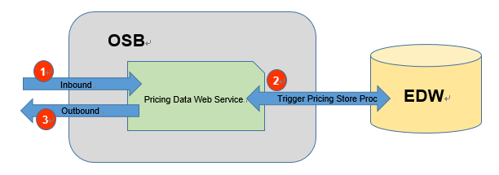

Staging Tables of

1. Send the request the OSB Restful Pricing Data Web Service through HTTP.
2. The service will trigger the pricing store procedure to update the EDW pricing tables in EDW.
3. The service will return the status to indicate whether the update is success.

Inbound Interface Format

|  |  |  |  |  |  |  |  |
| --- | --- | --- | --- | --- | --- | --- | --- |
| **#** | **Field Name** | **Description** | **Is Required** | **Format** | **Remarks** | **XML Example** | **JSON Example** |

Inbound Interface Format

|  |  |  |  |  |  |  |  |
| --- | --- | --- | --- | --- | --- | --- | --- |
| **#** | **Field Name** | **Description** | **Is Required** | **Format** | **Remarks** | **XML Example** | **JSON Example** |
| 1 | status | Update Status | Y | String |  | <status>MXM  </branchId> | {“status”:”A”} |
| 2 | remark | remark | Y | String |  | <remark>  </remark> | {“remark”:””} |

## EDW Checksum Web Service

### Process/Work Flow

Staging Tables of

1. Send the request the OSB Restful EDW Checksum Web Service through HTTP.
2. The service will get the information from the EDW.
3. The service will return the result and status to indicate whether the request is success.

Inbound Interface Format

|  |  |  |  |  |  |  |  |
| --- | --- | --- | --- | --- | --- | --- | --- |
| **#** | **Field Name** | **Description** | **Is Required** | **Format** | **Remarks** | **XML Example** | **JSON Example** |
| 1 | branchId | Maxim’s branch ID | Y | String |  | < branchId>MXM  </branchId> | {“branchId”:”MXM”} |
| 2 | businessDate | Transaction Business Date | Y | Date |  | < businessDate>2016-01-01  </businessDate> | {“businessDate”:”2016-01-01”} |

Outbound Interface Format

|  |  |  |  |  |  |  |  |
| --- | --- | --- | --- | --- | --- | --- | --- |
| **#** | **Field Name** | **Description** | **Is Required** | **Format** | **Remarks** | **XML Example** | **JSON Example** |
| 1 | noOfRecord | noOfRecord | Y | Numeric (19,0) |  | <noOfRecord>10  </noOfRecord> | {“noOfRecord”:”1-”} |
| 2 | checksum | checksum | Y | Numeric (19,4) |  | <checksum>1234  </checksum> | {“checksum”:”1234”} |
| 3 | status | Update Status | Y | String |  | <status>MXM  </branchId> | {“status”:”A”} |
| 4 | remark | remark | Y | String |  | <remark>  </remark> | {“remark”:””} |

- End –

# Appendix A – Staging Table Data Model

| **Table** | **Type** | **Update Freq.** | **Up/Down** | **Source** |
| --- | --- | --- | --- | --- |
| ACCOUNTS | Master | To be configure | Download | Carl |
| COUPON_CONTROL | Master | To be configure | Download | Carl |
| COUPON_RANGE | Master | To be configure | Download | Carl |
| CURRENCY | Master | To be configure | Download | Carl |
| EMPLOYEE | Master | To be configure | Download | Carl |
| HIST_CHECK_LOGS | HIST | EOD | Upload | Carl |
| HIST_COUPON_SALES | HIST | EOD | Upload | Carl |
| HIST_ITEM | HIST | EOD | Upload | Carl |
| HIST_ITEMSTOCK | HIST | EOD | Upload | Carl |
| HIST_ORDERS | HIST | EOD | Upload | Carl |
| HIST_ORDERS_EXTRA | HIST | EOD | Upload | Carl |
| HIST_ORDERS_PAY | HIST | EOD | Upload | Carl |
| HIST_ORDERS_PAY_PROGRESS | HIST | EOD | Upload | Carl |
| HIST_PAYFIG | HIST | EOD | Upload | Carl |
| HIST_PAYSUM | HIST | EOD | Upload | Carl |
| HIST_POSSYSTEM | HIST | EOD | Upload | Carl |
| HIST_REDEEMED_COUPON | HIST | EOD | Upload | Carl |
| HIST_SAFEBOXCHECK | HIST | EOD | Upload | Carl |
| HIST_SAFEBOXCHECKTENDER | HIST | EOD | Upload | Carl |
| HIST_SAFEBOXINOUT | HIST | EOD | Upload | Carl |
| HIST_SAFEBOXINOUTEXTENDINFO | HIST | EOD | Upload | Carl |
| HIST_SAFEBOXPICKUP | HIST | EOD | Upload | Carl |
| HIST_SESSIONINFO | HIST | EOD | Upload | Carl |
| HIST_SESSIONTENDER | HIST | EOD | Upload | Carl |
| HIST_STOCK_MOVEMENT | HIST | EOD | Upload | Carl |
| HIST_SUPP | HIST | EOD | Upload | Carl |
| HIST_TRANS | HIST | EOD | Upload | Carl |
| HIST_TRANS_ECARD | HIST | EOD | Upload | Carl |
| HIST_TRANS_MODIFIER | HIST | EOD | Upload | Carl |
| INVITATION | Master | To be configure | Download | Carl |
| ITEM | Master | To be configure | Download | Carl |
| ITEM_BARCODE | Master | To be configure | Download | Carl |
| ITEM_MODIFIER | Master | To be configure | Download | Carl |
| ITEMANLY | Master | To be configure | Download | Carl |
| ITEMDEPT | Master | To be configure | Download | Carl |
| MENU | Master | To be configure | Download | Carl |
| MENUITEM | Master | To be configure | Download | Carl |
| MESSAGES | Master | To be configure | Download | Carl |
| MODIFIER | Master | To be configure | Download | Carl |
| MODIFIER_GRP | Master | To be configure | Download | Carl |
| MODIFIER_LIST | Master | To be configure | Download | Carl |
| ONHOUSE | Master | To be configure | Download | Carl |
| OPTIONS | Master | To be configure | Download | Carl |
| ORDERS | Sales Data | To be configure | Upload | Carl |
| ORDERS_EXTRA | Sales Data | To be configure | Upload | Carl |
| ORDERS_PAY | Sales Data | To be configure | Upload | Carl |
| PAYCAT | Master | To be configure | Download | Carl |
| PAYMENT | Master | To be configure | Download | Carl |
| PMT_ACTION | Master | To be configure | Download | Carl |
| PMT_CONDITION | Master | To be configure | Download | Carl |
| PMT_HDR | Master | To be configure | Download | Carl |
| POSBUSDATE | Master | To be configure | Download | Carl |
| ROLE | Master | To be configure | Download | Carl |
| ROLE_PERMISSION | Master | To be configure | Download | Carl |
| SUPP | Sales Data | To be configure | Upload | Carl |
| SYSSETTINGS | Master | To be configure | Download | Carl |
| TRANS | Sales Data | To be configure | Upload | Carl |
| TRANS_ECARD | Sales Data | To be configure | Upload | Carl |
| TRANS_MODIFIER | Sales Data | To be configure | Upload | Carl |
| TRANS_TYPE | Master | To be configure | Download | Carl |
| USER_PERMISSION | Master | To be configure | Download | Carl |
| USER_ROLE | Master | To be configure | Download | Carl |
| WIFI CODE | Master | To be configure | Download | Carl |

# Appendix B – Database Schema of Working Table



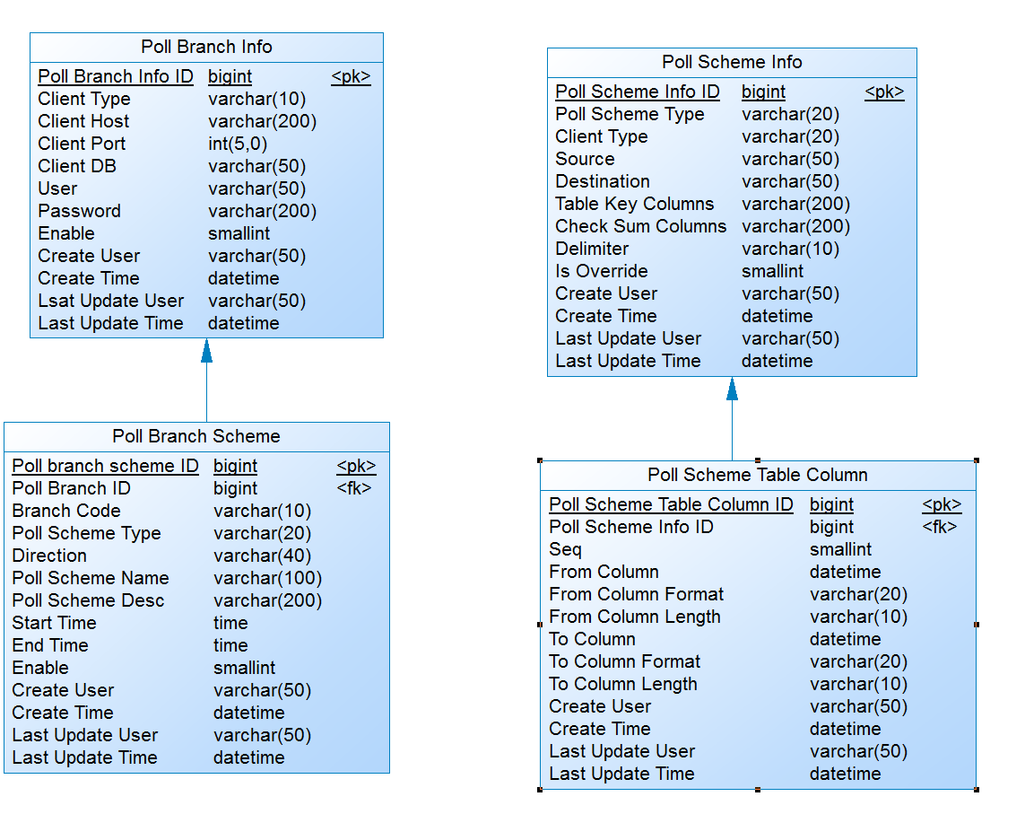

# Appendix C – User Requirement Traceability Matrix

| **User Requirement Function ID** | **Description** | **Chapter** |
| --- | --- | --- |
| ESB-SAL-01-01 | Sales Data Real Time  - Data staging to service bus working DB - Scheduling | 6.7.4.1 |
| ESB-SAL-01-02 | Sales Data Real Time  - Data staging to service bus working DB - Database Types | 6.7.5.1 |
| ESB-SAL-01-03 | Sales Data Real Time  - Data staging to service bus working DB - Transaction Handling - Mitpos | 6.7.5.1 |
| ESB-SAL-01-04 | Sales Data Real Time  - Data staging to service bus working DB - Transaction Handling - Pointsoft | 6.7.5.1 |
| ESB-SAL-01-05 | Sales Data Real Time  - Update POS Client’s Polling Flag | 6.7.5.1 |
| ESB-SAL-01-06 | Sales Data Real Time  - Polling to Staging DB Job Completion | 6.7.5.1 |
| ESB-SAL-02-01 | Sales Data Real Time  - Data Processing to EDW - Check Data Integrity (MIDPOS & POINTSOFT) | 6.8.6.1 |
| ESB-SAL-02-02 | Sales Data Real Time  - Data Processing to EDW - Retrieve Table List for Checking (Check_log, Orders..) | 6.8.6.1 |
| ESB-SAL-02-03 | Sales Data Real Time  - Data Processing to EDW - Send Data to EDW after verification | 6.8.6.1 |
| ESB-SAL-02-04 | Sales Data Real Time  - Data Processing to EDW - Exceptional Handling | 6.8.6.1 |
| ESB-SAL-02-05 | Sales Data Real Time  - Data Processing to EDW - Data Send Block by Block | Technical  Spec. |
| ESB-SAL-02-06 | Sales Data Real Time  - Data Processing to EDW Job Completion | 6.8.6.1 |
| ESB-SAL-03-01 | POS Client EOD Triggering | 6.8.4.1 |
| ESB-SAL-03-02 | POS Client EOD Monitoring | 6.8.4.1 |
| ESB-SAL-03-03 | POS Client EOD Data Process - Download all History Tables | 6.8.4.1 |
| ESB-SAL-03-04 | POS Client EOD Data Process - Update Synchronization Status | 6.8.4.1 |
| ESB-SAL-03-05 | POS Client EOD Process Job Summary | 6.8.4.1 |
| ESB-SAL-04-01 | POS Client EOD Data Process  - Data Processing to EDW - DB-to-DB copy to EDW Staging Table | 6.8.6.1 |
| ESB-SAL-04-02 | POS Client EOD Data Process  - Data Processing to EDW - Multiple Business Date Handling | 6.8.6.1 |
| ESB-SAL-04-03 | POS Client EOD Data Process  - Data Processing to EDW - Validation Check | 6.8.6.1 |
| ESB-SAL-04-04 | POS Client EOD Data Process  - Data Processing to EDW - Exceptional Handling | 6.8.4.1 |
| ESB-SAL-04-05 | POS Client EOD Data Process  - Data Processing to EDW - Update Synchronization Status | 6.8.4.1 |
| ESB-SAL-04-06 | POS Client EOD Data Process  - Data Processing to EDW - Process Job Summary | 6.8.4.1 |
| ESB-PRZ-REQ-01-01 | Pricing/Master Data Preparation | 6.9.4.1 |
| ESB-PRZ-REQ-01-02 | Pricing/Master Data Download to Staging | 6.9.4.1 |
| ESB-PRZ-REQ-01-03 | Pricing/Master Data Pre-Distribution Process | 6.10.4.1 |
| ESB-MST-REQ-02-01 | Pricing/Master Data Distribution - Initialization | 6.10.4.1 |
| ESB-MST-REQ-02-02 | Pricing/Master Data Distribution - Integrity Check | 6.10.5.1 |
| ESB-MST-REQ-02-03 | Pricing/Master Data Distribution - Incremental Update to POS Client | 6.10.5.1 |
| ESB-MST-REQ-02-04 | Pricing/Master Data Distribution - Update Synchronization Status | 6.10.5.1 |
| ESB-MST-REQ-02-05 | Pricing/Master Data Distribution - Process Job Summary | 6.10.5.1 |
| ESB-NF-REQ-01-01 | System Dashboard View - Real Time | 6.11 |
| ESB-NF-REQ-01-02 | POS Data Source Control - Control Indicators for Easy Manipulation | 4.5 |
| ESB-NF-REQ-01-03 | POS Data Source Control - Password Protected on Data Source Table | Technical  Spec. |
| ESB-NF-REQ-01-04 | System Exception Report - Jobs Process | 6.13 |
| ESB-NF-REQ-01-05 | System Exception Report - Data Process | 6.13 |
| ESB-NF-REQ-01-06 | System Exception Handling - Jobs Process | Technical  Spec. |
| ESB-NF-REQ-01-07 | System Exception Handling - Data Process (EOD) | Technical  Spec. |
| ESB-NF-REQ-01-08 | System Job Control - Polling Schema Maintenance | 6.5 |
| ESB-NF-REQ-01-09 | System Job Control - Branch Master Initiation | 6.3 |
| ESB-NF-REQ-01-10 | System Configuration | 6.12 |
| ESB-NF-REQ-02-01 | Sales Data Web Service | 7.1 |
| ESB-NF-REQ-02-02 | Pricing/Master Data DB Adapter | 7.2 |
| ESB-NF-REQ-02-03 | Sales Data DB Adapters - Total Number | 7.3 |
| ESB-NF-REQ-02-04 | Sales Data DB Adapters - Total Amount | 7.3 |
| ESB-NF-REQ-02-05 | Pricing/Master Data DB Adapter | Technical  Spec. |

# Sign Off

|  |  |  |
| --- | --- | --- |
| Description of Deliverable: System Design Document  The requirements specification for the application. | | |
| POS Part Sign-Off | | |
| Name (Print or Type) | Date | Signature |
| CARL CHOW |  |  |
|  | | |
| Staging to EDW Part Sign-Off | | |
| Name (Print or Type) | Date | Signature |
| POLLY KAM |  |  |
|  | | |
| Others Sections Sign-Off | | |
| Name (Print or Type) | Date | Signature |
| CHOI KA WING |  |  |
|  | | |
| Project Director | | |
| Name (Print or Type) | Date | Signature |
| LOUIS MAH |  |  |
|  | | |