Maxim’s POS Polling Enterprise Service Bus Implementation Service

**EL-FY16-902**

**Sales/Master/Pricing Data Exchange**

SOA Installation Guide

Prepared by: Buzz IT Company Limited

Author: Steven Chen

Date: 13/01/2017

Version: 0.9

# **Document Control**

## **Document History**

| Version | Date | Author | Revision Remark |
| --- | --- | --- | --- |
| 0.1 | 14/03/2017 | Steven Chen | 1st draft |

## **Document/Design Owner**

| Name | Title |
| --- | --- |
| Steven Chen | System Analyst |
|  |  |
|  |  |

# **Contents**

**Document Control** 2

**Document History** 2

**Document/Design Owner** 2

**User & User Group** 3

**Create Oracle File System** 3

**Setup Environment variables for oracle user** 4

**Install JDK to /home/oracle/products/** 4

**Install & Setup XWindows Server** 5

**Setup RCU** 6

**Install SOA** 7

**JDeveloper Setup** 16

**Reference Document** 16

# **User & User Group**

/usr/sbin/groupadd -g 501 oinstall

cut -d: -f1 /etc/group

/usr/sbin/useradd -u 502 -g oinstall –G adm,admin oracle

Passwd oracle

# **Create Oracle File System**

Create below file system for Oracle products and applications

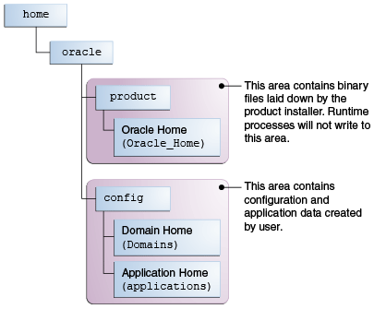

|  |
| --- |
| mkdir -p /home/oracle/products/Oracle_Home  chown oracle:oinstall /home/oracle/products/Oracle_Home  chmod 775 /home/oracle/products/Oracle_Home  mkdir –p /home/oracle/config/domains  chown oracle:oinstall /home/oracle/config/domains  chmod 775 /home/oracle/config/domains  mkdir –p /home/oracle/config/applications  chown oracle:oinstall /home/oracle/config/applications  chmod 775 /home/oracle/config/applications |

# **Setup Environment variables for oracle user**

|  |
| --- |
| vi /home/oracle/.bash_profile  export JAVA_HOME=/home/oracle/products/jdk1.8.0_121  export JRE_HOME=$JAVA_HOME/jre  export CLASSPATH=$JAVA_HOME/lib:$JRE_HOME/lib:WL_HOME%/server/lib:%WL_HOME%/server/liblogic.jar  export WLS_HOME=/home/oracle/products/wlserver  export ORACLE_HOME=/home/oracle/products/Oracle_Home  export DOMAIN_HOME=/home/oracle/config/domains  export WL_HOME=$ORACLE_HOME/wlserver  export PATH=$WL_HOME/server/bin:$JAVA_HOME/bin:$JRE_HOME/bin:$HOME/bin:$PATH |

# **Install JDK to /home/oracle/products/**

jdk-8u101-linux-x64.tar.gz ???

chmod 755 jdk-8u101-linux-x64.tar.gz

tar -xvf /home/oracle/products/jdk-8u101-linux-x64.tar.gz

jdk-8u121-linux-x64.tar.gz (location ??)

Upload jdk-8u121-linux-x64.tar.gz

To: /home/oracle/products/jdk-8u121-linux-x64.tar.gz

chown oracle:oinstall jdk-8u121-linux-x64.tar.gz

chmod 755 jdk-8u121-linux-x64.tar.gz

Use oracle account

cd /home/oracle/products/

|  |
| --- |
| tar -xvf /home/oracle/products/jdk-8u121-linux-x64.tar.gz |

# **Install & Setup XWindows Server**

1. Install Xming in local PC
2. Check parameter “X11Forwarding Yes” exists in target host’s /etc/ssh/sshd_config
3. Configure putty X11 configuration

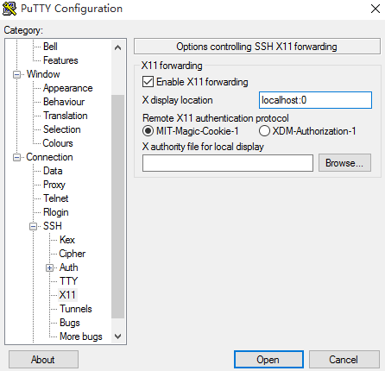

1. Export DISPLAY=your.intranet.ip.address:0.0
2. Now XWindows Server is ready to connect

# **Setup RCU**

|  |
| --- |
| **Start RCU**  cd $ORACLE_HOME/oracle_common/bin  ./rcu |

|  |
| --- |
| **For MS SQL Server ONLY**  ALTER DATABASE esb_dev SET READ_COMMITTED_SNAPSHOT ON  with rollback immediate; |

|  |
| --- |
| **Add component command line sample**  ./rcu -silent -createRepository -databaseType SQLSERVER -connectString 192.168.1.250:1433:esb_dev -dbUser sa -dbRole sysadmin -unicodeSupport Yes -schemaPrefix ESB -component SOAINFRA -component UMS |

|  |
| --- |
| **RCU Manual**  <https://docs.oracle.com/cd/E16764_01/doc.1111/e14259/rcu.htm> |

|  |
| --- |
| **RCU Reset Procedure (Delete Schema and Namespaces)**   1. drop user ×× cascade 2. DROP TABLESPACE tablespace_name INCLUDING CONTENTS AND DATAFILES; 3. select comp_name from SCHEMA_VERSION_REGISTRY; 4. delete from SCHEMA_VERSION_REGISTRY where COMP_NAME like 'WebLogic Services'; |

# **Install SOA**

Start Oracle SOA Suite Quick Start Installer

|  |
| --- |
| java -jar fmw_12.2.1.2.0_soa_quickstart_generic.jar |

|  |
| --- |
| **Create a Compact Domain**  cd $ORACLE_HOME/oracle_common/common/bin  CONFIG_JVM_ARGS="-Dcom.oracle.cie.config.showProfile=true"  export CONFIG_JVM_ARGS  ./config.sh |

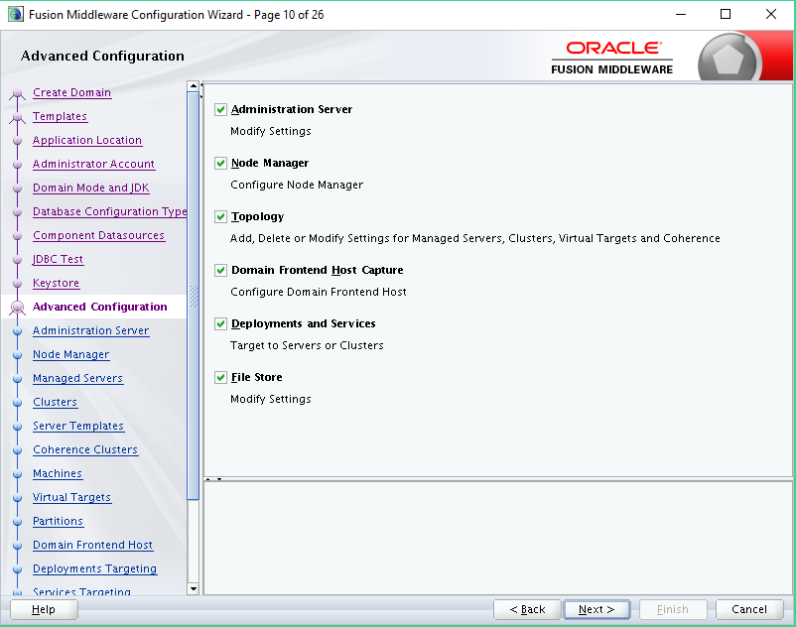

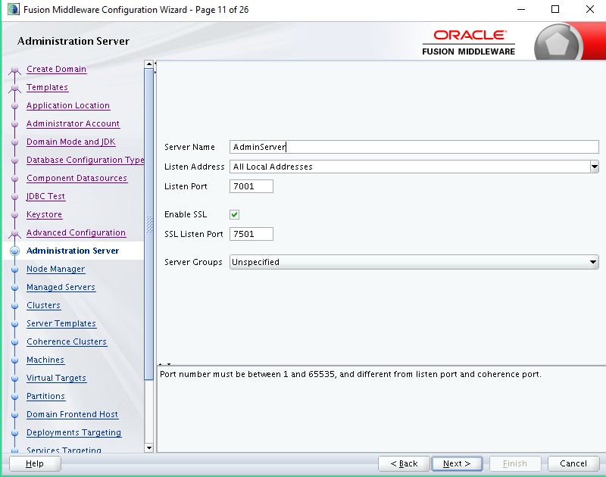

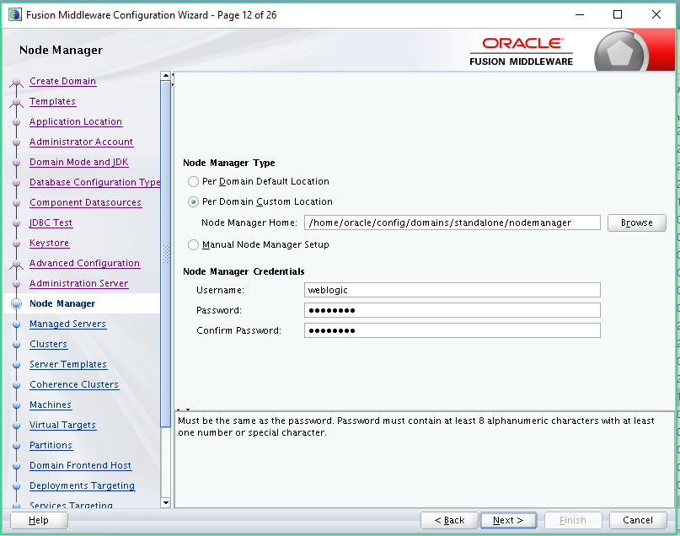

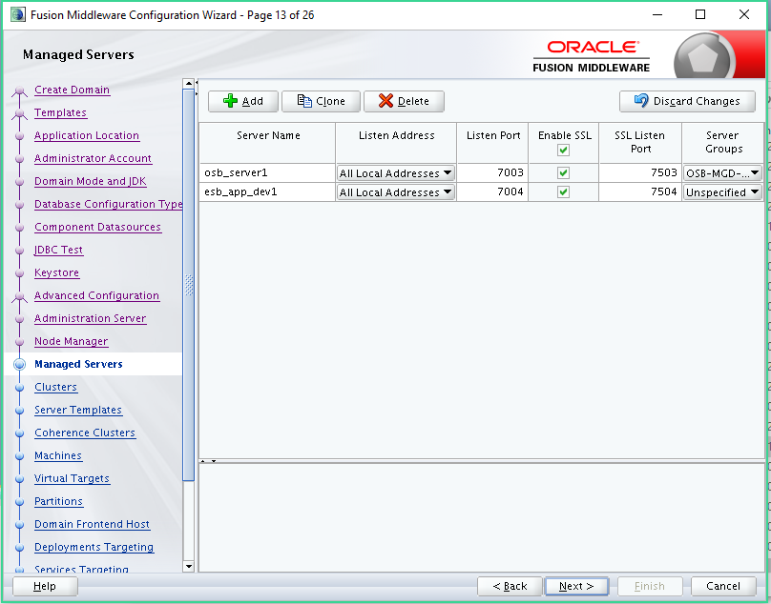

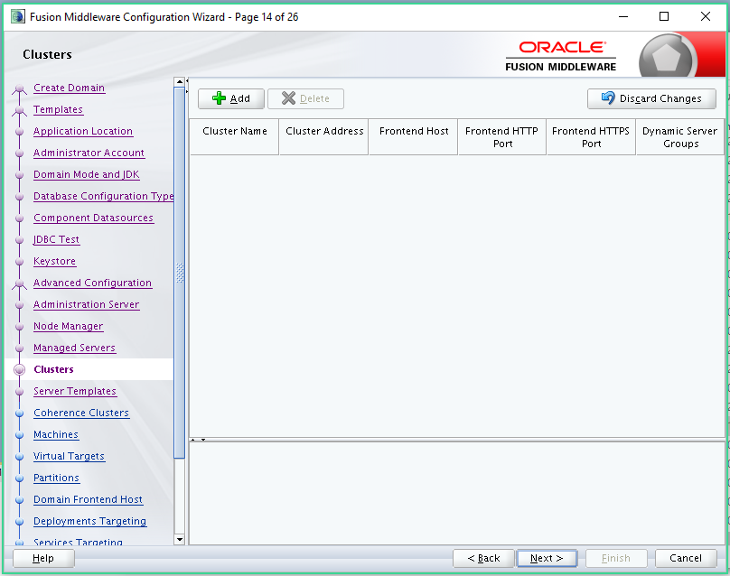

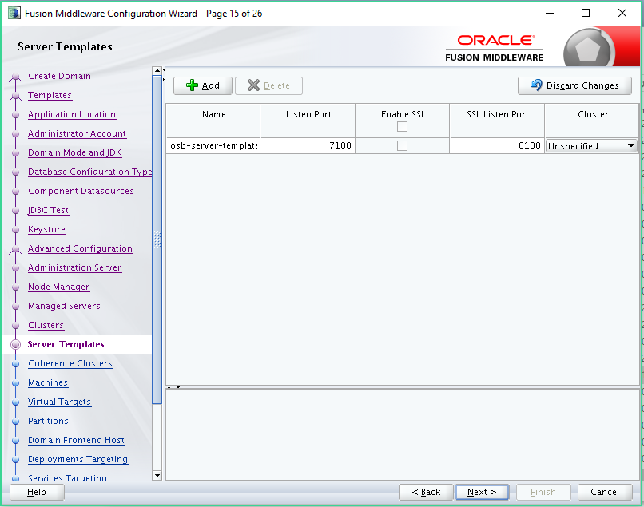

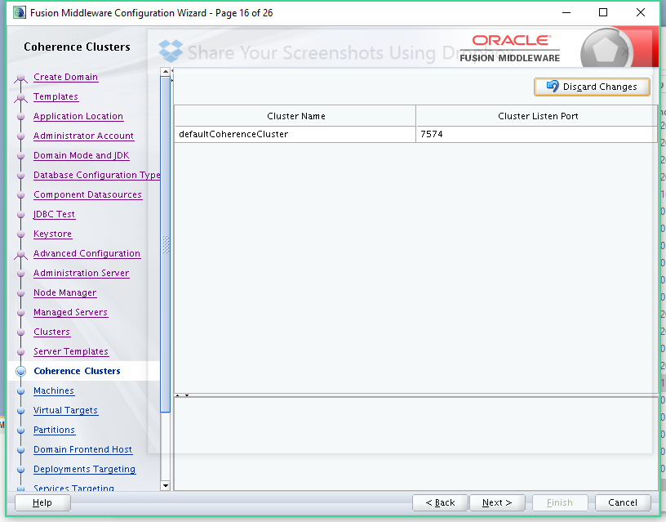

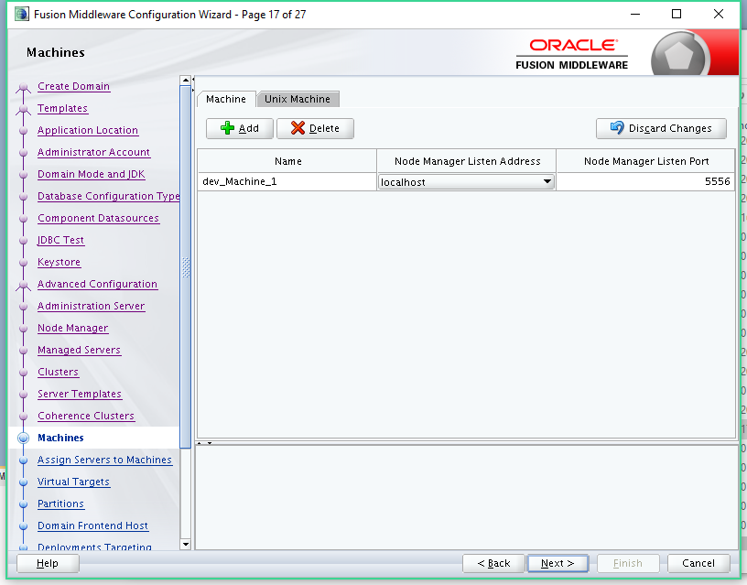

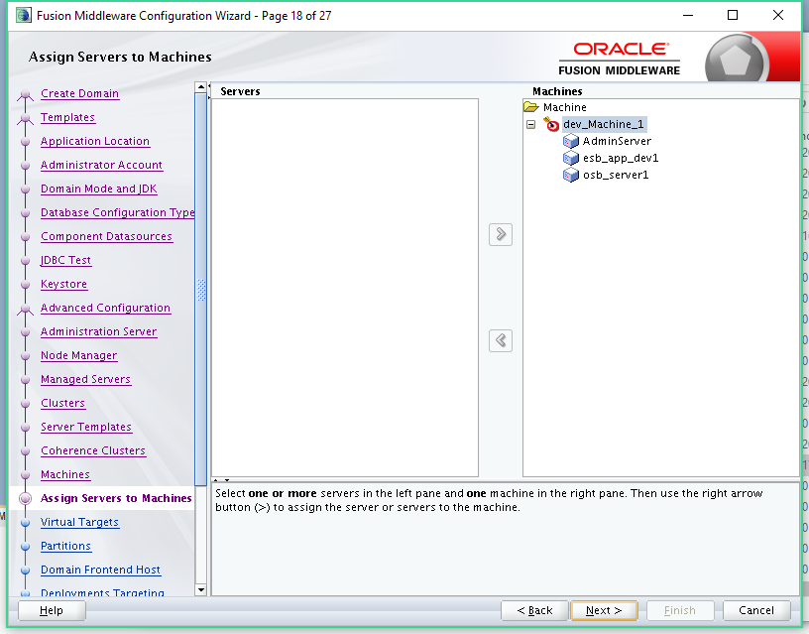

# **JDeveloper Setup**

**Set JDEV_USER_DIR**

(Default) $HOME/jdeveloper/mywork

(Recommended) $HOME/jdeveloper/osb.

|  |
| --- |
| cd $ORACLE_HOME/jdeveloper/jdev/bin  ./jdev  cat /proc/sys/kernel/random/entropy_avail  rngd -r /dev/urandom -o /dev/random -b  EXTRAOPTIONS="-i -r /dev/urandom -o /dev/random -b -t 60 -W 2048"  cd $ORACLE_HOME/jdeveloper/jdev/bin  ./jdev |

# **Appendix**



# **Reference Document**

<https://docs.oracle.com/middleware/1213/core/SOAQS/integrated.htm#SOAQS208>