/usr/sbin/groupadd -g 501 oinstall

cut -d: -f1 /etc/group

/usr/sbin/useradd -u 502 -g oinstall -G dba,asmdba oracle

usermod -a -G adm oracle

passwd oracle

vi /home/oracle/.bash_profile

export JAVA_HOME=/u01/app/Middleware/jdk1.8.0_74/

export JRE_HOME=$JAVA_HOME/jre

export CLASSPATH=$JAVA_HOME/lib/:$JAVA_HOME/jre/lib

export WLS_HOME=/u01/app/Middleware/wlserver12.1.3/wlserver

export DOMAIN_HOME=/u01/app/Middleware/user_projects/domains/dsat

export PATH=$JAVA_HOME/bin:$JAVA_HOME/jre/bin:$PATH:$HOME/bin

mkdir -p /u01/app/oraInventory

chown -R oracle:oinstall /u01/app/oraInventory

chmod -R 775 /u01/app/oraInventory

mkdir -p /u01/app/Middleware/wlserver12.1.3

chown -R oracle:oinstall /u01/app/Middleware

chmod -R 775 /u01/app/Middleware/

$ ls

jdk-8u74-linux-i586.tar.gz   WebLogicServer12.1.3.jar

$ java -jar WebLogicServer12.1.3.jar

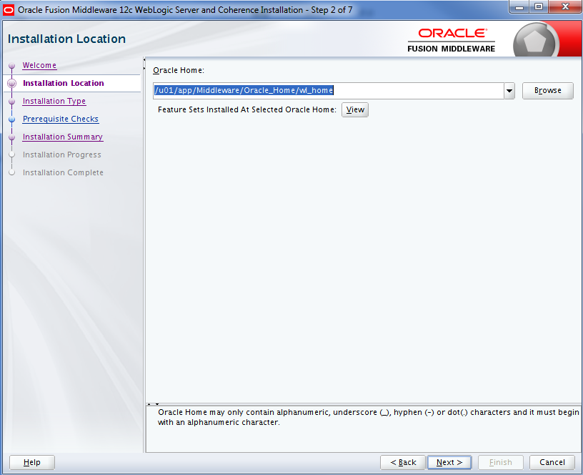

/u01/app/Middleware/wlserver12.1.3/wlserver

**$ $WLS_HOME/common/bin/config.sh**

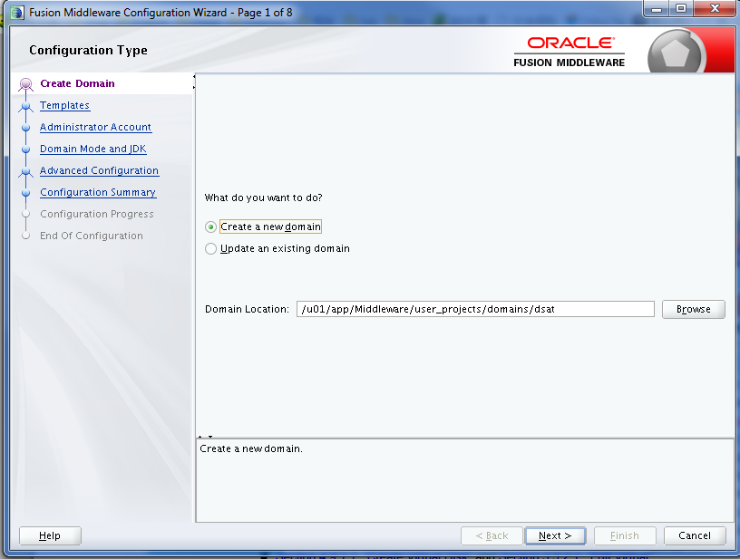

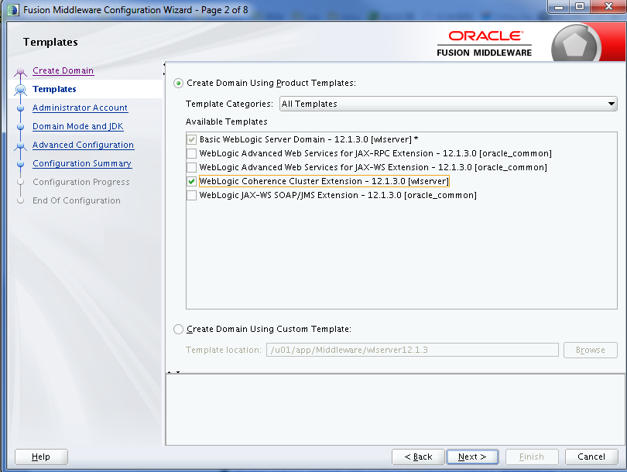

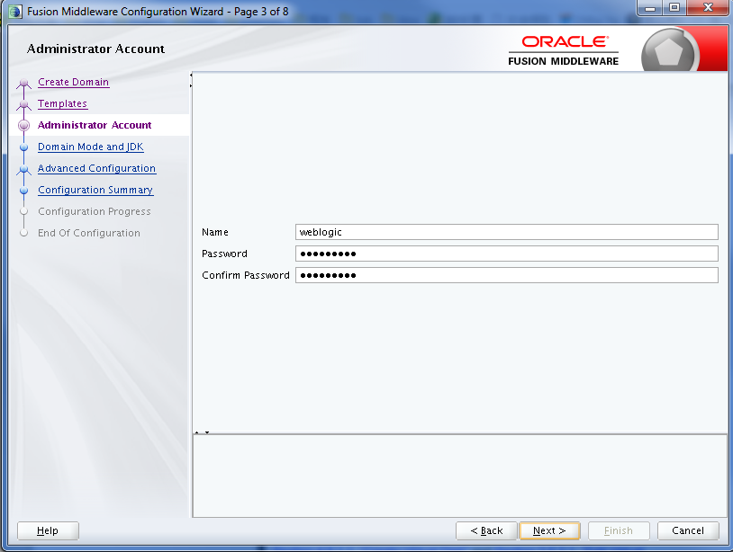

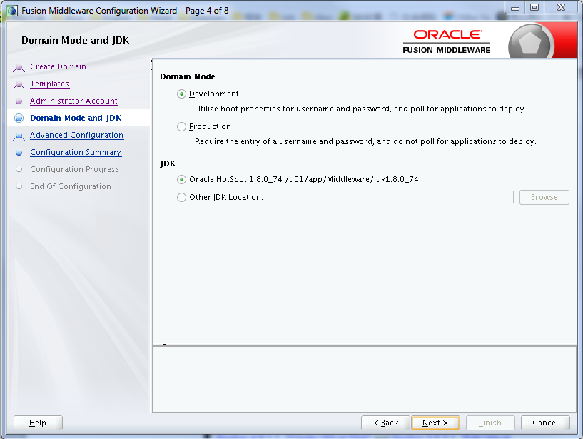

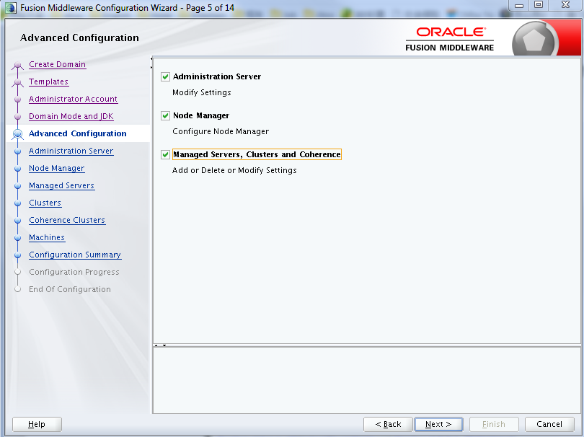

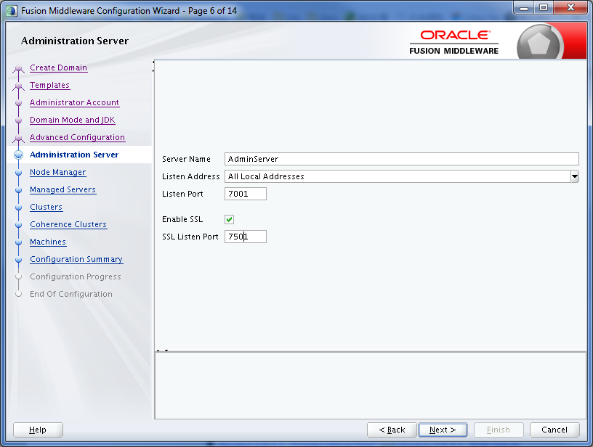

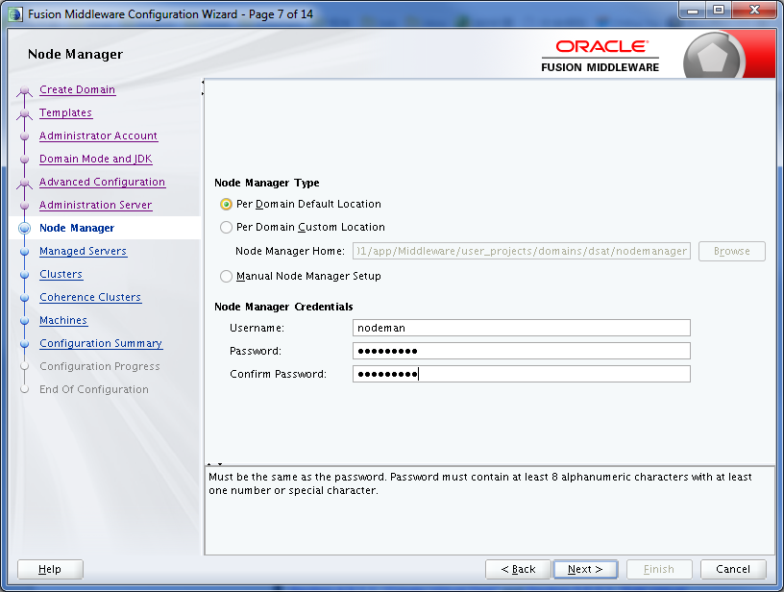

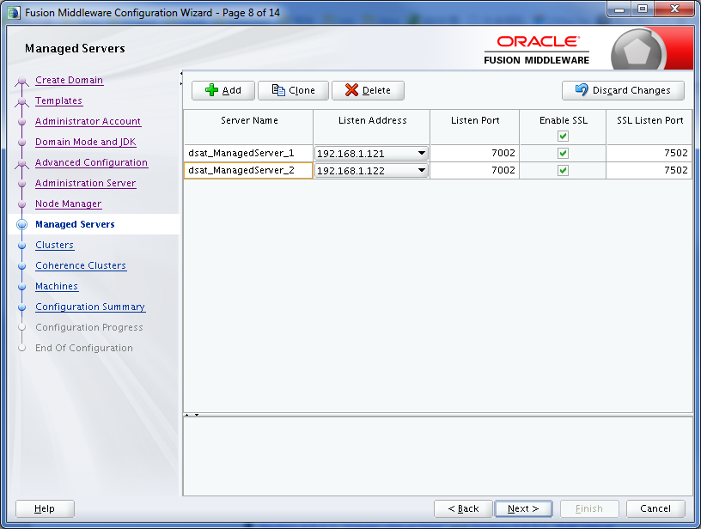

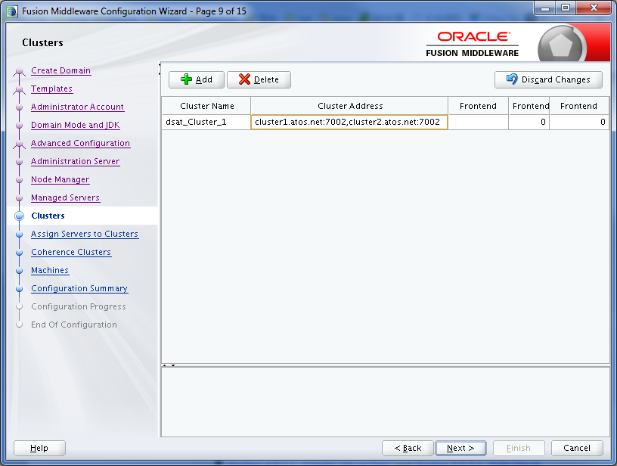

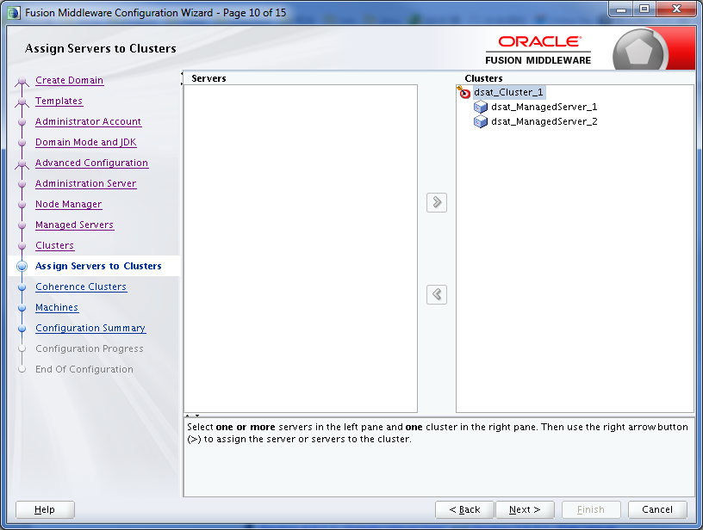

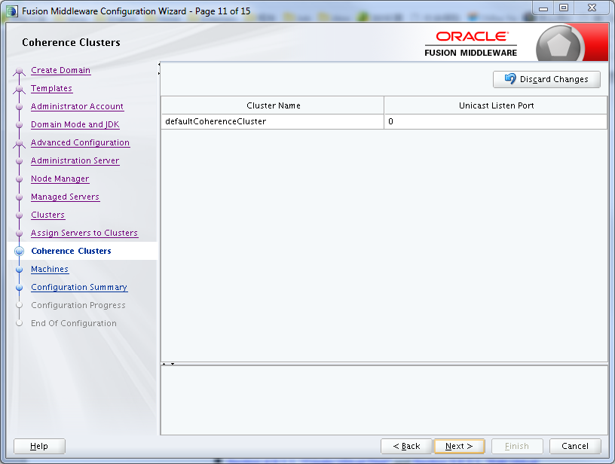

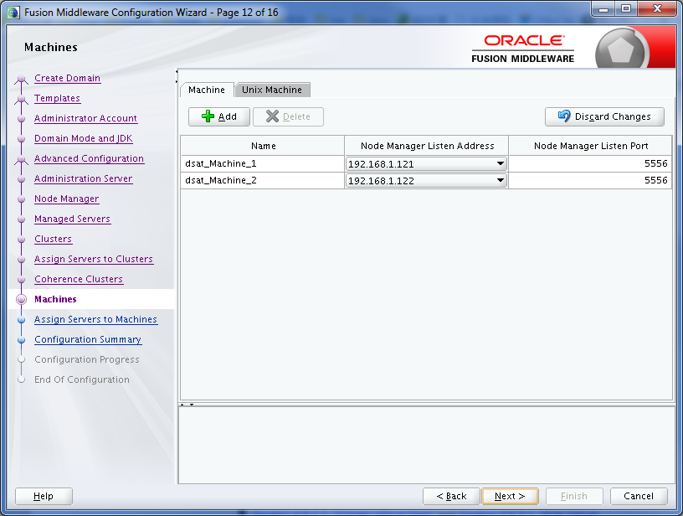

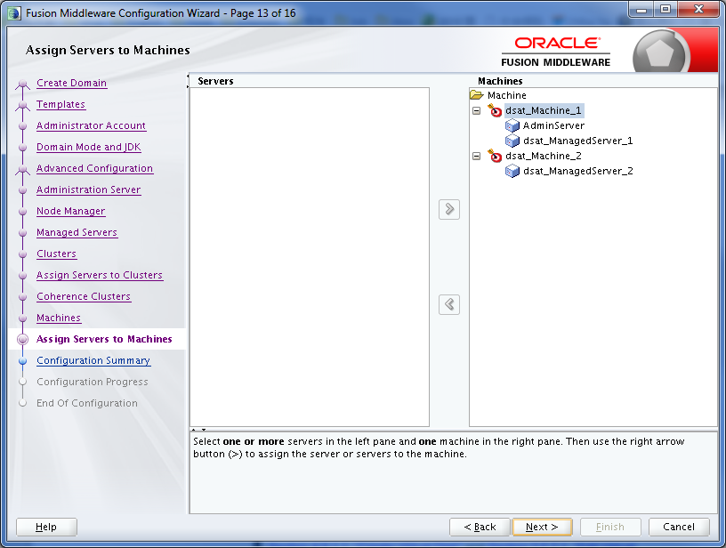

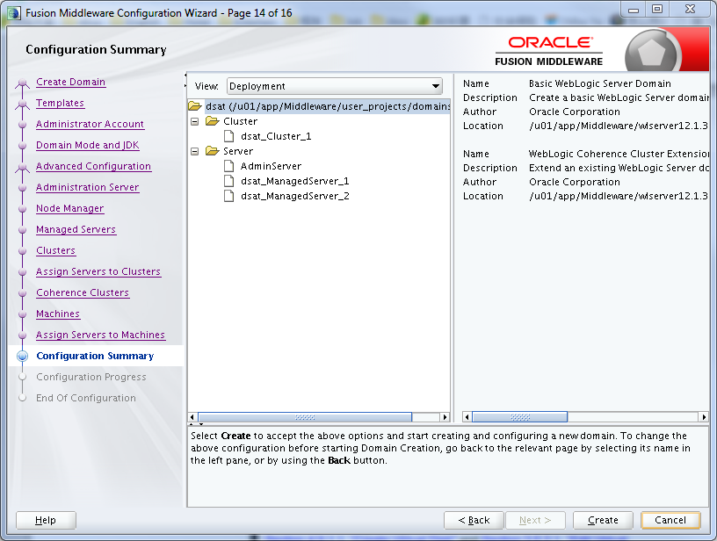

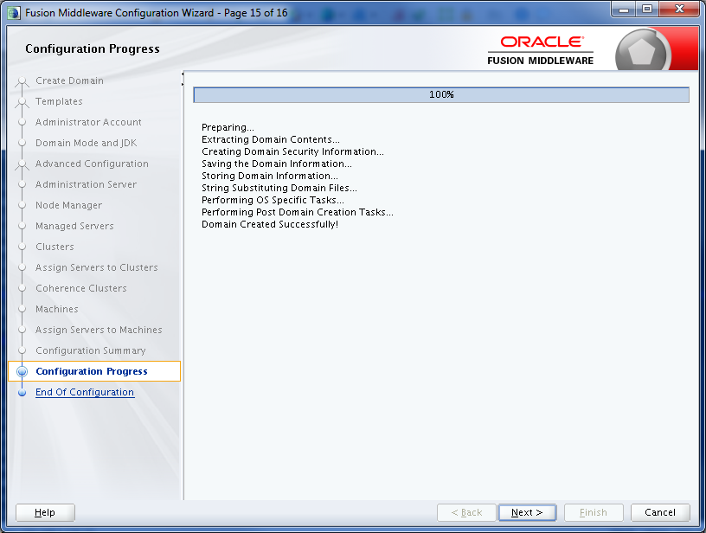

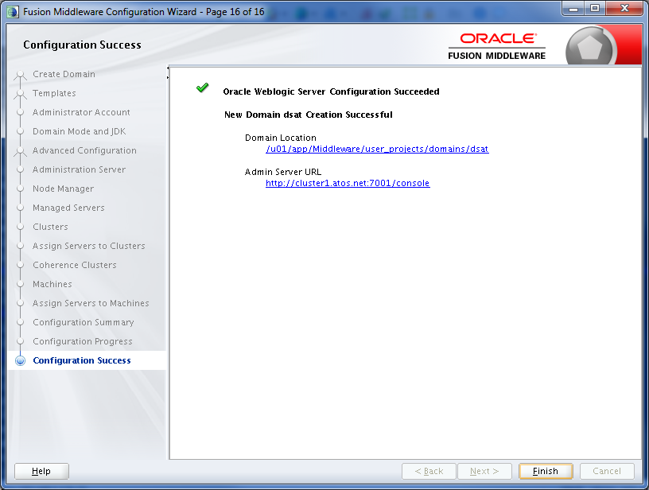

[[oracle@cluster1](mailto:oracle@cluster1) bin]$ pwd

/u01/app/Middleware/wlserver12.1.3/wlserver/common/bin

[[oracle@cluster1](mailto:oracle@cluster1) bin]$ ./pack.sh -managed=true -domain=$DOMAIN_HOME -template=${DOMAIN_HOME}-template.jar -template_name=dsatDomain

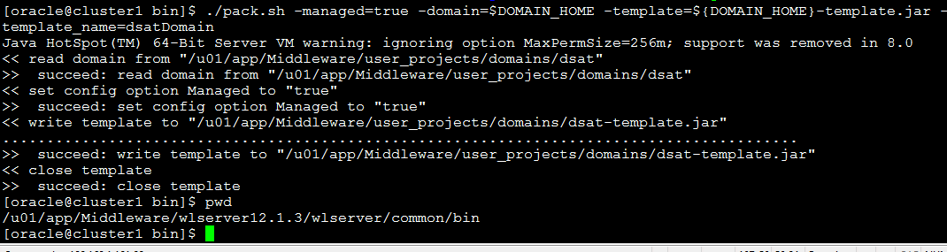

$ scp /u01/app/Middleware/user_projects/domains/dsat-template.jar [oracle@cluster2](mailto:oracle@cluster2):/home/oracle/



**on the second machine**

$ cd /u01/app/Middleware/wlserver12.1.3/wlserver/common/bin/

$ ./unpack.sh -domain=$DOMAIN_HOME -template=/home/oracle/dsat-template.jar

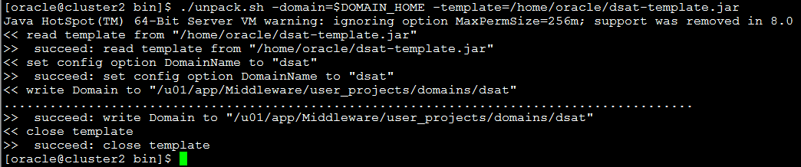

Restart the domain on the first machine. Wait until it is fully started before continuing.

wls:/offline> connect('weblogic', 'Oracle123', 't3://192.168.1.121:7001')

wls:/dsat/serverConfig> nmEnroll('/u01/app/Middleware/user_projects/domains/dsat', '/u01/app/Middleware/usr_projects/domains/dsat/nodemanager')

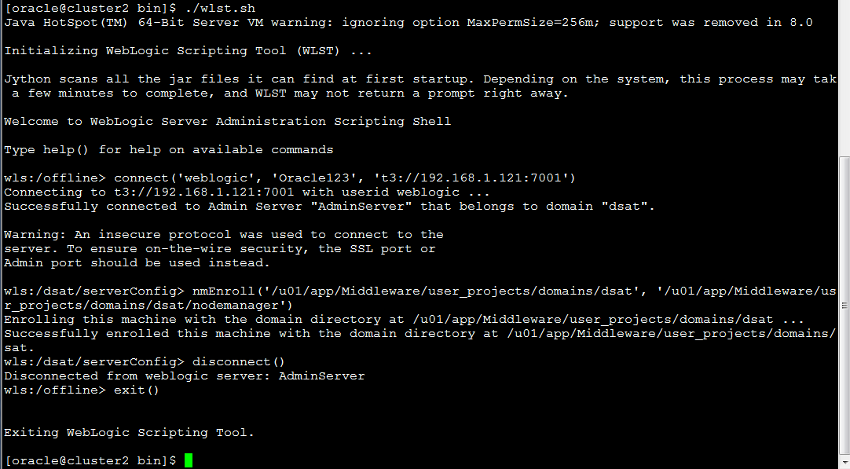

Check the "$MW_HOME/domain-registry.xml" file contains an entry like the following. If it doesn't, add it manually.

<domain location="/u01/app/oracle/config/domains/clusterDomain"/>

Check the "$DOMAIN_HOME/nodemanager/nodemanager.domains" file contains an entry like the following. If it doesn't, add it manually.

clusterDomain=/u01/app/oracle/config/domains/clusterDomain

If the node manager is not already started on this server, start it now.

$ nohup $DOMAIN_HOME/bin/startNodeManager.sh &