**Quantitative Physiology**

**Computational Lab 3**

**Tommy Peng (Lab Partners: Eric Dai, Randolph Qian)**

**Problem 1.1**



As one can see from the plot above, the steady state operating point is approximately .06mU/mL insulin and .8mg/mL glucose. This blood glucose level is similar to the between 70 and 100 mg/dL (.7 to 1mg/mL) found in literature. (U.S National Library of Medicine)

**Problem 1.2**

Beta is the rate parameter that effects the insulin production rate. Since type 1 diabetes have a decreased ability to create enough insulin, beta for the model should be decreased. This results in the following response for the system.



The plot above was produced at a modified beta value of approximately half the normal beta supplied by the lab manual. As one can see, the steady operating point is now approximately 1mg/mL glucose and .45mU/mL insulin. This is drop in steady operating point insulin level is understandable as the person with this diabetes has a lesser ability to produce insulin. In return, because insulin blood concentration effects the uptake of glucose by the tissue, this lowered insulin also means that the person’s tissue has less of an ability to uptake glucose, therefore there is a slight rise in the glucose steady operating point from that found in problem 1.1.

**Problem 1.3**

V is the rate parameter that effects the insulin-dependent uptake rate by the tissue in the body. Since type 2 diabetes have a decreased ability for insulin to stimulate glucose uptake, v for the model should be decreased. This results in the following response for the system.



The plot above was produced at a modified v value of approximately half the normal v supplied by the lab manual. As one can see, the steady operating point is now approximately 1mg/mL glucose and .8mU/mL insulin. This fundamentally makes sense from the description of Type 2 diabetes as the insulin is less able to stimulate glucose uptake by the tissue, so the blood glucose level at steady operating point should see some rise than those found in problem 1.1. Along the same lines, because it requires more insulin to stimulate similar glucose uptakes by the tissue, the insulin level should also be higher than those found in problem 1.1.

**Problem 1.4**

1. A substance such as cobalt chloride will block L and T type Ca channels which will decrease the ability for Ca ions to move into the cell during the membrane depolarization. This failure to build up the intracellular concentration of Ca ions will lead to the cells releasing little to no insulin (which is released through secretory vesicles once the intracellular Ca ion concentration is high). So in this case, one can model this as the rate of insulin production by the pancreas (the variable beta) being very close to zero. Therefore modelling the little to no release of insulin. The following graph is the resulting system response. The revised operating point (for when beta = 90mU*mL/(mg*h)) is approximately 1.8mg/mL glucose and .02mU/mL insulin.



1. By adding an agent to the bath that blocks mitochondrial respiration of cytosolic glucose, one essentially stops the facilitated diffusion of glucose into the tissue cells. This is because if mitochondrial respiration of glucose stops, the glucose concentration inside the cell would become high, so the concentration gradient of glucose between the cell and the surrounding solution will not be as high. This will result in a dramatically lower rate of passive diffusion (lambda) for the movement of glucose, and consequently cause a decrease in insulin release. A large decrease of lambda (to a value of 200ml/h) will result in the following graph. The revised operating point is approximately 0.8mg/mL glucose and .065mU/mL insulin.



1. By adding an amino acid that enters the beta cell and gets metabolized to CO2, H2O and NH3, one has essentially provided the ammonia which improves the ability for glutamate dehydrogenase to perform glutaminolysis. This process increases the ATP to ADP ratio in the beta-cells and causes the cell to release more insulin into the system. This gain in insulin release rate can be modelled by an increase in beta. The following graph shows the effects of a increase of beta from the supplied value of 1430mU*mL/(mg*h) to a value of 2000mU*mL/(mg*h). This results in a steady operating point of .7mg/mL glucose and 0.065mU/mL insulin.



**Problem 2.1**



By plotting the time course of the response for normal v value and reduced v value (to simulate type 2 diabetes), one can make the following conclusions when comparing the type 2 diabetes case to the normal case: type 2 diabetes have a generally higher glucose response for the time period, and type 2 diabetes have a higher insulin response for the time period. This change is also reflected in the answer for problem 1.3, where we also considered the type 2 diabetes case. In that case, the steady operating insulin level increased from .6mU/mL to .8mU/mL and the steady operating glucose level increased from .8mg/mL to 1mg/mL. These changes are qualitatively similar to those found in this problem.

The following model and code was used to create the diagram.

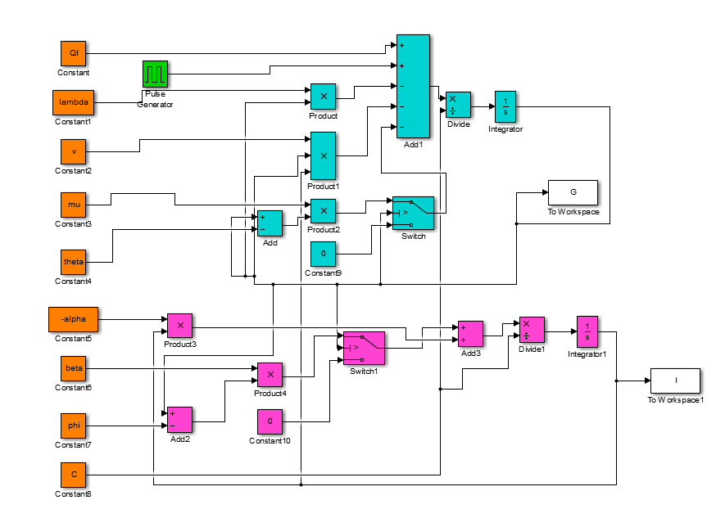

%Setting the variables as given - change them as needed in the questions

theta = 2.5;

mu = 7200;

lambda = 2470;

v = 139000;

phi = 0.51;

beta = 1430;

alpha = 7600;

Ql = 8400;

C = 15000;

sim('clab_3_2_sim');

subplot(2,1,1);

plot(G);

hold on;

subplot(2,1,2);

plot(I);

hold on;

%Decreasing beta for plot of type 1 diabetes

v = 70000;

sim('clab_3_2_sim');

subplot(2,1,1);

plot(G, 'r');

legend('Normal', 'Type 2 diabetes');

title('Plot of glucose concentration for normal and type 2 diabetes conditions');

xlabel('Time in hrs');

ylabel('Glucose concentration in mg/mL');

subplot(2,1,2);

plot(I, 'r');

legend('Normal', 'Type 2 diabetes');

title('Plot of insulin concentration for normal and type 2 diabetes conditions');

xlabel('Time in hrs');

ylabel('Insulin concentration in mU/mL');

**Problem 2.2**

Stolwijk notes that if the Vallance-Owen relationship for insulin and glucose is extended to low values of blood glucose, no insulin would be produced. Insulin control will then no longer be effective in this hypoglycemic state, and the system will then need to re-establish itself through glucose from tissue, live and the GI track. However, in this model, we assume a constant output of glucose from the liver that is unaffected by glucose or insulin levels. An important reason to make this assumption is that this model’s goal is to model glucose and insulin response behavior, and in order to model the hypoglycemic state, we would have to consider the concentration of glycogen.

Some of the other simplifications made include one to limit the extracellular fluid space to a constant 15L, which allows for constant glucose and insulin capacitance to be found, allowing for simpler, more linear calculations that do not deviate too far from realistic physiological conditions of around 19L for a 70kg human. (<http://www.anaesthesiamcq.com/FluidBook/fl2_1.php>) A further simplification is that the intracellular glucose level is 0. This is a viable assumption as the intracellular glycogen is not readily exchangeable with the extracellular glucose.

**Problem 2.3**

The non-linearity of the model comes from the terms: vIG, as I is a function of G for some values of G. From the graphs of problem 1, we can conclude the response is roughly linear for glucose levels above 1.5mg/mL and insulin levels smaller than .025mU/mL, or at least linear enough to apply frequency response analysis. Frequency response analysis is useful as it allows us to make general statements about the response of the system under a different range of input frequencies, so we can predict how the system responds to different inputs.

In this case, we can see that all three plotted dynamic responses of the system allow for responses within the lower frequency ranges, with the first two plots showing low pass filter behavior and the last plot showing low band-pass filter behavior (with maximal response frequency of approximately .2min-1). With this, we can deduce that the system is dynamically most sensitive with low frequency inputs, and high frequency inputs do not affect the system as effectively. This makes sense fundamentally as the control system behind blood glucose levels in the body is a homeostatic mechanism that maintains the glucose level around a steady state level over long periods of time. So frequent attempts to change the blood glucose level through input should be rejected, therefore only the less frequent, lower frequency inputs will be reflected in the response.

**Problem 3.1**

The term U(t) and Gin account for external glucose input. Ql, F5 correspond to liver glucose production. λG, F2 correspond to insulin independent glucose utilization. vGI, F3 and F4 correspond to insulin dependent glucose utilization.

**Problem 3.2**







As we can see from the plots above, the regular oscillatory behavior starts at around a time constant of 3mins and extends until a time constants of approximately 300mins.

**Problem 3.3**

**Problem 3.4**

The biphasic insulin response to a pulse of glucose is due to the fact that there are two phases for insulin release. There is an instantaneous secretion which releases the currently available insulin, while there is also a longer term insulin production-based release, which is somewhat controlled by the KATP channels.

In order to construct a viable mathematical model for this scenario, we must take into account two separate rate constants for the production of insulin. So in this case, we can break down the original rate constant for production, β, into two components: β1 the instantaneous rate constant, and β2 the longer term rate constant. This yields for following equation:

$$C_{I}\frac{dI}{dt}= -αI+\left(β_{1}+β_{2}\right)\left(G-φ\right), G>φ$$

**References**

"Blood Sugar Test - Blood: MedlinePlus Medical Encyclopedia." *U.S National Library of Medicine*. U.S. National Library of Medicine, n.d. Web. 11 Feb. 2015.