1. The difference between Gouraud and Phong shading is that Gouraud shading is done at the vertices, and relies on the shaders to distribute the color in the areas between vertices. Phong shading is done in the fragment shader, and so it calculates the lighting at each pixel. This is much more computationally expensive but it looks way better. For some reason only phong works in my code, but Gouraud looks like this except blurrier and a little more pixelated.

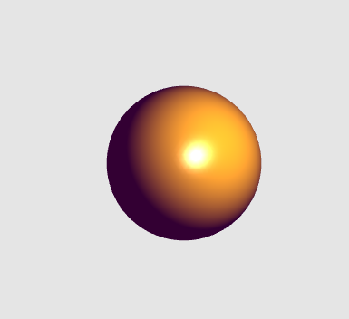

2. Phong shading isn’t totally realistic, partly because it doesn’t take into account every ray of light and trace it, it simply calculates what each pixel would look like based on properties of the material and the light. This is because ray tracing is incredibly computationally expensive, and this still looks good. In addition, it doesn’t use the normal vector, it instead uses the halfway vector, because the values are very similar and it is easier to calculate.