**State Point Analysis for Secondary Treatment Optimization**

*Background*

In early 2017, Philadelphia Water Department became a partner of the Better Plants program sponsored by the U.S. Department of Energy. This program was designed to help manufacturing facilities more energy efficient by offering numerous technical resources and encouraging a goal of 25% improvement in energy intensity over 10 years and was recently expanded to include water/wastewater utilities. One of the resources offered is in-plant trainings, a rigorous, three-day, classroom-style session hosted by a peer utility and instructed by wastewater process and mechanical system professionals. This year, PWD had sent a member of the Energy Team to attend an in-plant training at the Kent County Public Works Department in Dover, DE. One of the tools introduced for optimizing operations and thus providing inherent improvements in energy efficiency is known as the state point analysis. It is believed that this tool could also be applied to PWD’s wastewater operations.

*Introduction*

State Point Analysis (SPA) is a graphical-analytical model of secondary sedimentation in an activated sludge wastewater treatment process. It allows the operator to visualize the settling characteristics of the solids in secondary clarifiers as they compare to the hydraulic properties of the tanks’ influent. Ultimately, the operator can use the results of the analysis to optimize secondary treatment on the basis of the return activated sludge (RAS) flow rate.

While usually a visual tool, SPA has been integrated preliminarily into a program that takes certain input parameters and analytically calculates the optimal return activated sludge flow rate for ideal and most efficient operation. Naturally, this model is a simplification of a complex and dynamic treatment process and involves multiple assumptions/idealizations. It is intended, however, to act as a conservative guideline to improve ease of operation, ensure stability of the sludge blanket and food-to-mass ratios, and maximize energy efficiency related to the oxygen transfer of the aeration system.

*Breakdown of State Point Analysis*

A state point analysis, as displayed graphically below in Figure 1, takes in only six parameters to identify a somewhat generalized point of reference for how the system is behaving. These include influent flow (Qin), return activated sludge flow (Q­­RAS), mixed liquor suspended solids concentration (MLSS), number of secondary clarifiers (n), surface area of a single clarifier (Aclar), and sludge volume index (SVI). In later notations, total clarifier surface area will be denoted as Atot.

The figure is plotted as solids flux in pounds of solids per unit area and unit time (ft2 and days, respectively) against solids concentration in grams per liter and consists of three curves: the surface overflow rate (SOR) (positive green line), the solids underflow rate (SUR) (negative orange line), and the settling flux (blue). The equations for all three are given below, where x is solids concentration and alpha, beta, gamma, and delta are constants dependent on how SVI was determined.

*Equation 1:*

$$SOR=\frac{Q_{in}}{A_{tot}}x$$

*Equation 2:*

$$SUR=-\frac{Q_{RAS}}{A_{tot}}x+\frac{MLSS\left(Q_{in}+Q_{RAS}\right)}{A_{tot}}$$

*Equation 3:*

$$Flux=γxe^{-\left(δSVI+x\left(α+βSVI\right)\right)}$$

Specifically, as seen in the equations given, the slopes of the two lines are the SOR and SUR, respectively. The point at which these two intersect is the point of current operation of the secondary tanks, also known as the state point. The solids concentration here is the MLSS concentration. Therefore, any changes to the RAS flow rate or MLSS concentration will cause the solids underflow rate curve to pivot about this state point.

The purpose of SPA is to help the operator visualize the current process conditions relative to the settling characteristics of the sludge as illustrated by the settling flux curve. Basically, the SUR curve should be adjusted so that it remains underneath the right tail of the settling flux curve. If it were to intersect and go above it, this would indicate that sludge is moving upward through the clarifier at a rate faster than that at which it can settle. This means an increasing sludge blanket. As seen in the equation above, increasing the RAS flow would decrease the slope of that curve, potentially placing it back underneath the settling flux. However, it should be noted that adjusting the RAS flow also changes the y-intercept of the SUR equation, or in other words, increases the solids loading rate, something to keep in mind if it is of operational concern.

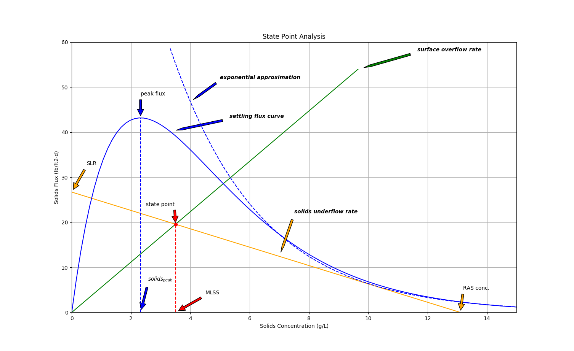

Figure : Typical State Point Analysis graph displaying the point of operation and settling characteristics

*RAS Flow Rate Optimization*

While the graphical representation of the secondary treatment system is useful, it still requires a visual “guess-and-check” to attain minimum required performance (stabilization of the sludge blanket depth). Furthermore, any excess increase in RAS flow results in two potentially negative consequences: an unnecessary increase in solids loading rate and an overuse of the RAS pump, not to mention the possibility of disturbing the laminar layering of the sludge zones in the tanks. The goal of this program, therefore, was to determine the optimal RAS flow at which solids underflow is less than sludge settling yet excessive work is not being done on the system (and minimizing the solids loading rate).

This ideal point would essentially occur where the solids underflow rate line is tangent to the settling flux curve. Mathematically, it can be described as the point on the graph that satisfies both of these conditions:

1. ***The solids underflow rate line and the settling flux curve intersect:*** for a given solids concentration, the solids fluxes are equal.
2. ***The slope of the solids underflow rate line is equal to the slope of the settling flux curve:*** at this same solids concentration, the first derivative of the settling flux curve with respect to solids concentration is equal to the solids underflow rate.

This method provided two equations with two unknowns (solids concentration and RAS flow) allowing one to find a single solution for QRAS. It was found, however, that using the actual first derivative of the settling flux equation produced a QRAS with an undefined solution. Ultimately, the right side of the curve had to be approximated as an exponential function, as shown above in Figure 1. Using this approximated model, instead, allowed for a solution of RAS flow rate given the rest of the required parameters as shown below in Equation 4, where k and A are constants estimated when the settling flux curve was approximated as an exponential function and W-1 represents the lower branch of the Lambert-W function. The complete derivation can be found in the attached appendix.

*Equation 4:*

$$Q_{RAS}=\frac{Q_{in}MLSSk}{W_{-1}\left[-\frac{Q_{in}MLSS}{A_{tot}Ae^{MLSSk+1}}\right]}$$

Naturally, a new QRAS would have to be calculated each time any of the parameters on which it depends changes. Total clarifier area likely would not change very often, if at all, but others such as Qin or MLSS may change multiple times throughout a day. Also, the two constants—k and A—would only stay constant so long as the SVI value does not change.

*Program*

The program developed is meant to simplify and automate this process whenever any of the operational variables changes. It takes into consideration all of the parameters mentioned including the method of how SVI was calculated (to determine the constants) and uses them to create the exponential approximation on the descending side of the settling flux curve. From there, the QRAS that would make the SUR line exactly tangent to the settling flux curve is calculated. For conservative reasons, this value is rounded up slightly to insure against any error from the approximation or unaccounted-for variables related to the non-ideality of the settling system, as well as ease of readability. The final output is a graphical representation of the current parameters (similar to the example above in Figure 1) with a display of the optimal yet conservative RAS flow rate suggested (see Figure 2 below). Figure 3 zooms in on the point at which the SUR line approaches the settling flux curve but still remains beneath it.

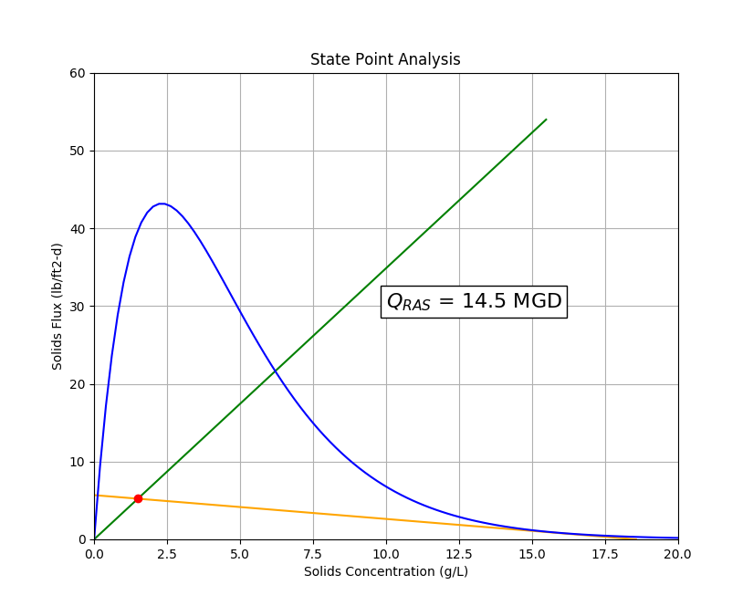

Figure : Resulting output of SPA program showing suggested QRAS flow rate

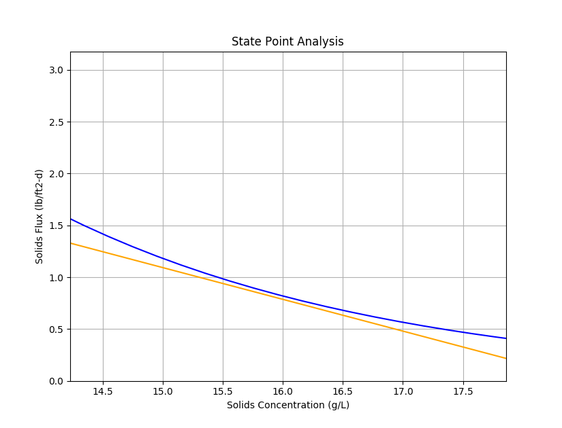

Figure : Zoom-in of output showing the near-tangency of the two approaching curves

The results shown here actually used data from Southwest WPCP’s operations. Specifically:

* SVI = 100 mL/g (determined using a 2-L settleometer without stirring)
* # Clarifiers = 20
* Clarifier Area = 19,760 ft2 (70’ x 260’)
* MLSS = 1.5 g/L
* Influent Flow = 165 mgd (average)

As seen above, it was determined that 14.5 mgd of RAS flow would be ideal for these conditions.

*Conclusion*

This programmatic solution is offered as a tool to aid in the operation of the secondary treatment process, a complex, recycle-flow system that is also responsible for the vast majority of wastewater treatment’s energy consumption. The primary purpose is to maximize ease of operation, and, secondarily, the hope is that optimization of secondary settling will allow for maximum energy efficiency during the aeration steps. Ideally, this tool would be used concurrently with an analysis of the aeration tanks to: minimize the amount of oxygen required and ensure that only the required amount is being transferred to the mixed liquor resulting in an operationally optimized version of what is usually a highly energy-intensive treatment process.

**Appendix – Analytical Derivation of Solution**

*Two Curves:*

$$SUR=-\frac{Q_{RAS}}{A_{tot}}x+\frac{MLSS\left(Q_{in}+Q_{RAS}\right)}{A_{tot}}$$

$$Flux=γxe^{-\left(δSVI+x\left(α+βSVI\right)\right)}$$

*Tangency:*

$$SUR\left(x\right)=Flux\left(x\right)$$

$$\frac{dSUR}{dx}=\frac{dFlux}{dx}\left(x\right)$$

*Exponential Approximation:*

$${Flux}_{approx}=Flux\left(x>x_{peak}\right)≅Ae^{kx} \\ \ln{{Flux}_{approx}=kx+\ln{A}}$$

$$x_{peak}→Flux\left(x_{peak}\right)→\frac{dFlux}{dx}=0$$

$$x_{peak}=\frac{1}{α+βSVI}$$

$$x_{1}=3x_{peak}, y_{1}=Flux\left(x_{1}\right) \\ x_{2}=6x_{peak}, y_{2}=Flux\left(x_{2}\right)$$

$$\left[\begin{matrix}x_{1} & 1 \\ x_{2} & 1\end{matrix}\right]\left[\begin{matrix}k \\ \ln{A}\end{matrix}\right]=\left[\begin{matrix}\ln{y_{1}} \\ \ln{y_{2}}\end{matrix}\right]→k,\ln{A}$$

*Tangency Applied:*

$$-\frac{Q_{RAS}}{A_{tot}}x+\frac{MLSS\left(Q_{in}+Q_{RAS}\right)}{A_{tot}}=Ae^{kx} \\ -\frac{Q_{RAS}}{A_{tot}}=Ake^{kx}$$

*Solution:*

$$x=\frac{\ln\left(-\frac{Q_{RAS}}{A_{tot}Ak}\right)}{k}$$

$$\frac{Q_{in}MLSSk}{Q_{RAS}}e^{\frac{Q_{in}MLSSk}{Q_{RAS}}}=-\frac{Q_{in}MLSS}{A_{tot}Ae^{MLSSk+1}}$$

$$\frac{Q_{in}MLSSk}{Q_{RAS}}=W\left[-\frac{Q_{in}MLSS}{A_{tot}Ae^{MLSSk+1}}\right]$$

$$Q_{RAS}=\frac{Q_{in}MLSSk}{W\left[-\frac{Q_{in}MLSS}{A_{tot}Ae^{MLSSk+1}}\right]}$$