COMPS321F Sample Test 1 Solution
Q1

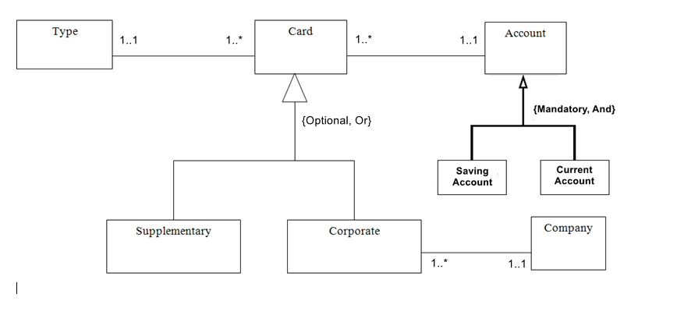

Q2

Employee (EmpID , fName, lName, address, bDate, sex, salary, DeptNo, SupEmpID )
Primary Key EmpID
Foreign Key DeptNo references Department (DeptNo)
Foreign Key SupEmpID references Employee (EmpID)

[Note] - The column name SupEmpID could be varied

Department (DeptNo, name, location, EmpID, startDate)
Primary Key DeptNo
Foreign Key EmpID references Employee (EmpID)

Project (ProjNo, name, location, DeptNo)
Primary Key ProjNo
Foreign Key DeptNo references Department (DeptNo)

EmployeeDetails (EmpID, mgrStartdate, bonus, salesArea, carAllowance, mgrOwnerFlag,
salesOwnerFlag)
Primary Key EmpID
Foreign Key EmpID references Employee (EmpID)

Q3

a)

FD1: StudID -> StudName, ProgCode, ProgName (given)

FD2: CourseCode -> CourseName
FD3: StudID, CourseCode -> Mark
FD4: ProgCode -> ProgName

b)

Primary Key: (StudID, CourseCode)

c)

Assume the relation is already in 1NF.

FD1 and FD2 violate 2NF as there are partial dependencies.

StudInfo (StudID, StudName, ProgCode, ProgName)
CourseInfo(CourseCode, CourseName)
StudResult (StudID*, CourseCode*, Mark)

d)

CourseInfo and StudResult are already in 3NF.

StudInfo is not in 3NF because FD4 violates 3NF as there is transitive dependency.

StudProg(StudID, StudName, ProgCode*)
ProgInfo (ProgCode, ProgName)

