Enterprise Architecture (CS544) Final Project

Professor Name – Michael Zijlstra
September, 2018

Done By - Thomas Tibebu
ID – 000-96-2008

Table of Contents

1. Acknowledgement 3
2. Introduction 4
3. Purpose 5
4. Requirements - Use-Case – Usage Scenarios 6
5. High Level Design 9
6. Detailed Design 11
6.1. Interaction Diagram 12
7. System user interface and Testing …………………….….……………………….….14
8. Issues, Risk and Dependencies 19
9. Design Alternatives 19
10. References 20

Acknowledgement

I would like to express my special thanks of gratitude to my Professor Michael Zijlstra, who gave me the golden opportunity to do this wonderful project using Spring MVC, Spring Security, JSR 303 Validation, Hibernate JPA, Exception Handling, Custom Validation, MySQL and different related technologies, which also helped and assist me to finish this project on time. I came to know about so many new things in this course and by doing this project. I am really thankful to him.

Introduction

I have designed the Hotel Reservation System. The proposed system is designed to make reservations of hotel rooms online. It is designed to be user-friendly that provides flexible accommodation of functions. The main objective of the system is too fulfilling the need of having the system that accommodates hotel reservation, to provide fast and accurate services to clients, administrative stuff and speed up transaction among clients.
Technologies used

The project has two main components front-end and Back-end.

- Spring MVC
- Annotation Drive
- Hibernate
- REST
- Spring Security for login and Authorization
- JSR 303 Validation
- PRG
- Exception Handling
- Bootstrap
- GitHub
- Data Binding
- Validation and Custom Validation
- Web Flow
- Persistent in Database

Purpose

Hotel Reservation System is used to manage and schedules the dates and length of stay for guests. It enables Customers to view available rooms, to reserve their rooms, to update reservation and to delete a reservation. For Reception it enables to login/logout, to view rooms, to view room reservation list and to approve and cancel customer reservation. For Manager it enables to login/logout, add rooms, to view rooms, to update room information and status, to delete rooms, to view room reservation list and daily reservation report, to approve and cancel customer reservation. The system is planned for three kinds of users, which have different access rights to the services and data of the system.

Who uses a Reservation system and how does it work?
A reservation system, though it might sound like a tool used at the reception desk, is actually an online web application that enables guests to reserve their own stays and hotel staff to manage rooms online. By this way, they can complete the transaction quickly, efficiently from any place.

Advantages of Hotel Reservation System
- Less work for the front office
When guests reserve their own stays, the reservation simply posted into the system with all details information, so all have to do is get ready for their arrival when the time comes. This allows reception staff more time to tend to their other tasks.

- Reduced chances of losing up a reservation
Reception tendency to make mistakes or be wrong is a far less significant factor when guests put in their dates and specifications themselves. That way, if something goes wrong, you have the data to prove it’s no fault of your business.

- Easily gathered data
An online reservation system feeds a huge amount of guest data right into the system: how many guests are traveling when they come, what they prefer, where they live, and so forth. That’s very useful to know and will help to improve both customer service and marketing.
- Simpler administration
The system enables to keep track of customer stays history and the hotel daily income. Also, no need to turn around to check rooms are occupied or not, it enables the stuff to control his task from anywhere.
Disadvantages of Hotel Reservation System
- Expensive system to develop and maintain.
- Hacking of Website may lead to the crash of the system.
- Requires internet access.

Requirements - Use-Case – Usage Scenarios

Requirements
- System should allow the Guest to make room reservation
- System should allow the Guest to check the available rooms
- System should allow the Reception to check the available rooms
- System should allow the Reception to login
- System should allow the Reception to logout
- System should allow the Reception to Confirm & Reject Reservation
- System should allow the Reception to View Reservation List
- System should allow the Manager to check the available rooms
- System should allow the Manager to login
- System should allow the Manager to logout
- System should allow the Manager to Confirm & Reject Reservation
- System should allow the Manager to View Reservation List
- System should allow the Manager to CRUD Room
- System should allow the Manager to CRUD User
- System should allow the Manager to View Report
- System should store the data
- System should accept the reservation
- System should ask for the check-in/check-out dates
- System Should store the booking of the rooms in the database
- System Should store the User profile in the database
- System Should store the Room information in the database

Data Flow Diagram

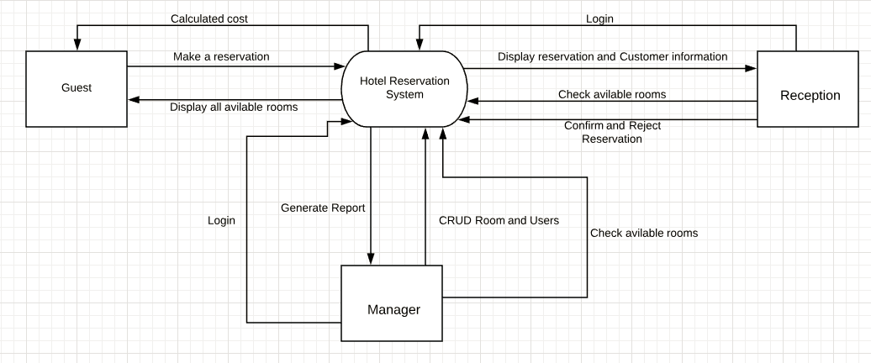

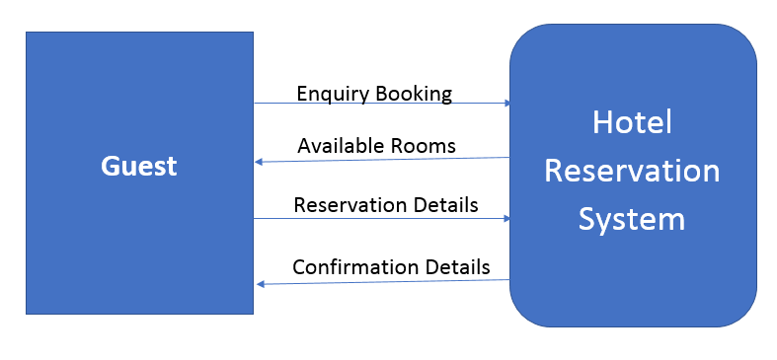

Use Case Diagram

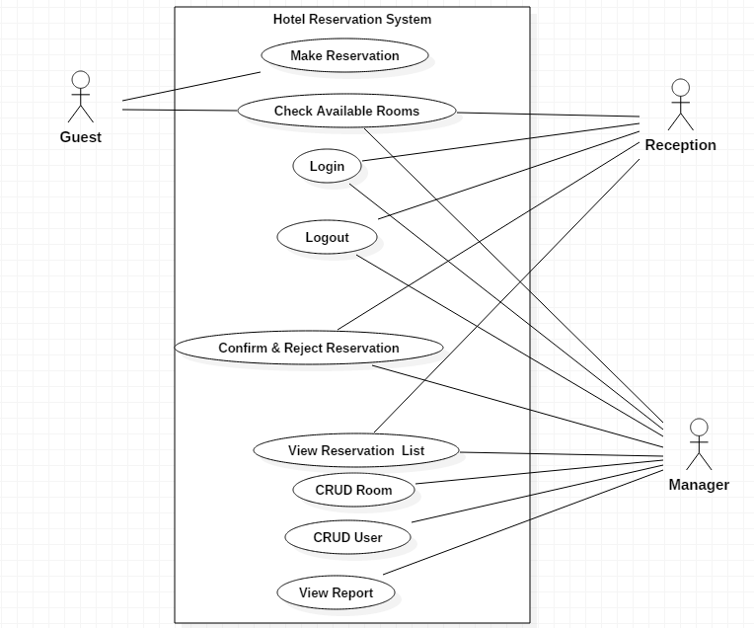

Entity Relationship Diagrams

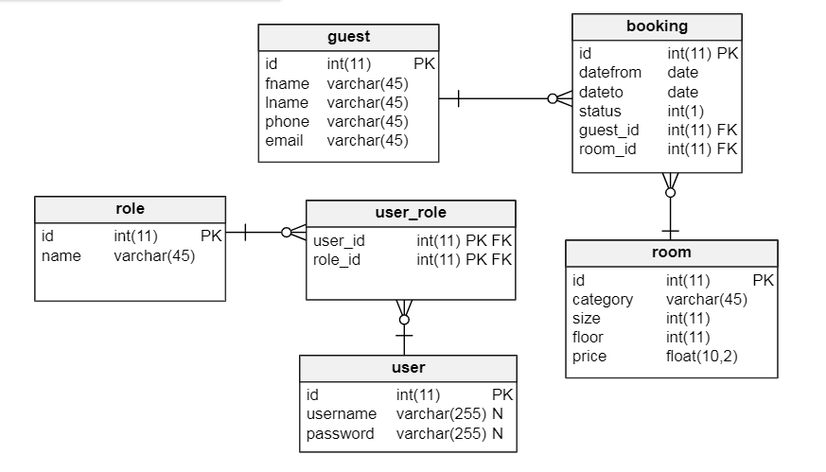

High Level Design

Reservation
This entity stores a new reservation to the system. Guest defines which type of room want to reserve. The guest enters the required customer information. As the result of this entity customer information is stored, a reservation is made and a confirmation page and payment amount displayed.
Customer
A Guest is an online hotel customer who has access only to create and showroom reservation services. The Guest able to see if there are free rooms is available for reservation on a certain timeline.

User
I have two type of users Reception and Manager. A Manager user can use all the functions of the system without restrictions: Login, CRUD Room and Users, creating reservations, modifying them and confirming and canceling reservations. But Reception user creating reservations, modifying them and confirming and canceling reservations.

Detailed Design

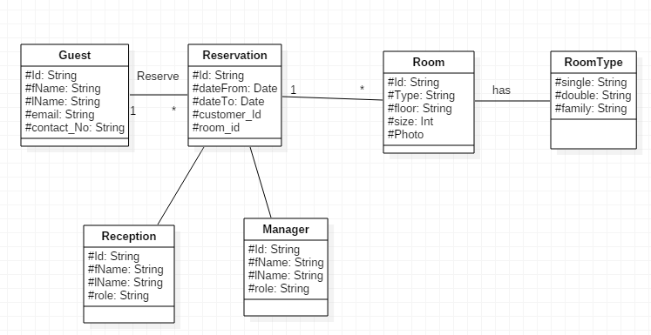

Interaction Diagram

Guest Room Reservation Sequential Diagram
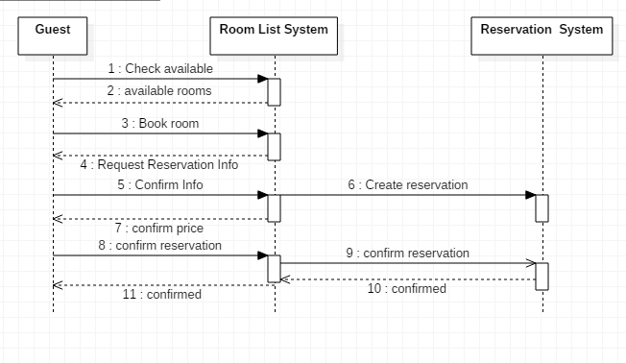

Reception Login Sequential Diagrams

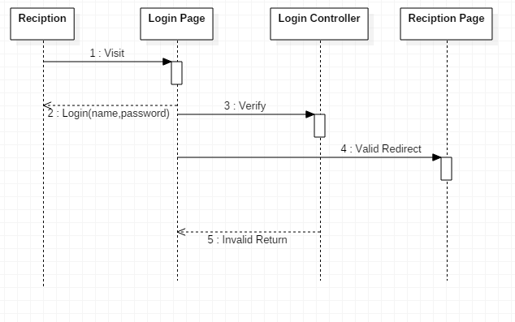

Manager Login Sequential Diagrams

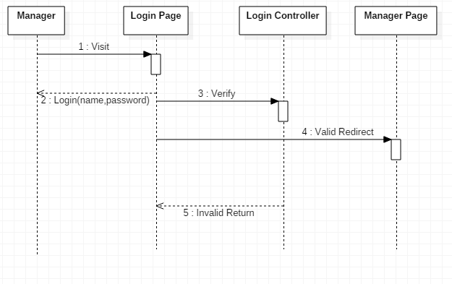

System user interface and Testing

- Project structure

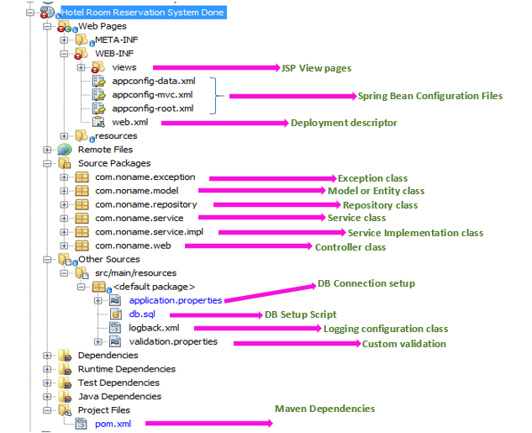

- Home page for frontend

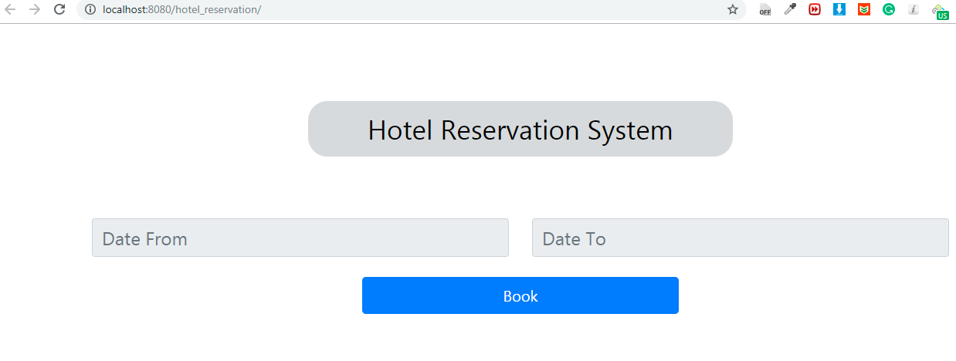
- Validation and Error Handling

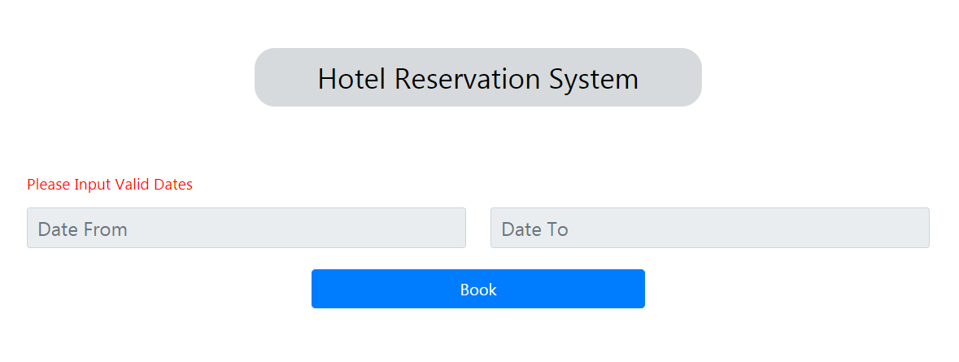
- Validation and Error Handling Code
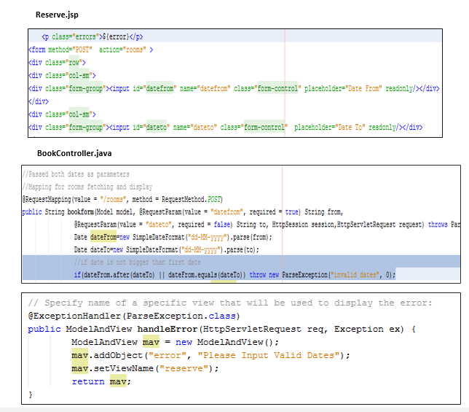

- Display Available rooms
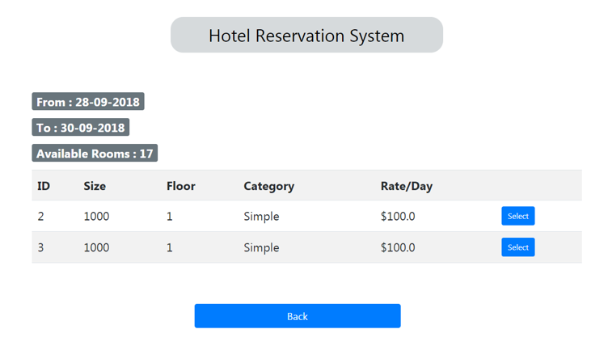
- Display Available rooms Code

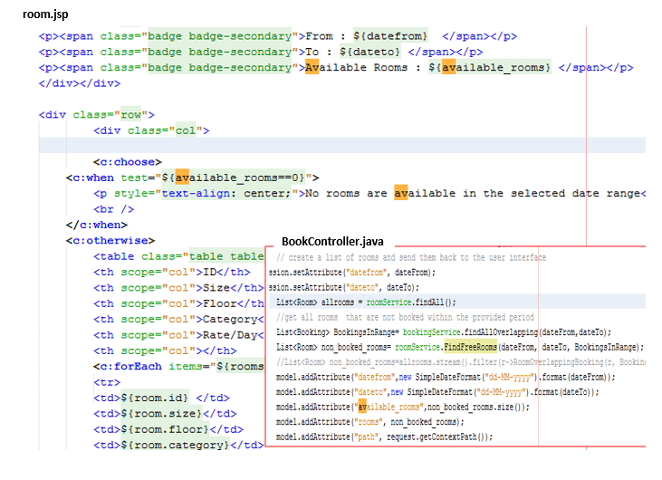

- Ask customer detail
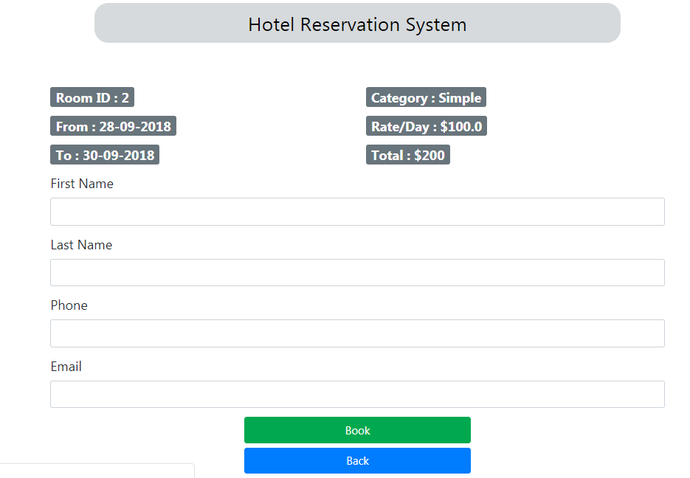

- Validate Customer Information
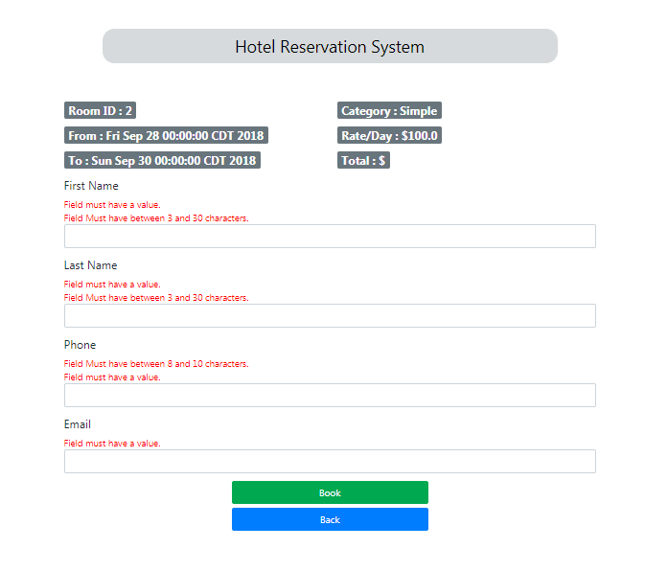
- Display Successful booking message
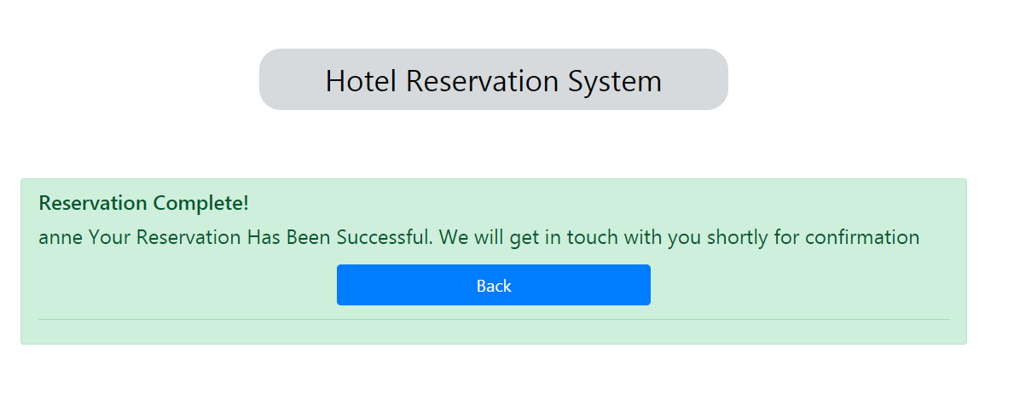

Issues, Risk and Dependencies

- Returning a list of objects as response body
- Design a query to select rooms based on a range dates and filtering out which one are booked within that range.
- Exception handling has challenged me but I ended up fixing the bug that was occurring

Design Alternatives

Instead of making this system specifically for one Hotel, change into a separate system that enables to add different optional hotels in the world that offer different service and price, this help customer to check different options by depending by their budget and their location.

Future Considerations

Because of a shortage of time, I perform only the basic tasks in this project. In this Hotel Reservation System, I want to add different functionalities. For example, adding customer registration, login and logout futures for Guests, to enable my system to track customer history and to give some discount offer after a certain period of time by depending their customer history. Enable the system to generate what type of customer come, from where they come and which type of room mostly used, this helps the hotel manager to improve the hotel service and facility. Also, I have a plan to enable online payment method and to enable to add a detail of rooms using a photo for more information and customer trust.

References
  - Spring Documentation ---------- https://spring.io/docs
  - Spring Security from our course lecturing slide
  - hotel-cloud-technology….https://www.siteminder.com/hotel-cloud-technology/why-reservation-system-important-hotel/

