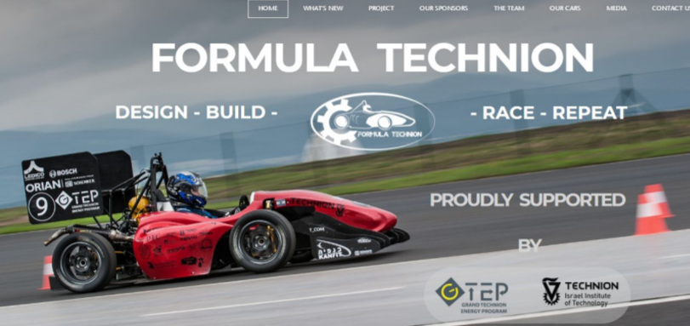

As part of the formula project we will develop an autonomous driving system for a driverless racing car, the first stage will make use in Monocular camera so in the first lap we will be able to create a map of the cones which describe the lap borders, based upon this map another team will create the driving path. In addition the system will provide the car’s location in the cones map. The second part will use a stereo camera.

