Django server setup after migration
Work History | 2026/3/27 document created  2026/3/27 document completed  2026/3/27 confirmed the server works.
Goal | Check if Django recognizes the migrations you applied to the WSL database  Run the Django server
Runtime Environment | WSL/venv
Directory/Folder | /mnt/c/Users/user/Documents/projects/ping_rtt_prediction
Note | The Order of Operations  python manage.py migrate  This prepares the "container" (the database tables) to hold your data. Since you already saw the [X] marks earlier, your WSL PostgreSQL is already prepared. You don't need to run this again unless you change your models.py.  python manage.py runserver  This starts the "listener" that waits for your browser to ask for data.

Workflow
Steps | Description
(move to the project directory.)
e.g.:
cd Documents/projects/ping_rtt_prediction
source venv/bin/activate | Activate the venv environment
python -m pip install --upgrade pip | pip version upgrade  you should indeed update pip first. Older versions of pip (like 18.1) do not support modern hash-checking features and security protocols as robustly as the newer versions.
pip-audit | It will check your library like pdfplumber (and its dependencies like pdfminer.six) against the Python Advisory Database.
# run the following command if necessary  pip-compile --generate-hashes requirements.in  pip install --require-hashes -r requirements.txt  python -m pip install --upgrade (library) (library) (library)...  e.g.:  python -m pip install --upgrade pip setuptools wheel | # Fixes pip, setuptools, and wheel  Using python -m pip is the most reliable way to ensure you are hitting the inside of your specific venv
# Same as above.  (Alternative command)  e.g.:  pip install --upgrade requests urllib3 zipp  (A safer way)  python -m pip install --upgrade requests urllib3 zipp | # Fixes requests and urllib3 (often used by pip-tools/pip-audit)  pip install (simply): This relies on your Terminal’s PATH. It runs whatever "pip" the terminal finds first. If your venv isn't activated perfectly, it might accidentally install packages into your Global/System Python, making a mess.
Configure settings.py for WSL PostgreSQL  DATABASES = {  'default': {  'ENGINE': 'django.db.backends.postgresql',  'NAME': 'your_db_name',  'USER': 'your_user',  'PASSWORD': 'your_password',  'HOST': '127.0.0.1', # Use 127.0.0.1 for WSL-to-WSL connections  'PORT': '5432',  }  } | Configure settings.py for WSL PostgreSQL  If you are running PostgreSQL directly inside WSL, your DATABASES setting in settings.py should typically point to 127.0.0.1 (the WSL loopback) rather than localhost to avoid certain IPv6 resolution issues.
Check if Django recognizes the migrations you applied to the WSL database:  python manage.py showmigrations  If you see [X] next to all migration names: Django is successfully connected to the migrated database.  And this is the sign you already ran “python manage.py migrate” in advance.  If you see [ ]: Django is likely looking at a different (empty) database, possibly a default SQLite file or a different PSQL schema. | You should run python manage.py runserver from within your WSL terminal, but you need to verify that Django is actually looking at the migrated database.  Since your Python scripts are now "bridging" between a Windows ping.exe and a PostgreSQL (PSQL) instance on WSL, you must ensure your Django settings.py is configured to connect to that same WSL PSQL instance.  1. Verify Django's "View" of the Database  Before starting the server, check if Django recognizes the migrations you applied to the WSL database:
#Run the local development server

python manage.py runserver
Hit the following URL.  http://localhost:8000/admin  http://localhost:8000/api  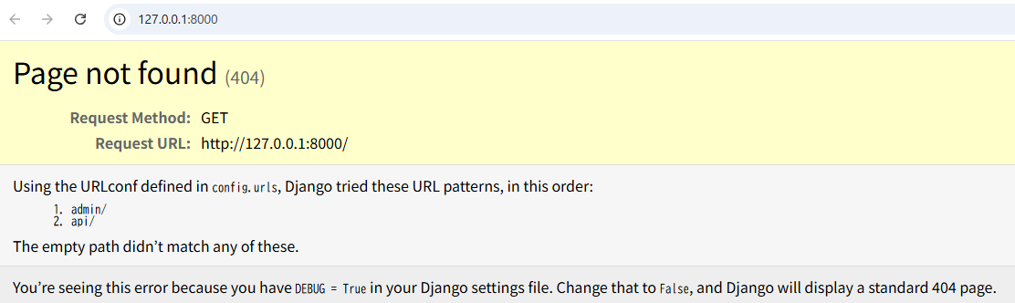  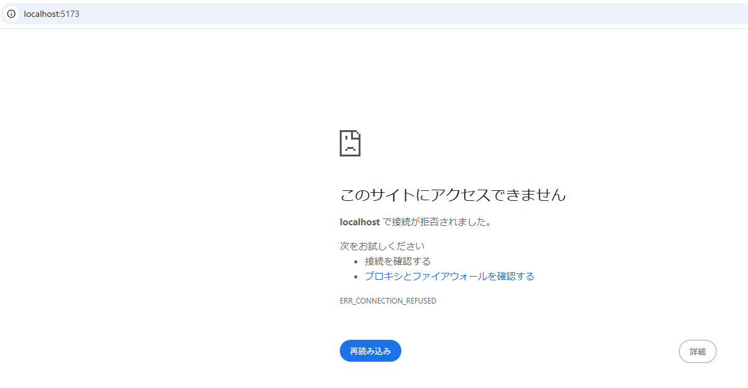  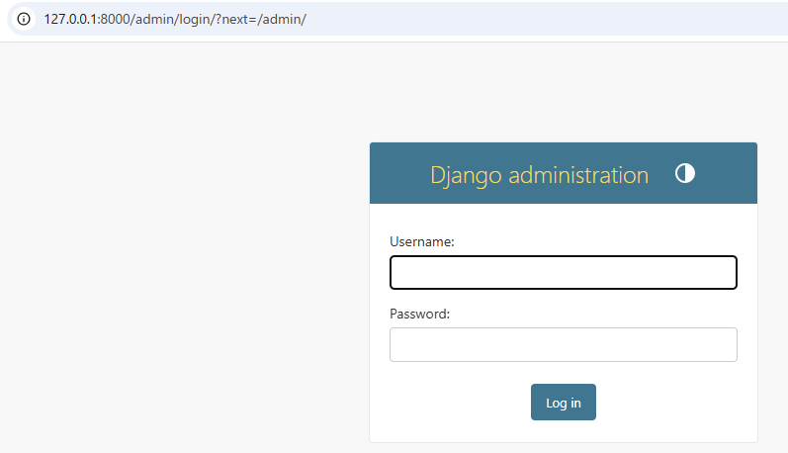  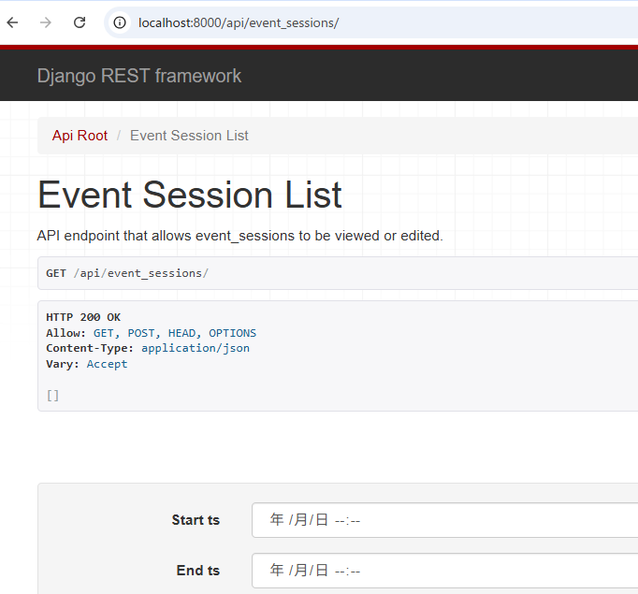 | The 404 error on port 8000 and the rejection on port 5173 indicate that while the "network bridge" is open, the services aren't correctly routing traffic inside the WSL environment.  1. Fix the 404 on Django (Port 8000)  A 404 usually means the Django server is running, but it doesn't recognize the URL you are hitting (likely the root /).  Check the URL: Try going to http://localhost:8000/admin  http://localhost:8000/api

