Install and integrate git with VS Code
Work History | 2026/4/5 document created  2026/4/5 git installed into Windows not into WSL  2026/4/6 git commit (initial commit) done by PowerShell  2026/4/6 integrated git with VS Code  2026/4/7 git commit done via VS Code  2026/4/7 document completed
Goal | Install and integrate git
Runtime Environment | Windows
Directory/Folder | /mnt/c/Users/user/Documents/projects/ping_rtt_prediction  C:\Users\user\Documents\projects\ping_rtt_prediction
Note | 1. Where to Install Git?  Since you are editing files on the Windows file system but running servers in WSL, the most efficient setup is to install Git on both:  - Git for Windows: Install this for your GUI tools (like VS Code or GitKraken) to handle staging and committing smoothly.  - Git in WSL (sudo apt install git -y): Install this so you can run Git commands directly in your Ubuntu terminal when you are already there managing your servers.  2. Can I use Git locally only?  Yes. When you run git init, Git creates a hidden .git folder in your project directory.  Local Repository: Lives on your laptop and tracks every change, version, and branch you create.  No Internet Needed: You can commit, branch, and see your history entirely offline.  Transitioning Later: If you ever decide to use GitHub for a recruiter to see, you simply "push" your existing local history to the remote server.  3. Quick Start Strategy  Install Git for Windows from the official site.  Open Git Bash (installed with Git for Windows) or your preferred Windows terminal in your project folder.  Run git init to start tracking.  Use VS Code: If you use VS Code, it will automatically detect the Git repository and give you a clean "Source Control" sidebar to manage changes without typing commands.

Workflow
Steps | Description
Follow these steps to convert your existing folder into a Git repository:  - Install Git for Windows from the official site.  https://git-scm.com/install/windows  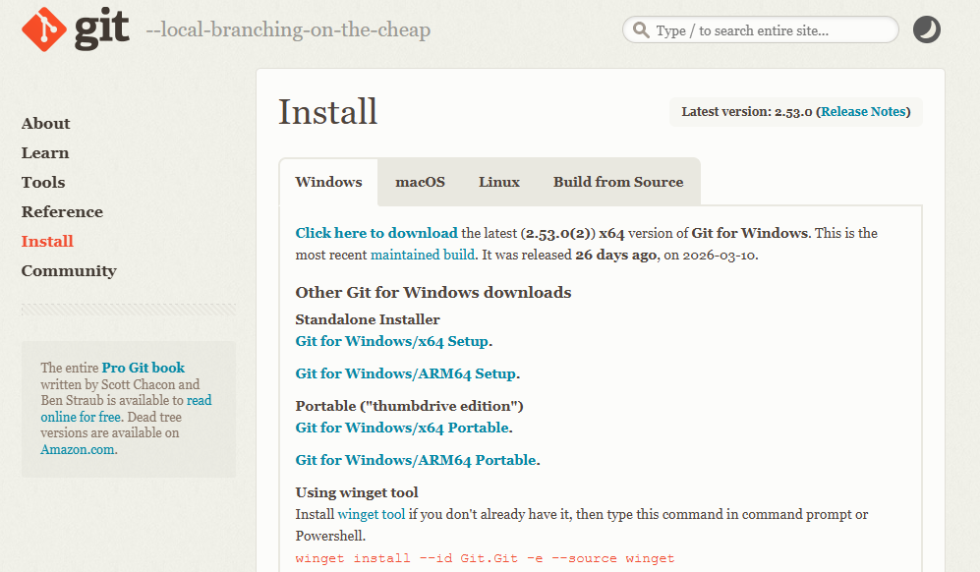  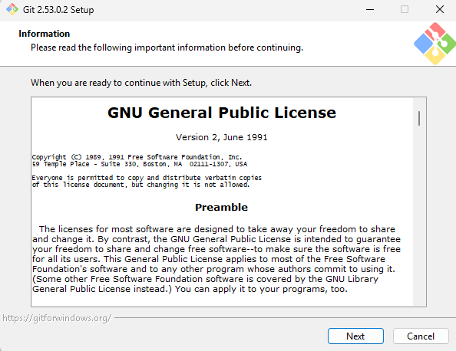  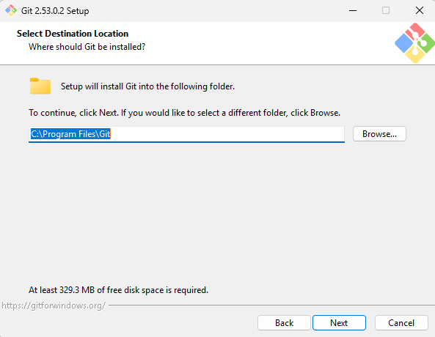  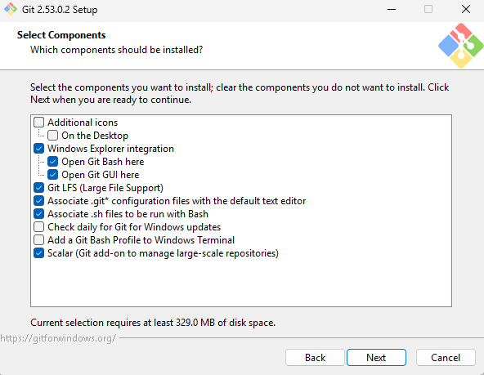  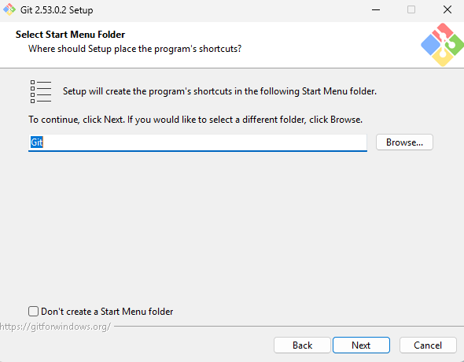  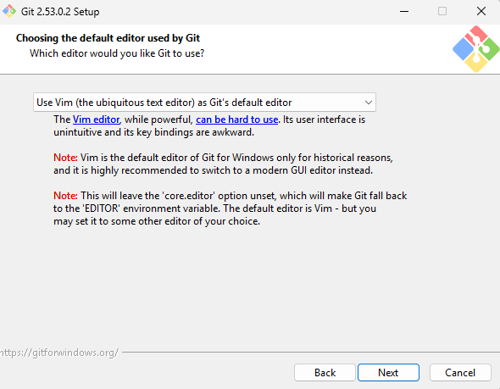  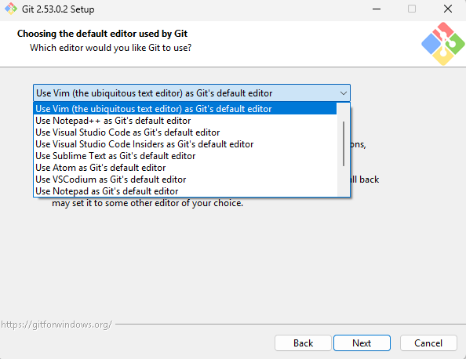 | 1. Where to Install Git?  Since you are editing files on the Windows file system but running servers in WSL, the most efficient setup is to install Git on both:  1. Install Git: Download and install it from the Official Git Website.  - Git for Windows:  Install this for your GUI tools (like VS Code or GitKraken) to handle staging and committing smoothly.  Dismissing "VS Code Insiders"  Yes, you should dismiss and ignore VS Code Insiders for now.  What it is: Insiders is a beta version of VS Code that receives daily updates with experimental features.  Why skip it: It is less stable and can occasionally break. As a learner, you should stick to the stable (Blue Icon) version of VS Code to ensure your development environment remains reliable.  Vim (Vi IMproved) is a highly efficient, open-source, terminal-based text editor  - Git in WSL (sudo apt install git -y): Install this so you can run Git commands directly in your Ubuntu terminal when you are already there managing your servers.  sudo apt install git -y
Efficiency: During the Git installation, selecting
Use Visual Studio Code as Git's default editor
ensures that when you run commands like git commit (without the -m flag), VS Code opens automatically.
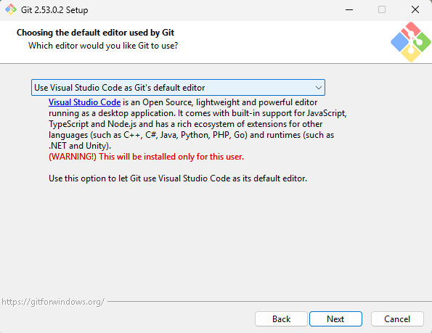
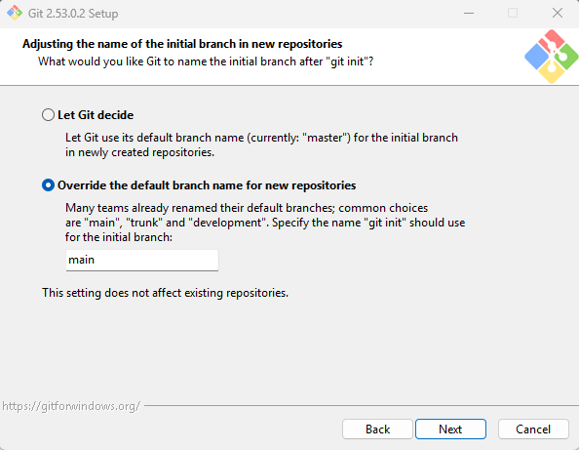 | Go with Option 2: Override the default branch name.  You should specifically set it to main.  While Git has historically used master as its default branch name (Option 1), the industry standard across GitHub, GitLab, and professional development teams has shifted to main.  Git does not "decide" the repository name for you; when you run git init, it simply starts tracking the folder you are already in. Because recruiters often skim profiles in seconds, your repository name is your first chance to make a professional impression.  Better Practices for Repository Naming  For your RTT Prediction app, follow these standard industry conventions:  Use Kebab-case: Write in all lowercase and separate words with hyphens (e.g., rtt-prediction-calendar). This is the standard for URL compatibility and readability.  Be Descriptive, Not Generic: Avoid names like my-project or calendar-app-v2. A recruiter should know exactly what the app does just by reading the title.  Include the Tech Stack (Optional but Helpful): Adding the main technologies can help your profile show up in searches (e.g., rtt-prediction-react-django).  Keep it Brief: While being descriptive, keep it short enough to be easy to type in a terminal.  Avoid Special Characters: Stick to letters, numbers, and hyphens. Avoid spaces, underscores, or symbols like @ or # which can break some command-line tools.  How to "Rename" your Local Repo  Since Git uses your folder name, you can simply rename the project folder on your Windows laptop. 1.Git will automatically detect the change and continue working as normal.  2.Close your code editor.  3.Rename the folder in Windows File Explorer (e.g., from MyProject to rtt-prediction-calendar).  Re-open the folder in VS Code.  Git will manage everything inside the folder where you initialize it, including all subfolders and files.  When you run git init in your project's root folder, Git creates a hidden directory called .git. This folder is the "brain" of your repository—it stores the entire history and all the metadata for every file in that root folder and its sub-directories.  How Git Tracks Your Folder  The Working Tree: Your project folder (e.g., rtt_prediction_calendar) becomes your "working tree". Git watches this entire tree for any changes.  Explicit Tracking: Even though Git "sees" all files, it doesn't automatically save them. You must tell Git which files to track using git add and then "save" those changes with git commit.  Subfolders are Included: If you have subfolders like /frontend or /backend, Git manages those as part of the same repository automatically.  ⚠️ Essential Step: The .gitignore File  Because Git manages everything by default, it will try to track "junk" files that you don't need (and that recruiters don't want to see). Before you make your first commit, you should create a text file named .gitignore in your root folder.  For your React + Django project, you should definitely ignore these:  node_modules/: (React dependencies—huge and unnecessary to track).  __pycache__/: (Python execution files).  db.sqlite3: (Your local database file; usually better to keep this out of Git).  .env: (Contains private passwords or API keys).  .vscode/: (Your personal editor settings).  Pro Tip for Recruiters  By keeping your repository clean with a .gitignore file, you show recruiters that you understand professional repository hygiene and don't just "upload everything" blindly.
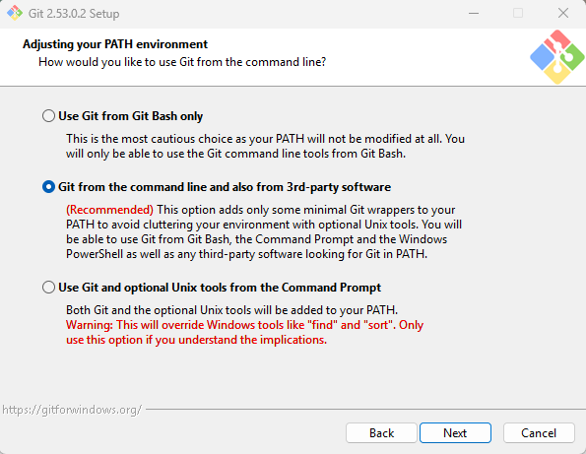 | Pick Option B: "Git from the command line and also from 3rd-party software."  This is the standard "middle-ground" choice and is by far the best for your setup. [1, 3]  Why Option B is the right move:  PowerShell & WSL Compatibility: It adds the git command to your Windows PATH (the environment variable that tells your computer where programs live). This means you can type git in PowerShell, Command Prompt, or VS Code’s terminal, and it will just work. [1, 3]  VS Code Integration: Since you want to use Git inside VS Code, this option allows VS Code’s built-in Git features to find the Git engine on your laptop without you having to manually configure paths. [3, 4]  Safety: It only adds the essential Git tools to your PATH, avoiding any messy conflicts with other Windows tools. [1, 3]  What about Option A or C?  Option A (Git Bash only): This is too restrictive. You wouldn't be able to use Git in PowerShell or VS Code easily. [1]  Option C (Optional Unix tools): This replaces some Windows commands (like find or sort) with Unix versions. It’s usually overkill and can sometimes break specific Windows scripts
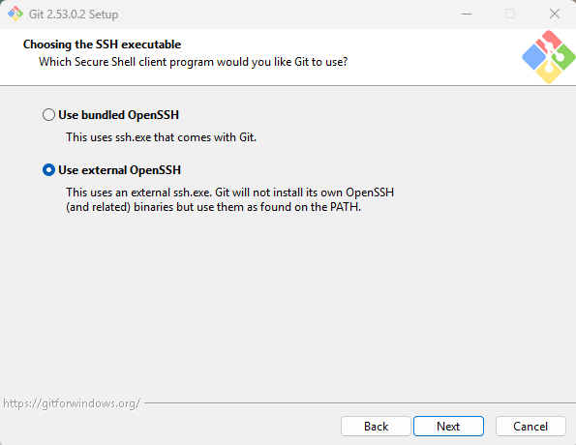 | If you already have a custom OpenSSH setup that you use to connect to your home server, Option B (Use external OpenSSH) is actually a great choice.  Why Option B fits your specific case:  Consistency: Since you already use SSH for your home server, you likely have an SSH agent or keys configured in Windows. Using "External" tells Git to use the same SSH tools you already trust, rather than having a second, separate "bundled" version.  Key Management: If you ever decide to push code to a private server or GitHub via SSH, you can use your existing keys in C:\Users\YourName\.ssh without having to jump through hoops to make the "bundled" version see them.  Pro Workflow: Most professional developers prefer using the system's native OpenSSH (which is now built into Windows 10/11) because it’s easier to manage one set of keys than two.  Is it risky?  No. As mentioned before, this is the SSH Client, not the SSH Server. It doesn't "listen" for incoming connections from the internet; it only "speaks" when you tell it to connect to your home server or a Git host. Your home server's remote access is handled by the SSH Server (service) on that machine, not by this setting on your laptop.  Recommendation:  If you are comfortable with how you currently connect to your home server, go with Option B. It keeps your environment "clean" by using one single SSH tool for everything.  1. The "Bundled" vs. "External" Difference  Bundled OpenSSH (Recommended): Git comes with its own version of OpenSSH. It is self-contained and guaranteed to work perfectly with Git's commands.  External OpenSSH: This tells Git to look for an SSH program already installed on your Windows system (like the one built into modern Windows 10/11). While it works, it can sometimes lead to "path" conflicts if you have multiple versions of SSH installed.  2. Is it risky? (The "Internet Connection" Misconception)  No, neither option allows people from the internet to connect to your computer.  SSH in this context is a Client, not a Server.  It is used only when you want to securely send ("push") your code to a remote place like GitHub or a private server.  It does not open a "door" for others to enter your machine. It is simply the "key" you use to talk to other servers.  3. Why Bundled is better for WSL users  Since you are using WSL Ubuntu and Windows, keeping Git's SSH tools bundled ensures that your Windows Git environment stays stable and independent of whatever SSH configurations you might change later inside your Ubuntu subsystem.  Summary for a Professional Setup:  Pick "Use bundled OpenSSH" for the easiest, most reliable experience.  Pick "Use the OpenSSL library" (if it asks about server certificates) for maximum compatibility.
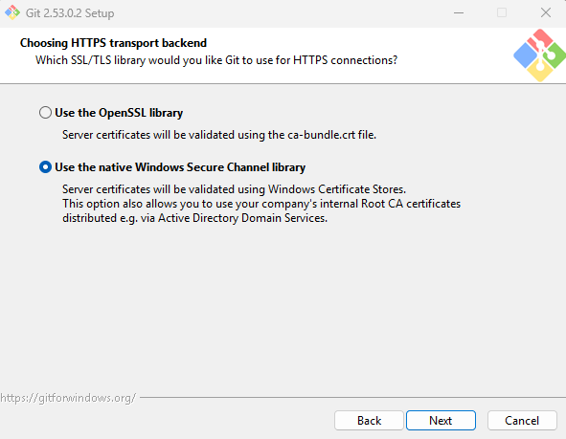 | Pick "Use the native Windows Secure Channel library" (also known as SChannel).  For a developer working on a Windows machine with WSL, this is the more modern and integrated choice.  The Difference  Native Windows Secure Channel (SChannel):  This uses the built-in Windows networking layer. It is the same system Windows itself uses for security updates and web browsing. It automatically uses the Windows Certificate Store, which means if your computer already trusts a website (like GitHub), Git will trust it too without extra configuration.  OpenSSL Library: *Not OpenSSH!  This is the traditional, open-source library used primarily in Linux. It uses a separate file (usually ca-bundle.crt) to manage trusted certificates.  Why SChannel is better for you  Professional "Cleanliness":  Recruiters and IT departments prefer SChannel because it allows security settings to be managed centrally by the OS rather than having to configure each application individually.  Less Troubleshooting:  If you ever work in a corporate environment or use a VPN, OpenSSL can sometimes fail to "see" the company's security certificates, leading to frustrating connection errors. SChannel avoids this by "talking" directly to Windows.  Simplicity:  Since you are already managing a complex setup with WSL and React/Django, using the native Windows library for your Git transport reduces the number of separate "toolchains" you need to maintain.  Note for WSL: Your Ubuntu/WSL environment will still use OpenSSL internally (because Linux requires it), but your Windows/VS Code Git operations will use SChannel. This "best of both worlds" approach is standard for cross-platform developers.  This is not for your local Django/React servers. It is strictly for Git acting as a client when it talks to the outside world (like GitHub or a corporate server) over HTTPS [4, 5].  Think of it like choosing which "security guard" your Git command uses to verify that a website is safe before it sends your code there.  The Breakdown  It’s for Outbound connections: When you run git push or git clone using an https://... URL, Git needs to verify the SSL/TLS certificate of the destination [4, 5].  Native Windows (SChannel): Git asks Windows to verify the certificate. This is the "Pro" choice for Windows users because if your browser (Edge/Chrome) trusts a site, Git will too [1, 2].  OpenSSL: Git uses its own separate list of "trusted sites." This sometimes causes errors on Windows if you are behind a VPN or a specific firewall that Windows already knows how to handle but OpenSSL doesn't [5].  Why you should pick "Native Windows Library"  Since you are a developer on a Windows machine:  Zero Maintenance: You won't have to manually update certificate files [5].  Corporate Friendly: If you ever get a job where the company uses a "Proxy" or a "Zscaler" type security tool, the Native Windows option is often the only one that works without massive headaches [2, 5].  Does not affect your WSL servers: Your Django (port 8000) and React (port 3000) servers are running locally on your machine. This Git setting won't touch them at all.  You’ve hit on a common point of confusion! Here’s the simple breakdown:  1. "HTTPS only for browsers?"  While browsers are the most famous HTTPS clients, any program that talks to a server (like Spotify, Discord, or Git) is its own "client."  When you run git clone https://github.com..., Git isn't using Chrome or Edge; it’s using its own internal code to send that data.  That setting asks: "Should I use the Windows internal security team to verify the connection, or my own private security team (OpenSSL)?"  The Pro Choice: Stick with the Windows Native Library. It’s much more "set it and forget it."
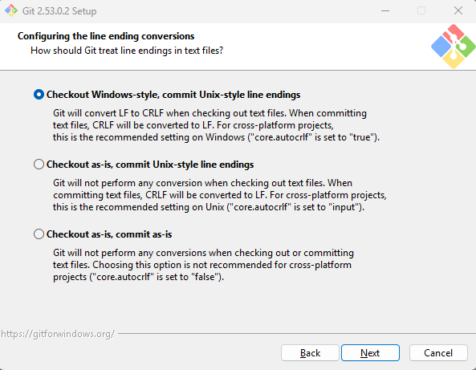 | Since you are a WSL (Linux) user who edits files on Windows, this is the most critical setting for your project's health.  The Best Choice:  Select "Checkout Windows-style, commit Unix-style line endings" (often the first or default option).  Why this matters for your RTT app:  Windows (VS Code) likes files to end with CRLF (hidden characters that mean "Return" and "New Line").  Linux (WSL/Ubuntu) only likes LF ("New Line").  The "Magic": This setting tells Git: "When I'm coding in Windows, let me see CRLF so my editor is happy. But when I 'Save' (Commit) to the database, convert it to LF so the Linux server (WSL) won't crash or show weird symbols."
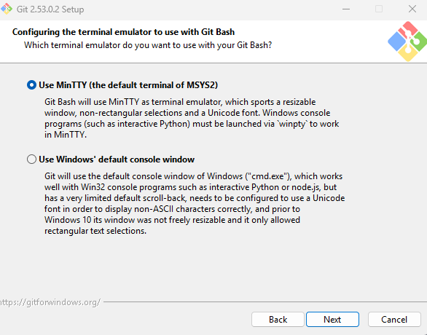 | Pick MinTTY.  While you plan to use PowerShell for your daily Git commands, you should still choose MinTTY as the emulator for the Git Bash shortcut.  Why MinTTY is better than the Windows Default Console:  Resizability & UI: MinTTY is a much more modern window. You can easily resize it, it has better font rendering, and it supports transparency and better color schemes.  Unix-like Experience: Since you are already working with WSL (Ubuntu), MinTTY behaves more like a Linux terminal. It handles things like Ctrl+C (to stop a process) and text selection much more predictably.  The "Default Console" is Old: The "Windows default console" (conhost.exe) is the old-school Command Prompt window. It is notorious for having "clunky" copy-paste behavior and limited layout options.  To be clear:  Choosing MinTTY does not prevent you from using Git in PowerShell.  It only changes the "look and feel" of the window that pops up if you ever specifically click the "Git Bash" icon.  VS Code will still use its own internal terminal (which you've set to PowerShell), so this choice won't affect your VS Code workflow at all.
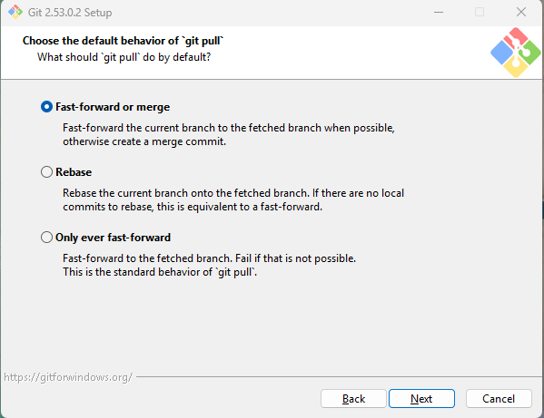 | Choose "Default (fast-forward or merge)".  What does this mean?  When you "pull" code (which means "download updates from a remote place and combine them with my local files"), Git needs to know how to handle the "joining" of that data.  Fast-forward or merge (Recommended): This is the classic, most common way Git works. If your local code and the remote code haven't drifted apart, it just "fast-forwards" your timeline. If they have both changed, it creates a "merge commit" to join them. This is what 90% of developers use.  Rebase: This is a "cleaner" but more advanced method that rewrites your history to make it look like a straight line. It can be confusing for beginners because it "moves" your commits around.  Only ever fast-forward: This is very strict and will fail if there are any conflicting changes, forcing you to fix them manually every time.  Why "Default" is best for you:  Recruiter Friendly: It shows you are using the standard Git workflow.  Safety: It is the "safest" option. If there is a conflict, Git will stop and ask you to fix it rather than trying to do something "clever" with your history.  Local Use: Since you are currently working only on your local machine, you won't actually be "pulling" from anywhere yet! This setting only matters once you connect to GitHub or a team server later.
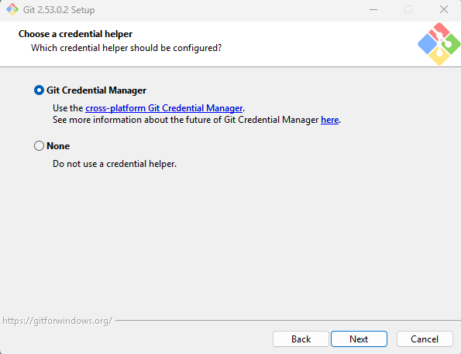 | Pick "Git Credential Manager" (the core/modern one). It safely remembers your GitHub passwords/tokens so you don't have to type them every time.
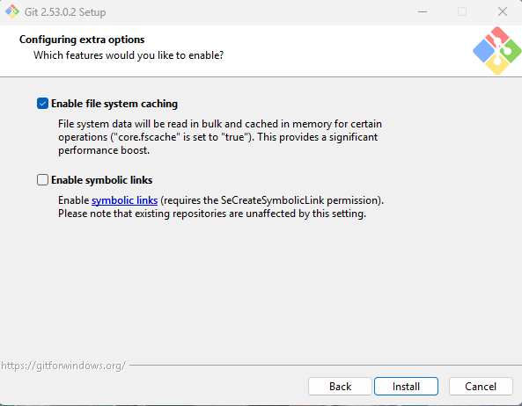 | Enable file system caching: (Yes - makes Git faster on Windows).  Enable symbolic links: (No - usually not needed for your setup).
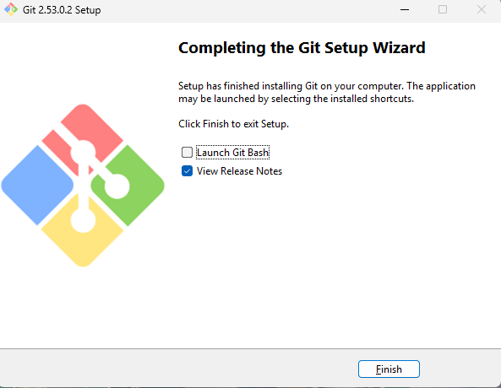 | file:///C:/Program%20Files/Git/ReleaseNotes.html
2. Open Git Bash (installed with Git for Windows) or your preferred Windows terminal (PowerShell) in your project folder.  You can definitely use PowerShell for Git instead of Git Bash. Since you are on Windows, PowerShell is the default terminal in VS Code. | Since your files are on the Windows file system, running Git from Windows (PowerShell) is the best practice for now.  Here is the deal:  Either is fine, but Windows is faster for this specific setup.  Use Windows (PowerShell): Because your files live on the C: drive, Windows Git can "talk" to them instantly.  Avoid WSL for Git (for now): When you run Git inside WSL to look at Windows files (under /mnt/c/), it has to cross a "bridge" between Linux and Windows. This makes Git commands like git status or git add much slower.  Can you use both?  Yes! Since you installed Git on Windows and (optionally) on WSL:  You can Commit and Branch using PowerShell or VS Code (Windows side).  The .git folder is just a folder. If you jump into WSL to run your server, you can still type git status there, and it will see the exact same history. They share the same "brain."  The "Pro" Workflow:  Terminal 1 (PowerShell): Use this for all your Git commands (git add, git commit).  Terminal 2 (WSL/Ubuntu): Use this only to run your servers (python manage.py runserver).
- Verification:  Type  [PowerShell]  git --version  in PowerShell to confirm it's working.  Move to the folder.  cd “C:\Users\user\Documents\projects\ping_rtt_prediction”  git init  to start tracking. | Your Project Structure will look like this:  rtt_prediction_calendar/ <-- Run 'git init' HERE  ├── .git/ (Hidden brain)  ├── .gitignore (The "do not track" list)  ├── docs/ (Your manuals, PDFs, and notes)  ├── frontend/ (React code)  └── backend/ (Django code)
Create a file named .env in your root folder.  Add your sensitive info there:  SECRET_KEY=xxxxxx  DB_PASSWORD=your_secure_password_here | The Best Practice: Environment Variables (.env)  Instead of hardcoding your PostgreSQL password in a configuration file or pointing to a .pgpass file (which can be tricky for Django/React to read), the industry standard is using a .env file.  You are right that "dot files" started in Unix/Linux to denote hidden configuration files. However, because almost all modern developer tools (Git, Docker, Node.js, Python) are cross-platform, Windows now fully supports them.
1. Install the library in WSL  Since your Django server runs in WSL, run this in your Ubuntu/WSL terminal:  Bash  Add python-dotenv in requirements.in and install it. | To fix your configuration.py (or settings.py) to use the .env file, the best practice is to use a library called python-dotenv.  This library "loads" the variables from your .env file into your system's memory so your code can read them securely without ever seeing the actual password in the script.
Modify the settings.py as below:

[settings.py]
import os
from pathlib import Path
from dotenv import load_dotenv

# 1. Build paths inside the project like this: BASE_DIR / 'subdir'.
BASE_DIR = Path(__file__).resolve().parent.parent

# 2. Load the .env file
load_dotenv(os.path.join(BASE_DIR, '.env'))

# 3. Now replace your plain-text password with this:
DB_PASSWORD = os.getenv('DB_PASSWORD')

SECRET_KEY = os.getenv('SECRET_KEY')

# Then use these variables in your DATABASES dictionary:
DATABASES = {
'default': {
'ENGINE': 'django.db.backends.postgresql',
'NAME': 'your_db_name',
'USER': DB_USER,
'PASSWORD': DB_PASSWORD,
'HOST': 'localhost',
'PORT': '5432',
}
}

Create .gitignore as below;  [.gitignore]  # --- Secrets & Config ---  .env  .vscode/  hint.txt  # --- Logs & Temp Data ---  logs/  *.log  # --- Python / Django ---  __pycache__/  *.py[cod]  *$py.class  venv/  virenv/  db.sqlite3  .pytest_cache/  .python-version  # --- Node / React ---  node_modules/  npm-debug.log*  yarn-debug.log*  yarn-error.log*  build/  dist/  # --- OS Specific ---  .DS_Store  Thumbs.db  # --- Large/Legacy Data & Work Instructions ---  1_data/  7_work_instruction/  old/  test_log_collector | Creating/Editing in VS Code: This is the easiest way. In your project's root folder, right-click and create a new file named .gitignore (ensure the dot is at the start). Open it and simply type .env on a new line.
PowerShell  git config --global user.name "tony"  git config --global user.email "tomo.komuro01@gmail.com" | 1. Identify Yourself (Crucial for Recruiters)  If you haven't done this yet, Git needs to know who is making the commits. Run these two commands in PowerShell:
PowerShell  git status | 2. Verify the "Invisibility" of Secrets  Run this command to see what Git is currently "looking at":  Check: Do you see .env in the "Untracked files" list?  Success: If .env is NOT there, your .gitignore is working perfectly.
Stage everything:  git add . | 3. Your First Official Snapshot  Now that your secrets are hidden, you can save the current state of your project:  1. git add .  The dot (.) is a shorthand for "everything in the current folder and all subfolders."  The Tray (git add .): You place the finished "dishes" (files) onto a tray. They aren't served yet; you're just getting them ready.
git status

If you see red, something goes wrong.
Fix the gitignore and run “git reset” and “git add .” again.

- Fix the gitignore
- Run
git reset
- Run
git add .
- Run
git status
Make sure you see a clean list of green files, with no venv or node_modules.  Changes to be committed:  (use "git rm --cached <file>..." to unstage)  new file: .env.example  new file: .gitignore  new file: 6_scripts/app_script_lesson_extraction.txt  new file: 6_scripts/debug_structure.txt  new file: 6_scripts/start_app.sh  new file: 6_scripts/test_fetch_save_lessons.py  new file: 6_scripts/test_get_daily_lessons.py  new file: 6_scripts/test_import_pdfplumber.py  new file: calendar_api/__init__.py  new file: calendar_api/admin.py  new file: calendar_api/apps.py  new file: calendar_api/migrations/0001_initial.py  new file: calendar_api/migrations/__init__.py  new file: calendar_api/models.py  new file: calendar_api/serializers.py  new file: calendar_api/tests.py  new file: calendar_api/views.py  new file: config/__init__.py  new file: config/asgi.py  new file: config/port_list_memo.txt  new file: config/settings.py  new file: config/urls.py  new file: config/wsgi.py  new file: ingest_ping_stream.py  new file: manage.py  new file: network-ui/.gitignore  new file: network-ui/README.md  new file: network-ui/eslint.config.js  new file: network-ui/index.html  new file: network-ui/package-lock.json  new file: network-ui/package.json  new file: network-ui/public/favicon.svg  new file: network-ui/public/icons.svg  new file: network-ui/src/#App.jsx_for_coding.txt  new file: network-ui/src/App.css  new file: network-ui/src/App.jsx  new file: network-ui/src/assets/hero.png  new file: network-ui/src/assets/react.svg  new file: network-ui/src/assets/vite.svg  new file: network-ui/src/index.css  new file: network-ui/src/main.jsx  new file: network-ui/vite.config.js  new file: requirements.in  new file: requirements.txt | The result looks perfect. You have successfully filtered out the "noise" and kept only the high-value files.  Why this is a "Pro" list:  The Big Ones are gone: No venv, no node_modules, and no .env. This shows excellent repository hygiene.  Structure is clear: A recruiter can clearly see your Backend (calendar_api, config, manage.py), your Frontend (network-ui), and your Dependencies (requirements.txt, package.json).  Documentation is included: Keeping things like port_list_memo.txt and README.md shows you are organized and care about team communication.  One Tiny Detail (Optional)  I noticed a file called network-ui/src/#App.jsx_for_coding.txt.  If this is just a temporary "scratchpad" file, you might want to delete it or ignore it later.  But for an Initial Commit, it’s totally fine to leave it in. It won't hurt anything!
Commit:  git commit -m "Initial commit: RTT Prediction app with React and Django" | 2. git commit -m "..."  The text between the double quotations is your Commit Message.  It is a description, not a "name": Unlike a filename (e.g., Project_v1.zip), a commit message is a short note explaining what you changed and why.  The -m flag:  This stands for "message." It tells Git, "I'm going to type the description right here in the command line."  Recruiter Tip: Professional developers use the "Imperative Mood." Instead of saying "I added the calendar," they say "Add RTT prediction calendar feature." It makes the project timeline read like a clear list of instructions.  The Table (git commit): You deliver the tray to the customer. This "saves" the meal into the restaurant's history (the Git Log) forever.
Checking the History  git log --oneline | You can check the history with a hash next to your message.
Integrate Git with VS Code
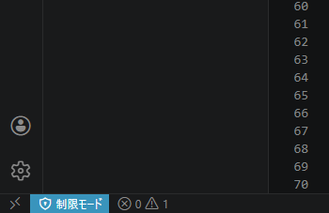  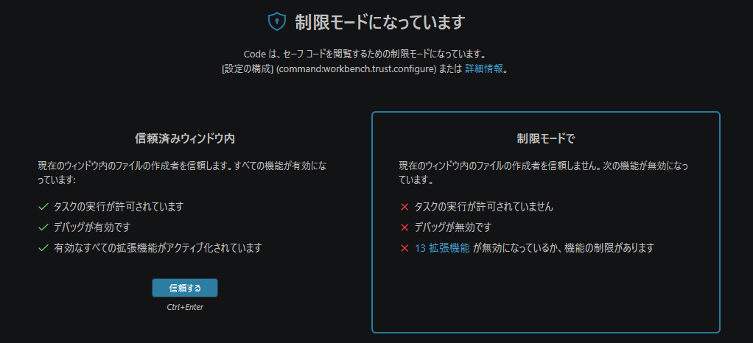  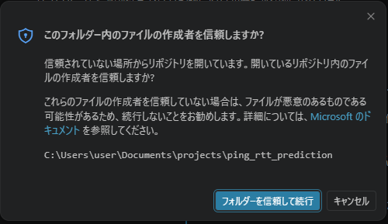  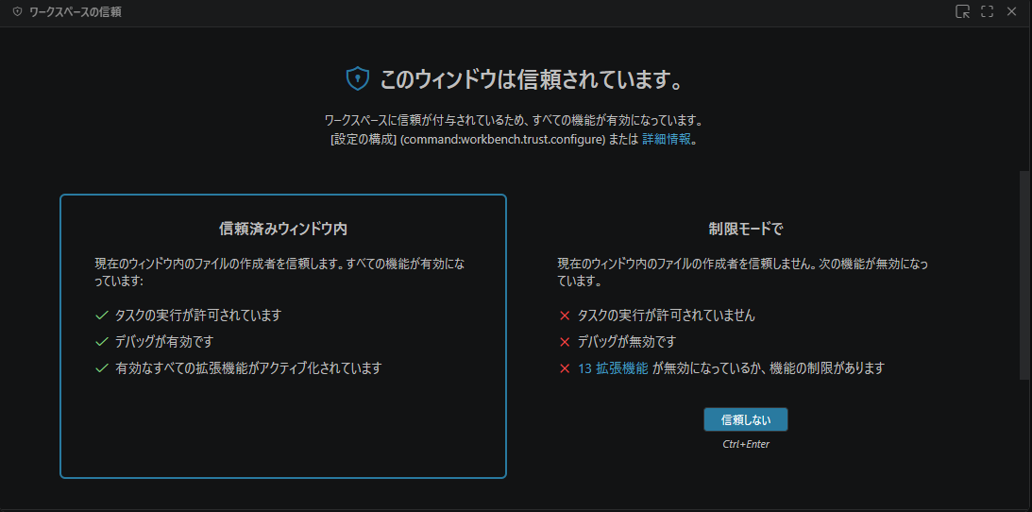 | VS Code's "Workspace Trust" is a security feature to prevent malicious code (like a script hidden in a downloaded project) from running automatically when you open a folder. Since you wrote this code on your own machine, there is zero risk.  What happens when you "Trust" the folder?  Git Integration: VS Code will finally "activate" the Git features we discussed. The Source Control icon will show your branch name (main) and any changes.  IntelliSense: Autocomplete and error checking for React and Django will start working properly.  Terminal: You’ll be able to run your WSL and PowerShell terminals directly inside VS Code without switching windows.  How to do it:  Click "Manage" or the Restricted Mode notification at the bottom.  Click the button that says "Trust the authors of all files in the parent folder..." (or just this folder).  Once you've Trusted it:  Look at the Source Control tab (Ctrl + Shift + G). You should now see a clean interface. If you make a small change (like adding a space or a comment) to App.jsx and save it, that file will immediately appear in the "Changes" list.
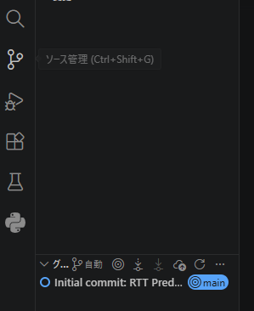 | Click the Source Control icon (it looks like a branch/three dots connected by lines, or press Ctrl + Shift + G).  You will see a list of any files you've changed since your last commit.
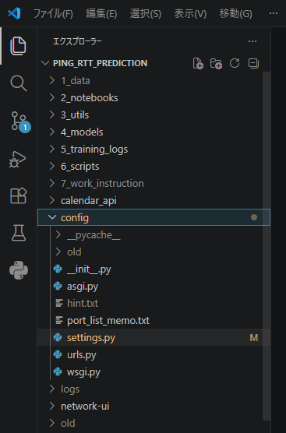 | Get back to "Editable" mode:  Close the "Read-Only" Tab: Close the tab at the top that has the Lock icon or says (Index).  Use the Explorer (Files) Icon: Go to the very top icon in the left sidebar (the two papers icon, or Ctrl + Shift + E).  Open the file from there: This opens your actual project file where you have full permission to type and save.
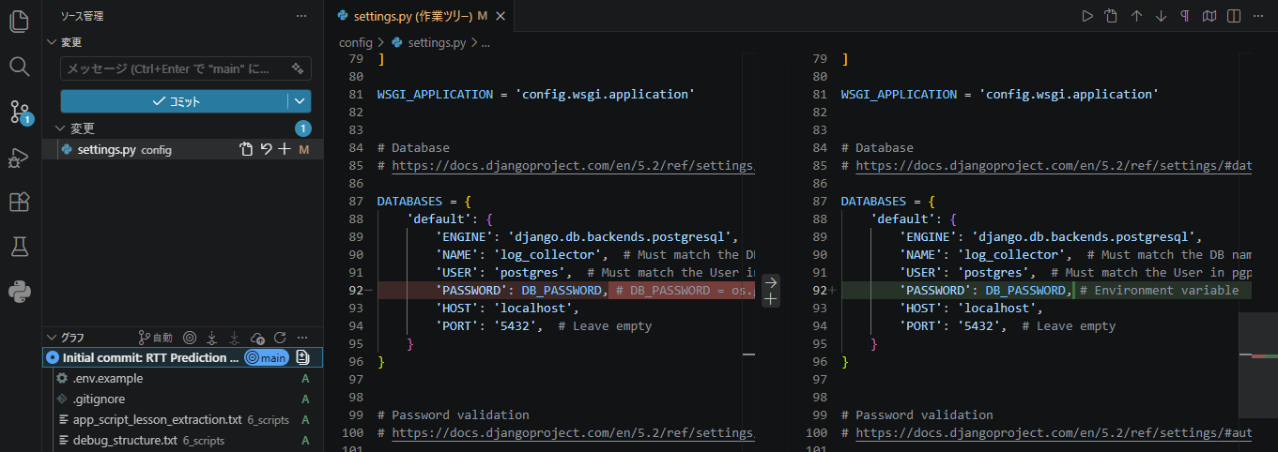 | If you click a file name here, VS Code opens a "Diff View"—it shows your old code on the left and your new changes on the right. This is incredibly helpful for catching bugs before you save.
git add . (via GUI)  How to do it in the VS Code GUI:  1. Open the Source Control Tab (Ctrl + Shift + G).  2. Find your file under the "Changes" section.  3. Click the Plus (+) Icon next to the filename.  -This is the same as running git add [filename].  -The file will move up into a new section called "Staged Changes".  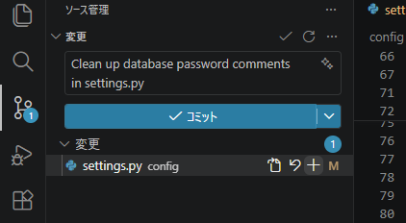  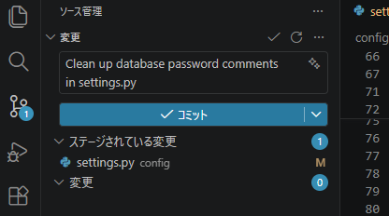 | You are exactly right! VS Code is asking you to do the GUI equivalent of git add . before it allows the commit.  In Git, there is a middle step called the "Staging Area" (the "tray" we talked about earlier). Even in VS Code, you have to move files from Changes to Staged Changes before hitting the Commit button.
git commit -m (via GUI)  1. Type your message in the box at the top.  2. Click the Commit button (the checkmark icon).  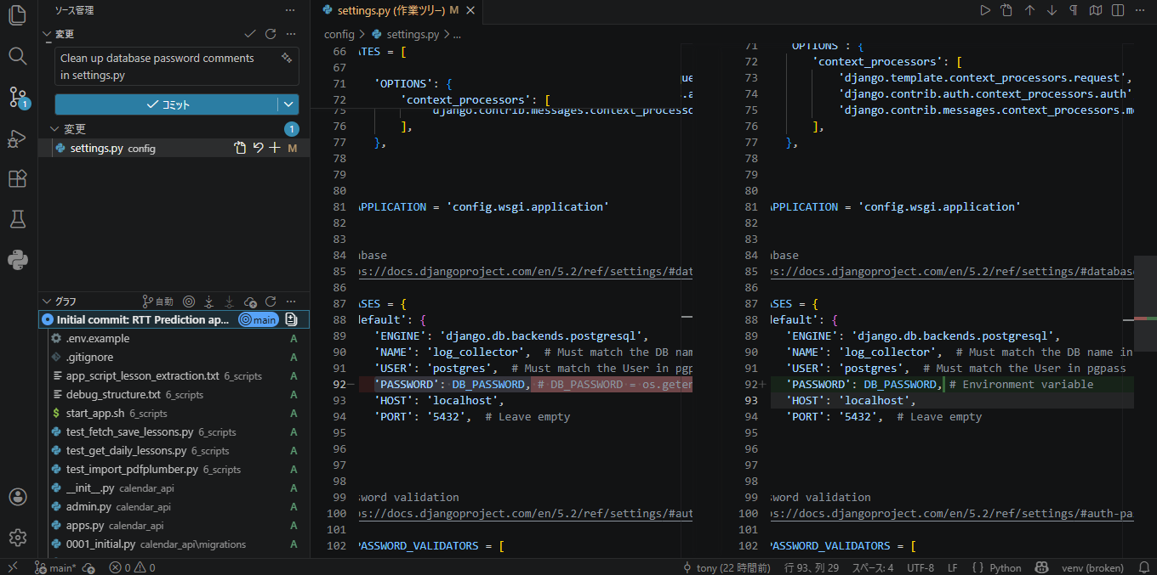  Commit Naming Ideas (The "Pro" Patterns)  For New Features: "Add [Feature Name]"  Example: "Add delete button to calendar events"  For Fixes: "Fix [Bug Description]"  Example: "Fix time alignment in DayGrid view"  For Refactoring/Cleaning: "Refactor [Code Section]" or "Clean up [File Name]"  Example: "Refactor event fetching logic for better performance"  For Documentation: "Docs: Update [Document Name]"  Example: "Docs: Update manual for server installation" | 1. What happens if you commit without saving manually?  No, it won't crash Git! However, Git only commits what is on the hard drive.  If you type new code in VS Code but don't hit Ctrl+S, that new code only exists in the "air" (your computer's RAM).  When you hit Commit, Git looks at the file on the disk, not on RAM.  Result: Your commit will save the old version of the file, and your new unsaved typing will still be sitting there as an "unsaved change."  Pro-Tip: Most developers turn on File > Auto Save in VS Code to ensure they never accidentally commit an old version.  Now I understand Commit button is separated from saving into a hard drive.  So will AutoSave function save a file automatically and frequently when I'm editting the file without pressing ctrl + S?  But that sounds a little bit risky since it will save whatever I edit even if I don't intend to save it. Could be not for me... But I can restore from the previous snapshots... Difficult.  You have hit on the exact reason many professional developers actually disable Auto Save. Your intuition is 100% correct:  The Risk: If you accidentally delete a huge block of code or make a "messy" experiment, Auto Save will immediately write that mess to your hard drive.  The "Safety" is Git: You are right that you can restore from a snapshot, but it’s much easier to just not save the mistake in the first place by closing the file without hitting Ctrl + S.  My Recommendation for You:  Keep Auto Save OFF.
1. The "Timeline" View (Built-in to VS Code)  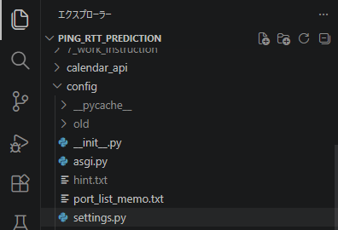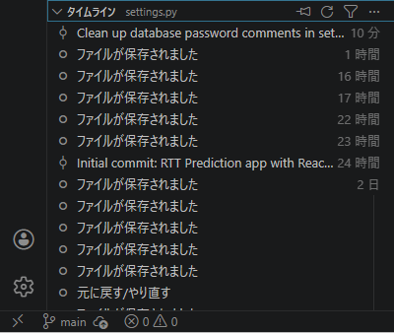  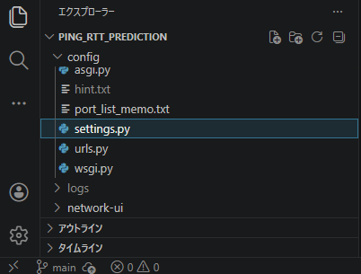  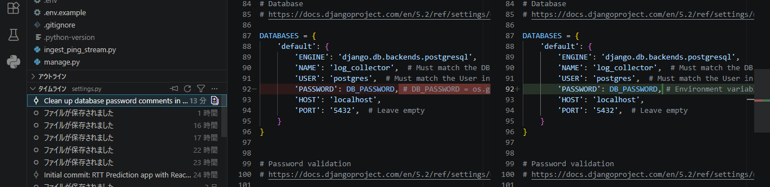  2. Using "Git Graph" (Visual Tree)  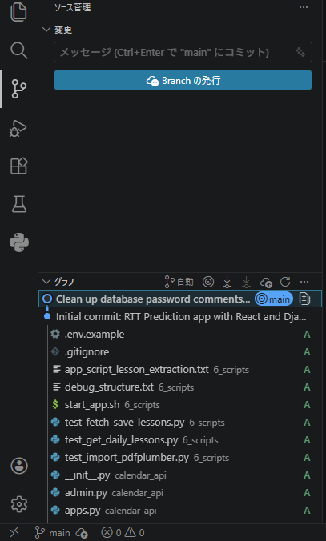  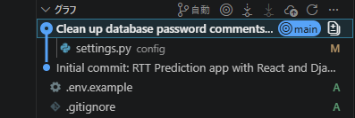  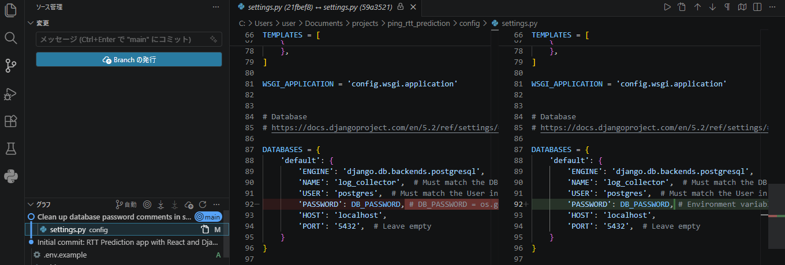 | 1. The "Timeline" View (Built-in to VS Code)  This is the easiest way to see exactly what changed in a specific file over time:  1. Open your settings.py file in the editor.  2. In the Explorer sidebar (the file list on the left), look at the very bottom section titled TIMELINE.  3. You will see a list of all your commits involving this file (e.g., "Initial commit", "Clean up database password...").  4. Click on a commit in that list. VS Code will open a side-by-side Diff View showing you exactly what that specific commit changed compared to the version before it.  2. Using "Git Graph" (Visual Tree)  If you installed the Git Graph extension:  1. Open the Git Graph tab.  2. Click on your latest "Clean up..." commit (the circle on the line).  3. A panel will slide up showing all files changed in that commit.  4. Click on settings.py in that list. It will open the "Diff" showing your "Before" (Red) and "After" (Green) code.

