making shortcut to run bash script
Work History | 2026/4/3 document created  2026/4/3 confirmed the shortcuts work  2026/4/4 document completed  2026/4/4 shortcuts created on the Windows desktop
Goal | making shortcut to run bash script
Runtime Environment | Windows
Directory/Folder | Desktop
Note | making shortcut to run bash script

Workflow
Steps | Description
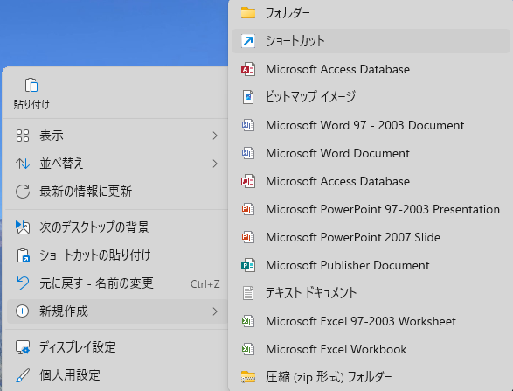 | 1. Right-click on your Windows Desktop and select New > Shortcut.
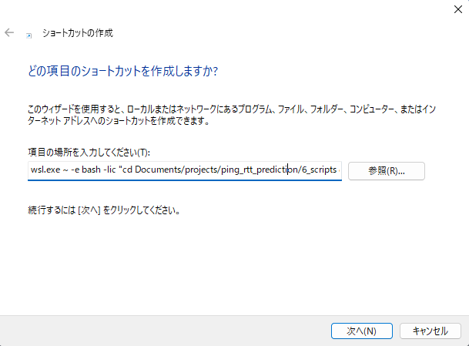 | - In the "location" box, paste the following command (replacing the path with your actual project location):  * Designate with absolute paths  [start_calendar_app]  C:\Windows\System32\wsl.exe ~ -e bash -lic "cd /mnt/c/Users/user/Documents/projects/ping_rtt_prediction/6_scripts && ./start_app.sh; exec bash"  [start_ingest_ping_stream_py]  C:\Windows\System32\wsl.exe -e bash -lic "cd /mnt/c/Users/user/Documents/projects/ping_rtt_prediction && ./venv/bin/python ingest_ping_stream.py; exec bash"  1. The Windows Entry Point  C:\Windows\System32\wsl.exe:  This is the absolute path to the WSL engine on your Windows drive.  -e:  This stands for Execute.  2. The Linux Shell Setup  bash:  This is the Linux "language" (shell) we want to use to interpret the command.  -lic:  This is the most important "secret sauce" for your setup:  l (Login): Tells Linux to read your .bash_profile.  i (Interactive): Tells Linux to read your .bashrc. (This ensures nvm, node, and your aliases are "awake").  c (Command): Tells Bash: "Here is the actual script I want you to run."  3. The Project Navigation  "cd /mnt/c/Users/.../ping_rtt_prediction: This moves the Linux terminal to your project folder on the Windows C: drive (/mnt/c/).  &&: This means "AND then." It ensures the script only tries to run the next part if the folder change was successful.  4. The Python Execution (The "Smart" Way)  ./venv/bin/python:  Instead of manually running source venv/bin/activate, you are pointing directly to the Python engine inside your toolbelt (venv).  This automatically "activates" the environment for this one command, so Django and your other libraries are available.  The Dot (.): Means "Start looking right here in the current folder."  ingest_ping_stream.py:  The name of the Python script you want to run.  The "Bash" Perspective (Needs ./)  The "Python" Perspective (No ./ needed)  5. The "Safety" Ending  ; exec bash:  This is your "Anti-Vanish" insurance.  Normally, when a command finishes (or crashes), the window closes instantly.  By adding this, you tell the window: "When you're done with the Python script, just turn back into a normal terminal." This allows you to read any error messages or see the logs if the script stops.  I totally get it. The dot feels like it’s doing two different things, but here is the secret: The dot (.) always means "Right Here."  It doesn't actually mean "execute"; it just tells the computer where to look.  1. Why do we need it? (The "Security Guard")  Linux has a safety rule: It will never look in your current folder for a program unless you explicitly tell it to. It only looks in "Trusted System Folders" (like /usr/bin).  If you just type python, the "Security Guard" looks in the Trusted System Folders. It finds the Global Python.  If you type ./venv/bin/python, you are saying: "Ignore the trusted folders. Look Right Here in this specific project folder."  2. The "Execution" Confusion  The reason it feels like the dot means "execute" is because of what happens next:  ./start_app.sh: You are pointing to a file Right Here. Because it’s a script, Linux sees the path, finds the file, and starts running it.  ./venv/bin/python: You are pointing to the Python engine Right Here. Linux finds that specific engine and turns it on.
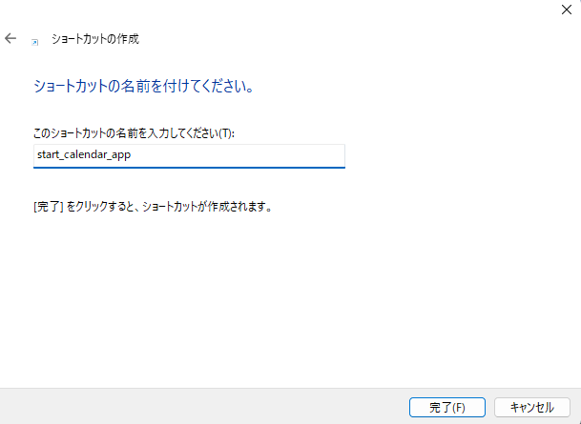 | Name the shortcuts  start_calendar_app  start_ingest_ping_stream_py

