npm audit fix with VS Code terminal
Work History | 2026/4/13 document created  2026/4/13 npm audit fix on WSL  2026/4/13 git commit done via VS Code  2026/4/13 document completed
Goal | npm audit fix with VS Code terminal
Runtime Environment | Windows/WSL
Directory/Folder | /mnt/c/Users/user/Documents/projects/ping_rtt_prediction  C:\Users\user\Documents\projects\ping_rtt_prediction
Note | Use VS Code terminals to fix NPM.  Git on PowerShell (Windows):  Since your project files are physically stored on your Windows hard drive (likely under C:\Users\...), Windows Git can read and write to them instantly [2]. If you ran git status inside WSL on these files, it would have to cross a "bridge" between Linux and Windows, making it run very slowly [2].  NPM on WSL (Ubuntu):  Since your React and Django servers are running inside the Linux environment, Linux needs to be the one to install and manage the packages (node_modules) [2]. If you ran npm on Windows, it might install Windows-specific binary files that your WSL Ubuntu server won't understand.

Workflow
Steps | Description
Open your project in VS Code.

Open the terminal panel at the bottom (Ctrl + ~).

2. Using the Top Menu
Navigate to the top menu bar.
Select View > Terminal.
Alternatively, you can select Terminal > New Terminal.
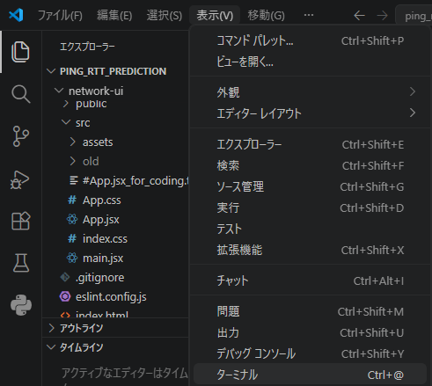

Terminal 1 (PowerShell): Use this for your Git commands.

git add .
git commit -m "..."

e.g.:
git add .
git commit -m "Save state before running npm audit fix"

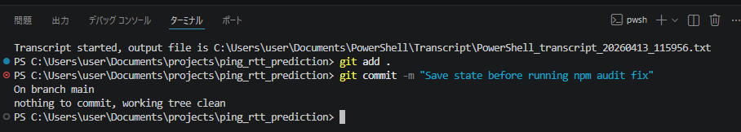
Terminal 2 (WSL/Ubuntu): Click the + icon in the terminal panel and select Ubuntu or WSL.

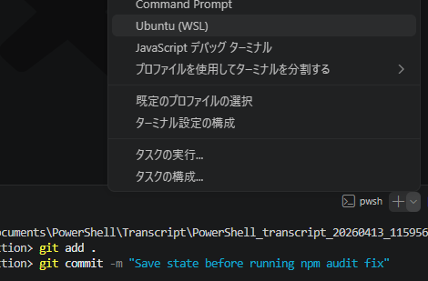

Use this for running your app and package managers:

Open your WSL/Ubuntu terminal (or the WSL terminal inside VS Code).
Navigate to your frontend folder:
cd network-ui

Run:
npm audit
npm audit fix

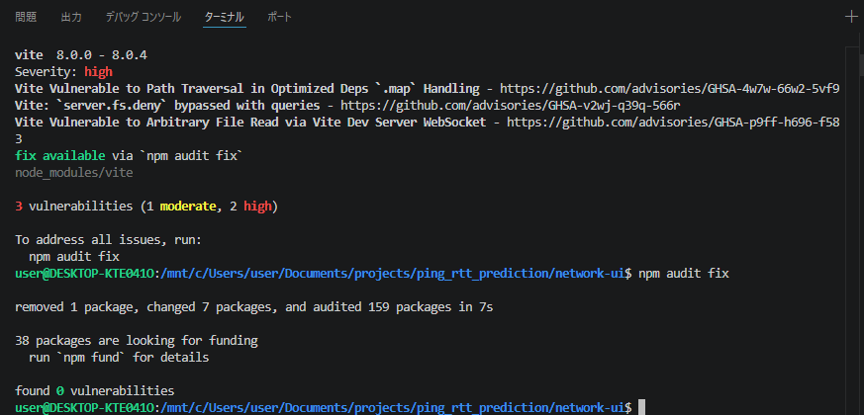

Once it finishes, go to your PowerShell terminal and run git status to see if any lockfiles changed!
Record terminal outputs  If you run a command like npm audit and want to save the output, simply click and drag to highlight the text in the VS Code terminal, copy it, and paste it into a file like logs/npm_audit_result.txt. | How to record terminal outputs?  Method 1: Manual Copy & Paste (Easiest)  If you run a command like npm audit and want to save the output, simply click and drag to highlight the text in the VS Code terminal, copy it, and paste it into a file like logs/npm_audit_result.txt.  Method 2: Use "Output Redirection" in the Terminal  You can instruct the computer to save the results of a command directly into a text file instead of printing it to the screen by using the > symbol.  Example in PowerShell: git log --oneline > git_history_log.txt  Example in WSL: npm audit > npm_audit_log.txt  Method 3: Check Dedicated App Logs  Most servers create their own logs. For example, if you want to check server errors later without looking at the terminal, you can configure Django in your settings.py to write all terminal outputs directly into a file inside your logs/ folder.
Click the plus (+) to stage the update.
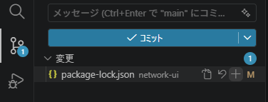
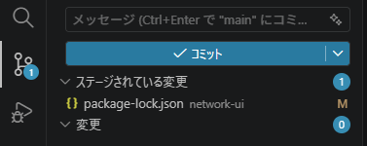
Terminal 1 (PowerShell): Use this for your Git commands.

git add .
git commit -m "..."

e.g.:
git add .
git commit -m "Save state after running npm audit fix"
