Running Django local development server
Work History | 2026/3/27 document created  2026/3/27 document completed
Goal | Run the Django local development server
Runtime Environment | WSL/venv
Directory/Folder | /mnt/c/Users/user/Documents/projects/ping_rtt_prediction
Note | Run the Django local development server

Workflow
Steps | Description
(move to the project directory.)
e.g.:
cd Documents/projects/ping_rtt_prediction
source venv/bin/activate | Activate the venv environment
python -m pip install --upgrade pip | pip version upgrade  you should indeed update pip first. Older versions of pip (like 18.1) do not support modern hash-checking features and security protocols as robustly as the newer versions.
pip-audit | It will check your library like pdfplumber (and its dependencies like pdfminer.six) against the Python Advisory Database.
# run the following command if necessary  pip-compile --generate-hashes requirements.in  pip install --require-hashes -r requirements.txt  python -m pip install --upgrade (library) (library) (library)...  e.g.:  python -m pip install --upgrade pip setuptools wheel | # Fixes pip, setuptools, and wheel  Using python -m pip is the most reliable way to ensure you are hitting the inside of your specific venv
# Same as above.  (Alternative command)  e.g.:  pip install --upgrade requests urllib3 zipp  (A safer way)  python -m pip install --upgrade requests urllib3 zipp | # Fixes requests and urllib3 (often used by pip-tools/pip-audit)  pip install (simply): This relies on your Terminal’s PATH. It runs whatever "pip" the terminal finds first. If your venv isn't activated perfectly, it might accidentally install packages into your Global/System Python, making a mess.
#Run the local development server

python manage.py runserver
Hit the following URL.  http://localhost:8000/admin  http://localhost:8000/api  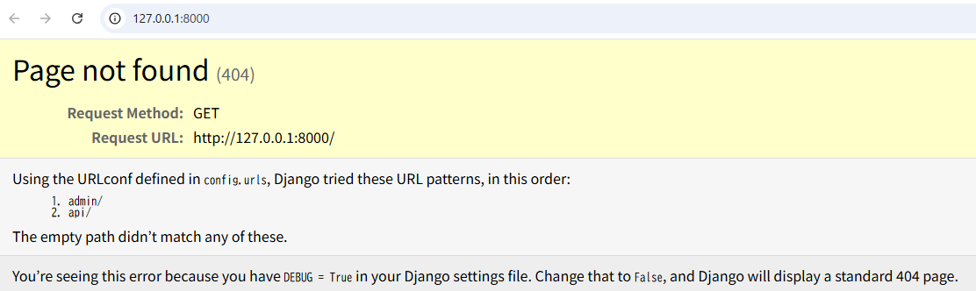  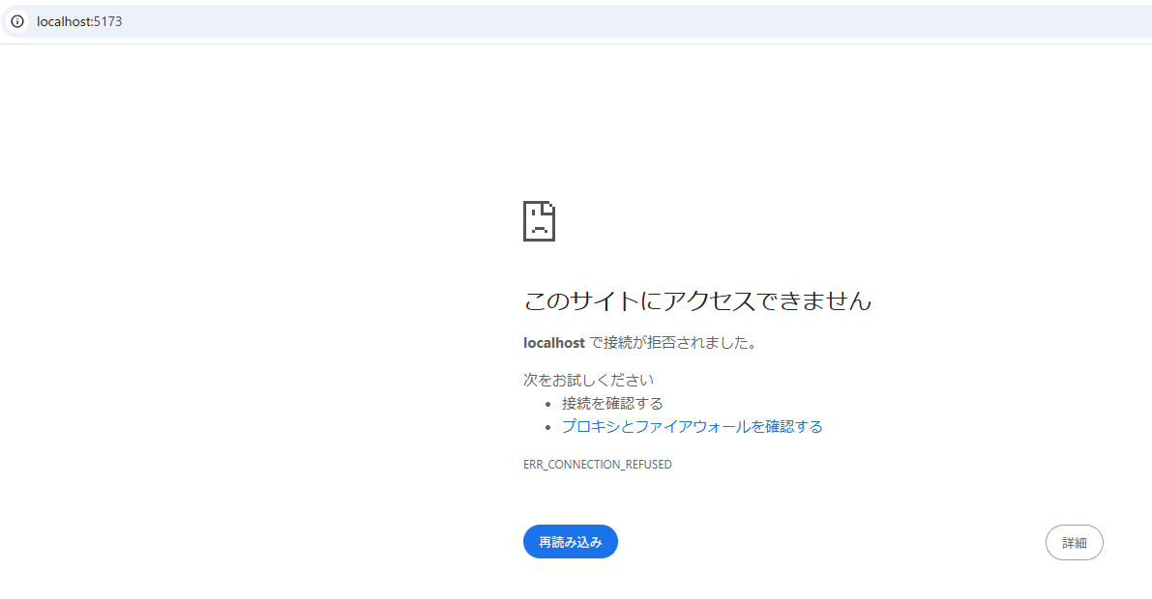  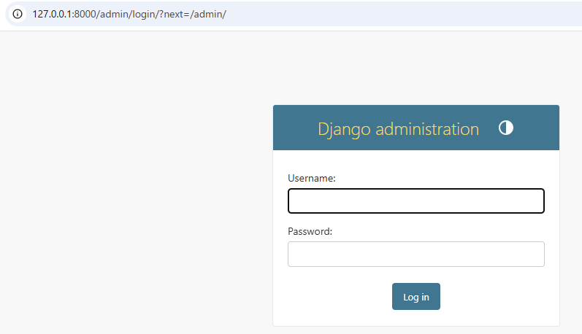  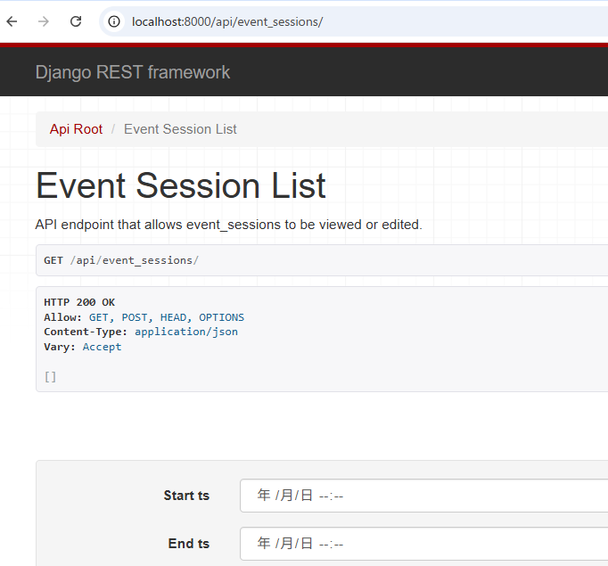 | The 404 error on port 8000 and the rejection on port 5173 indicate that while the "network bridge" is open, the services aren't correctly routing traffic inside the WSL environment.  1. Fix the 404 on Django (Port 8000)  A 404 usually means the Django server is running, but it doesn't recognize the URL you are hitting (likely the root /).  Check the URL: Try going to http://localhost:8000/admin  http://localhost:8000/api

