Restore file from past git snapshot
Work History | 2026/4/5 document created  2026/4/5 git installed into Windows not into WSL  2026/4/6 git commit (initial commit) done  2026/4/7 git commit done  2026/4/7 document completed
Goal | Restore file from past git snapshot
Runtime Environment | Windows
Directory/Folder | /mnt/c/Users/user/Documents/projects/ping_rtt_prediction/6_scripts  C:\Users\user\Documents\projects\ping_rtt_prediction
Note | Restore file from past git snapshot

Workflow
Steps | Description
How to view or restore past code (via CLI)

To just LOOK at an old file:
If you want to see what a file looked like in a specific commit without changing your current work:

[PowerShell]
git show [hash]:[file_path]
e.g.
git show a1b2c3d:config/settings.py
To RESTORE a file to its past state:

[PowerShell]
git checkout [hash] -- [file_path]
e.g.
git checkout a1b2c3d -- network-ui/src/App.jsx
How to restore with "Restore Contents"  - Open the file (e.g., settings.py).  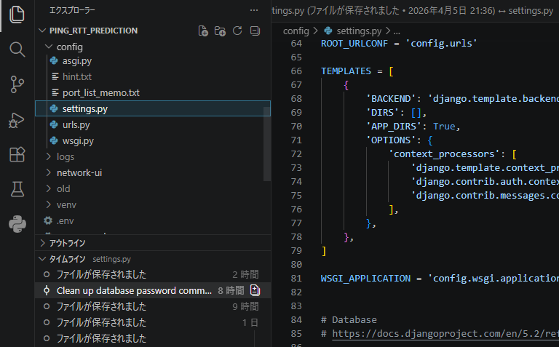  - Go to Timeline.  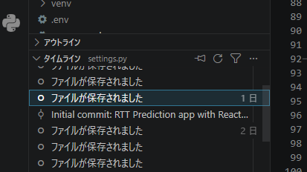  - Find the entry with the Git/Branch icon (your professional commit).    - Right-click it and select Restore Contents.  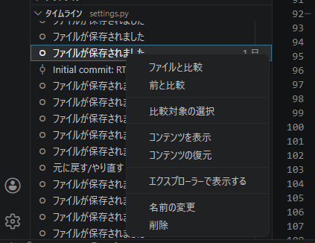  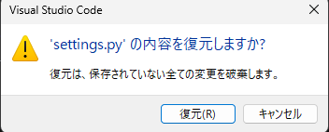  5. Save (Ctrl + S). | Actually, seeing "Restore Contents" means you have a modern version of VS Code! That is the correct button to use.  1. Using "Restore Contents"  When you right-click a commit in the Timeline and select Restore Contents, VS Code instantly replaces your current file with the code from that specific commit. It is the easiest way to "undo" your work.  2. What are those "circles" in the Timeline?  You are very observant. VS Code tracks two different histories in that same timeline:  The Git Icon (Branch icon): These are your Commits. These only appear when you manually click the "Commit" button or run a command. These are your "Official Snapshots."  The Circle Icon: These are Local History entries. VS Code automatically saves a "mini-snapshot" every time you save a file (Ctrl + S).  Why they are there: These are a safety net in case you mess up between commits.  Recruiter Tip: Professionals focus on the Git icons for major rollbacks, but use the Circles if they just accidentally deleted a line five minutes ago.  3. Should you upgrade VS Code?  You likely don't need to. If you see "Restore Contents," you are up to date. To check for updates anyway:  Go to the Gear icon (bottom left) > Check for Updates.
*For an older version  How to view or restore past code (via GUI)  - The "Timeline" View (Built-in to VS Code)  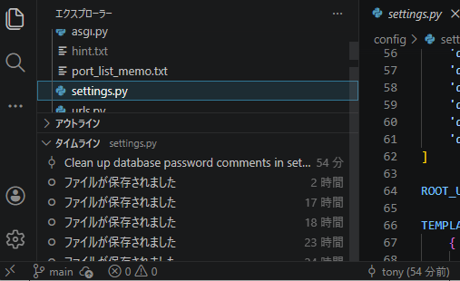  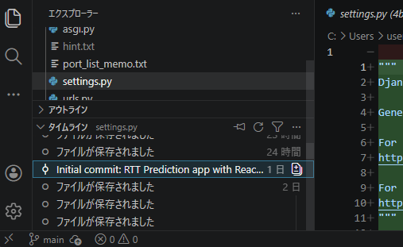  - Using "Git Graph" (Visual Tree)  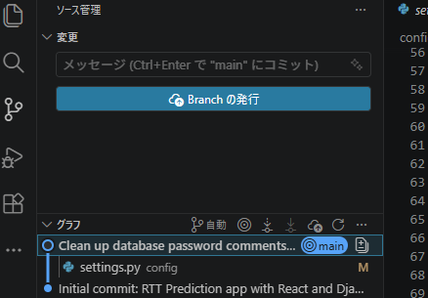  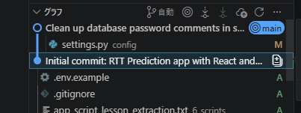 | *For an older version  1. Using the Timeline View (Easiest for a single file)  This is best if you just want to "undo" a specific file to a past state:  1. Open the file you want to restore (e.g., settings.py).  2. Go to the TIMELINE section at the bottom of the Explorer (left sidebar).  3. Right-click the past commit you want to go back to.  4. Select Restore File.  Result: VS Code will instantly overwrite your current file with the version from that commit.  2. Using Git Graph (Best for seeing the whole project)  If you want to pull a file from a specific "generation" in your history:  1. Open the Git Graph tab.  2. Click on the Commit (the dot) that contains the "good" version of the code.  3. A panel opens showing all files in that commit. Right-click on the specific file.  4. Select Checkout File.  Result: This "checks out" that specific file from the past and brings it into your current workspace.

