Roll back file versions with git checkout
Work History | 2026/5/9 document created  2026/5/10 document completed
Goal | Roll back file versions with git
Runtime Environment | Windows
Directory/Folder | /mnt/c/Users/user/Documents/projects/ping_rtt_prediction/6_scripts  C:\Users\user\Documents\projects\ping_rtt_prediction
Note | Roll back file versions with git.  Git's timeline and checkout features  To compare and temporarily test different versions of your App.jsx, you should use Git's timeline and checkout features. These tools allow you to pinpoint changes between specific dates and swap out just that file for a test run without affecting your new Django logic.

Workflow
Steps | Description
- Open Timeline: Open App.jsx, then in the Explorer sidebar (left), look at the bottom section labeled Timeline.  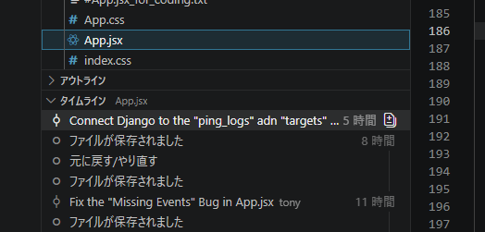  - Select for Compare: Right-click a version from 2–3 days ago and select "Select for Compare".  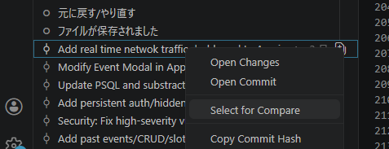  - Compare with Current: Right-click your current (latest) version and select "Compare with Selected".  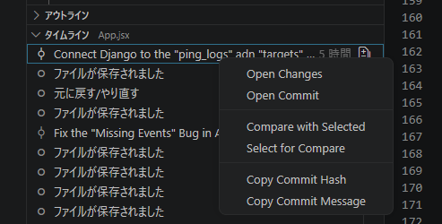 | 1. How to Compare Versions (Side-by-Side)  The most visual way to identify which blocks changed is through the Timeline View in VS Code.  - Open Timeline: Open App.jsx, then in the Explorer sidebar (left), look at the bottom section labeled Timeline.  - Select for Compare: Right-click a version from 2–3 days ago and select "Select for Compare".  - Compare with Current: Right-click your current (latest) version and select "Compare with Selected".  - Identify the Blocks: VS Code will open a side-by-side view. Red lines indicate what was removed (the old "fit" version), and green lines indicate what was added (the current "broken" version). Look specifically for changes in your useEffect or renderCalendar blocks.
[bash]  git log --oneline <File Path>  e.g.:  git log --oneline App.jsx  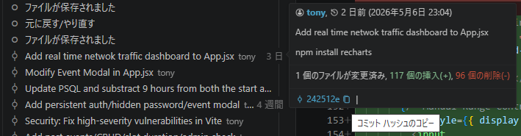 | 2. How to Temporarily "Roll Back" App.jsx  You can force your local server to use an older App.jsx while keeping your latest Django and Python files intact.  - Find the Commit ID: Run git log --oneline App.jsx in your terminal to see a list of recent changes to that file. Copy the 7-character hash (e.g., da9cc5f) from a date when it was working.
[bash]  git checkout <commit-hash> -- <File Path>  e.g.:  git checkout 242512e -- App.jsx  This replaces your current App.jsx with the old version in your working directory but leaves everything else (like your views.py and models.py) exactly as they are. | - Restore Just That File: Run the following command:  This replaces your current App.jsx with the old version in your working directory but leaves everything else (like your views.py and models.py) exactly as they are.
 | - Run the Server: Start your React server (npm start). If the events reappear, you know the problem was in the React code. If they are still missing, the problem is likely in the new Django View or Serializer.
git checkout HEAD -- App.jsx | - Return to Latest: Once you are done testing, you can return to your latest version of the file with:
3. Likely Culprits for "Missing Events"
If you are comparing versions, pay close attention to these three areas that often cause this issue when transitioning to Django:

- Primary Key Names: Old versions might have looked for evt.id, while your new Django version might be sending evt.session_id. If the ID is missing, FullCalendar may refuse to render the event.

- Event Keying: If you are missing the key={events.length} in your <FullCalendar> component, it won't re-render when the Django data arrives.

- Date Formats: Ensure the ISO strings from Django haven't changed (e.g., the addition of timezone offsets like +09:00 can sometimes break old parsing logic).

