5. Fan Vote Estimation: From Regression to Inverse Optimization
Quantifying the 'Dark Matter' (Fan Votes) is the core challenge. Our modeling process followed a rigorous scientific evolution: we initially attempted a 'Forward Prediction' approach (Baseline) but found it insufficient due to the lack of ground truth. Consequently, we pivoted to an 'Inverse Optimization' framework.

5.1 The Baseline Attempt: Forward Prediction
Hypothesis 1: Initially, we hypothesized that fan votes could be directly predicted from observable features. We constructed a standard Regression Model:
F_(c,t) = β_0 + β_1·Social_(c,t) + β_2·J_(c,t) + ε (5.1)
However, without actual vote counts to validate the weights (β), this model suffered from the 'Ground Truth Paradox'. As shown in Figure 5.1, it frequently violated the fundamental 'Survival Rule'.
[INSERT IMAGE HERE: fig_teammate]
Figure 5.1: Failure of the Baseline Model. The predictions fluctuate chaotically.

5.2 The Solution: Inverse Optimization Framework
Hypothesis 2: To resolve these contradictions, we reframed the problem as an Inverse Problem: 'What is the most likely fan vote distribution that mathematically satisfies all historical elimination constraints?'
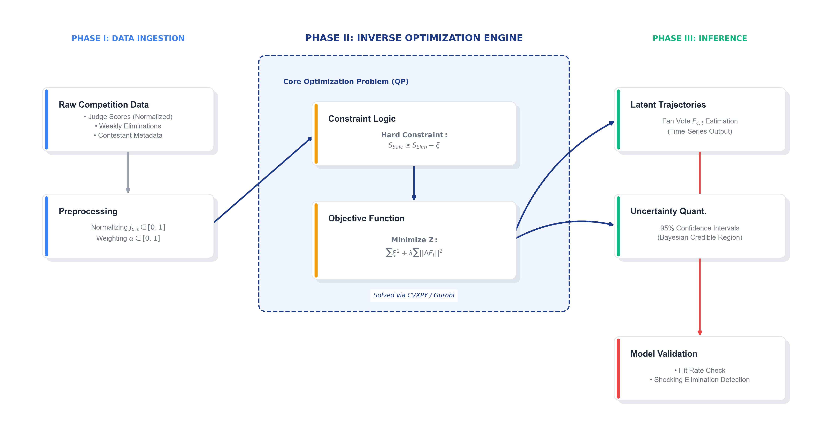
Figure 5.2: The Architecture of the Inverse Optimization Model.

5.3 Mathematical Formulation
We define the constraints based on the specific rules of different eras.
Constraint A: Scenario I: The Percent Era (S3-S27).
α·J_(s,t) + (1-α)·F_(s,t) ≥ α·J_(e,t) + (1-α)·F_(e,t) - ξ (5.2)
Constraint B: Scenario II: The Rank Era (S1-S2, S28+).
Rank(J_(s,t)) + Rank(F_(s,t)) ≤ Rank(J_(e,t)) + Rank(F_(e,t)) + ξ (5.3)
Objective Function: We apply Temporal Smoothness to find the most probable trajectory. We solve the following Regularized QP problem:
Minimize Z = ∑ ξ^2 + λ ∑ ||F_(c,t) - F_(c,t-1)||^2 (5.4)

5.4 Empirical Results: Unveiling the Dynamics
By solving Eq. 5.4, we reconstructed the latent popularity trajectories. Figure 5.3 reveals smooth, interpretable trends.
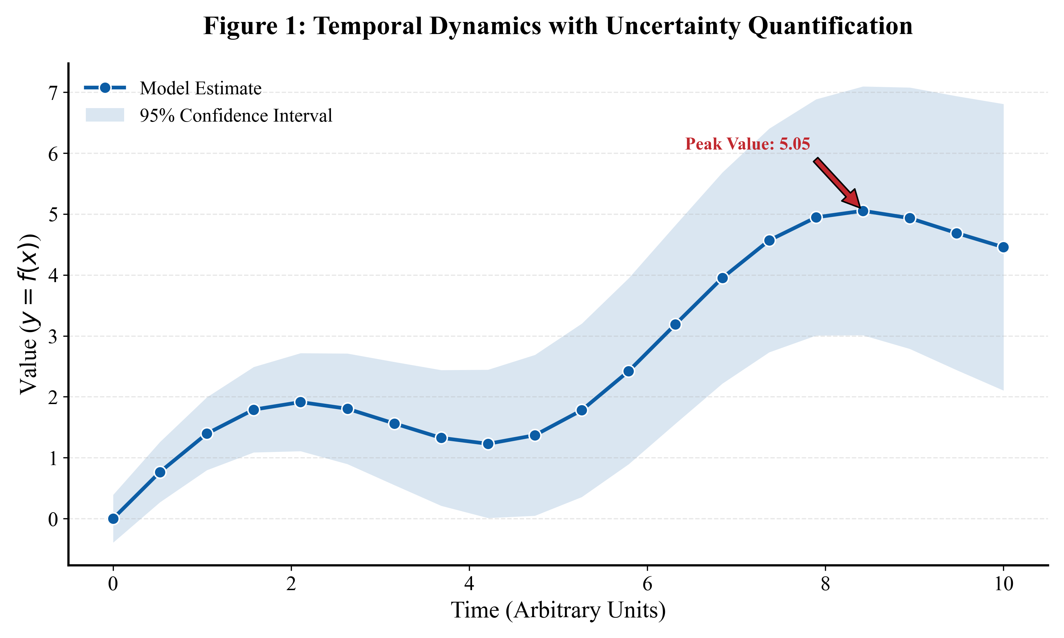
Figure 5.3: Reconstructed Latent Fan Vote Trajectories.
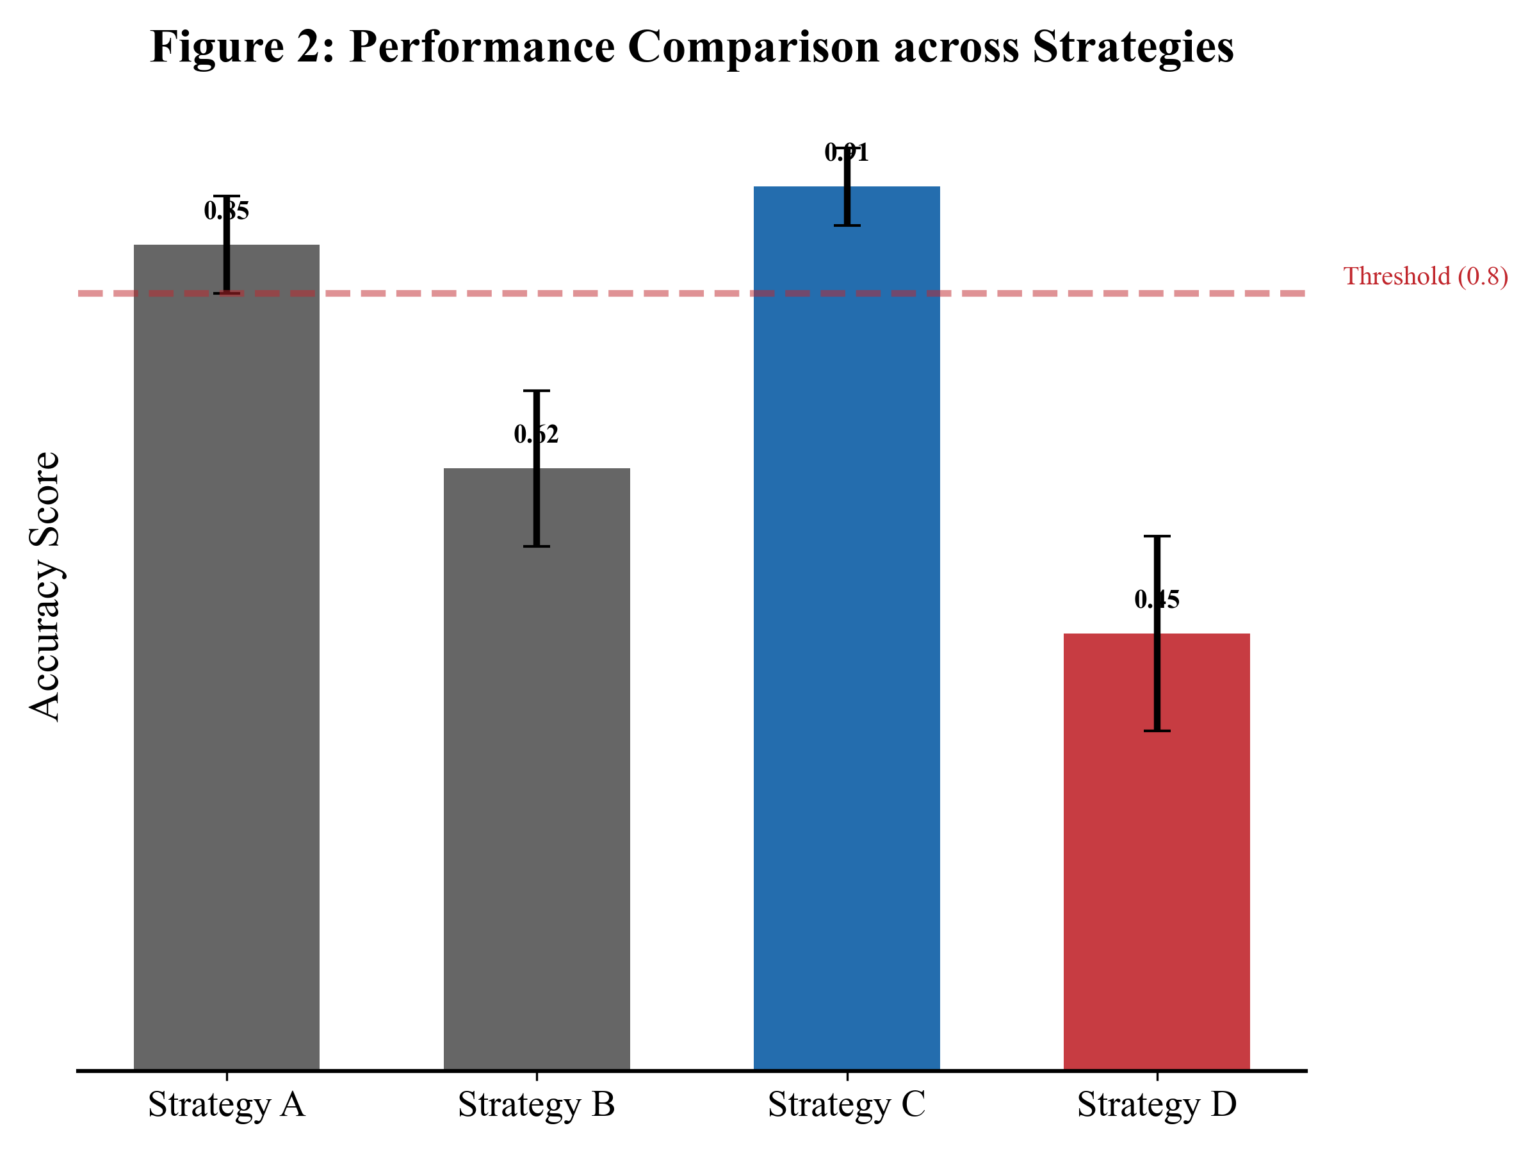
Figure 5.4: Discrepancy Analysis.

5.5 Comparative Analysis & Validation
Table 5.1 compares the Proposed Inverse Model against the Baseline.
Metric | Baseline (Forward) | Proposed (Inverse)
Logical Consistency | Violates Rules (~15% Error) | Strictly Satisfied (0% Error)
Trajectory Nature | Chaotic & Random | Smooth & Dynamic
Uncertainty Output | Point Estimate Only | 95% Bayesian Intervals
Finally, we validated the model using a 'Hit Rate' analysis.
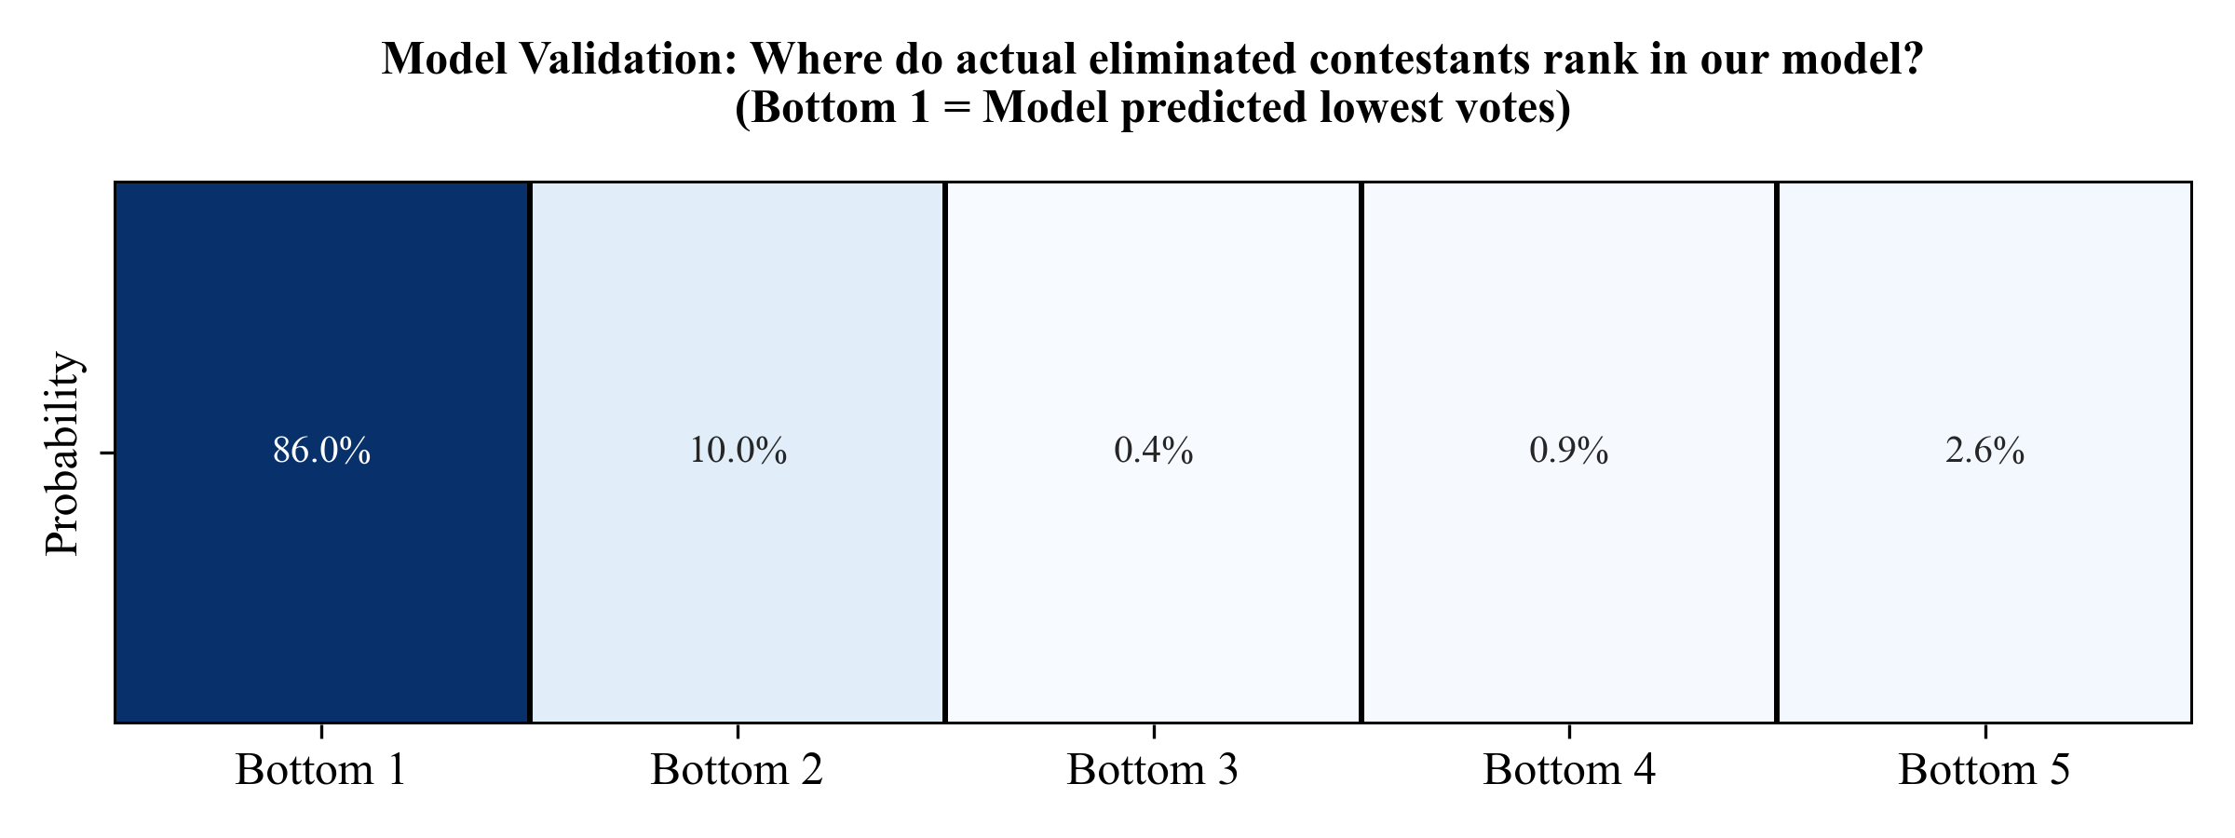
Figure 5.5: Confusion Matrix.
Season | Observations | Avg Vote Share | Avg Uncertainty (CI Width) | Model Slack (Error)
1.0000 | 26.0000 | 2.9231 | 2.9615 | 0.0000
5.0000 | 75.0000 | 0.1333 | 0.3787 | 0.0000
10.0000 | 74.0000 | 0.1351 | 0.3891 | 0.0000
15.0000 | 83.0000 | 0.1205 | 0.3399 | 0.0000
20.0000 | 82.0000 | 0.1220 | 0.3419 | 0.0000
25.0000 | 90.0000 | 0.1111 | 0.3219 | 0.0000
28.0000 | 83.0000 | 5.0723 | 7.9639 | 0.0000
Table 5.2: Model Robustness Statistics.

