Agent Interaction
Lely Menure Cleaning System
Author: Eric Dortmans, Yanzheng Xiao
Date: March 10, 2022

Introduction
This document describes the agent interaction in the Lely Menure Cleaning System as developed in the DurableCASE project. In this system Lely Discovery 120 barn cleaning robots will be extended with software agents to make them able to cooperate in a robust way. Each robot will be extended with an embedded Vehicle Operating Agent (VOA). Furthermore, a Cooperativity Agent (CA), a Monitoring & Logging Agent (MLA) and a Forecasting Agents (FA) will run on a central server computer. The CA and MLA are supposed to interact with the VOA agents on the robots via a local area network.
Our multiagent architecture is supposed to realize following system goals:
- Increase system up-time and improve redundancy (one fails other takes over)
- Collaborate on resources (passageway, dumping spot, charging station)
From Lely point of view, it is better to aim for a robust system that is risk averse. For instance if one robot fails it should prevent other robots from getting stuck as well due to collision with the failed robot. The robots should be also be able to function with or without the CA because it may not be always available.


System Architecure
The software agents and their interaction in the DurableCASE project will be based on the second generation of the Robot Operating System (ROS2). Under the hood ROS2 uses the DDS (Data Distribution Service) protocol as its communication middleware. DDS makes it transparent for ROS nodes, such as our agents, whether they are running on a robot or on a central server.
Agents cooperate by exchanging ROS messages. For all identified agent interfaces we need to create appropriate interface definitions.
Figure 1 shows the proposed architecture in terms of agents, topics and messages.
Figure 2 shows the meaning of various architectural elements.
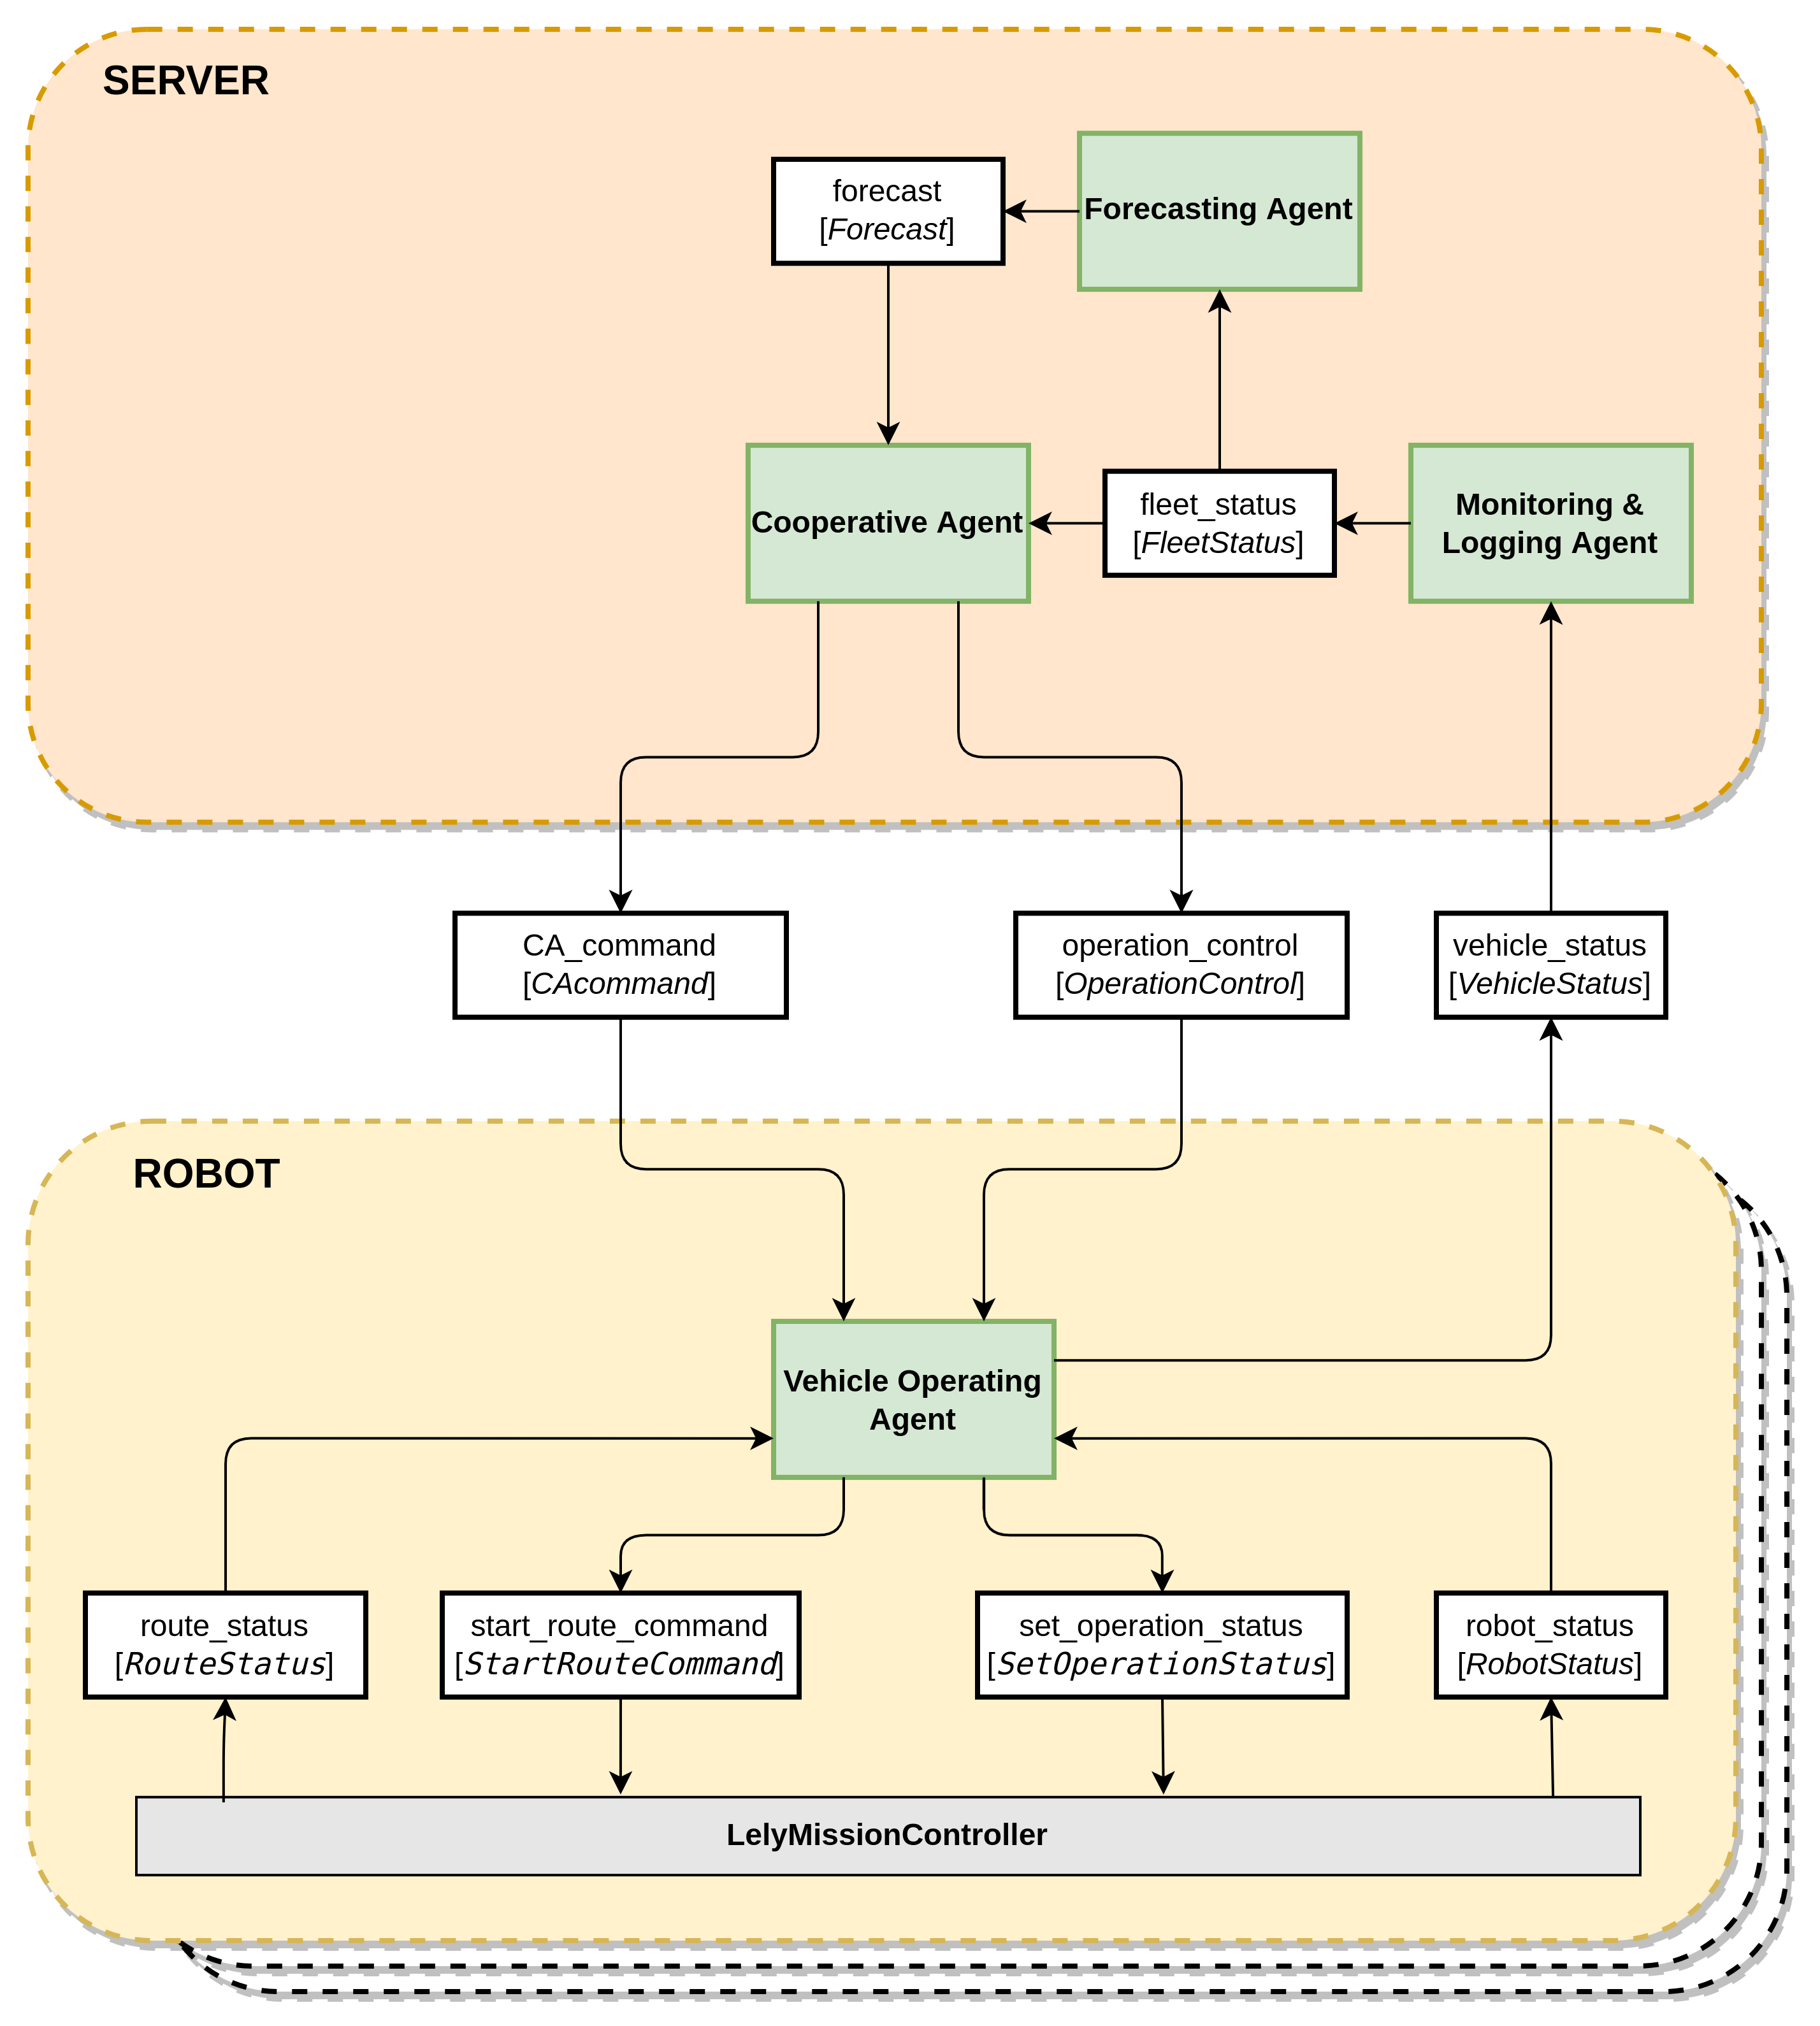
Figure 1 Architecture

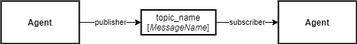
Figure 2 Legenda

Agent Interaction

Each robot is (manually) loaded with a set of predefined routes and a time schedule. A robot starts driving a route whenever one is due according to its local route schedule or when a route drive order is received from the CA.

Status publishing
Each robot frequently publishes its detailed vehicle status in the form of a VehicleStatus message. The MLA, if available, subscribes to the vehicle_status topic to collect the status of all robots in the barn in order to compose and publish an overall FleetStatus.
Based on received FleetStatus messages the FA knows which routes have been completed. It updates its manure level forecast and publishes it in the form of a Forecast message.
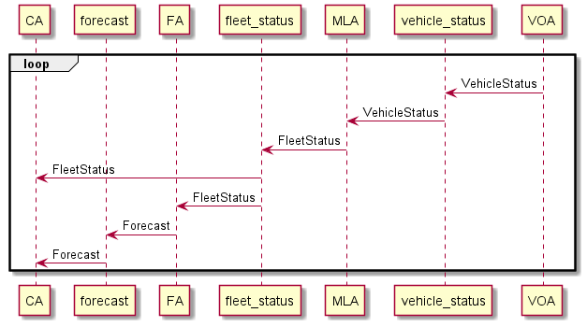
Figure 3 Status publishing

Driving
The CA, if available, will subsume the local route schedules of the robots. It is supposed to know all predefined routes and, via the FleetStatus messages it receives, also knows the status of all robots in the fleet. Given a forecast of the manure level distribution in the barn and the status of the robot fleet, the CA regularly calculates an optimal cleaning route schedule for the barn. When a route becomes available according to this schedule, the CA dispatches it to the best candidate among the idle robots. It sends a DriveOrder message to this robot to start this route.
The CA will monitor the status of all robots by subscribing to the FleetStatus messages and, to prevent collisions at shared resources, may issue OperationControl messages to robots to make them pause when a resource is occupied and resume driving when the resource becomes available again.
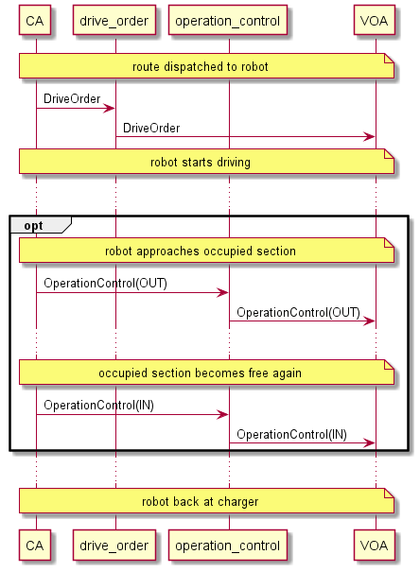
Figure 4 Driving

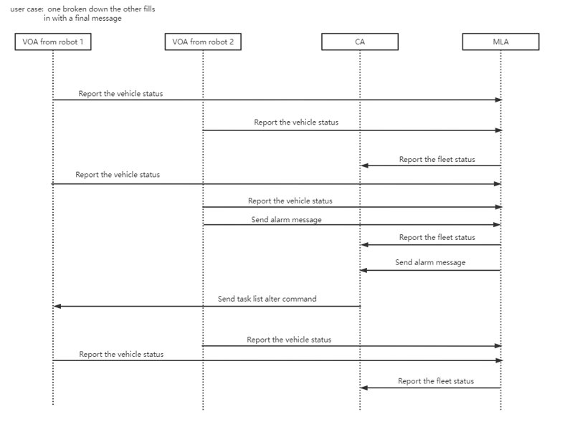

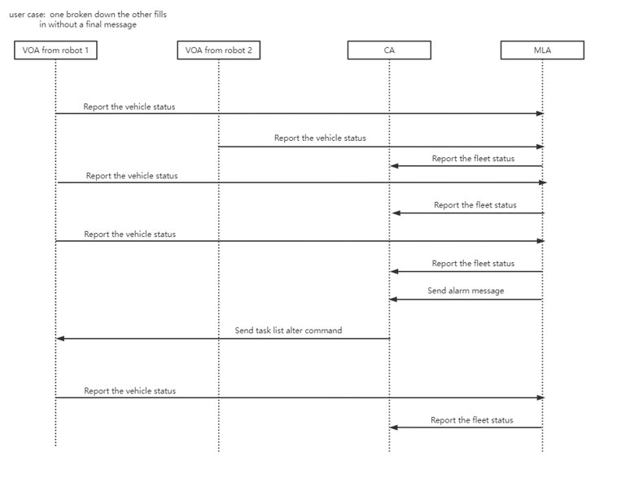

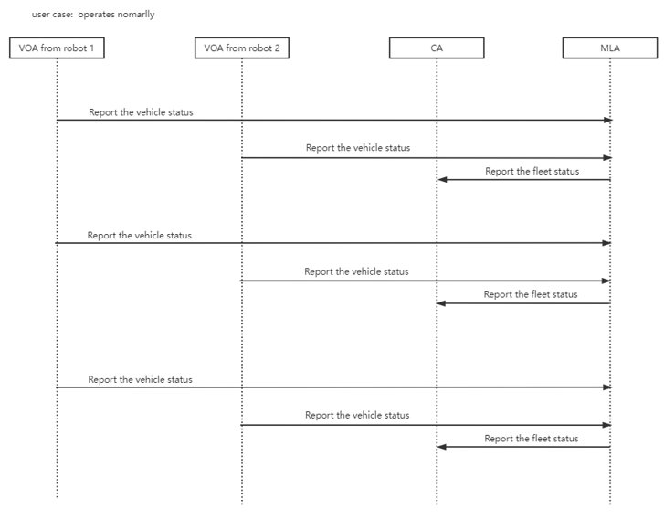

References

About ROS 2 interfaces
https://index.ros.org/doc/ros2/Concepts/About-ROS-Interfaces/
Data Distribution Service
https://en.wikipedia.org/wiki/Data_Distribution_Service

