**Install Amazon CL Tools**

*Create an AWS Account (You can use your Amazon.com Credientials)*

**https://aws.amazon.com/**

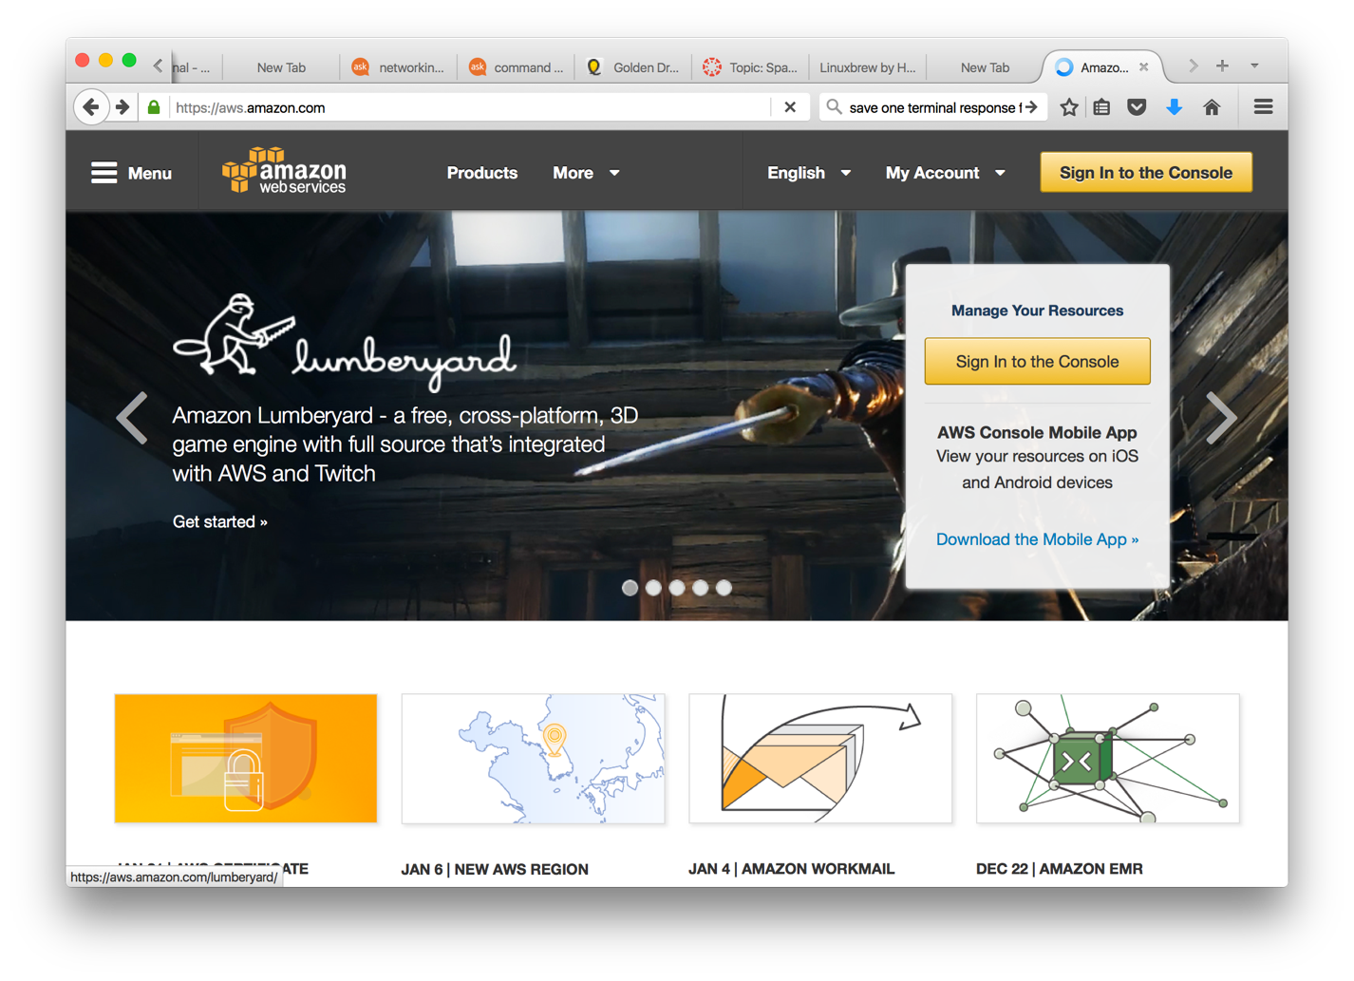

*Once Logged Click:* ***SERVICES > IAM > CREATE USER > CREATE ACCESS KEY***

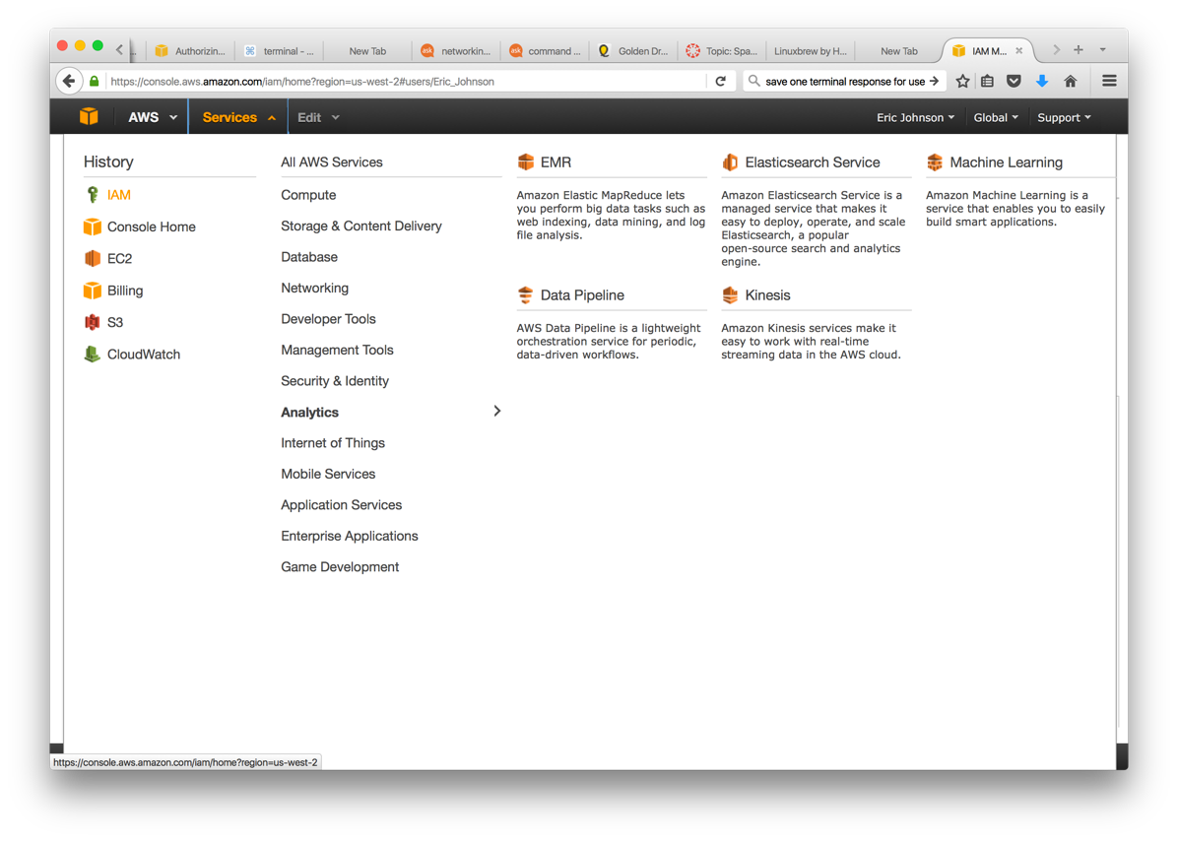

*Once Logged Click: Copy and save your* ***Access Key ID*** *and* ***Secret Access Key****, you will need these*

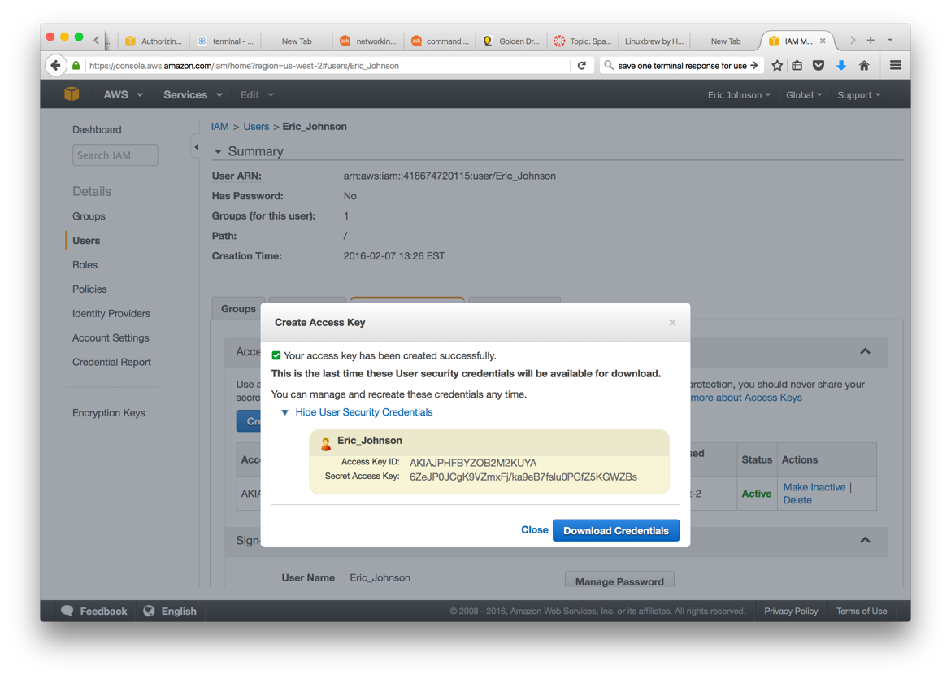

*From a Terminal Install aws-cli*

**sudo -H pip install awscli --upgrade --ignore-installed six**

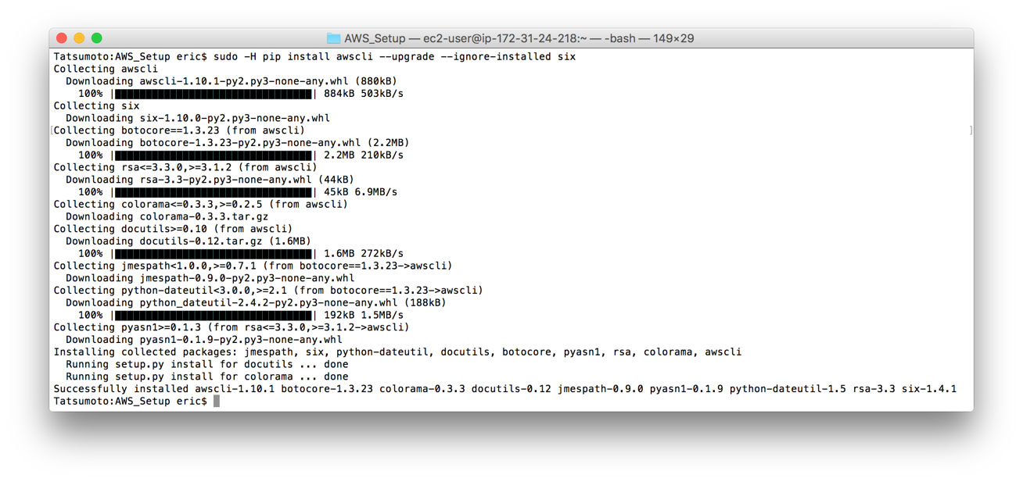

*Configure Your AWS Command Line Terminal Using:*

**aws configure**

*Copy and Paste Your* ***Access Key ID*** *and* ***Secret Access Key***

*For region you can put: us-west-2*

*For output you can put: text*

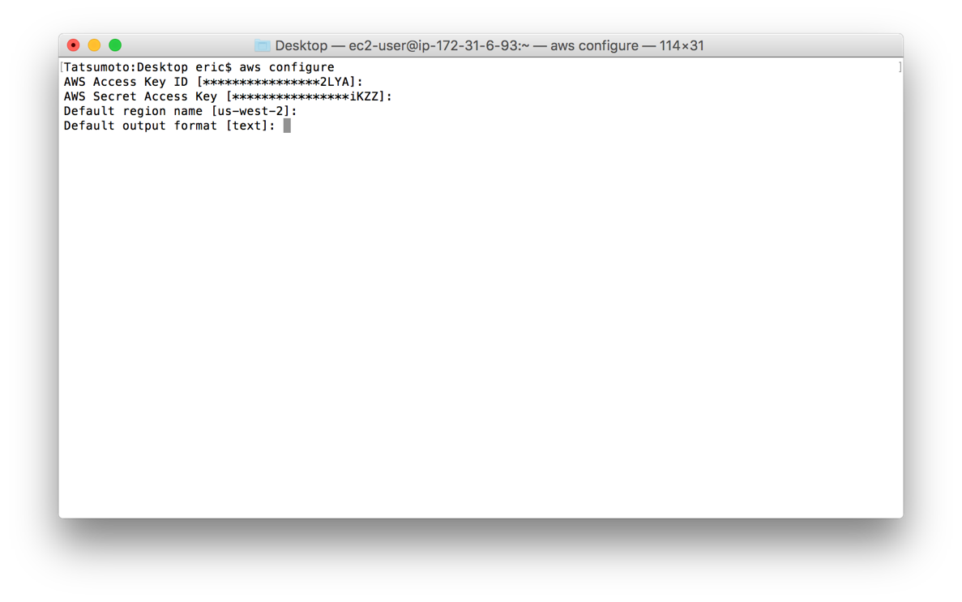

*Unzip the Folder Called AWS_Spark to Your Desktop:*

*Open a terminal, direct to the folder and launch*

***./Setup_EC2.sh <your UNI>***

***\*\* make sure to run this only once and to input a space, your uni, then hit enter \*\****

*The script will take 4-5 minutes to run. Do not stop or interrupt it.*

*Once done you can use the* ***./Login.sh*** *script to logon to your EC2 instance*

***!!! USE THIS SCRIPT WHENEVER YOU WANT TO TERMINAL INTO YOUR EC2 INSTANCE !!!***

*Login to your AWS EC2 Instance:*

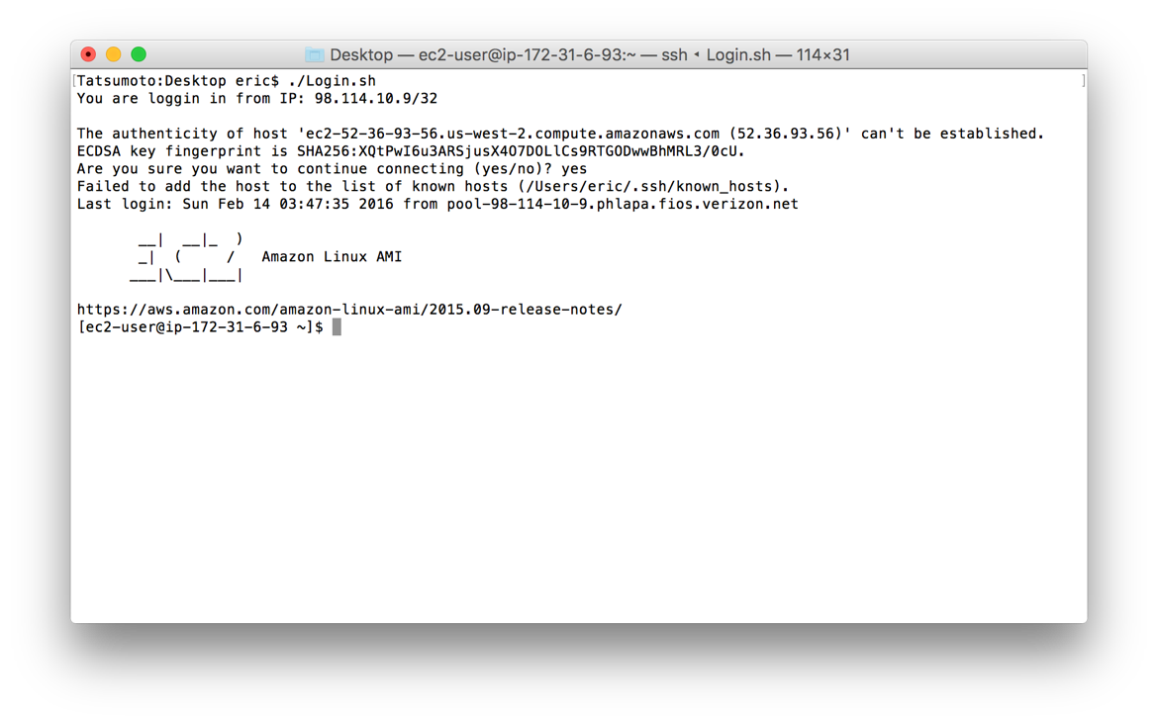

***YOU HAVE A WORKING EC2 Amazon Linux Cloud Instance***

*Update the Utilities:*

**sudo yum update**

**sudo yum groupinstall 'Development Tools'**

**sudo yum groupinstall 'Development Tools' && sudo yum install curl git irb m4 ruby texinfo bzip2-devel curl-devel expat-devel ncurses-devel zlib-devel**

**ruby -e "$(curl -fsSL https://raw.githubusercontent.com/Homebrew/linuxbrew/go/install)"**

*Install and Launch Spark:*

**brew install wget**

**wget http://shinyfeather.com/spark/spark-1.6.0/spark-1.6.0-bin-hadoop2.6.tgz**

**tar -zxvf spark-1.6.0-bin-hadoop2.6.tgz**

**cd ./spark-1.6.0-bin-hadoop2.6/bin**

*Execute Spark:*

**pySpark** - *./pyspark* **sparkR** - *./sparkR*

You should see the following console open:

pySpark Console:

  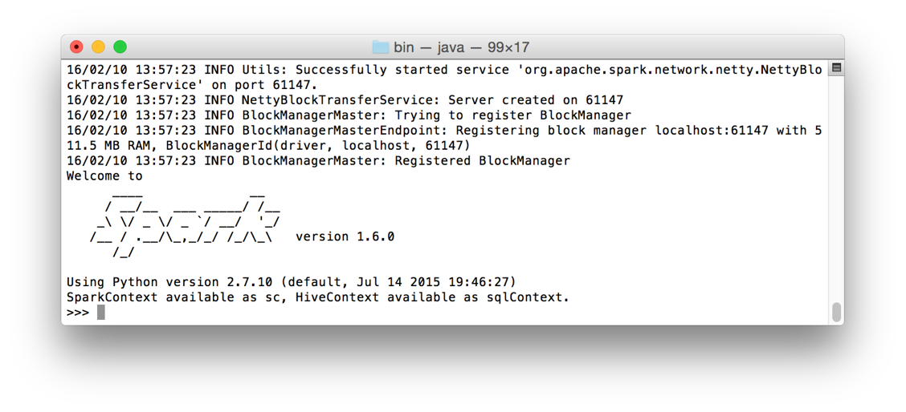

sparkR Console:

