Pocket SDR ver. 0.14
Command References
2025-03-20

Contents
Satellite ID and Signal ID 1
pocket_scan 2
pocket_conf 3
pocket_dump 7
pocket_acq 9
pocket_trk 11
pocket_snap 15
fftw_wisdom 17
convbin 18
pocket_sdr.py 22
pocket_plot.py 23
pocket_trk.py 28
pocket_acq.py 31
pocket_psd.py 33
pocket_snap.py 34

Satellite ID and Signal ID
Satellite IDs for Pocket SDR comply with RINEX 4.01 [1], where Gnn for GPS, Rnn for GLONASS, Enn for Galileo, Jnn for QZSS, Cnn for BeiDou, Inn for NavIC and Snn for SBAS (nn = 01, 02, 03, ...). The following table also shows signal IDs used for Pocket SDR.

Pocket SDR Signal ID Table
System | Signal | Signal ID | System | Signal | Signal ID
GPS | L1C/A | L1CA | BeiDou | B1I | B1I
 | L1C-D | L1CD |  | B1C-D | B1CD
 | L1C-P | L1CP |  | B1C-P | B1CP
 | L2C-M | L2CM |  | B2a-D | B2AD
 | L5-I | L5I |  | B2a-P | B2AP
 | L5-Q | L5Q |  | B2I | B2I
GLONASS | L1C/A (L1OF) | G1CA |  | B2b-I | B2BI
 | L1OCd | G1OCD |  | B3I | B3I
 | L1OCp | G1OCP | NavIC | L1-SPS-D | I1SD
 | L2C/A (L2OF) | G2CA |  | L1-SPS-P | I1SP
 | L2OCp | G2OCP |  | L5-SPS | I5S
 | L3OCd | G3OCD |  | S-SPS | ISS^{*2}
 | L3OCp | G3OCP | SBAS | L1C/A | L1CA
Galileo | E1-B | E1B |  | L5-I | L5I
 | E1-C | E1C |  | L5-Q | L5Q
 | E5a-I | E5AI
 | E5a-Q | E5AQ
 | E5b-I | E5BI
 | E5b-Q | E5BQ
 | E6-B | E6B
 | E6-C | E6C
QZSS | L1C/A | L1CA
 | L1C/B | L1CB
 | L1C-D | L1CD
 | L1C-P | L1CP
 | L1S | L1S
 | L2C-M | L2CM
 | L5-I | L5I
 | L5Q | L5Q
 | L5S-I | L5SI
 |  | L5SIV^{*1}
 | L5S-Q | L5SQ
 |  | L5SQV^{*1}
 | L6D | L6D
 | L6E | L6E
*1 QZSS L5S verification mode signals, *2 Pocket SDR FE currently does not support S-band signals

[1] RINEX - The Receiver Independent Exchange Format Version 4.01, July 10, 2023

pocket_scan

Synopsis
pocket_scan [-e]

Description
Scan and list USB devices. In the USB device list, ADDR (in Windows) or BUS/PORT (other environments) shows USB device address or USB bus/port number. SPEED shows USB version (HIGH: USB 2.0/480 Mbps, SUPPER: USB 3.0/5Gbps, ...). ID shows the vender ID and the product ID for the USB device in HEX format. Pocket SDR FE utilizes Cypress vendor ID (04B4) and product ID for sample devices of EZ-USB FX2LP or FX3 (1004 or 00F1). If no device with proper vendor ID and product ID is found, check the connectivity to Pocket SDR FE devices.

Options
-e
Show end point information for USB devices.

Execution Examples
$ pocket_scan.exe (Windows)
( 0) ADDR= 1 SPEED=SUPER ID=04B4:00F1 FX3,Cypress FX3 USB StreamerExample Device
( 1) ADDR= 2 SPEED=HIGH ID=04B4:1004 EZ-USB,Cypress FX2LP Sample Device

$ pocket_scan (Linux)
( 0) BUS= 4 PORT= 1 SPEED=SUPER ID=05E3:0612
( 1) BUS= 4 PORT= 0 SPEED=SUPER_PLUS ID=1D6B:0003
( 2) BUS= 3 PORT= 1 SPEED=HIGH ID=05E3:0610
( 3) BUS= 3 PORT= 0 SPEED=HIGH ID=1D6B:0002
( 4) BUS= 2 PORT= 2 SPEED=SUPER ID=04B4:00F1

% pocket_scan (macOS)
( 0) BUS= 0 PORT= 3 SPEED=SUPER ID=04B4:00F1 Cypress FX3
( 1) BUS= 0 PORT= 2 SPEED=LOW ID=1DDD:1002 SIGMACHIP USB Keyboard SIGMA ?
( 2) BUS= 0 PORT= 1 SPEED=LOW ID=046D:C077 Logitech USB Optical Mouse
( 3) BUS= 0 PORT= 1 SPEED=HIGH ID=05E3:0610 GenesysLogic USB2.0 Hub USB2.0 Hub
( 4) BUS= 0 PORT= 2 SPEED=SUPER ID=05E3:0612 GenesysLogic USB3.0 Hub USB3.0 Hub

pocket_conf

Synopsis
pocket_conf [-s] [-a] [-h] [-p bus[,port]] [conf_file]

Description
Configure or show settings for a Pocket SDR FE device. If conf_file specified, the settings in the configuration file are set to the Pocket SDR FE device registers. The configuration is a text file containing records of MAX2771 register field settings as like follows. The register field settings are written as keyword = value format or hexadecimal format. In the case of keyword = value format, a keyword is a field name shown in MAX2771 manual [1]. Strings after # in a line is treated as comments. If conf_file omitted, the command shows the settings of the Pocket SDR FE device in the same format of the configuration file.

Keyword = value format:
[CHx]
FCEN = 97 ...
FBW = 0 ...
F3OR5 = 1 ...
...

Hexadecimal format:
#CH ADDR VALUE
1 0x00 0xA2241C17
1 0x01 0x20550288
...

Options
-s
Save the settings to EEPROM of the SDR device. These settings are also loaded at reset of the Pocket SDR FE device.

-a
Show all of the register fields.

-h
Configure or show registers in a hexadecimal format.

-p [bus[,port]]
USB bus and port number of the Pocket SDR FE device. Without the option, the command selects the device firstly found.

conf_file
Path of the configuration file. Without the option, the command shows current register field settings of the Pocket SDR FE device.

References
[1] maxim integrated, MAX2771 Multiband Universal GNSS Receiver, July 2018

Execution Example
$ pocket_conf.exe conf/pocket_L1L6_12MHz.conf
Pocket SDR device settings are changed.

$ pocket_conf.exe
#
# Pocket SDR device settings (MAX2771)
#
# [CH1] F_LO = 1572.420000 MHz, F_ADC = 12.000000 MHz (I ), F_FILT = ...
# [CH2] F_LO = 1278.750000 MHz, F_ADC = 0.000000 MHz (IQ), F_FILT = ...

[CH1]
LNAMODE = 0 # LNA mode selection (0:high-band,1:low-band,2:disable)
MIXERMODE = 0 # Mixer mode selection (0:high-band,1:low-band,2:disable)
...

Example of conf_file
#
# Pocket SDR device settings
#
# [CH1] F_LO = 1569.420 MHz, F_ADC = 24.000 MHz (I ), F_FILT = 6.0 MHz, BW_FILT = 4.2 MHz
# [CH2] F_LO = 1176.450 MHz, F_ADC = 0.000 MHz (IQ), F_FILT = 0.0 MHz, BW_FILT = 23.4 MHz

[CH1]
CHIPEN = 1 # Chip enable (0:disable,1:enable)
IDLE = 0 # Idle enable (0:operating-mode,1:idle-mode)
MIXPOLE = 0 # Mixer pole selection (0:13MHz,1:36MHz)
LNAMODE = 0 # LNA mode selection (0:high-band,1:low-band,2:disable)
MIXERMODE = 0 # Mixer mode selection (0:high-band,1:low-band,2:disable)
FCEN = 94 # IF filter center frequency: (128-FCEN)/2*{0.195|0.66|0.355} MHz
FBW = 2 # IF filter BW
# (0:2.5MHz,1:8.7MHz,2:4.2MHz,3:23.4MHz,4:36MHz,7:16.4MHz)
F3OR5 = 1 # Filter order selection (0:5th,1:3rd)
FCENX = 1 # Polyphase filter selection (0:lowpass,1:bandpass)
FGAIN = 1 # IF filter gain setting (0:-6dB,1:normal)
ANAIMON = 0 # Enable continuous spectrum monitoring (0:disable,1:enable)
IQEN = 0 # I and Q channel enable (0:I-CH-only,1:I/Q-CH)
GAINREF = 170 # AGC gain reference value (0-4095)
SPI_SDIO_CONFIG = 0 # SPI SDIO pin config (0:none,1:pull-down,2:pull-up,3:bus-hold)
AGCMODE = 0 # AGC mode control (0:independent-I/Q,2:gain-set-by-GAININ)
FORMAT = 1 # Output data format (0:unsigned,1:sign-magnitude,2:2's-complement)
BITS = 2 # Number of bits in ADC (0:1bit,2:2bit,4:3bit)
DRVCFG = 0 # Output driver config (0:CMOS-logic,2:analog)
DIEID = 0 # Identifiers version of IC
GAININ = 58 # PGA gain value programming in steps of approx 1dB per LSB (0-63)
HILODEN = 1 # Enable output driver to drive high loads (0:disable,1:enable)
FHIPEN = 0 # Enable of highpass coupling between filter and PGA
# (0:disable,1:enable)
PGAIEN = 1 # I-CH PGA enable (0:disable,1:enable)
PGAQEN = 0 # Q-CH PGA enable (0:disable,1:enable)
STRMEN = 0 # Enable DSP interface (0:disable,1:enable)
STRMSTART = 0 # Enable data streaming (rising edge)
STRMSTOP = 0 # Disable data streaming (rising edge)
STRMBITS = 1 # Number of bits streamed (1:IMSB/ILSB,3:IMSB/ILSB/QMSB/QLSB)
STAMPEN = 1 # Enable insersion of frame numbers (0:disable,1:enable)
TIMESYNCEN = 1 # Enable output of time sync pulse when streaming enabled by STRMEN
DATASYNCEN = 0 # Enable sync pulse at DATASYNC
STRMRST = 0 # Reset all counters
LOBAND = 0 # Local oscillator band selection (0:L1,1:L2/L5)
REFOUTEN = 1 # Output clock buffer enable (0:disable,1:enable)
IXTAL = 1 # Current programing for XTAL (1:normal,3:high-current)
ICP = 0 # Charge pump current selection (0:0.5mA,1:1mA)
INT_PLL = 0 # PLL mode control (0:fractional-N,1:integer-N)
PWRSAV = 0 # Enable PLL power-save mode (0:disable,1:enable)
NDIV = 65 # PLL integer division ratio (36-32767):
# F_LO=F_XTAL/RDIV*(NDIV+FDIV/2^20)
RDIV = 1 # PLL reference division ratio (1-1023)
FDIV = 411566 # PLL fractional division ratio (0-1048575)
EXTADCCLK = 0 # External ADC clock selection (0:internal,1:ADC_CLKIN)
PREFRACDIV_SEL = 0 # Clock pre-divider selection (0:bypass,1:enable)
REFCLK_L_CNT = 0 # Clock pre-divider L counter value (0-4095):
# L_CNT/(4096-M_CNT+L_CNT)
REFCLK_M_CNT = 0 # Clock pre-divider M counter value (0-4095)
ADCCLK = 0 # Integer clock div/mul selection (0:enable,1:bypass)
REFDIV = 3 # Integer clock div/mul ratio (0:x2,1:1/4,2:1/2,3:x1,4:x4)
FCLKIN = 0 # ADC clock divider selection (0:bypass,1:enable)
ADCCLK_L_CNT = 0 # ADC clock divider L counter value (0-4095):
# L_CNT/(4096-M_CNT+L_CNT)
ADCCLK_M_CNT = 0 # ADC clock divider M counter value (0-4095)
CLKOUT_SEL = 1 # CLKOUT selection (0:integer-clock-div/mul,1:ADC-clock)
MODE = 0 # DSP interface mode selection

[CH2]
CHIPEN = 1 # Chip enable (0:disable,1:enable)
IDLE = 0 # Idle enable (0:operating-mode,1:idle-mode)
MIXPOLE = 0 # Mixer pole selection (0:13MHz,1:36MHz)
LNAMODE = 1 # LNA mode selection (0:high-band,1:low-band,2:disable)
MIXERMODE = 1 # Mixer mode selection (0:high-band,1:low-band,2:disable)
FCEN = 0 # IF filter center frequency: (128-FCEN)/2*{0.195|0.66|0.355} MHz
FBW = 3 # IF filter BW
# (0:2.5MHz,1:8.7MHz,2:4.2MHz,3:23.4MHz,4:36MHz,7:16.4MHz)
F3OR5 = 1 # Filter order selection (0:5th,1:3rd)
FCENX = 0 # Polyphase filter selection (0:lowpass,1:bandpass)
FGAIN = 1 # IF filter gain setting (0:-6dB,1:normal)
ANAIMON = 0 # Enable continuous spectrum monitoring (0:disable,1:enable)
IQEN = 1 # I and Q channel enable (0:I-CH-only,1:I/Q-CH)
GAINREF = 170 # AGC gain reference value (0-4095)
SPI_SDIO_CONFIG = 0 # SPI SDIO pin config (0:none,1:pull-down,2:pull-up,3:bus-hold)
AGCMODE = 0 # AGC mode control (0:independent-I/Q,2:gain-set-by-GAININ)
FORMAT = 1 # Output data format (0:unsigned,1:sign-magnitude,2:2's-complement)
BITS = 2 # Number of bits in ADC (0:1bit,2:2bit,4:3bit)
DRVCFG = 0 # Output driver config (0:CMOS-logic,2:analog)
DIEID = 0 # Identifiers version of IC
GAININ = 58 # PGA gain value programming in steps of approx 1dB per LSB (0-63)
HILODEN = 1 # Enable output driver to drive high loads (0:disable,1:enable)
FHIPEN = 0 # Enable of highpass coupling between filter and PGA
# (0:disable,1:enable)
PGAIEN = 1 # I-CH PGA enable (0:disable,1:enable)
PGAQEN = 1 # Q-CH PGA enable (0:disable,1:enable)
STRMEN = 0 # Enable DSP interface (0:disable,1:enable)
STRMSTART = 0 # Enable data streaming (rising edge)
STRMSTOP = 0 # Disable data streaming (rising edge)
STRMBITS = 1 # Number of bits streamed (1:IMSB/ILSB,3:IMSB/ILSB/QMSB/QLSB)
STAMPEN = 1 # Enable insersion of frame numbers (0:disable,1:enable)
TIMESYNCEN = 1 # Enable output of time sync pulse when streaming enabled by STRMEN
DATASYNCEN = 0 # Enable sync pulse at DATASYNC
STRMRST = 0 # Reset all counters
LOBAND = 1 # Local oscillator band selection (0:L1,1:L2/L5)
REFOUTEN = 0 # Output clock buffer enable (0:disable,1:enable)
IXTAL = 1 # Current programing for XTAL (1:normal,3:high-current)
ICP = 0 # Charge pump current selection (0:0.5mA,1:1mA)
INT_PLL = 0 # PLL mode control (0:fractional-N,1:integer-N)
PWRSAV = 0 # Enable PLL power-save mode (0:disable,1:enable)
NDIV = 49 # PLL integer division ratio (36-32767):
# F_LO=F_XTAL/RDIV*(NDIV+FDIV/2^20)
RDIV = 1 # PLL reference division ratio (1-1023)
FDIV = 19661 # PLL fractional division ratio (0-1048575)
EXTADCCLK = 1 # External ADC clock selection (0:internal,1:ADC_CLKIN)
PREFRACDIV_SEL = 0 # Clock pre-divider selection (0:bypass,1:enable)
REFCLK_L_CNT = 0 # Clock pre-divider L counter value (0-4095): L_CNT/(4096-M_CNT+L_CNT)
REFCLK_M_CNT = 0 # Clock pre-divider M counter value (0-4095)
ADCCLK = 0 # Integer clock div/mul selection (0:enable,1:bypass)
REFDIV = 3 # Integer clock div/mul ratio (0:x2,1:1/4,2:1/2,3:x1,4:x4)
FCLKIN = 0 # ADC clock divider selection (0:bypass,1:enable)
ADCCLK_L_CNT = 0 # ADC clock divider L counter value (0-4095):
# L_CNT/(4096-M_CNT+L_CNT)
ADCCLK_M_CNT = 0 # ADC clock divider M counter value (0-4095)
CLKOUT_SEL = 1 # CLKOUT selection (0:integer-clock-div/mul,1:ADC-clock)
MODE = 0 # DSP interface mode selection

pocket_dump

Synopsis
pocket_dump [-t tsec] [-r] [-p bus[,port]] [-c conf_file] [-q] [file [file ...]]

Description
Capture and dump digital IF (DIF) data of a Pocket SDR FE device to output files. To stop capturing, press Ctrl-C.

Options
-t tsec
Data capturing time in seconds.

-r
Dump raw data of the Pocket SDR FE device without channel separation and quantization.

-p bus[,port]
USB bus and port number of the Pocket SDR FE device. Without the option, the command selects the device firstly found.

-c conf_file
Configure the Pocket SDR FE device with a device configuration file before capturing.

-q
Suppress showing data dump status.

[file [file ...]]
Output digital IF data file paths. The first path is for CH1, the second one is for CH2 and so on. The second one or the later can be omitted. With option -r, only the first path is used. If the file path is "", data are not output to anywhere. If the file path is "-", data are output to stdout. If all of the file paths omitted, the following default file paths are used.

CH1: ch1_YYYYMMDD_hhmmss.bin
CH2: ch2_YYYYMMDD_hhmmss.bin
...
(YYYYMMDD: dump start date in UTC, hhmmss: dump start time in UTC)

Execution Example
$ pocket_dump.exe
TIME(s) T CH1(Bytes) T CH2(Bytes) T CH3(Bytes) T CH4(Bytes) RATE(Ks/s)
6.4 IQ 51511296 IQ 51511296 IQ 51511296 IQ 51511296 3996.2
(Ctrl-C to stop)

$ pocket_dump.exe ch1.bin ch2.bin ch3.bin
TIME(s) T CH1(Bytes) T CH2(Bytes) T CH3(Bytes) RATE(Ks/s)
2.4 IQ 115998720 IQ 115998720 IQ 115998720 24006.4

$ pocket_dump.exe -t 10 "" L2.bin "" L6.bin
TIME(s) T CH2(Bytes) T CH4(Bytes) RATE(Ks/s)
10.0 IQ 480641024 IQ 480641024 23998.5

$ pocket_dump.exe -r -t 10 -p 2 raw.bin -c conf\pocket_L1L2_4MHz.conf
TIME(s) T CH1(Bytes) RATE(Ks/s)
10.0 IQ 80084992 4000.6

pocket_acq

Synopsis
pocket_acq [-sig sig] [-prn prn[,...]] [-tint tint] [-toff toff] [-f freq] [-fi freq] [-d freq] [-nz] file

Description
Search GNSS signals in digital IF data and plot signal search results. If single PRN number by -prn option, it plots correlation power and correlation shape of the specified GNSS signal. If multiple PRN numbers specified by -prn option, it plots C/N0 for each PRN.

Options ([]: default)
-sig sig
GNSS signal ID (L1CA, L2CM, ...). [L1CA]

-prn prn[,...]
PRN numbers of the GNSS signal separated by ','. A PRN number can be a PRN number range like 1-32 with start and end PRN numbers. For GLONASS FDMA signals (G1CA, G2CA), the PRN number is treated as FCN (frequency channel number). [1]

-tint tint
Integration time in ms to search GNSS signals. [code cycle]

-toff toff
Time offset from the start of digital IF data in ms. [0.0]

-f freq
Sampling frequency of digital IF data in MHz. [12.0]

-fi freq
IF frequency of digital IF data in MHz. The IF frequency equals 0, the IF data is treated as IQ-sampling (zero-IF). [0.0]

-d freq[,freq]
Reference and max Doppler frequency to search the signal in Hz. [0.0,5000.0]

-nz
Disable zero-padding for circular correlation to search the signal. [enabled]

-h
Show usage and signal type IDs

file
File path of the input digital IF data. The format should be a series of int8_t (signed byte) for real-sampling (I-sampling) or interleaved int8_t for complex-sampling (IQ-sampling). Pocket SDR FE and pocket_dump can be used to capture such digital IF data. If the tag file <file>.tag of the input IF data exists, the format, the sampling frequency, the LO frequencies and the sampling types are automatically recognized by the tag file and the options -fmt, -f, -fi, and -IQ are ignored.

Execution Example
$ pocket_acq.exe L1.bin -f 12 -fi 3 -sig L1CA -prn 1-32
SIG= L1CA, PRN= 1, COFF= 0.61525 ms, DOP= -4562 Hz, C/N0= 33.9 dB-Hz
SIG= L1CA, PRN= 2, COFF= 0.36950 ms, DOP= 4485 Hz, C/N0= 33.2 dB-Hz
SIG= L1CA, PRN= 3, COFF= 0.26550 ms, DOP= 5000 Hz, C/N0= 34.0 dB-Hz
SIG= L1CA, PRN= 4, COFF= 0.01867 ms, DOP= -2474 Hz, C/N0= 43.4 dB-Hz
SIG= L1CA, PRN= 5, COFF= 0.68383 ms, DOP= 2440 Hz, C/N0= 33.2 dB-Hz
SIG= L1CA, PRN= 6, COFF= 0.76083 ms, DOP= 288 Hz, C/N0= 47.7 dB-Hz
SIG= L1CA, PRN= 7, COFF= 0.15250 ms, DOP= 1041 Hz, C/N0= 33.3 dB-Hz
SIG= L1CA, PRN= 8, COFF= 0.36267 ms, DOP= -5000 Hz, C/N0= 33.0 dB-Hz
SIG= L1CA, PRN= 9, COFF= 0.05408 ms, DOP= -669 Hz, C/N0= 46.5 dB-Hz
SIG= L1CA, PRN= 10, COFF= 0.54692 ms, DOP= 5000 Hz, C/N0= 33.4 dB-Hz
SIG= L1CA, PRN= 11, COFF= 0.19942 ms, DOP= 1691 Hz, C/N0= 43.6 dB-Hz
SIG= L1CA, PRN= 12, COFF= 0.13917 ms, DOP= -1080 Hz, C/N0= 37.7 dB-Hz
SIG= L1CA, PRN= 13, COFF= 0.39917 ms, DOP= 4544 Hz, C/N0= 33.1 dB-Hz
SIG= L1CA, PRN= 14, COFF= 0.25658 ms, DOP= 1585 Hz, C/N0= 34.1 dB-Hz
SIG= L1CA, PRN= 15, COFF= 0.48525 ms, DOP= -567 Hz, C/N0= 34.3 dB-Hz
SIG= L1CA, PRN= 16, COFF= 0.02683 ms, DOP= 5000 Hz, C/N0= 33.9 dB-Hz
SIG= L1CA, PRN= 17, COFF= 0.31133 ms, DOP= -3321 Hz, C/N0= 39.5 dB-Hz
SIG= L1CA, PRN= 18, COFF= 0.21833 ms, DOP= 1988 Hz, C/N0= 33.4 dB-Hz
SIG= L1CA, PRN= 19, COFF= 0.83550 ms, DOP= -2085 Hz, C/N0= 48.0 dB-Hz
SIG= L1CA, PRN= 20, COFF= 0.22417 ms, DOP= 1720 Hz, C/N0= 41.2 dB-Hz
SIG= L1CA, PRN= 21, COFF= 0.45583 ms, DOP= -5000 Hz, C/N0= 34.6 dB-Hz
SIG= L1CA, PRN= 22, COFF= 0.17050 ms, DOP= -112 Hz, C/N0= 33.5 dB-Hz
SIG= L1CA, PRN= 23, COFF= 0.20500 ms, DOP= 2480 Hz, C/N0= 32.9 dB-Hz
SIG= L1CA, PRN= 24, COFF= 0.05442 ms, DOP= 4039 Hz, C/N0= 34.3 dB-Hz
SIG= L1CA, PRN= 25, COFF= 0.59517 ms, DOP= -3600 Hz, C/N0= 34.0 dB-Hz
SIG= L1CA, PRN= 26, COFF= 0.25550 ms, DOP= 1891 Hz, C/N0= 33.7 dB-Hz
SIG= L1CA, PRN= 27, COFF= 0.26450 ms, DOP= -1990 Hz, C/N0= 34.3 dB-Hz
SIG= L1CA, PRN= 28, COFF= 0.72192 ms, DOP= 1101 Hz, C/N0= 34.0 dB-Hz
SIG= L1CA, PRN= 29, COFF= 0.55192 ms, DOP= -40 Hz, C/N0= 34.3 dB-Hz
SIG= L1CA, PRN= 30, COFF= 0.15492 ms, DOP= -2116 Hz, C/N0= 33.9 dB-Hz
SIG= L1CA, PRN= 31, COFF= 0.56458 ms, DOP= -995 Hz, C/N0= 33.4 dB-Hz
SIG= L1CA, PRN= 32, COFF= 0.83233 ms, DOP= 4522 Hz, C/N0= 33.8 dB-Hz
TIME = 0.923 s

pocket_trk

Synopsis
pocket_trk [-sig sig -prn prn[,...] [-rfch ch[,...]] ...] [-fmt {INT8|INT8X2|RAW8|RAW16|RAW32}]
[-f freq] [-fo freq[,...]] [-IQ {1|2}[,...]] [-bits {2|3}[,...]] [-toff toff] [-ti tint] [-p bus,[,port]
[-c conf_file] [-log path] [-nmea path] [-rtcm path] [-raw path] [-opt file] [file]

Description
It searches and tracks GNSS signals in the input digital IF data, extract observation data, decode navigation data and generate PVT solutions. The observation and navigation data can be output as a RTCM3 stream. The PVT solutions can be output as a NMEA stream. The observation data and raw navigation data and some event logs can be output as a log stream. As default, the signal tracking status is shown as like the execution example. The first line of the status indicates:

2024-05-30 08:39:50.996: Signal reception time expressed in GPS time
35.1234065 : PVT solution latitude (deg, +: north, -: south)
138.1234560 : PVT solution longitude (deg, +: east, -: west)
1234.45 : PVT solution ellipsoidal height (m)
8/ 9 : Numbers of satellites for PVT and all tracking satellites
FIX : FIX PVT fixed, --- PVT not available
BUFF: 1% : Internal IF data buffer usage rate (overloaded if exceeding 100%)
SRCH: 17 : Signal search channel number
LOCK: 11/ 32: Numbers of signal lock channels and all channels

The third and following lines of the status indicates:

CH : Receiver channel number (1-999)
RF : RF frontend RF channel number (1-4)
SAT : GNSS satellite ID
SIG : GNSS signal ID
PRN : PRN number or FCN for GLONASS FDMA
LOCK: Continuous lock time (s)
C/N0: C/N0 (dB-Hz) and C/N0 bar
COFF: Tracking PRN code offset (ms)
DOP : Doppler frequency (Hz)
ADR : Accumulated Doppler range (cycle)
SYNC: Synchronization status (secondary code, bit, frame, and polarity)
#NAV: Number of properly decoded navigation subframes or messages
#ERR: Number of error navigation subframes or messages
#LOL: Number of loss-of-lock tracking
FEC : Number of corrected error bits by FEC (-1: unrecoverable errors)

Options ([]: default)
-sig sig -prn prn[,...] [-rfch ch[,...]] ...
A GNSS signal type ID (L1CA, L2CM, ...) and a PRN number list of the signal. For signal type IDs, refer pocket_acq.py manual. The PRN number list shall be PRN numbers or PRN number ranges like 1-32 with the start and the end numbers. They are separated by ",". For GLONASS FDMA signals (G1CA, G2CA), the PRN number is treated as the FCN (frequency channel number). To assign the signal to specific RF channel(s), -rfch option can be followed. Specify the assigned RF channel list with "," or "-". Without the -rfch option, RF channel for the signal is automatically assigned. The signal option can be repeated for multiple GNSS signals to be tracked.

-fmt {INT8|INT8X2|RAW8|RAW16|RAW32}
Specify IF data format as follows: INT8 = int8 (I-sampling), INT8X2 = interleaved int8 (IQ-sampling), RAW8 = Pocket SDR FE 2CH raw (packed 8 bits), RAW16 = Pocket SDR FE 4CH raw (packed 16 bits), RAW32 = Pocket SDR FE 8CH raw (packed 32 bits) [INT8X2]

-f freq
Specify the sampling frequency of the IF data in MHz. [12.0]

-fo freq[,...]
Specify LO frequency for each RF channel in MHz. In case of the IF data format as RAW8, RAW16 or RAW32, multiple (2, 4 or 8) frequencies have to be specified separated by ",".

-IQ {1|2}[,...]
Specify the sampling type (1 = I-sampline, 2 = IQ-sampling) for each RF channel separated by "," in case of the IF data foramt as RAW8, RAW16 or RAW32. [2,2,2,2,2,2,2,2]

-bits {2|3}[,...]
Specify the number of sampling data bits (2 or 3) for each RF channel separated by "," in case of the IF data foramt as RAW8, RAW16 or RAW32 and the sampling type as I-sampling. [2,2,2,2,2,2,2,2]

-toff toff
Time offset from the start of the IF data in s. [0.0]

-tscale scale
Time scale to replay the IF data file. [1.0]

-ti tint
Update interval of the signal tracking status in seconds. If 0 specified, the signal tracking status is suppressed. [0.1]

-p bus[,port]
USB bus and port number of the Pocket SDR FE device in case of IF data input from the device.

-c conf_file
Configure the Pocket SDR FE device with a device configuration file before signal acquisition and tracking.

-log path
A stream path to write the signal tracking log. The log includes observation data, navigation data, PVT solutions and some event logs. The stream path should be one of the followings.

- local file file path without ':'. The file path can be contain time keywords (%Y, %m, %d, %h, %M) as same as the RTKLIB stream.
- TCP server :port
- TCP client address:port

-nmea path
A stream path to write PVT solutions as NMEA GNRMC, GNGGA, GNGSA and GxGSV sentences. The stream path is as same as the -log option.

-rtcm path
A stream path to write raw observation and navigation data as RTCM3.4 messages with extensions. The stream path is as same as the -log option.

-raw path
A stream path to write raw IF data. The stream path is as same as the -log option.

-h height
Specify the console height (rows). [64]

-opt file
Specify the system options file. Refer pocket_trk_default.conf for the contents of the file. []

[file]
A file path of the input IF data. The Pocket SDR FE device and pocket_dump can be used to capture such digitized IF data. If the tag file <file>.tag for the input IF data exists, the format, the sampling frequency, the LO frequencies and the sampling types are automatically recognized by the tag file. In this case, the options -fmt, -f, -fo, and -IQ are ignored. If the file path omitted, the input is taken from a Pocket SDR FE device directly. In this case, the format, the sampling frequency, the LO frequencies and the sampling types are automatically configured according to the device information.

Execution Example
$ pocket_trk.exe L1.bin -sig L1CA -prn 1-32
1970-01-01 00:00:00.0 0.00000000 0.00000000 0.000 0/0 --- BUFF: 2% SRCH: ...
CH RF SAT SIG PRN LOCK(s) C/N0 (dB-Hz) COFF(ms) DOP(Hz) ADR(cyc) SYNC ...
4 1 G04 L1CA 4 29.40 41.5 |||||| 0.0653090 -2460.1 -72099.5 -BF- ...
6 1 G06 L1CA 6 29.15 48.4 ||||||||||| 0.7556646 268.5 7937.6 -BFR ...
9 1 G09 L1CA 9 28.69 48.2 |||||||||| 0.0668859 -683.7 -19348.5 -BFR ...
11 1 G11 L1CA 11 28.44 46.4 ||||||||| 0.1669617 1703.3 48483.0 -BFR ...
12 1 G12 L1CA 12 28.37 38.3 ||||| 0.1587866 -1041.9 -29325.1 -BFR ...
17 1 G17 L1CA 17 27.53 41.0 |||||| 0.3729781 -3248.3 -89329.0 -BFR ...
19 1 G19 L1CA 19 27.28 47.1 |||||||||| 0.8762527 -2153.4 -58491.2 -BFR ...
20 1 G20 L1CA 20 27.21 43.8 |||||||| 0.1924167 1665.7 45411.9 -BFR ...
TIME(s) = 30.672

pocket_snap

Synopsis
pocket_snap [-ts time] [-pos lat,lon,hgt] [-ti sec] [-toff toff] [-f freq] [-fi freq] [-tint tint]
[-sys sys[,...]] [-v] [-w file] -nav file [-out file] file

Description
Snapshot positioning with GNSS signals in digitized IF file.

Options ([]: default)
-ts time
Captured start time in UTC as YYYY/MM/DD HH:mm:ss format. [parsed by file name]

-pos lat,lon,hgt
Coarse receiver position as latitude, longitude in degree and height in m. [no coarse position]

-ti sec
Time interval of positioning in seconds. (0.0: single) [0.0]

-toff toff
Time offset from the start of digital IF data in seconds. [0.0]

-f freq
Sampling frequency of digital IF data in MHz. [12.0]

-fi freq
IF frequency of digital IF data in MHz. The IF frequency equals 0, the IF data is treated as IQ-sampling (zero-IF). [0.0]

-tint tint
Integration time for signal search in msec. [20.0]

-sys sys[,...]
Select navigation system(s) (G=GPS,E=Galileo,J=QZSS,C=BDS). [G]

-verp
Enable verbose status display.

-w file
Specify FFTW wisdom file. [../python/fftw_wisdom.txt]

-nav file
RINEX navigation data file.

-out file
Output solution file as RTKLIB solution format.

file
Digitized IF data file.

fftw_wisdom

Synopsis
fftw_wisdowm [-n size] [file]

Description
Generate FFTW wisdom. FFTW wisdom is used to optimize FFT and IFFT performance by FFTW in target environment.

Options ([]: default)
-n size
FFT and IFFT size. [48000]

file
Output FFTW wisdom file. [fftw_wisdom.txt]

convbin

Synopsis
convbin [option ...] file

Description,
Convert RTCM or receiver raw data log to RINEX file. It is a Pocket SDR port of a RTKLIB AP ^{[1]}. It supports the following messages or files, including RTCM 3.4 MSM extensions for Pocket SDR.

RTCM 3 : Type 1002, 1004, 1005, 1006, 1007, 1008, 1010, 1012, 1019, 1020, 1029, 1033,
1041, 1044, 1045, 1046, 1042, 1074, 1075, 1076, 1077, 1084, 1085, 1086,
1087, 1094, 1095, 1096, 1097, 1104, 1105, 1106, 1107, 1114, 1115, 1116,
1117, 1124, 1125, 1126, 1127, 1230
NovAtel OEM7 : RANGECMPB, RANGEB, RAWEPHEMB, IONUTCB, RAWWAASFRAMEB,
RAWSBASFRAMEB, GLOEPHEMERISB, GALEPHEMERISB, GALIONB, GALCLOCKB,
QZSSRAWEPHEMB, QZSSRAWSUBFRAMEB, BDSEPHEMERISB,
NAVICEPHEMERISB
u-blox F9 : UBX-RXM-RAW, UBX-RXM-SFRB, UBX-RXM-RAWX, UBS-RXM-SFRBX
BINEX : 0x00, 0x01-01, 0x01-02, 0x01-03, 0x01-04, 0x01-05, 0x01-06, 0x01-07,
0x01-14, 0x7F-05 (big-endian, regular CRC, forward record (sync=0xE2))
Septentrio SBF : MEASEPOCH, GPSRAWCA, GLORAWCA, GALRAWFNAV, GALRAWINAV,
GEORAWL1, BDSRAW, QZSRAWL1CA, NAVICRAW
RINEX : OBS, NAV, GNAV, HNAV, LNAV, QNAV, CNAV, INAV

Options [default]
file
Input receiver log file path (wild-cards (*) can be included)

-ts y/m/d h:m:s
Start time [all]

-te y/m/d h:m:s
End time [all]

-tr y/m/d h:m:s
Approximated log start time for RTCM [see below]

-ti tint
Observation data epoch interval (s) [all]

-tt ttol
Observation data epoch tolerance (s) [0.005]

-span span
Time span (h) [all]

-r format
Receiver log format
rtcm3 = RTCM 3
nov = NovAtel OEM7
ubx = ublox F9
binex = BINEX
sbf = Septentrio SBF
rinex = RINEX

-ro opt
Receiver options

-f freq
Number of signal frequencies [5]

-hc comment
RINEX header: comment line

-hm marker
RINEX header: marker name

-hn markno
RINEX header: marker number

-ht marktype
RINEX header: marker type

-ho observ
RINEX header: observer name and agency separated by /

-hr rec
RINEX header: receiver number, type and version separated by /

-ha ant
RINEX header: antenna number and type separated by /

-hp pos
RINEX header: approx position x/y/z separated by /

-hd delta
RINEX header: antenna delta h/e/n separated by /

-v ver
RINEX version [3.05]

-xd
Exclude Doppler frequency in RINEX OBS file [off]

-xs
Exclude SNR in RINEX OBS file [off]

-oi
Include iono correction in RINEX NAV header [off]

-ot
Include time correction in RINEX NAV header [off]

-ol
Include leap seconds in RINEX NAV header [off]

-halfc
Half-cycle ambiguity correction [off]

-mask [sig[,...]]
Signal mask(s) (sig={G|R|E|J|S|C|I}L{1C|1P|1W|...})

-nomask [sig[,...]]
Signal no mask(s) (same as above)

-x sat[,...]
Excluded satellite(s)

-y sys[,...]
Excluded system(s) (G:GPS, R:GLONASS, E:Galileo, J:QZSS, S:SBAS, C:BDS, I:NavIC)

-d dir
Output directory path [same as input directory]

-c staid
Used RINEX file name convention with station ID staid [off]

-o ofile
Output OBS file path

-n nfile
Output GPS or mixed NAV file path
-trace level
Output debug trace level [off]

-ver
Print version

References
- RTKLIB: An Open Source Program Package for GNSS Positioning (https://www.rtklib.com, https://github.com/tomojitakasu/RTKLIB)

pocket_sdr.py

Synopsis
pocket_sdr.py

Description
A GNSS SDR receiver with GUI (graphical user interface). To start the receiver, push Start button. To stop the receiver, push Stop button. To configure the receiver options, push Input..., Output..., Signal... or System... button and input settings and push OK on the options dialog. By pushing tab Receiver, RF CH, BB CH, Correlator, Satellites, Solution or Log, the contents of the receiver internal status can be switched. To exit the receiver, push Exit button. In this case, the receiver options are saved as pocket_sdr.ini file in the same directory of the program. The detailed instruction for the program, refer doc/pocket_sdr_help.pdf.

Options
No option.

Execution Example
$ pocket_sdr.py
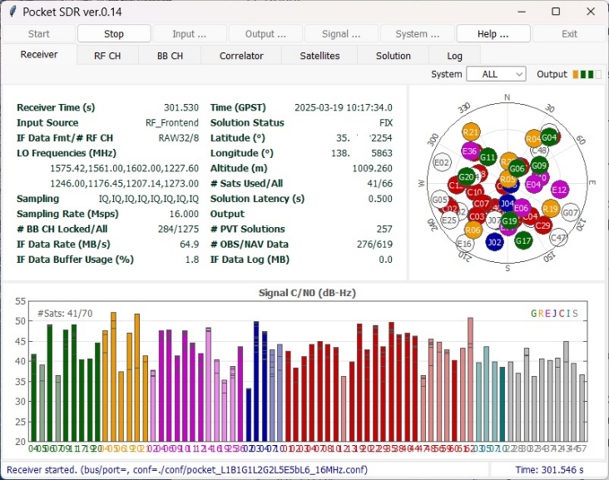

pocket_plot.py

Synopsis
pocket_plot.py [-type type[,type...]] [-sat sat[,...]] [-sig sig[,...]] [-tspan [ts],[te]] [-tint ti]
[-range rng[,...]] [-style {-|.|.-|...}] [-mark size] [-stats] [-legend] [-opt option [-opt ...]]
file ...

Description
Plot GNSS receiver log(s) written by pocket_trk or pocket_sdr.py.

Example:
pocket_plot.py -type CN0,EL -sat G01,G04,J -sig L1CA,L2CM -tspan 2025/1/1,2025/1/2 \
-tint 30 -range 0/60,0/100 -style . -mark 3 test_20250101*.log

Options ([]: default)
-type type[,type...]
Plot type(s) of receiver log as follows.

TRK : signal tracking status
SKY : satellite positions in skyplot
LOCK : signal lock time
CN0 : signal C/N0
COFF : code offset
DOP : Doppler frequency
ADR : accumulated Doppler range
SSYNC : secondary code sync status (0:no-sync,1:normal-sync,-1:reverse-sync)
BSYNC : bit sync status (0:no-sync, 1:sync)
FSYNC : subframe/message sync status (0:no-sync,1:normal-sync,-1:reverse-sync)
ERR_PHAS : phase error in PLL
ERR_CODE : code error in DLL
NFEC : number of bit errors corrected
PR : pseudorange
CP : carrier-phase
PR-CP : pseudorange - carrier-phase
LLI : loss-of-lock indicator
AZ : satellite azimuth angle
EL : satellite elevation angle
RES : residuals for position solution
POS : position solution east, north, up
POS-E : position solution east
POS-N : position solution north
POS-U : position solution up
POS-H : position solution horizontal
NSAT : number of used satellites for solution
RCLK : receiver clock bias

-sat sat[,...]
GNSS satellite IDs (G01, R01, ...), satellite system IDs (G, R, ...) or ALL to be plotted. It is required for plot type: TRK, SKY, LOCK, CN0, COFF, DOP, ADR, SSYNC, BSYNC, FSYNC, ERR_PHAS, ERR_CODE, NFEC, PR, CP, PR-CP, LLI, AZ, EL, RES.

-sig sig[,...]
GNSS signal type IDs (L1CA, L2CM, ...) or ALL to be plotted. If omitted, default signals are selected. [default]

-tspan [ts],[te]
Plot start time ts and end time te in GPST. The format for ts or te should be y/m/d_h:m:s, where _h:m:s can be omitted. [auto]

-tint ti
Time interval ti for plot in seconds. [all]

-range rng[,...]
Y-axis ranges as format ymax for range [-ymax...ymax] or ymin/ymax for range [ymin...ymax]. Multiple ranges correspond to multiple plot types. With NULL, the range is automatically configured by data values. [auto]

-color color[,color...]
Mark and line color(s). Multiple colors correspond to multiple plot types. With NULL, the color is automatically selected. sys or cn0 can be allowed for system or C/N0 colors in several plot types. [auto]

-style {-|.|.-|...}
Plot style as same as by matplotlib plot. [.-]

-mark size
Mark size in pixels. [2]

-stats
Show statistics in plots. [no]

-legend
Show legends in plots. [no]

-opt option [-opt ...]
Special options as string. Multiple options should be separated by spaces. ['']

MIN_CN0=cn0 : Minimum C/N0 (dB-Hz)
MIN_EL=el : Minimum elevation angle (deg)
MIN_LOCK=lock : Minimum lock time (s)
PLOT_SAT={S|E|L} : Plot satellite positions in plot type 'SKY'
(S: mark at start, E: mark at end, L: only label)
RFCH=ch[,...] : Select specified RFCH(s)
RFCH_DIFF=ch,ch[,...] : Make difference of RFCHs referenced by first RFCH

file ...
GNSS receiver log file(s) written by pocket_trk or pocket_sdr.py.

Execution Example
$ pocket_plot.py ../../data/ubuntu15/test_202503200000.log -type TRK -sat G -sig ALL -color cn0 -opt MIN_LOCK=35 -tint 10

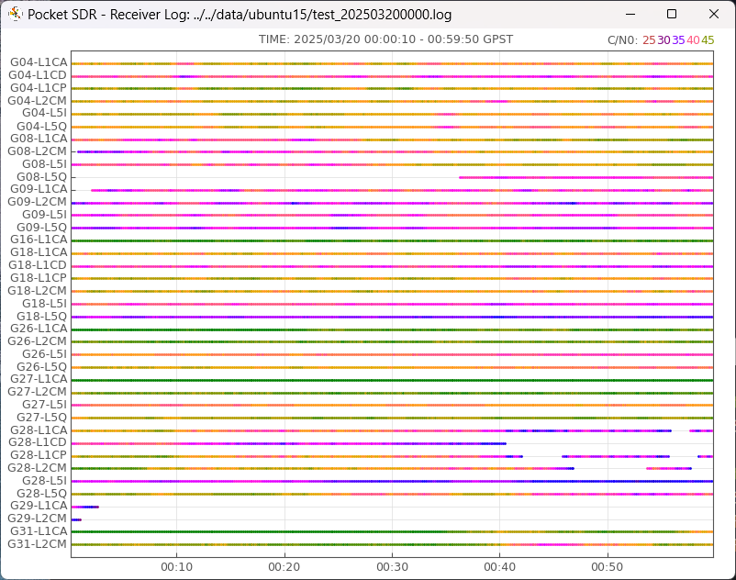

$ pocket_plot.py ../../data/ubuntu15/test_202503200000.log -type SKY -sat ALL -opt PLOT_SAT=S -tint 10 -color sys
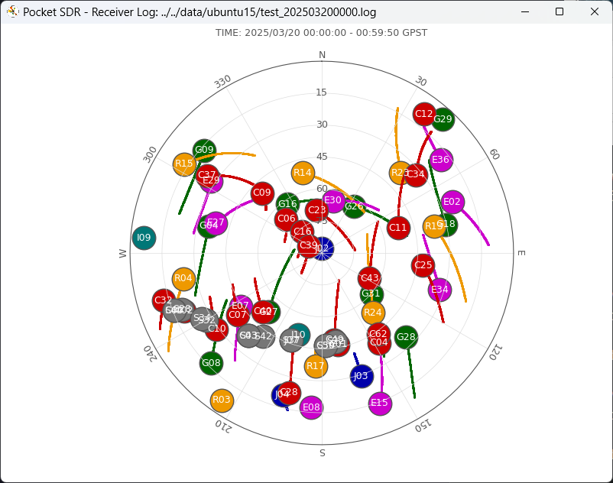

$ pocket_plot.py ../../data/ubuntu15/test_202503200000.log -type POS-E,POS-N,POS-U,NSAT -range 5,5,5,0/100
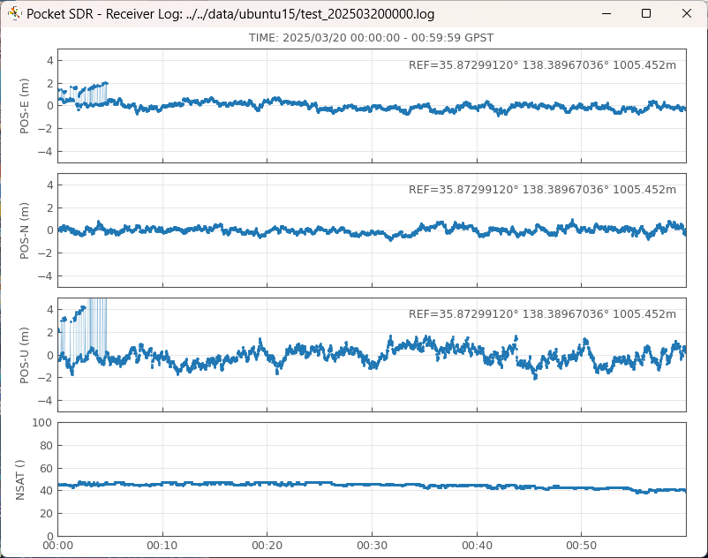

$ pocket_plot.py ../../data/ubuntu15/test_202503200000.log -type CN0,EL -sat G,R,E -legend -style -
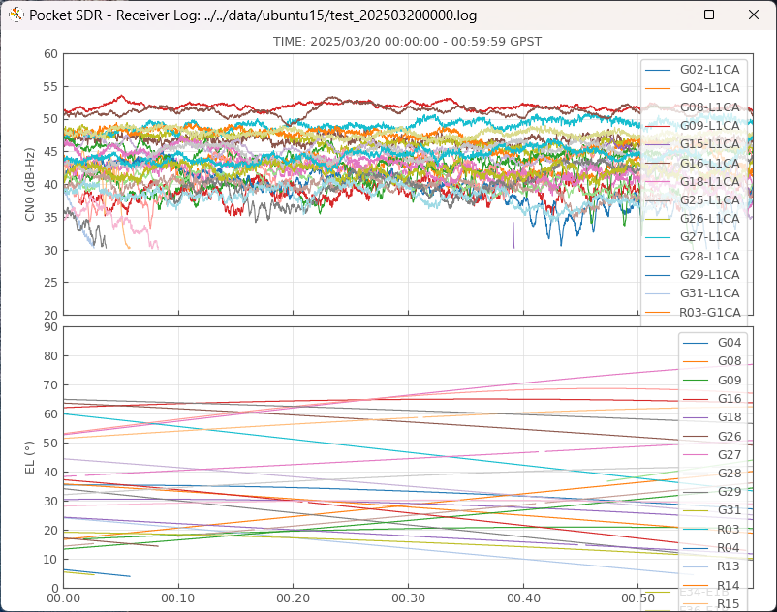

pocket_trk.py

Synopsis
pocket_trk.py [-sig sig -prn prn[,...] ...] [-p] [-e] [-toff toff] [-f freq] [-fi freq] [-IQ] [-ti tint]
[-ts tspan] [-yl ylim] [-log path] [-q] [file]

Description
It tracks GNSS signals in digital IF data and decode navigation data in the signals. If single PRN number by -prn option, it plots correlation power and correlation shape of the specified GNSS signal. If multiple PRN numbers specified by -prn option, it plots C/N0 for each PRN.

Options ([]: default)
-sig sig -prn prn[,...] ...
A GNSS signal type ID (L1CA, L2CM, ...) and a PRN number list of the signal. For signal type IDs, refer pocket_acq.py manual. The PRN number list shall be PRN numbers or PRN number ranges like 1-32 with the start and the end numbers. They are separated by . For GLONASS FDMA signals (G1CA, G2CA), the PRN number is treated as the FCN (frequency channel number). The pair of a signal type ID and a PRN number list can be repeated for multiple GNSS signals to be tracked.

-p
Plot signal tracking status in an integrated window. The window shows correlation envelope, correlation I-Q plot, correlation I/Q to time plot and navigation data decoded. You easily find the signal tracking situation. If multiple PRN number specified in -prn option, only the signal with the first PRN number is plotted. [no plot]

-e
Plot correlation shape as an envelop (SQRT(I^2+Q^2)). [I*sign(IP)]

-3d
3D Plot of correlation shapes. [no]

-toff toff
Time offset from the start of digital IF data in s. [0.0]

-f freq
Sampling frequency of digital IF data in MHz. [12.0]

-fi freq
IF frequency of digital IF data in MHz. The IF frequency is equal 0, the IF data is treated as IQ-sampling without -IQ option (zero-IF). [0.0]

-IQ
IQ-sampling even if the IF frequency is not equal 0.

-ti tint
Update interval of signal tracking status, plot and log in s. [0.1]

-ts tspan
Time span for correlation to time plot in s. [1.0]

-yl ylim
Y-axis limit of plots. [0.3]

-log path
A Log stream path to write signal tracking status. The log includes decoded navigation data and code offset, including navigation data decoded. The stream path should be one of the followings.

- local file file path without ':'. The file path can be contain time keywords (%Y, %m, %d, %h, %M) as same as RTKLIB stream.
- TCP server :port
- TCP client address:port

-q
Suppress showing signal tracking status.

[file]
A file path of the input digital IF data. The format should be a series of int8_t (signed byte) for real-sampling (I-sampling), interleaved int8_t for complex-sampling (IQ-sampling). The Pocket SDR RF-frontend and pocket_dump can be used to capture such digital IF data. If the option omitted, the input is taken from stdin.

pocket_acq.py

Synopsis
pocket_aqc.py [-sig sig] [-prn prn[,...]] [-tint tint] [-toff toff] [-f freq] [-fi freq] [-IQ] [-d freq] [-nz]
[-np] [-s] [-p] [-l] [-3d] file

Description
Search GNSS signals in digital IF data and plot signal search results. If single PRN number by -prn option, it plots correlation power and correlation shape of the specified GNSS signal. If multiple PRN numbers specified by -prn option, it plots C/N0 for each PRN.

Options ([]: default)
-sig sig
GNSS signal type ID (L1CA, L2CM, ...). See below for details. [L1CA]

-prn prn[,...]
PRN numbers of the GNSS signal separated by ','. A PRN number can be a PRN number range like 1-32 with start and end PRN numbers. For GLONASS FDMA signals (G1CA, G2CA), the PRN number is treated as FCN (frequency channel number). [1]

-tint tint
Integration time in ms to search GNSS signals. [code cycle]

-toff toff
Time offset from the start of digital IF data in ms. [0.0]

-f freq
Sampling frequency of digital IF data in MHz. [12.0]

-fi freq
IF frequency of digital IF data in MHz. The IF frequency is equal 0, the IF data is treated as IQ-sampling without -IQ option (zero-IF). [0.0]

-IQ
IQ-sampling even if the IF frequency is not equal 0.

-d freq
Max Doppler frequency to search the signal in Hz. [5000.0]

-nz
Disable zero-padding for circular correlation to search the signal. [enabled]

-np
Disable plot even with single PRN number. [enabled]

-s
Short output mode. [long output]

-p
Plot correlation powers with correlation peak graph.

-l
Plot correlation powers along Doppler frequencies.

-3d
Plot correlation powers in a 3D-plot.

-h
Show usage and signal type IDs

file
File path of the input digital IF data. The format should be a series of int8_t (signed byte) for real-sampling (I-sampling) or interleaved int8_t for complex-sampling (IQ-sampling). PocketSDR and AP pocket_dump can be used to capture such digital IF data.

pocket_psd.py

Synopsis
pocket_psd.py [-t tint] [-f freq] [-IQ] [-h] [-n NFFT] file

Description
Plot PSD (power spectrum density) and histogram of input digital IF data.

Options ([]: default)
-t tint
Time interval for PSD and histogram in seconds. [0.01]

-f freq
Sampling frequency of digital IF data in MHz. [24.000]

-IQ
I/Q sampling type of digital IF data. [no]

-h
Enable histogram plots. [no]

-n NFFT
Number of FFT data points for PSD. [4096]

pocket_snap.py

Synopsis
pocket_snap.py [-ts time] [-pos lat,lon,hgt] [-ti sec] [-toff toff] [-f freq] [-fi freq] [-tint tint]
[-sys sys[,...]] -nav file [-out file] file

Description
Snapshot positioning with GNSS signals in digitized IF file.

Options ([]: default)
-ts time
Captured start time in UTC as YYYY/MM/DD HH:mm:ss format. [parsed by file name]

-pos lat,lon,hgt
Coarse receiver position as latitude, longitude in degree and height in m. [no coarse position]

-ti sec
Time interval of positioning in seconds. (0.0: single) [0.0]

-toff toff
Time offset from the start of digital IF data in seconds. [0.0]

-f freq
Sampling frequency of digital IF data in MHz. [12.0]

-fi freq
IF frequency of digital IF data in MHz. The IF frequency equals 0, the IF data is treated as IQ-sampling (zero-IF). [0.0]

-tint tint
Integration time for signal search in msec. [20.0]

-sys sys[,...]
Select navigation system(s) (G=GPS, E=Galileo, J=QZSS, C=BDS). [G]

-v
Enable verbose status display.

-nav file
RINEX navigation data file.

-out file
Output solution file as RTKLIB solution format.

file
Digitized IF data file.

