10 January 2011
Dear Editors of Nature Materials
We should like to submit our manuscript entitled
“Hyperbolic Tiling on the Gyroid Membrane in Star Block Copolymers,”
which is an interdisciplinary study completed by chemists, a physicist, and a mathematician. Our recent result that the same star polymer with different composition ratio produces the first polymer quasicrytalline tiling has been reported in Research Highlight, Nature 447 256 (2007), however, the present advance is not just only a notable scientific achievement in material sciences (polymer chemistry and physics), but also it is appealing to popular audience because it is related to M.C.Escher’s artwork through mathematical (or aesthetic) aspect. The worldwide top specialist Professor Ludwik Leibler (ESPCI, Paris; the author of nature materials) who allowed us to use his name said in his mail:
“Only this morning I had the opportunity to close my office and spend a delightful moment going through your work. I am really under spell. Both the structures you discovered and the depth of the analysis are impressive in beauty and very interesting indeed.”

Summary-1 (99)
Block copolymers - two or more different polymer chains linked together - are considered as key agents to construct nanostructures. Here we show a “hyperbolic tiling” structure associated with the gyroid minimal surface with a lattice constant of 100 nm in an ABC star-shaped block copolymer, which is composed of polyisoprene, polystyrene, and poly (2-vinylpyridine). The tessellation of the polyisoprene spheroids on the polystyrene gyroid membrane can be viewed as a hyperbolic tiling on the Poincaré disk with a negative Gaussian curvature. Our investigation opens up the possibility of the regular arrangement on saddle-shaped membranes in versatile soft materials.
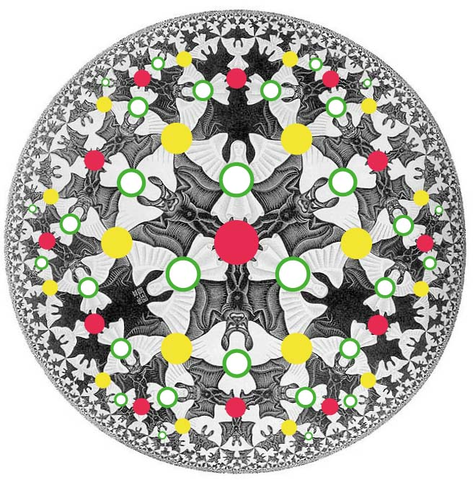
Fig.1 Circle Limit IV (Heaven and Hell) superimposed by our hyperbolic tiling (green circles).

Summary-2 (100)
The encounter of different domains sometimes makes great achievement. When Escher met Coxeter, the foremost 20th-century mathematician of geometry, a series of enchanting hyperbolic tiling artworks "Circle Limit" was born. Hyperbolic tiling, the hyperbolic analogue of tiling on a plane, is familiar not by math-books, rather by the Escher’s artworks. Surprisingly, we have found the arrangement of angels in “Circle Limit IV” appears in an advanced synthetic polymeric material. The structure is a new Archimedean tiling on a three-dimensionally periodic minimal surface, and experimental data was obtained from electron microscopy and the world’s largest synchrotron radiation facility, SPring-8 (Japan).

We submit one manuscript (pdf) with four figures (comprising 8+6+4+1=18 panels), and include two pdf documents (supplementary information and ref.27) and two gif-formatted movies as supplementary information. The number of words of text excluding abstract and methods is 1998.

Yours sincerely
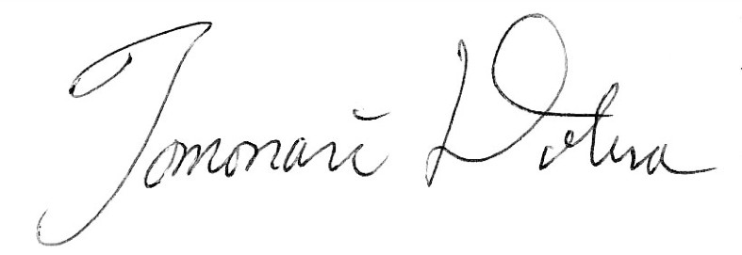
Corresponding author for publication
Tomonari DOTERA
Professor of Physics
Department of Physics, Kinki University
Kowakae 3-4-1, Higashi-Osaka 577-8502, Japan
dotera@phys.kindai.ac.jp

Authors
Yushu MATSUSHITA
Department of Applied Chemistry, Graduate School of Engineering,
Nagoya University, Nagoya 464-8603, Japan
yushu@apchem.nagoya-u.ac.jp

Kenichi HAYASHIDA
Department of Applied Chemistry, Graduate School of Engineering
Nagoya University, Nagoya 464-8603, Japan
Present address: Organic Materials Research Lab, Toyota Central R&D Labs., Inc., Nagakute, Aichi 480-1192, Japan.
hayashid@grace.ocn.ne.jp

Atsushi TAKANO
Department of Applied Chemistry, Graduate School of Engineering
Nagoya University, Nagoya 464-8603, Japan
atakano@apchem.nagoya-u.ac.jp

Junichi MATSUZAWA
Department of Mathematics, Nara Women's University
Kitauoyahigashi-machi, Nara 630-8506, Japan
matsuzawa@cc.nara-wu.ac.jp

S. Roberts, King of Infinite Space: Donald Coxeter, the Man Who Saved Geometry, (2006, Walker & Company). See also, D. Schattschneider, The Mathematical Side of M. C. Escher, Notices of the AMS 57, 706-718 (June/July 2010) and the cover.

