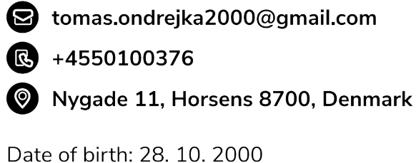2nd February 2022

**Cover letter for the Java Full Stack Developer Position at Accenture**

Dear Hiring Manager,

I am writing this letter to express my interest in the Java Full Stack Developer at Accenture. Currently, I am looking for an internship starting from summer 2022 with a minimum length of 6 months. This position would be a great opportunity for me to use my practical knowledge and skills from school and projects.

I am currently taking a Bachelor degree at Via University College. While working on projects in school, I have developed a skill to adapt to every situation I am in and come up with creative solutions to problems that can occurr. Developing semester projects taught me how to cooperate in a group of software developers and how to together achieve the best result possible. My Git and Github knowledge expanded to a proficient level. Waterfall and Scrum methodologies were strictly followed during the projects for the highest learning outcome. Our latest project was full-stack development of an application for selling experience products. The persistence server of the system was developed following technologies: Java, Java Spring Boot and Hibernate.

I am proficient with a number of programming languages, including JavaScript, Java, C#. Currently, I am working as a Game Developer at TrainYourEyes.dk where I am creating exercises in JavaScript and TypeScript. My work is now used for helping people with various types of sight problems. Because TrainYourEyes.dk is not a software company, I have developed a skill to work independently, solve complex problems with the only help of google, extract client requirements and implement them.

Because of my solid knowledge of programming languages and my passion, I have a foundation for learning new technologies and frameworks that can benefit your company. I am an excellent team player with attention to detail and with the knowledge required for the position.

Accenture is a company in which I hear a lot of great insights. Currently, my aunt works in your branch in Bratislava, Slovakia, and she appreciates the amount of opportunities where one can grow. This is one of the reasons why I am applying for the position.

Please do not hesitate to reach out if you have any questions about my background, projects or my skills. I look forward to the opportunity to speak with you further.

Thank you for your time and consideration.

Sincerely,

Tomas Ondrejka