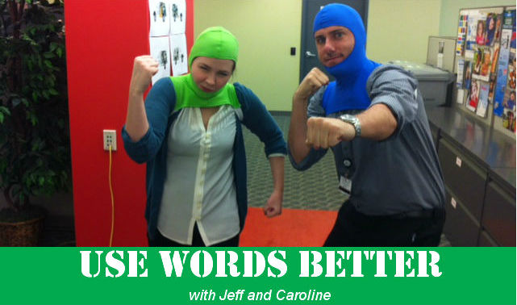

Editorial Style Guide update
The name for the Primary Care Center you know and love in Chamblee, one of our 20 neighborhood locations, has been changed. It is now called the Children’s Primary Care Center of Chamblee on first reference. This allows for the differentiation between future Primary Care Centers in other locations.

AP Stylebook update
The Associated Press added “insure” to their guide to help distinguish the word from “ensure” and “assure.” Their explanation follows:
- Use ensure to mean guarantee: Steps were taken to ensure accuracy.
- Use insure for references to insurance: The policy insures his life.
- Use assure to mean to make sure or give confidence: She assured us the statement was accurate.

Words of the month that are not words
Funner, funnest
If you’re comparing fun things, the correct forms are “more fun” and “most fun.”

Idioms: You’re doing it wrong
People will often use “flesh out” and “flush out” interchangeably to describe developing an idea or concept. To “flesh something out” means to make it more detailed or fuller. To “flush something out” means something else entirely and probably isn’t applicable to work-related discussions … hopefully.

Did you know?
Though it might sound better in conversation, the word “snuck” is not a word in formal writing. The proper past tense of “sneak” is “sneaked.” Snuck didn’t enter the lexicon until the 20th century, y’all.

Caroline Ervin
Writer/Editor
Marketing and Public Relations
Children's Healthcare of Atlanta
P. 404-785-7311
E. caroline.ervin@choa.org

Dedicated to All Better

